ST PHILOMENA COLLEGE (AUTONOMOUS), PUTTUR
DEPARTMENT OF COMPUTER SCIENCE
DATABASE DESIGN DOCUMENT
"AI Crop Disease Detection and Treatment System"
Submitted By:

Shruthy R.S A.V. Ancilla Mary
(U05PH23C0198) (U05PH23C0201)
Jeevitha
(U05PH23C0184)

Submitted To:

Internal guide Head of Dept

Dr.Vinayachandra Dr.Vinayachandra

St.Philomena college St.Philomena college

1. General Information

1.1 Introduction
Database Design is the process of producing a detailed data model of a database. This document describes the logical and physical design of the crop_disease_db database used in the AI Crop Disease Detection and Treatment System. Since no farmer login is required, the database stores uploaded images, AI prediction results, crop information, disease data, and treatment recommendations only.
The design process involves: determining relationships between data elements, dividing information into normalized tables, specifying primary and foreign keys, and applying normalization rules to ensure data integrity and eliminate redundancy.

1.2 Purpose
- Define the complete structure of the crop_disease_db database
- Describe each table, its fields, data types, lengths, constraints, and relationships
- Provide an Entity-Relationship (ER) diagram for visual representation
- Ensure the design supports all functional requirements in the SRS
- Serve as a reference for developers during implementation and testing

1.3 System Overview
The AI Crop Disease Detection and Treatment System is a web-based application. No login is required for farmers — any user can upload a crop leaf image and instantly receive disease detection results and treatment recommendations. A separate secured Admin interface allows management of crop, disease, and treatment records. The database is implemented in MySQL or SQLite, accessed via Python Flask and SQLAlchemy ORM.

1.4 Acronyms and Abbreviations

Acronym | Full Form
DB | Database
PK | Primary Key
FK | Foreign Key
ER | Entity-Relationship
DDD | Database Design Document
SRS | Software Requirements Specification
CNN | Convolutional Neural Network
AI | Artificial Intelligence
DBMS | Database Management System
NULL | No value / Optional field
NOT NULL | Mandatory field
DDL | Data Definition Language

2. Database Identification and Description

2.1 Database Identification
Database Name: crop_disease_db
Database Type: Relational Database (MySQL / SQLite)
Version: 1.0
Note: No User/Farmer table is required since the system does not need farmer login or registration.

2.2 Systems Using the Database

System / Module | Database Operations Performed
Farmer (User) Module | INSERT into Image; SELECT from Prediction for displaying results
Admin Module | INSERT / UPDATE / DELETE in Crop, Disease, and Treatment tables
Image Processing Module | INSERT into Image table; UPDATE image status
AI Disease Detection Module | SELECT from Disease; INSERT into Prediction table
Recommendation Module | SELECT from Disease and Treatment tables

2.3 Database Table Structure
The database consists of 5 tables. Each table is described with field names, descriptions, data types, lengths, constraints, and remarks.

Table 1: Image
Stores information about crop leaf images uploaded by users for disease detection.

Field Name | Field Description | Data Type | Length | Constraints | Remarks
Image_ID | Unique image identifier | INT | - | PK, NOT NULL, AUTO_INCREMENT | Primary Key
Image_Path | Server file path of image | VARCHAR | 255 | NOT NULL | Path to /uploads/
Upload_Date | Date and time of upload | DATETIME | - | DEFAULT CURRENT_TIMESTAMP | Auto-set on insert
Status | Processing status | VARCHAR | 20 | DEFAULT 'Pending' | Pending / Processed / Failed

Table 2: Crop
Stores the list of supported crops in the system.

Field Name | Field Description | Data Type | Length | Constraints | Remarks
Crop_ID | Unique crop identifier | INT | - | PK, NOT NULL, AUTO_INCREMENT | Primary Key
Crop_Name | Name of the crop | VARCHAR | 100 | NOT NULL, UNIQUE | e.g., Tomato, Brinjal
Description | Brief crop description | TEXT | - | NULL | Optional information
Season | Growing season | VARCHAR | 50 | NULL | e.g., Kharif, Rabi

Table 3: Disease
Stores information about crop diseases detectable by the AI model.

Field Name | Field Description | Data Type | Length | Constraints | Remarks
Disease_ID | Unique disease identifier | INT | - | PK, NOT NULL, AUTO_INCREMENT | Primary Key
Disease_Name | Name of the disease | VARCHAR | 150 | NOT NULL, UNIQUE | e.g., Tomato Late Blight
Symptoms | Visible symptoms description | TEXT | - | NOT NULL | Displayed to users
Cause | Cause of disease | VARCHAR | 200 | NULL | Fungal / Bacterial / Viral
Crop_ID | Linked crop | INT | - | FK (Crop.Crop_ID), NOT NULL | References Crop table

Table 4: Treatment
Stores treatment and prevention recommendations for each disease.

Field Name | Field Description | Data Type | Length | Constraints | Remarks
Treatment_ID | Unique treatment identifier | INT | - | PK, NOT NULL, AUTO_INCREMENT | Primary Key
Disease_ID | Linked disease | INT | - | FK (Disease.Disease_ID), NOT NULL | References Disease table
Fertilizer | Recommended fertilizer | VARCHAR | 200 | NULL | e.g., NPK 20-20-20
Pesticide | Recommended pesticide | VARCHAR | 200 | NULL | e.g., Mancozeb 75% WP
Prevention | Prevention tips | TEXT | - | NULL | Cultural / organic measures
Dosage | Application dosage | VARCHAR | 100 | NULL | e.g., 2g per litre water

Table 5: Prediction
Stores AI disease detection results for each uploaded image.

Field Name | Field Description | Data Type | Length | Constraints | Remarks
Prediction_ID | Unique prediction identifier | INT | - | PK, NOT NULL, AUTO_INCREMENT | Primary Key
Image_ID | Linked uploaded image | INT | - | FK (Image.Image_ID), NOT NULL | References Image table
Disease_ID | Predicted disease | INT | - | FK (Disease.Disease_ID), NULL | NULL if crop is healthy
Accuracy | Model confidence score | FLOAT | - | NOT NULL | Value 0.0 to 1.0
Result_Label | Human-readable result | VARCHAR | 150 | NOT NULL | e.g., Tomato Late Blight
Predicted_At | Timestamp of prediction | DATETIME | - | DEFAULT CURRENT_TIMESTAMP | Auto-set on insert

3. ER Diagram
The ER Diagram below illustrates the 5 entities, their attributes, and relationships in the crop_disease_db database. Rectangles represent entities, ovals represent attributes (underlined oval = Primary Key attribute), and diamonds represent relationships. Numbers on connecting lines indicate cardinality (1 = one, N = many).

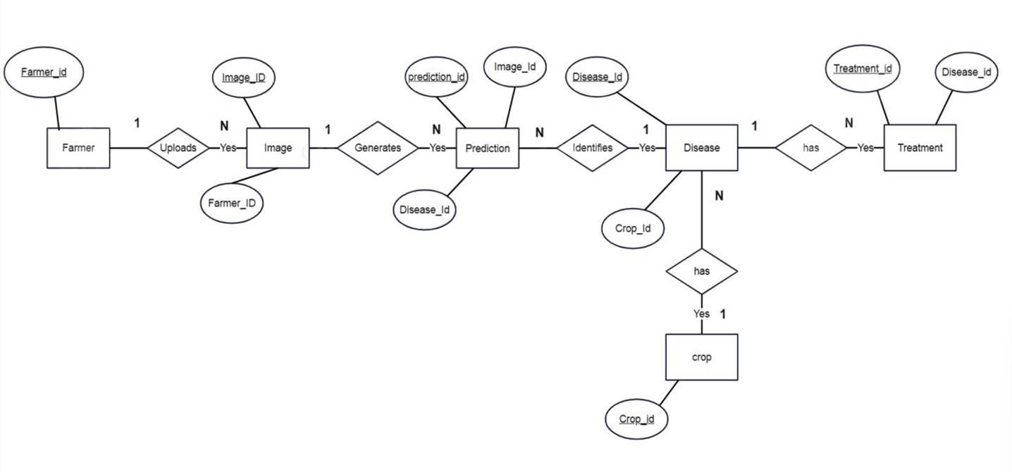
Fig 3.1: ER Diagram — AI Crop Disease Detection and Treatment System

3.1 Entity Descriptions

Entity | Attributes | Description
Image | Image_ID (PK), Image_Path, Upload_Date, Status | Crop leaf image uploaded by any user (no login required)
Prediction | Prediction_ID (PK), Image_ID (FK), Disease_ID (FK), Accuracy, Result_Label, Predicted_At | AI model result linked to an uploaded image
Disease | Disease_ID (PK), Disease_Name, Symptoms, Cause, Crop_ID (FK) | Crop disease detectable by the AI model
Treatment | Treatment_ID (PK), Disease_ID (FK), Fertilizer, Pesticide, Prevention, Dosage | Treatment recommendation for a disease
Crop | Crop_ID (PK), Crop_Name, Description, Season | Type of crop supported by the system

3.2 Relationship Descriptions

Relationship | Entities Involved | Cardinality | Description
has | Image — Prediction | 1 : 1 | Each uploaded image produces exactly one prediction result
identifies | Prediction — Disease | N : 1 | Many predictions may identify the same disease
affects | Disease — Crop | N : 1 | Many diseases can affect the same crop type
has | Disease — Treatment | 1 : N | One disease can have multiple treatment records

4. Database Normalization

4.1 First Normal Form (1NF)
All tables satisfy 1NF: each table has a primary key, all column values are atomic (no multi-valued attributes in a single field), and each row is unique.

4.2 Second Normal Form (2NF)
All tables satisfy 2NF: all non-key attributes are fully functionally dependent on the entire primary key. Since all primary keys are single-column, no partial dependencies exist.

4.3 Third Normal Form (3NF)
All tables satisfy 3NF: no transitive dependencies exist between non-key attributes. Treatment data is stored separately in the Treatment table and referenced via Disease_ID, rather than being duplicated in the Disease table.

4.4 Anomalies Handled

Anomaly Type | Problem Scenario | How the Design Handles It
Update Anomaly | Disease name stored in multiple rows | Disease stored once in Disease table; referenced by Disease_ID in other tables
Insertion Anomaly | Cannot add treatment without disease record | Treatment has FK to Disease; Disease record must exist before adding treatment
Deletion Anomaly | Deleting disease removes its treatments | Handled via ON DELETE CASCADE or application-level constraint

