ST PHILOMENA COLLEGE (AUTONOMOUS), PUTTUR
DEPARTMENT OF COMPUTER SCIENCE

DETAILED DESIGN DOCUMENT
"AI Crop Disease Detection and Treatment System"

Submitted By:
Shruthy R.S A.V. Ancilla Mary Jeevitha
(U05PH23C0198) (U05PH23C0201) (U05PH23C0184)

Submitted To:

Internal Guide Head of Dept
Dept. of Computer Science Dept. of Computer Science
St. Philomena college St. Philomena college

1. Introduction
This Detailed Design Document (DDD) provides a comprehensive low-level design of the AI Crop Disease Detection and Treatment System. It refines the system design described in the SDD by specifying the internal design of each functional module, including module decomposition, structure charts, data structures, and flowcharts.
The system allows any user to directly upload a crop leaf image through a web browser — no login is required. The uploaded image is processed by a Convolutional Neural Network (CNN) to detect the disease, and the system returns the detected disease name along with treatment recommendations. A separate Admin interface (login required) manages disease and treatment data.

2. Applicable Documents
The documents used during the preparation of this Detailed Design Document are:
- System Requirements Specification (SRS) — AI Crop Disease Detection and Treatment System
- System Design Description (SDD) — AI Crop Disease Detection and Treatment System
- Database Design Document (DDD) — AI Crop Disease Detection and Treatment System

3. Structure of the Software Package
The functional components identified during system design are:
- Functional Component 1: Farmer (User) Module — Direct image upload and result display (no login required)
- Functional Component 2: Admin Module — Manages disease, treatment, and crop data (login required)
- Functional Component 3: Image Processing Module — Preprocesses uploaded images for AI analysis
- Functional Component 4: AI Disease Detection Module — CNN-based crop disease classification
- Functional Component 5: Recommendation Module — Retrieves and displays treatment suggestions
- Functional Component 6: Database Module — Manages all persistent data storage

4. Modular Decomposition of Components

4.1 Modules of Component 1: Farmer (User) Module

4.1.1 Design Assumptions
No login or registration is required. Any user can access the system via a web browser, upload a crop leaf image, and receive disease detection results immediately. The system is publicly accessible.

4.1.2 Identification of Modules
- Module 1.1: Image Upload
- Module 1.2: View Disease Detection Result

4.1.3 Structure Chart

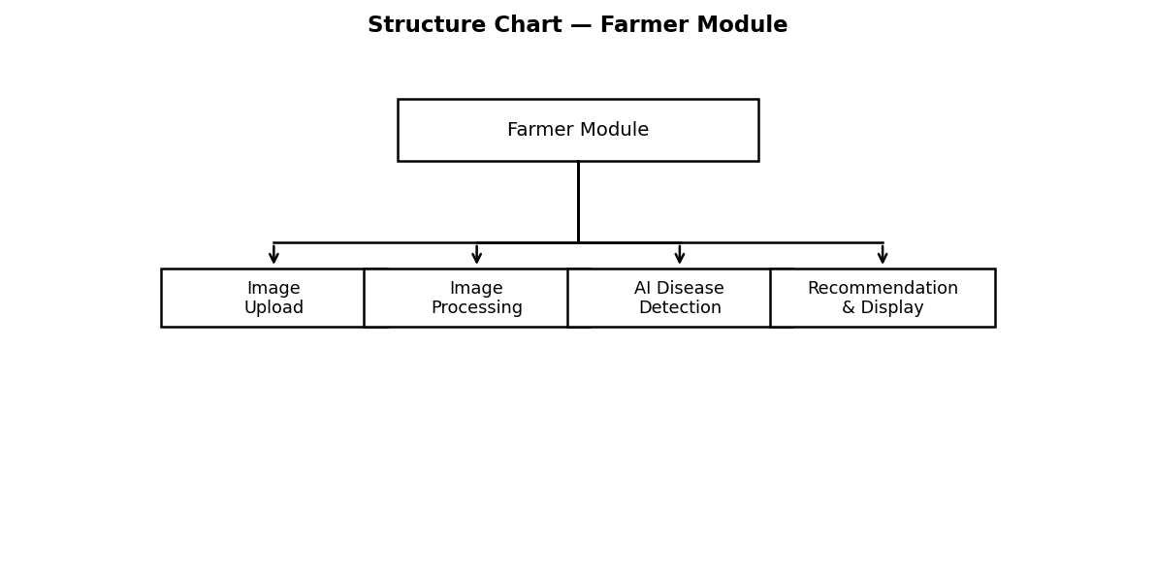
Fig 4.1.3: Structure Chart — Farmer Module

4.1.4 Data Structures Shared Among Modules

Data Element | Type | Description | Shared With
image_path | STRING | Server path to uploaded image | Image Upload, AI Module
disease_result | STRING | Detected disease name | View Result, Recommendation
confidence_score | FLOAT (0.0–1.0) | AI model prediction confidence | View Result
treatment_info | STRING | Treatment recommendation text | View Result

4.2 Modules of Component 2: Admin Module

4.2.1 Design Assumptions
The admin has a secured login with username and password. Only the admin can add, edit, or delete disease and treatment records. Admin operations directly update the database.

4.2.2 Identification of Modules
- Module 2.1: Admin Login
- Module 2.2: Add / Edit Disease Data
- Module 2.3: Add / Edit Treatment Data
- Module 2.4: View Reports

4.2.3 Structure Chart

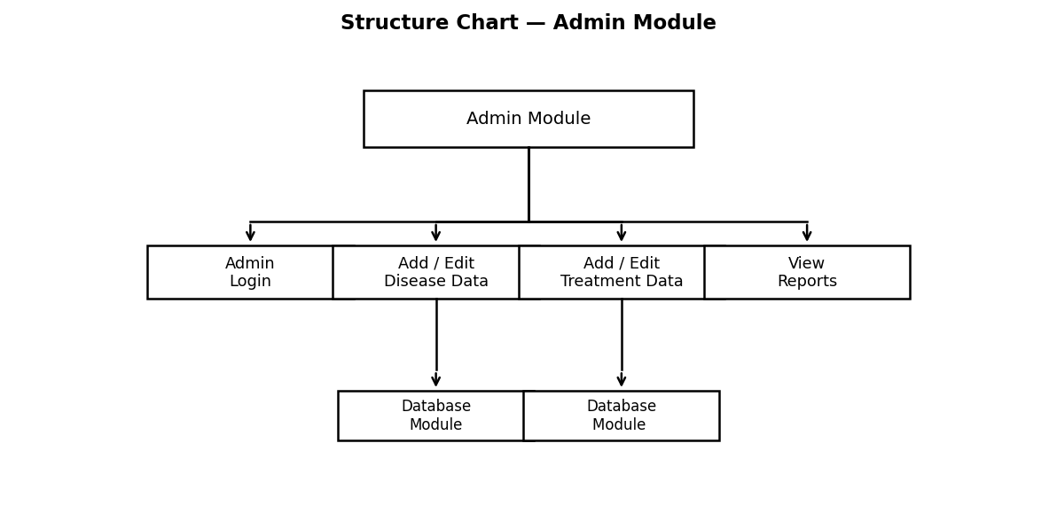
Fig 4.2.3: Structure Chart — Admin Module

4.2.4 Data Structures Shared Among Modules

Data Element | Type | Description | Shared With
admin_id | INT (PK) | Unique admin identifier | Login, Disease, Treatment
disease_id | INT (PK) | Disease record ID | Disease, Treatment, Prediction
treatment_id | INT (PK) | Treatment record ID | Treatment, Recommendation
crop_id | INT (FK) | Linked crop ID | Disease, Crop

4.3 Modules of Component 3: Image Processing Module

4.3.1 Design Assumptions
Input images must be JPG or PNG format. Images are resized to 224×224 pixels for CNN model compatibility. OpenCV and Pillow libraries are used for preprocessing.

4.3.2 Identification of Modules
- Module 3.1: Image Validation
- Module 3.2: Image Resizing and Normalization
- Module 3.3: Prepare Input Array for CNN

4.3.3 Structure Chart

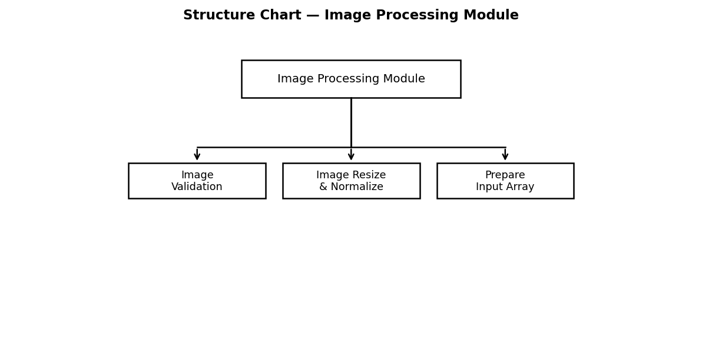
Fig 4.3.3: Structure Chart — Image Processing Module

4.3.4 Data Structures Shared Among Modules

Data Element | Type | Description | Shared With
raw_image | FILE (JPG/PNG) | Original uploaded image | Image Validation
processed_array | NumPy Array (224,224,3) | Normalized image array | AI Detection Module
image_id | INT (PK) | Stored image reference ID | Prediction Table

4.4 Modules of Component 4: AI Disease Detection Module

4.4.1 Design Assumptions
A pre-trained CNN model in TensorFlow/Keras (.h5 format) is available on the server. The model is trained on the PlantVillage dataset covering tomato, spinach, ladyfinger, brinjal, and arecanut.

4.4.2 Identification of Modules
- Module 4.1: Model Loading
- Module 4.2: Disease Prediction
- Module 4.3: Accuracy Score Computation

4.4.3 Structure Chart

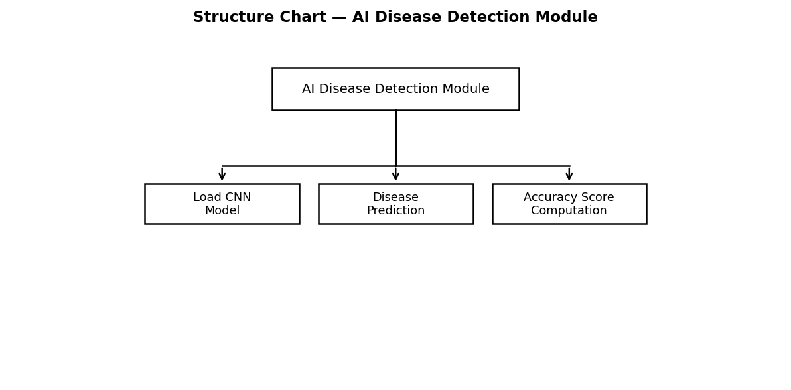
Fig 4.4.3: Structure Chart — AI Disease Detection Module

4.4.4 Data Structures Shared Among Modules

Data Element | Type | Description | Shared With
model_file | H5 / SavedModel | Trained CNN model file | Model Loading
input_tensor | NumPy Array (1,224,224,3) | Preprocessed image tensor | Image Processing Module
prediction_class | STRING | Predicted disease class label | Recommendation Module
confidence_score | FLOAT (0.0–1.0) | Prediction confidence | Result Display, Prediction Table

4.5 Modules of Component 5: Recommendation Module

4.5.1 Design Assumptions
Disease-to-treatment mapping exists in the database. If no treatment is found for a detected disease, a default advisory message is returned to the user.

4.5.2 Identification of Modules
- Module 5.1: Disease Lookup
- Module 5.2: Treatment Retrieval
- Module 5.3: Format and Display Result

4.5.3 Structure Chart

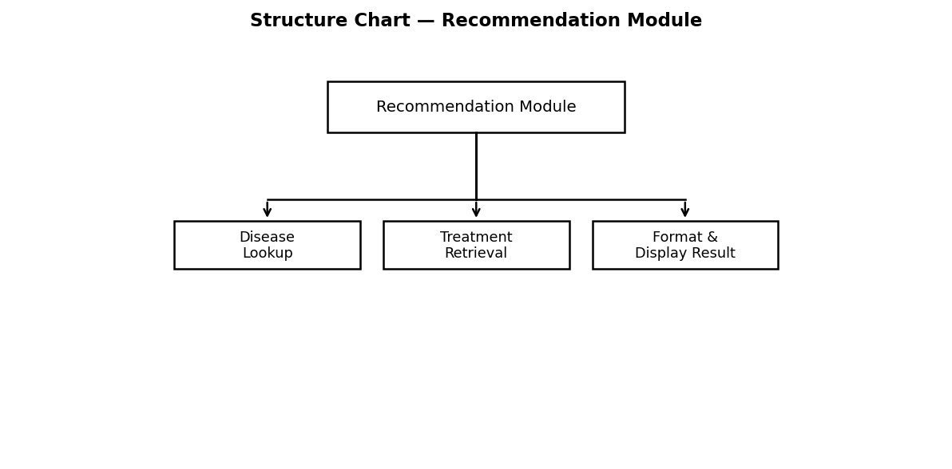
Fig 4.5.3: Structure Chart — Recommendation Module

4.5.4 Data Structures Shared Among Modules

Data Element | Type | Description | Shared With
disease_name | STRING | Detected disease name | AI Module, Database Module
treatment_info | STRING | Treatment description | Result Display
fertilizer | STRING | Recommended fertilizer | Result Display
pesticide | STRING | Recommended pesticide | Result Display

4.6 Modules of Component 6: Database Module

4.6.1 Design Assumptions
MySQL or SQLite is used. All tables are normalized to 3NF. Foreign key constraints are enforced. No User table is needed since there is no farmer login.

4.6.2 Identification of Modules
- Module 6.1: Crop and Disease Data Management
- Module 6.2: Treatment Data Management
- Module 6.3: Image and Prediction Storage

4.6.3 Structure Chart

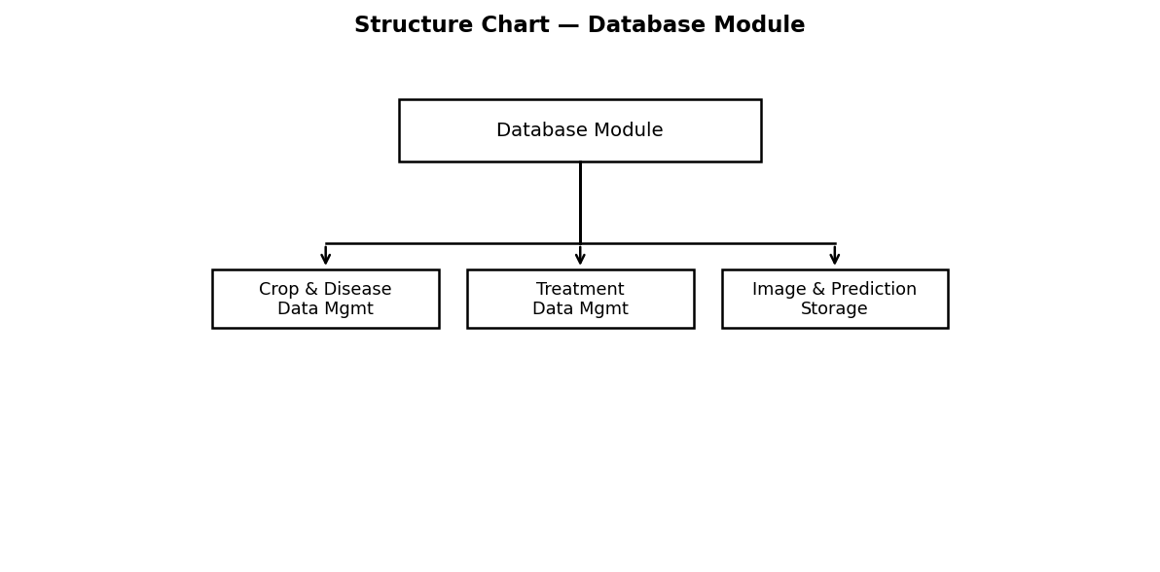
Fig 4.6.3: Structure Chart — Database Module

5. Detailed Design

5.1 Module Design of Component 1: Farmer (User) Module

5.1.1 Module 1.1 — Image Upload
5.1.1.1 Inputs:

Parameter | Source | Format | Valid Range
Crop leaf image | User file input (web browser) | JPG / PNG | Max 5MB, minimum 100×100 pixels

5.1.1.2 Procedural Details (Flow Chart):

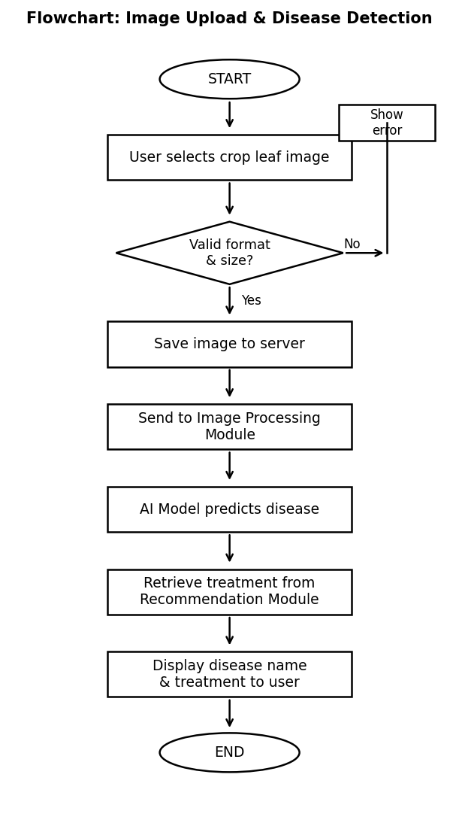
Fig 5.1.1: Flowchart — Image Upload & Disease Detection

5.1.1.3 File I/O Interfaces:
- Writes: Image file saved to /uploads/ directory on server
- Inserts: Record into Image table (Image_Path, Upload_Date)

5.1.1.4 Outputs:
- Disease name detected by AI model
- Confidence score (prediction accuracy percentage)
- Treatment recommendation (fertilizer, pesticide, prevention tips)
5.1.1.5 Implementation: Flask file upload, os.path, Pillow (PIL) for file validation

5.2 Module Design of Component 3: Image Processing Module

5.2.1 Module 3.2 — Image Resizing and Normalization
5.2.1.1 Inputs:

Parameter | Source | Format | Valid Range
Raw image | Image Upload Module | JPG / PNG file | Any resolution
Target size | System configuration | Integer tuple | (224, 224)

5.2.1.2 Procedural Details (Pseudo-code in Structured English):
Load image → Resize to (224, 224) → Convert to NumPy array (224,224,3) → Normalize pixel values by dividing by 255.0 → Expand dimensions to (1,224,224,3) → Return preprocessed array to AI module.
5.2.1.3 File I/O Interfaces:
- Reads: Image file from /uploads/ directory
- Outputs: In-memory NumPy array passed directly to AI Detection Module
5.2.1.4 Outputs: Normalized NumPy array of shape (1, 224, 224, 3)
5.2.1.5 Implementation: OpenCV (cv2.resize), PIL/Pillow, NumPy libraries

5.3 Module Design of Component 4: AI Disease Detection Module

5.3.1 Module 4.2 — Disease Prediction

5.3.1.1 Inputs:

Parameter | Source | Format | Valid Range
Preprocessed image array | Image Processing Module | NumPy Array (1,224,224,3) | Float values 0.0 to 1.0
CNN Model | Model file (model.h5) | Keras Model object | Pre-trained, loaded at startup

5.3.1.2 Procedural Details (Flow Chart):
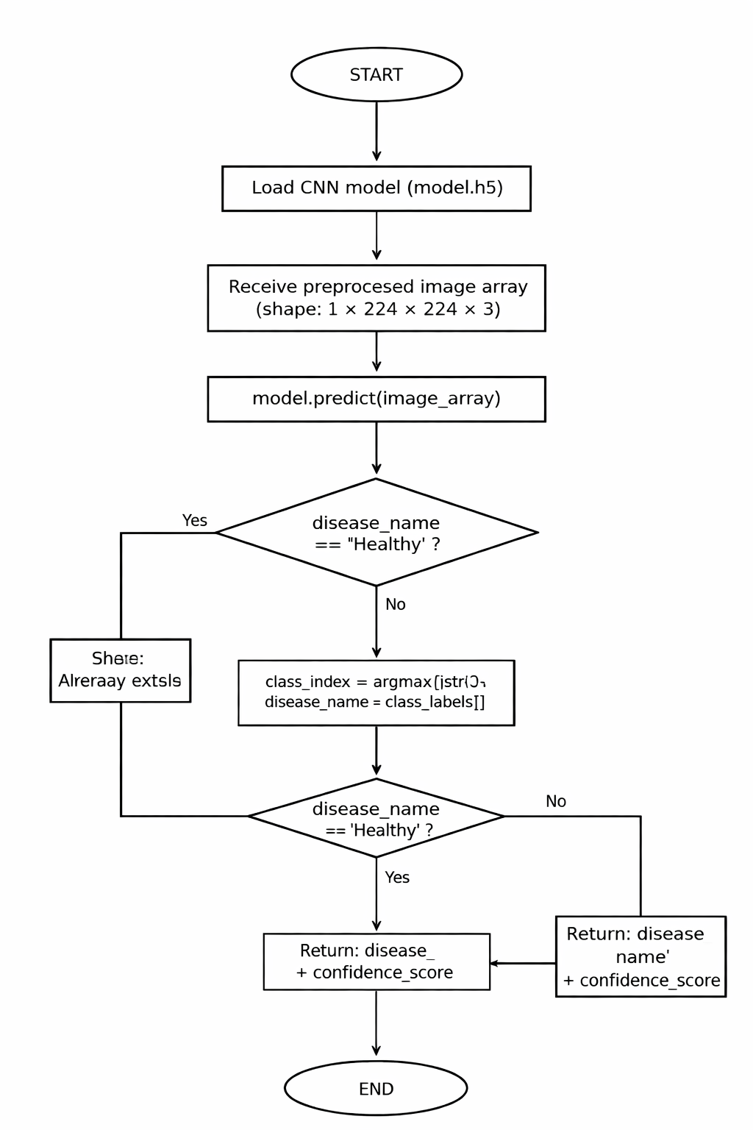
Fig 5.3.1: Flowchart — CNN Disease Prediction

5.3.1.3 Table I/O Interfaces:
- Reads: class_labels list (list of disease class names)
- Writes: Result to Prediction table (Image_ID, Disease_ID, Accuracy, Result_Label)
5.3.1.4 Outputs:
- disease_name: String (e.g., 'Tomato Late Blight')
- confidence_score: Float (e.g., 0.94 representing 94% confidence)
5.3.1.5 Implementation: TensorFlow 2.x, Keras model.predict(), numpy.argmax()

5.4 Module Design of Component 5: Recommendation Module

5.4.1 Module 5.2 — Treatment Retrieval
5.4.1.1 Inputs:

Parameter | Source | Format | Valid Range
disease_name | AI Detection Module | String | Must match entry in Disease table
disease_id | Database lookup | Integer (FK) | Must exist in Disease table

5.4.1.2 Procedural Details (Flow Chart):

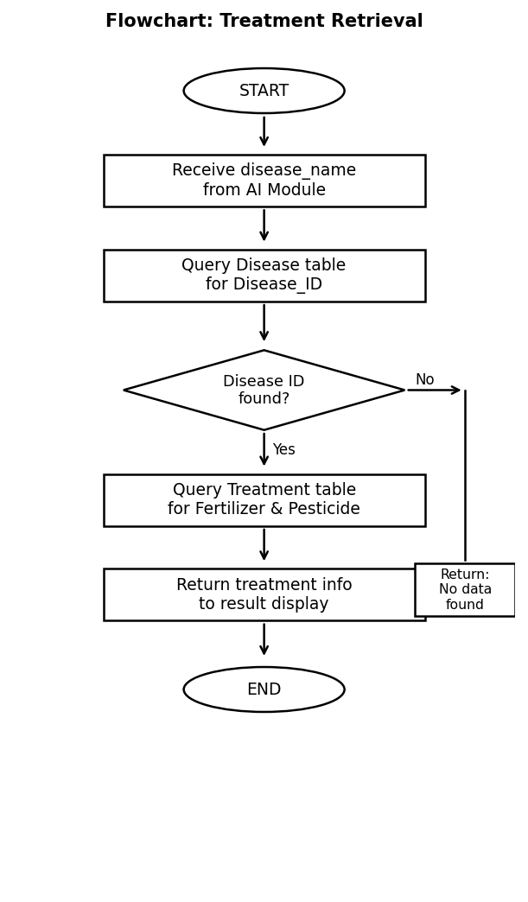
Fig 5.4.1: Flowchart — Treatment Retrieval

5.4.1.3 Table I/O Interfaces:
- Reads: Disease table (Disease_ID, Disease_Name)
- Reads: Treatment table (Fertilizer, Pesticide, Prevention, Dosage)
5.4.1.4 Outputs: Fertilizer, pesticide, and prevention tips displayed to user
5.4.1.5 Implementation: Flask-SQLAlchemy ORM or MySQL-connector-python

5.5 Module Design of Component 2: Admin Module

5.5.1 Module 2.2 — Add / Edit Disease Data
5.5.1.1 Inputs:

Parameter | Source | Format | Valid Range
disease_name | Admin form | String | Max 150 characters, non-empty
symptoms | Admin form | Text | Max 500 characters
crop_id | Admin dropdown | Integer (FK) | Must exist in Crop table

5.5.1.2 Procedural Details (Flow Chart):

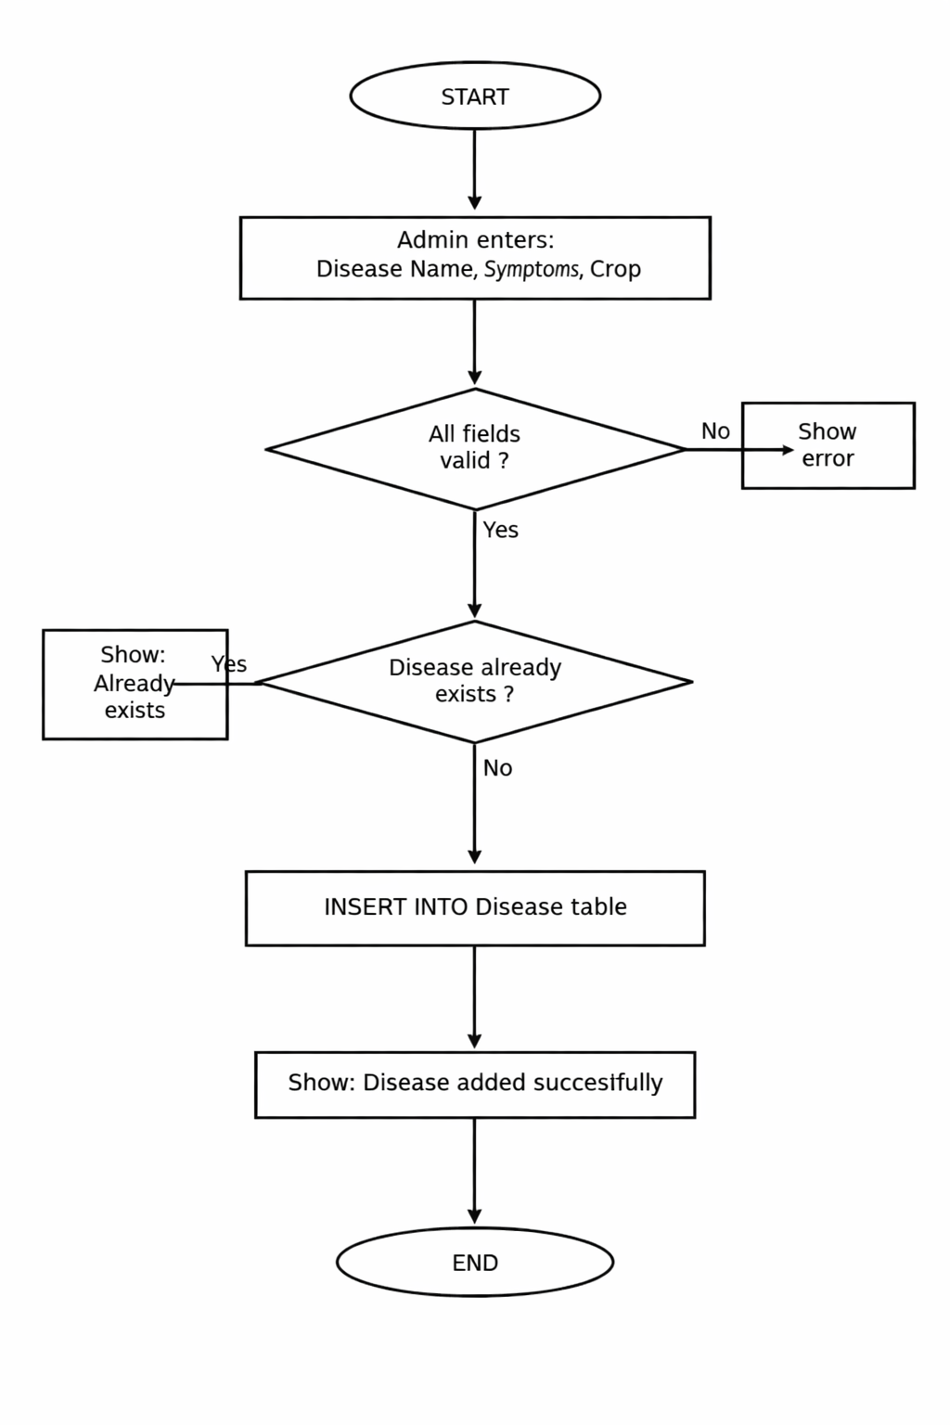
Fig 5.5.1: Flowchart — Admin Add Disease

5.5.1.3 Table I/O Interfaces:
- Reads: Crop table (for foreign key validation)
- Writes: New record into Disease table
5.5.1.4 Outputs: New Disease record inserted; success or error message displayed to Admin
5.5.1.5 Implementation: Flask route with form validation, SQLAlchemy ORM

