Sri Shakthi
Institute of Engineering and Technology


SEMESTER III
ACADEMIC YEAR 2020- 2021

MATHEMATICAL APPLICATION PROBLEMS

DISCRETE MATHEMATICS

CSE AND IT

PREFACE

The course on “Discrete Mathematics” for Computer Science Engineering& Information Technology, is to expose students to understand the basics and importance of Propositional Calculus, Predicate Calculus, Combinatorics, Vector spaces, Elements of Number Theory and their applications in the field of Computer Science Engineering& Information Technology.
This course covers Vector spaces and Number theory to solve the equations which arise in Computer Graphics and Multimedia, and to study graphics and pixels transformations. Also, the Course Propositional Calculus and Combinatorics, deals with which arise in Principles of Compiler Design and in Theory of Computations to solve the grammars during compilation. Further the idea of computations is used in particular compilation module of code while processing any programming languages.
This course presents engineering mathematics for first year undergraduates of Computer Science Engineering & Information Technology with an emphasis on Computer Science Engineering& Information Technology concepts. Each problem is derived from Computer Science Engineering& Information Technology applications. Emphasis is given to the fundamental concepts behind the mathematics, for problem solving and undertaking critical analysis of results. The fundamental concepts required to solve the mathematical problems are sufficiently covered.
This course recognizes the real requirement for practicing Computer Science Engineering& Information Technology domain and to understand the applications of mathematics in everyday engineering contexts. The study material is framed with numerous exercises, firmly rooted in basic fundamentals, ensuring that all mathematical theory introduced is directly relevant to real-world Computer Science Engineering& Information Technology problems.

INTRODUCTION

Artificial Intelligence | an Introduction
Before leading to the meaning of artificial intelligence let understand what is the meaning of the Intelligence-Intelligence: The ability to learn and solve problems. This definition is taken from Webster’s Dictionary.
The most common answer that one expects is “to make computers intelligent so that they can act intelligently!”, but the question is how much intelligent? How can one judge the intelligence?
If the computers can, somehow, solve real-world problems, by improving on their own from the past experiences, they would be called “intelligent”.
Thus, the AI systems are more generic (rather than specific), have the ability to “think” and are more flexible. Intelligence, as we know, is the ability to acquire and apply the knowledge. Knowledge is the information acquired through experience. Experience is the knowledge gained through exposure (training). Summing the terms up, we get artificial intelligence as the “copy of something natural (i.e., human beings) ‘WHO’ is capable of acquiring and applying the information it has gained through exposure.”
Intelligence is composed of:
- Reasoning
- Learning
- Problem Solving
- Perception
- Linguistic Intelligence
Many tools are used in AI, including versions of search and mathematical optimization, logic, methods based on probability and economics. The AI field draws upon computer science, mathematics, psychology, linguistics, philosophy, neuro-science, artificial psychology and many others.

Need for Artificial Intelligence
- To create expert systems which exhibit intelligent behavior with the capability to learn, demonstrate, explain and advice its users.
- Helping machines find solutions to complex problems like humans do and applying them as algorithms in a computer-friendly manner.

Applications of AI include Natural Language Processing, Gaming, Speech Recognition, Vision Systems, Healthcare, and Automotive etc.
An AI system is composed of an agent and its environment. An agent (e.g., human or robot) is anything that can perceive its environment through sensors and acts upon that environment through effectors. Intelligent agents must be able to set goals and achieve them. In classical planning problems, the agent can assume that it is the only system acting in the world, allowing the agent to be certain of the consequences of its actions. However, if the agent is not the only actor, then it requires that the agent can reason under uncertainty. This calls for an agent that cannot only assess its environment and make predictions but also evaluate its predictions and adapt based on its assessment. Natural language processing gives machines the ability to read and understand human language. Some straightforward applications of natural language processing include information retrieval, text mining, question answering and machine translation. Machine perception is the ability to use input from sensors (such as cameras, microphones, sensors etc.) to deduce aspects of the world. e.g., Computer Vision. Concepts such as game theory, decision theory, necessitate that an agent be able to detect and model human emotions.
Many times, students get confused between Machine Learning and Artificial Intelligence, but Machine learning, a fundamental concept of AI research since the field’s inception, is the study of computer algorithms that improve automatically through experience. The mathematical analysis of machine learning algorithms and their performance is a branch of theoretical computer science known as a computational learning theory. Stuart Shapiro divides AI research into three approaches, which he calls computational psychology, computational philosophy, and computer science. Computational psychology is used to make computer programs that mimic human behaviour. Computational philosophy is used to develop an adaptive, free-flowing computer mind. Implementing computer science serves the goal of creating computers that can perform tasks that only people could previously accomplish.

AI has developed a large number of tools to solve the most difficult problems in computer science, like:
- Search and optimization
- Logic
- Probabilistic methods for uncertain reasoning
- Classifiers and statistical learning methods
- Neural networks
- Control theory
- Languages

High-profile examples of AI include autonomous vehicles (such as drones and self-driving cars), medical diagnosis, creating art (such as poetry), proving mathematical theorems, playing games (such as Chess or Go), search engines (such as Google search), online assistants (such as Siri), image recognition in photographs, spam filtering, prediction of judicial decisions[204] and targeting online advertisements. Other applications include Healthcare, Automotive, Finance, Video games etc
Are there limits to how intelligent machines – or human-machine hybrids – can be? A super intelligence, hyper intelligence, or superhuman intelligence is a hypothetical agent that would possess intelligence far surpassing that of the brightest and most gifted human mind. “Super intelligence’’ may also refer to the form or degree of intelligence possessed by such an agent.

Compiler Design | an Introduction
Compiler is software which converts a program written in high level language (Source Language) to low level language (Object/Target/Machine Language).

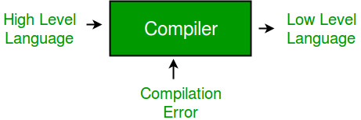

- Cross Compiler that runs on a machine ‘A’ and produces a code for another machine ‘B’. It is capable of creating code for a platform other than the one on which the compiler is running.
- Source-to-source Compiler or trans-compiler or transpiler is a compiler that translates source code written in one programming language into source code of another programming language.

Language processing systems (using Compiler)
We know a computer is a logical assembly of Software and Hardware. The hardware knows a language that is hard for us to grasp, consequently we tend to write programs in high-level language that is much less complicated for us to comprehend and maintain in thoughts. Now these programs go through a series of transformation so that they can readily be used machines. This is where language procedure systems come handy.
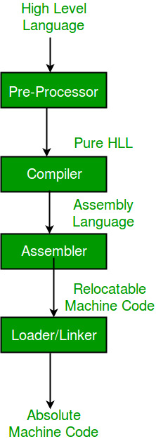

- High Level Language – If a program contains #define or #include directives such as #include or #define it is called HLL. They are closer to humans but far from machines. These (#) tags are called pre-processor directives. They direct the pre-processor about what to do.

- Pre-Processor – The pre-processor removes all the #include directives by including the files called file inclusion and all the #define directives using macro expansion. It performs file inclusion, augmentation, macro-processing etc.

- Assembly Language –Its neither in binary form nor high level. It is an intermediate state that is a combination of machine instructions and some other useful data needed for execution.

- Assembler – For every platform (Hardware + OS) we will have a assembler. They are not universal since for each platform we have one. The output of assembler is called object file. Its translates assembly language to machine code.

- Interpreter – An interpreter converts high level language into low level machine language, just like a compiler. But they are different in the way they read the input. The Compiler in one go reads the inputs, does the processing and executes the source code whereas the interpreter does the same line by line. Compiler scans the entire program and translates it as a whole into machine code whereas an interpreter translates the program one statement at a time. Interpreted programs are usually slower with respect to compiled ones.

- Relocatable Machine Code – It can be loaded at any point and can be run. The address within the program will be in such a way that it will cooperate for the program movement.

- Loader/Linker – It converts the relocatable code into absolute code and tries to run the program resulting in a running program or an error message (or sometimes both can happen). Linker loads a variety of object files into a single file to make it executable. Then loader loads it in memory and executes it.

Phases of a Compiler –There are two major phases of compilation, which in turn have many parts. Each of them takes input from the output of the previous level and work in a coordinated way.

Analysis Phase – An intermediate representation is created from the give source code:
- Lexical Analyzer
- Syntax Analyzer
- Semantic Analyzer
- Intermediate Code Generator

Lexical analyzer divides the program into “tokens”, Syntax analyzer recognizes “sentences” in the program using syntax of language and Semantic analyzer checks static semantics of each construct. Intermediate Code Generator generates “abstract” code.
Synthesis Phase – Equivalent target program is created from the intermediate representation. It has two parts:

- Code Optimizer
- Code Generator

Code Optimizer optimizes the abstract code, and final Code Generator translates abstract intermediate code into specific machine instructions.
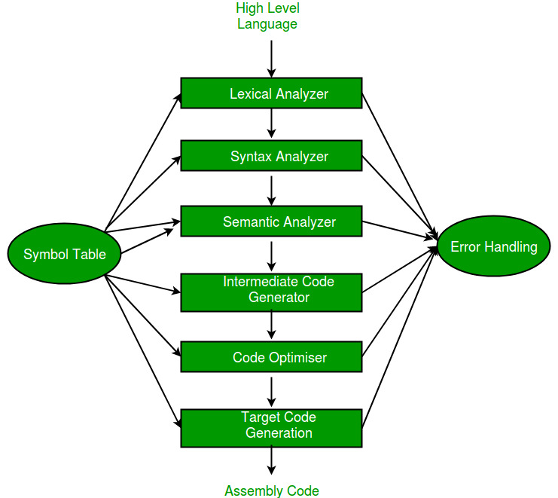

Classification of Context Free Grammars
Context Free Grammars (CFG) can be classified on the basis of following two properties:

1) Based on number of strings it generates.
- If CFG is generating finite number of strings, then CFG is Non-Recursive (or the grammar is said to be Non-recursive grammar)
- If CFG can generate infinite number of strings then the grammar is said to be Recursive grammar
During Compilation, the parser uses the grammar of the language to make a parse tree(or derivation tree) out of the source code. The grammar used must be unambiguous. An ambiguous grammar must not be used for parsing.
2) Based on number of derivation trees.
- If there is only 1 derivation tree then the CFG is unambiguous.
- If there are more than 1 derivation tree, then the CFG is ambiguous.

Examples of Recursive and Non-Recursive Grammars
Recursive Grammars
1) S->SaS
S->b
The language (set of strings) generated by the above grammar is: { b, bab, babab,…}, which is infinite.
2) S->Aa
A->Ab|c
The language generated by the above grammar is: {ca, cba, cbba …}, which is infinite.
Note: A recursive context-free grammar that contains no useless rules necessarily produces an infinite language.
Non-Recursive Grammars
S->Aa
A->b|c
The language generated by the above grammar is :{ba, ca}, which is finite.

Types of Recursive Grammars

Based on the nature of the recursion in a recursive grammar, a recursive CFG can be again divided into the following:
- Left Recursive Grammar (having left Recursion)
- Right Recursive Grammar (having right Recursion)
- General Recursive Grammar (having general Recursion)

Chomsky Normal Form
A grammar where every production is either of the form A→BC or A →c (where A, B, C are arbitrary variables and can arbitrary symbol).
Why Chomsky Normal Form?
The key advantage is that in Chomsky Normal Form, every derivation of a string of letters hasexactly2n−1steps.Thus: one can determine if a string is in the language by exhaustive search of all derivations. The conversion to Chomsky Normal Form has four main steps:
1. Get rid of all ε productions.
2. Get rid of all productions where RHS is one variable.
3. Replace every production that is too long by shorter productions.
4. Move all terminals to productions where RHS is one terminal.

Introduction of Theory of Computation

Automata theory (also known as Theory of Computation) is a theoretical branch of Computer Science and Mathematics, which mainly deals with the logic of computation with respect to simple machines, referred to as automata.
Automata* enables the scientists to understand how machines compute the functions and solve problems. The main motivation behind developing Automata Theory was to develop methods to describe and analyze the dynamic behavior of discrete systems.
An automaton is originated from the word “Automaton” which is closely related to “Automation”. Now; let’s understand the basic terminologies, which are important and frequently used in Theory of Computation.

Symbol: Symbol is the smallest building block, which can be any alphabet, letter or any picture.
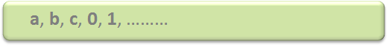
Alphabets (Σ): Alphabets are set of symbols, which are always finite.
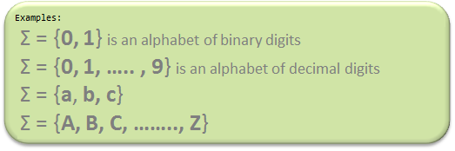
String: String is a finite sequence of symbols from some alphabet. String is generally denoted as w and length of a string is denoted as |w|. Empty string is the string with zero occurrences of symbols, represented as ε.
Example: Number of Strings (of length 2) and that can be generated over the alphabet {a, b} -
- -
aa
a b
b a
bb

Here, Length of String |w| = 2 and Number of Strings = 4
Conclusion:
For alphabet {a, b} with length n, number of strings can be generated = 2n.
Note – If the number of Σ’s is represented by |Σ|, then number of strings of length n, possible over Σ is |Σ|n.
Language: A language is a set of strings, chosen from some Σ* or we can say- ‘A language is a subset of Σ* ‘. A language which can be formed over ‘ Σ ‘ can be Finite or Infinite.
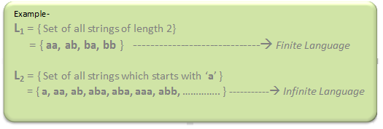
Powers of ‘ Σ‘:
Say Σ = {a,b} then
Σ0 = Set of all strings over Σ of length 0. {ε}
Σ1 = Set of all strings over Σ of length 1. {a, b}
Σ2 = Set of all strings over Σ of length 2. {aa, ab, ba, bb}
i.e. |Σ2|= 4 and Similarly, |Σ3| = 8
Σ* is a Universal Set.
Σ* = Σ0 U Σ1 U Σ2 ..........
= {ε} U {a, b} U {aa, ab, ba, bb}
= ............. //infinite language.

Introduction to Computer Graphics

Today there are very few aspects of our lives not affected by computers. Practically every cash or monetary transaction that takes place daily involves a computer. In many cases, the same is true of computer graphics. Whether you see them on television, in newspapers, in weather reports or while at the doctor’s surgery, computer images are all around you.

“A picture is worth a thousand words” is a well-known saying and highlights the advantages and benefits of the visual presentation of our data. We are able to obtain a comprehensive overall view of our data and also study features and areas of particular interest.

A well-chosen graph is able to transform a complex table of numbers into meaningful results. You know that such graphs are used to illustrate papers, reports and thesis, as well as providing the basis for presentation material in the form of slides and overhead transparencies. A range of tools and facilities are available to enable users to visualize their data, and this document provides a brief summary and overview. Computer graphics can be used in many disciplines. Charting, Presentations, Drawing, Painting and Design, Image Processing and Scientific Visualization are some among them.
In particular, we will emphasize the following

a) Basic concepts of Computer Graphics

b) Different types of Computer Graphics

c) Origin of Computer Graphics

d) Working of an interactive graphics display

e) Importance of speed in displaying pictures

f) The change in size an orientation of pictures

g) Applications of Computer Graphics

Basic concepts of Computer Graphics:

I hope all of you are fond of video games and you may be good at playing them. Have you seen the game of ping-pong? It’s a game played by two people with a pair video game controller and a home television set. You can see that when a game is switched on, a small bright spot, representing a ball, is seen bouncing to and for across the screen.

Now each player uses his video game controller to position a paddle to bounce the ball back to his opponent. The player who hits the ball past his opponent wins a point and the one who gains 15 points wins the game. Now how did you invent this video game? This has been done with the aid of Computer Graphics. Video games represent a major use in the home of computer graphics. Computer graphics helps to create and manipulate pictures with the aid of computers. Computer graphics is concerned with all aspects of producing images using a computer. It concerns with the pictorial synthesis of real or imaginary objects from their computer-based models.

Different types of Computer Graphics: Computer Graphics can be broadly divided into two:

Non-Interactive Computer Graphics: In non-interactive computer graphics otherwise known as passive computer graphics, the observer has no control over the image. Familiar examples of this type of computer graphics include the titles shown on TV and other forms of computer art. Interactive Computer Graphics: Interactive Computer Graphics involves a two-way communication between computer and user.

Here the observer is given some control over the image by providing him with an input device for example the video game controller of the ping pong game. This helps him to signal his request to the computer. The computer on receiving signals from the input device can modify the displayed picture appropriately.
To the user it appears that the picture is changing instantaneously in response to his commands. He can give a series of commands, each one generating a graphical response from the computer. In this way he maintains a conversation, or dialogue, with the computer.

Interactive computer graphics: affects our lives in a number of indirect ways. For example, it helps to train the pilots of our airplanes. We can create a flight simulator which may help the pilots to get trained not in a real aircraft but on the grounds at the control of the flight simulator.

The flight simulator is a mock-up of an aircraft flight deck, containing all the usual controls and surrounded by screens on which we have the projected computer-generated views of the terrain visible on take-off and landing. Flight simulators have many advantages over the real aircrafts for training purposes, including fuel savings, safety, and the ability to familiarize the trainee with a large number of the world’s airports.
Origin of Computer Graphics

Years of research and development were made to achieve the goals in the field of computer graphics. In 1950 the first computer driven display was used to generate only simple pictures. This display made use of a cathode ray tube similar to the one used in television sets. During 1950’s interactive computer graphics made little progress because the computers of that period were so unsuited to interactive use. These computers were used to perform only lengthy calculations.

The single vent that did the most to promote interactive computer graphics as an important new field was the publication in 1962 of a brilliant thesis by Ivan E. Sutherland. His thesis, entitled ‘Sketchpad: A Man- Machine Graphical Communication System proved to many readers that interactive computer graphics was a viable, useful, and exciting field of research. By the mid -1960’s large computer graphics research projects were under taken at MIT, Bell Telephone Labs and General Motors. Thus, the golden age of computer graphics began. In 1970’s thee researches began to bear fruit. The instant appeal of computer graphics to users of all ages has helped it to spread into many applications throughout the world.

Applications of Computer Graphics:

As ancient says “a pixel is worth thousand words”, graphics is essential everywhere to understand the things, concepts, etc easily. Computer graphics is useful in almost all part of our life. In the following sections we are discussing some of the popular areas of computer graphics.
Design and Drawing: In almost all areas of engineering, be it civil, mechanical, electronic etc., drawings are of prime importance. In fact, drawing is said to be the language of engineers. The ability of computers to store complex drawings and display them on demand was one of the major attractions for using computers in graphic mode. However, these were further advantages.
Most of these drawings were the result of engineering calculations. In fact, programs can be written to make these calculations and the results can be used to draw diagrams on the screen. If changes are to be made, one can get back to the design formulae and so on. Thus, they are of design and drawing was one of the earliest and most useful applications of graphics.
Animation: But what brought the computers pretty close to the average individuals is the concept of animation moving pictures. It is the well-known principle of moving pictures that a succession of related pictures, when flashed with sufficient speed will make the succession of pictures appear to be moving. In movies, a sequence of such pictures is shot and is displayed with sufficient speed to make them appear moving. Computers can do it in another way. The properties of the picture can be modified at a fairly fast rate to make it appear moving. For example, if a hand is to be moved, say, the successive positions of the hand at different periods of time can be computed and pictures showing the position of the hand at these positions can be flashed on the screen. This led to the concept of “animation” or moving pictures. In the initial stages, animation was mainly used in computer games. However, this led to a host of other possibilities. As we see later on in this course, computers not only allow you to display the figures but also offer you facilities to manipulate them in various ways – you can enlarge, reduce, rotate, twist, morph (make one picture gradually change to another – like an advertisement showing a cheetah change into a motor bike) and do a whole lot of other things. Thus, a whole lot of films made use of computers to generate tricks. In fact, several advertisement films and cartons strips are built with no actors at all – only the computer-generated pictures.

Multimedia applications: The use of sound cards to make computers produce sound effect led to other uses of graphics. The concept of virtual reality, where in one can be taken through an unreal experience, like going through an unbuilt house ( to see how it feels inside, once it is built ) are possible by the use of computer graphics technology. In fact the ability of computers to convert electronic signals (0 & 1) to data and then on to figures and pictures has made it possible for us to get photographs of distant planets like mars being reproduced here on the earth in almost real time.

Simulation: The other revolutionary change that graphics made was in the area of simulation. Basically, simulation is a mock-up of an environment elsewhere to study or experience it. The availability of easily interactive devices (mouse is one of them, we are going to see a few other later in the course) made it possible to build simulators. One example is of flight simulators, wherein the trainee, sitting in front of a computer, can operate on the interactive devices as if he were operating on the flight controls and the changes he is expected to see outside his window are made to appear on the screen, so that he can master the skills of flight operations before actually trying his hand on the actual flights. The graphic capabilities of computers are used in a very large variety of areas like criminology (to recreate faces of victims, assailants etz.,) medical fields (recreating pictures of internal cavities, using signals sent by miniature cameras), recreation of Satellite pictures etc.

Artificial Intelligence | an Introduction
Before leading to the meaning of artificial intelligence let understand what is the meaning of the Intelligence-Intelligence: The ability to learn and solve problems. This definition is taken from Webster’s Dictionary. The most common answer that one expects is “to make computers intelligent so that they can act intelligently!”, but the question is how much intelligent? How can one judge the intelligence?
If the computers can, somehow, solve real-world problems, by improving on their own from the past experiences, they would be called “intelligent”.
Thus, the AI systems are more generic (rather than specific), have the ability to “think” and are more flexible. Intelligence, as we know, is the ability to acquire and apply the knowledge. Knowledge is the information acquired through experience. Experience is the knowledge gained through exposure (training). Summing the terms up, we get artificial intelligence as the “copy of something natural (i.e., human beings) ‘WHO’ is capable of acquiring and applying the information it has gained through exposure.”

Intelligence is composed of:
- Reasoning
- Learning
- Problem Solving
- Perception
- Linguistic Intelligence
Many tools are used in AI, including versions of search and mathematical optimization, logic, methods based on probability and economics. The AI field draws upon computer science, mathematics, psychology, linguistics, philosophy, neuro-science, artificial psychology and many others.

Need for Artificial Intelligence
- To create expert systems which exhibit intelligent behaviour with the capability to learn, demonstrate, explain and advice its users.
- Helping machines find solutions to complex problems like humans do and applying them as algorithms in a computer-friendly manner.

Cryptography and network security:
Introduction
Human being from ages had two inherent needs − (a) to communicate and share information and (b) to communicate selectively. These two needs gave rise to the art of coding the messages in such a way that only the intended people could have access to the information. Unauthorized people could not extract any information, even if the scrambled messages fell in their hand.
The art and science of concealing the messages to introduce secrecy in information security is recognized as cryptography.
The word ‘cryptography’ was coined by combining two Greek words, ‘Krypto’ meaning hidden and ‘graphene’ meaning writing.
What is Cryptography?
Cryptography is the art and science of making a cryptosystem that is capable of providing information security.
Cryptography deals with the actual securing of digital data. It refers to the design of mechanisms based on mathematical algorithms that provide fundamental information security services. You can think of cryptography as the establishment of a large toolkit containing different techniques in security applications.
A cryptosystem is an implementation of cryptographic techniques and their accompanying infrastructure to provide information security services. A cryptosystem is also referred to as a cipher system.
Let us discuss a simple model of a cryptosystem that provides confidentiality to the information being transmitted. This basic model is depicted in the illustration below −
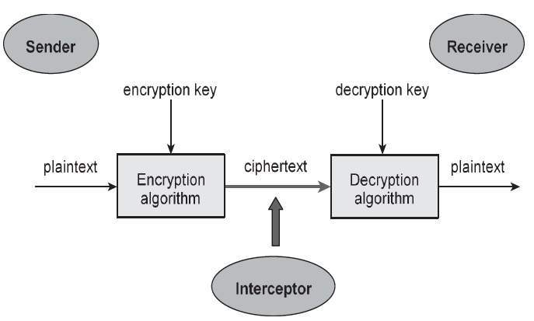
The illustration shows a sender who wants to transfer some sensitive data to a receiver in such a way that any party intercepting or eavesdropping on the communication channel cannot extract the data.
The objective of this simple cryptosystem is that at the end of the process, only the sender and the receiver will know the plaintext.

Normal Forms
Arbitrary propositional formulas can be translated to syntactically restricted forms. This can serve two main purposes. First, it may be more straightforward to deﬁne algorithms and inference methods when the formulas are in certain simple forms. The resolution rule is an example of this. Second, the process of translating a formula into a normal form does much of the work in solving important computational problems related to propositional formulas. For example, an answer to the question of whether a formula is valid is obtained as a by-product of translating the formula into certain normal forms. In this course we focus on the best-known normal form which is the conjunctive normal form.

Deﬁnition: 1(Literals) If x is an atomic proposition, then x and are literals.

Deﬁnition 2(Clauses) If l1,,ln are literals, then l1 ∨···∨ln is a clause.

Deﬁnition 3(Terms) If l1,,ln are literals, then l1 ∧···∧ln is a term.

Deﬁnition 4 (Conjunctive Normal Form) If φ1,φm are clauses, then the formula φ1 ∧···∧φm is in conjunctive normal form.

1. Convert the following normal form production rule into conjunctive normal form to perform computational problem.
¬x
¬x1 ∨¬x2
x3 ∧x4
(¬x1 ∨¬x2)∧¬x3 ∧(x4 ∨¬x5)

Solution:
Rewriting Rules for Translating Formulas to Conjunctive Normal Form as,
α ↔ β (¬α∨β)∧(¬β ∨α) (1)
α → β ¬α∨β (2)
¬(α∨β) ¬α∧¬β (3)
¬(α∧β) ¬α∨¬β (4)
¬¬α α (5)
α∨(β ∧γ) (α∨β)∧(α∨γ) (6)
(α∧β)∨γ (α∨γ)∧(β ∨γ) (7)

The conversions are used in compiler design, where the high level codes are being converted into machine understandable form.

2. Translate the given normal form rule, A∨B → (B ↔ C) into CNF.

Solution:
A∨B → (B → C)∧(C → B) (1)
¬(A∨B)∨((¬B∨C)∧(¬C ∨B)) (2)
(¬A∧¬B)∨((¬B∨C)∧(¬C ∨B)) (3)
(¬A∨((¬B∨C)∧(¬C∨B)))∧(¬B∨((¬B∨C)∧(¬C∨B))) (4)
(¬A∨¬B∨C)∧(¬A∨¬C∨B)∧(¬B∨((¬B∨C)∧(¬C∨B))) (5)
(¬A∨¬B∨C)∧(¬A∨¬C ∨B)∧(¬B∨¬B∨C)∧(¬B∨¬C ∨B) (6)

The conversions are used in compiler design, where the high level codes are being converted into machine understandable form.

Deﬁnition 5(Disjunctive Normal Form) If φ1,,φm are terms, then the formula φ1 ∨···∨φm is in disjunctive normal form.
Disjunctive normal forms are found with a procedure similar to that for CNF. The only difference is that a different set of distributive rules is applied, for moving∧inside∨instead of the other way round.
A less restrictive normal form that includes both CNF and DNF is the Negation Normal Form (NNF). It is useful in many types of automated processing of formulas because of its simplicity and the fact that translation into NNF only minimally affects the size of a formula, unlike the translations into DNF and CNF which may increase the size exponentially.

Deﬁnition 6(Negation Normal Form) Let X be a set of atomic propositions.
1. ⊥and>are in negation normal form.
2. x and¬x for any x ∈ X are in negation normal form.
3. φ1 ∧φ2 is in negation normal form if φ1 and φ2 both are.
4. φ1 ∨φ2 is in negation normal form if φ1 and φ2 both are.

No other formula is in negation normal form.

After performing the ﬁrst three steps in the translation into CNF the formula is in NNF. Notice that only the application of the distributivity equivalences increases the number of atomic propositions in the CNF translation. The translation into NNF does not affect the number of occurrences of atomic propositions or the connectives∨ and ∧, and the size of the resulting formula can be bigger only because of the higher number of occurrences of negation symbols¬. Hence the NNF is never more than twice as big as the original formula.

Logic
The statements ‘one plus one equals two’ and ‘Earth is farther from thesun than Venus’ are both true statements; therefore, by definition. So is the following statement: ‘one plus one equals two’ and ‘Earth is farther from the sun than Venus’. Since ‘Earth is farther from the sun than Mars’ is a false statement, so is: ‘one plus one equals two’ and ‘Earth is farther from the sun than Mars’. Rules of syntax define the legal structure of formulas in propositional logic.
The semantics—the meaning of formulas—is defined by interpretations, which assign one of the (truth) values T or F to every atomic proposition. For every legal way that a formula can be constructed, a semantic rule specifies the truth value of the formula based upon the values of its constituents. Proofs another syntactical concept.
A proof is a deduction of a formula from asset of formulas called axiom susin gruels of inference. The central theoretical result that we prove is the soundness and completeness of the axiom system: the set of provable formulas is the same as the set of formulas which are always true. Propositional logic is central to the design of computer hardware because hard-ware is usually designed with components having two voltage levels that are arbitrarily assigned the symbols 0 and 1.
Circuits are described by idealized elements called logic gates; for example, an and gate produces the voltage level associated with 1 if and only if both its input terminals are held at this same voltage level.

3. Construct a half-adder using the logics: and, or and not gates.

Solution:
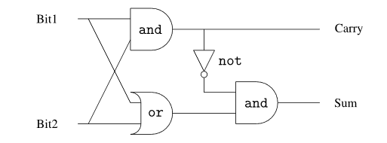
Explanation:
The half-adder adds two one-bit binary numbers and by joining several half-adders we can add binary numbers composed of many bits. Propositional logic is widely used in software, too. The reason is that any program is a finite entity. Mathematicians may consider the natural numbers to be infinite (0,1,2,...), but a word of a computer’s memory can only store numbers in a finite range.
By using an atomic proposition for each bit of a program’s state, the meaning of a computation can be expressed as a (very large) formula. Algorithm shave been developed to study properties of computations by evaluating properties of formulas in propositional logic.

4. In the process of compilation, the statements that are written in other languages are converted to machine understandable language, if the given string is
↔→pq→¬p¬q,
→p↔q¬→p¬q and there is no longer any ambiguity.

Construct the assembly instructions for the above strings:

Solution:

The formulas are said to be in Polish notation, named after a group of Polish logicians led by Jan Lukasiewicz. We find infix notation easier to read because it is familiar from arithmetic, so Polish notation is normally used only in the internal representation of arithmetic and logical expressions in a computer.

The advantage of Polish notation is that the expression can be evaluated in the linear order that the symbols appear using a stack. If we rewrite the first formula backwards (reverse Polish notation):
q¬p¬→qp→↔,

It can be directly compiled to the following sequence of instructions of an assembly language:

Push q
Negate
Push p
Negate
Imply
Push q
Push p
Imply
Equiv

The operators are applied to the top operands on the stack which are then popped and the result pushed.
The conversions are used in compiler design, where the high-level codes are being converted into machine understandable form.

5. In complier design we formalize the statements which help in optimizing and executing the code in an efficient manner. The statements that are formalized should be unambiguous.
Formalize the following sentences:
1. “if Paola is happy and paints a picture then Renzo isn’t happy”
2. “if Paola is happy, then she paints a picture”
3. “Paola is happy only if she paints a picture”

Solution:
Let’s consider a propositional language where
• p means “Paola is happy”,
• q means “Paola paints a picture”,
• r means “Renzo is happy”.

1. p ∧ q → ¬r
2. p → q
3. ¬(p ∧ ¬q) which is equivalent to p → q

The precision of formal languages avoid the ambiguities of natural languages.
The conversions are used in compiler design, where the high level codes are being converted into machine understandable form.

6. Aladdin finds two memory blocks A and B in a primary memory. He knows that each of them either contains a valid data or an in valid data. In memory block A the statement written is: “At least one of these two contains a valid data.” On memory block B it is written as: “In A there’s an invalid data.” Aladdin knows that either both the inscriptions are true, or they are both false. Can Aladdin choose a memory block being sure that he will find a treasure? If this is the case, which trunk should he open?

Solution.

Let’s consider a propositional language where a =“Memory block A contains the valid data” and b =“Memory block B contains the Valid data”.
Obviously ¬a =“Memory block a contains a invalid data” (and similarly for ¬b), since each memory block either contains a valid data or an invalid data (exclusive or). Let’s formalize what Aladdin knows:
• Formalization of the inscriptions:
a ∨ b “At least one of these two memory block contains a valid data.”
¬a “A contains an invalid data”
• Formalization of the problem: 1. “either both the inscriptions are true, or they are both false” (a ∨ b) ↔ ¬a

What we can do is to verify whether there is any interpretation satisfying the formula in 1. :
• The only interpretation satisfying 1. is: v(a) = F and v(b) = T
• Thus Aladdin can open memory block B, being sure that it contains a valid data.

In compiler design for deriving the normalized production rule, context free grammar (CFG) is in Chomsky Normal Form (CNF) if all production rules satisfy one of the following conditions:
- A non-terminal generating a terminal (e.g.; X->x)
- A non-terminal generating two non-terminals (e.g.; X->YZ)
- Start symbol generating ε. (e.g.; S-> ε)

7. Construct a decision table with Boolean values which can be used in an ML algorithm to decide whether a credit card can be given to a person matching the following condition. Condition is “Credit card can be issued to Government employed people of any age with any credit score. Non-government employees should have credit score more than 8 and age lesser than 50.
Explanation: Decision table is a simple structure to understand various reasons or factors and their impact in making a decision. Boolean algebra helps to arrive unambiguous results in our decision table.
Solution:
Age >50 | Credit score > 8 | Government Employed | Credit Card Issue
Yes | Yes | Yes | Yes
Yes | Yes | No | No
Yes / No | Yes / No | No | No
No | Yes | No | Yes

Conclusion:
Decision table is one of the important tools used in machine learning to enable automated decision making. The machine is expected to learn from the existing data to understand the scenario and to make decisions on a newer situation based on that learning. The suitability test for credit card approval is a popular data science problem in which huge amounts of data related to the customer is analysed by the computer and it takes a decision if the customer can be given a card or not.

8.Identify the outcome of the given program with the help of proper understanding of Boolean logics.
Explanation:
Boolean algebra is the branch of algebra in which the values of the variables are the truth values true and false, usually denoted 1 and 0 respectively. Instead of elementary algebra where the values of the variables are numbers, and the prime operations are addition and multiplication, the main operations of Boolean algebra are the conjunction (and) denoted as ∧, the disjunction (or) denoted as ∨, and the negation (not) denoted as ¬. It is thus a formalism for describing logical operations in the same way that elementary algebra describes numerical operations.
Solution:
main()
{
inti=4,j=-1,k=0,w,x,y,z;

w=i||j||k;
x=i&&j&&k;
y=i||j&&k;
z=i&&j||k;

printf("\nw=%d x=%d y=%d z=%d\n",w,x,y,z);
}

Answer : w=1 x=0 y=1 z=1

Conclusion:
Every non zero value is considered as ‘True’ and zero is ‘False’. Applying the above fact, w= true OR true OR false which results true, thus w=1. Similarly, the student should work all the other statements.

9.Develop a flow chart with Boolean conditions to find out if a given year is leap or not and obtain the algorithm.
Explanation:

A Boolean logical statement is a logical proposition that is either true or false. The following are examples of true and false statements:

Los Angeles is in California. (TRUE)

Boston lies on the Mississippi River. (FALSE)

2 + 2 = 4 (TRUE)

10 < 6 (FALSE)

Logical statements can be linked using operators. An operator links logical statements and defines how the statements should be processed. A combined statement is two or more logical statements linked together.

Logical statements can be linked using operators. An operator links logical statements and defines how the statements should be processed. A combined statement is two or more logical statements linked together.

Boolean logic uses the following operators:

AND (conjunction)

When you use this operator, both statements must be true for the combined statement to be true.
OR (disjunction)

When you use this operator, at least one of the statements must be true for the combined statement to be true.

NOT (negation)

When you use this operator, the statement that follows the NOT operator must be false for the statement to be true.
Solution:

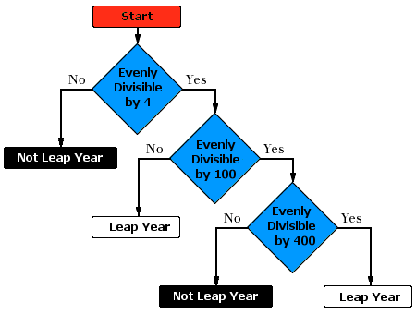

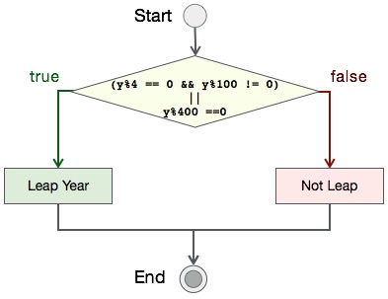

10.How to represent negation operation in a simple conditional branching statement of a C program. Illustrate with example.
Explanation:

The logical negation operator (!) reverses the meaning of its operand. The operand must be of arithmetic or pointer type (or an expression that evaluates to arithmetic or pointer type). The operand is implicitly converted to type bool. The result is TRUE if the converted operand is FALSE; the result is FALSE if the converted operand is TRUE. The result is of type bool.
Solution:
Assuming the statement: If you are not under 18 and if your salary is not lesser than 50,000 go to next level.
if (! under18 && (! salary <50,000))
level = level++;
Conclusion:
The logic is used to write an algorithm for identifying given year leap year or not.

11. Investigate the output of the given program in terms of Boolean statements. Assume the inputs.
int c;
if(a==0)
c=0;
if(((b==0) &&(d! =0))||(a!=0))
c=1;
else
c=0;
System.out.println(c);
Explanation:
A Boolean logical statement is a logical proposition that is either true or false. The following are examples of true and false statements:
Los Angeles is in California. (TRUE)

Boston lies on the Mississippi River. (FALSE)
2 + 2 = 4 (TRUE)
10 < 6 (FALSE)
Logical statements can be linked using operators. An operator links logical statements and defines how the statements should be processed. A combined statement is two or more logical statements linked together.
Solution:
Inputs a=1, b=1, d=0 -- > output: 1

- Use the conjunction and disjunction in a programming example and discuss the significance.

Explanation:
A Boolean logical statement is a logical proposition that is either true or false. The following are examples of true and false statements: Logical statements can be linked using operators. An operator links logical statements and defines how the statements should be processed. A combined statement is two or more logical statements linked together.
Solution:
Boolean eligibility;
Float cgpa=7.5;
Float attendance = 81;
Float communication grade=6.5;
if (cgpa > 8.5 || (attendance >85 && communication grade >7.5)
Eligibility=true;
else
Eligibility=false;
Conclusion:
Students should be able to use the conjunction and disjunction to represent complex real world logical sequences.
- and (conjunction): &&
- or (disjunction): ||

13. Develop a set of specifications and configurations for a home security system. Use truth tables to define the combinations.
Explanation:
A Boolean logical statement is a logical proposition that is either true or false. It can be used to define any programmable system including a home security system.
Solution:
[ This can be developed by each student in a different way with more complex combinations with an introduction to IoT systems]
The security system only works at night and responds to a window being opened.
If you have a light sensor you can treat this as giving off a signal that indicates the truth of the statement:
P = signal from light sensor = true during day time
Q = signal from window frames = true when window moves away from frames. ie., opened
P = It is daytime.
Not (P) is true when it is night-time
Q = Window open
R= Burglary in progress
Drawing the truth table for the above conditions to find out the conditional checks implemented in the computer program.

P | Q | NOT(P) | NOT(P)AND Q
F | F | T | F
F | T | T | T
T | F | F | F
T | T | F | F

From the above truth table =>
R = Not (P) And Q

The implementation can be a computer program or an electronic circuit.
Pseudo code:

While (true){
sense (p);
sense(q);
{
If (! p && q)
trigger alarm ();
}

- Develop a C program to implement the OR gate with the help of two arrays with binary values.

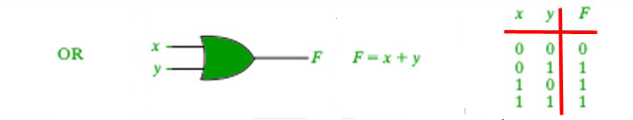
Explanation
A Boolean logical statement is a logical proposition that is either true or false. The following are examples of true and false statements:
Los Angeles is in California. (TRUE)
Boston lies on the Mississippi River. (FALSE)

Solution:
#include <stdio.h>
#include <stdlib.h>

intmain()
{
inta[5] = { 1, 0, 1, 0, 1 };
intb[5] = { 0, 1, 1, 0, 0 };
inti, or_ans;

for(i = 0; i < 5; i++) {

// using the || operator
or_ans = a[i] || b[i];

printf("\n %d OR %d = %d",
a[i], b[i], or_ans);
}
}

Ouput:

1 OR 0 = 1
0 OR 1 = 1
1 OR 1 = 1
0 OR 0 = 0
1 OR 0 = 1
.

- Develop a C program to implement the AND gate with the help of two arrays with binary values.

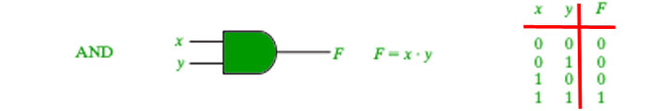
Explanation:
Logical statements can be linked using operators . An operator links logical statements and defines how the statements should be processed. A combined statement is two or more logical statements linked together.

Solution:

#include <stdio.h>
#include <stdlib.h>

intmain()
{
inta[5] = { 1, 0, 1, 0, 1 };
intb[5] = { 0, 1, 1, 0, 0 };
inti, and_ans;

for(i = 0; i < 5; i++) {

// using the && operator
and_ans = a[i] && b[i];

printf("\n %d AND %d = %d",
a[i], b[i], and_ans);
}
}

Output:

1 AND 0 = 0
0 AND 1 = 0
1 AND 1 = 1
0 AND 0 = 0
1 AND 0 = 0
C:
AND (conjunction)
When you use this operator, both statements must be true for the combined statement to be true.

- Implement the operation of NOR gate as illustrated

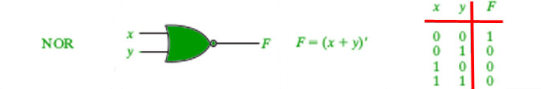
Explanation:
Logical statements can be linked using operators . An operator links logical statements and defines how the statements should be processed. A combined statement is two or more logical statements linked together.

Solution:
#include <stdio.h>
#include <stdlib.h>

intmain()
{

inta[5] = { 1, 0, 1, 0, 1 };
intb[5] = { 0, 1, 1, 0, 0 };
inti, ans;

for(i = 0; i < 5; i++) {
ans = !(a[i] + b[i]);
printf("\n %d NOR %d = %d",
a[i], b[i], ans);
}
}

1 NOR 0 = 0
0 NOR 1 = 0
1 NOR 1 = 0
0 NOR 0 = 1
1 NOR 0 = 0
Conclusion:
NOR (NOT OR)
When you use this operator, both statements must be false for the combined statement to be true.

- Implement the operation of NAND gate as illustrated

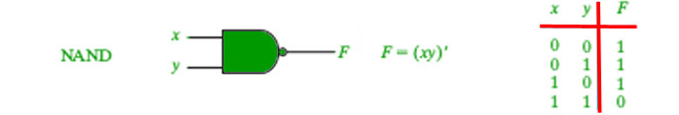
Explanation
Logical statements can be linked using operators . An operator links logical statements and defines how the statements should be processed. A combined statement is two or more logical statements linked together.

Solution:
#include <stdio.h>
#include <stdlib.h>

intmain()
{

inta[5] = { 1, 0, 1, 0, 1 };
intb[5] = { 0, 1, 1, 0, 0 };
inti, ans;

for(i = 0; i < 5; i++) {
ans = !(a[i] && b[i]);
printf("\n %d NAND %d = %d",
a[i], b[i], ans);
}
}
Output:
1 NAND 0 = 1
0 NAND 1 = 1
1 NAND 1 = 0
0 NAND 0 = 1
1 NAND 0 = 1
Conclusion:
Boolean logic uses the following operators:
NAND (NOT AND)
When you use this operator, at least one statement must be false for the combined statement to be true.

18.Implement NOT gate .
Explanation
Logical statements can be linked using operators . An operator links logical statements and defines how the statements should be processed. A combined statement is two or more logical statements linked together.
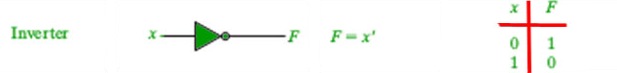
Solution:

// C program implementing the NOT gate

#include <stdio.h>
#include <stdlib.h>

intmain()
{

inta[5] = { 1, 0, 1, 0, 1 };
inti, ans;

for(i = 0; i < 5; i++) {
ans = !(a[i]);
printf("\n NOT %d = %d", a[i], ans);
}
}

Ouput
NOT 1 = 0
NOT 0 = 1
NOT 1 = 0
NOT 0 = 1
NOT 1 = 0
C
NOT (negation)
When you use this operator, the statement that follows the NOT operator must be false for the statement to be true.

- Provide an algorithm to implement A U B with an example.

Explanation:
Set theory is closely related to logic. The intersection and union of sets can be defined in terms of the logical “and” and logical “or” operators.
The union of two sets A and B is the set of elements which are in A, in B, or in both A and B. In symbols,

Solution:
Assuming, A = {1, 2, 3, 4, 5} B = {3, 4, 5, 6} Then union set of A and B is, AUB = elements either in A or B = C = {1, 2, 3, 4, 5, 6}

Algorithm:
For every element in array A
Write the element in C
For every element in array B
If the element is in A
Continue the loop
Else
Write the element in C
Example
The union of two sets A and B is the set of elements which are in A, in B, or in both A and B. In symbols,
{\display style A\cup B=\{x: x\in A{\text{ or }}x\in B\}}A \cup B = \{ x: x \in A \text{ or } x \in B\}.[2]
Consider for A = {1, 3, 5, 7} and B = {1, 2, 4, 6, 7} then A ∪ B = {1, 2, 3, 4, 5, 6, 7}. A more elaborate example (involving two infinite sets) is:
A = {x is an even integer larger than 1}
B = {x is an odd integer larger than 1}
{\display style A\cup B=\{2,3,4,5,6,\dots \}}A \cup B = \{2,3,4,5,6, \dots\}
As another example, the number 9 is not contained in the union of the set of prime numbers {2, 3, 5, 7, 11, ...} and the set of even numbers {2, 4, 6, 8, 10, ...}, because 9 is neither prime nor even.
Sets cannot have duplicate elements,[2][3] so the union of the sets {1, 2, 3} and {2, 3, 4} is {1, 2, 3, 4}. Multiple occurrences of identical elements have no effect on the cardinality of a set or its contents.

- Provide an algorithm A ∩ B with an example.

Solution:
Assuming, A = {1, 2, 3, 4, 5} B = {3, 4, 5, 6} Then union set of A and B is, AUB = elements either in A or B = C = {3, 4, 5}

Algorithm:
For every element in array A
For every element in array B
If the element is available in B
Write the element to C
Else
Continue the loop

Example
The intersection of two sets A and B, denoted by A ∩ B, is the set containing all elements of A that also belong to B (or equivalently, all elements of B that also belong to A)
The intersection of two sets A and B, denoted by A ∩ B, is the set of all objects that are members of both the sets A and B. In symbols,
{\displaystyle A\cap B=\{x:x\in A{\text{ and }}x\in B\}.}{\displaystyle A\cap B=\{x:x\in A{\text{ and }}x\in B\}.}
That is, x is an element of the intersection A ∩ B if and only if x is both an element of A and an element of B.
For example:
The intersection of the sets {1, 2, 3} and {2, 3, 4} is {2, 3}.
The number 9 is not in the intersection of the set of prime numbers {2, 3, 5, 7, 11, ...} and the set of odd numbers {1, 3, 5, 7, 9, 11, ...}, because 9 is not prime.

- Illustrate how to implement nested Boolean conditions to find out the biggest of 3 numbers. Also illustrate, how it can be done without nested if else structure.
Explanation
A Boolean logical statement is a logical proposition that is either true or false. The following are examples of true and false statements:
Los Angeles is in California. (TRUE)
Boston lies on the Mississippi River. (FALSE)
Solution:
#include <stdio.h>int main() {
double n1, n2, n3;
printf("Enter three numbers: ");
scanf("%lf %lf %lf", &n1, &n2, &n3);
if (n1 >= n2) {
if (n1 >= n3)
printf("%.2lf is the largest number.", n1);
else
printf("%.2lf is the largest number.", n3);
} else {
if (n2 >= n3)
printf("%.2lf is the largest number.", n2);
else
printf("%.2lf is the largest number.", n3);
}

return0;
}

#include <stdio.h>int main() {
double n1, n2, n3;
printf("Enter three different numbers: ");
scanf("%lf %lf %lf", &n1, &n2, &n3);

if (n1 >= n2 && n1 >= n3)
printf("%.2f is the largest number.", n1);
if (n2 >= n1 && n2 >= n3)
printf("%.2f is the largest number.", n2);
if (n3 >= n1 && n3 >= n2)
printf("%.2f is the largest number.", n3);
return 0;
}

22. Convert the given grammar in Context Free grammar to Chomsky Normal Form. The following is the Grammar:
G1: S → ASB
A → aAS|a|ε
B → SbS|A|bb
Solution:

Step1: As start symbol S appears on the RHS, we will create a new production rule S0->S. Therefore, the grammar will become:
S0->S
S → ASB
A → aAS|a|ε
B → SbS|A|bb

Step 2: As grammar contains null production A-> ε, its removal from the grammar yields:
S0->S
S → ASB|SB
A → aAS|aS|a
B → SbS| A|ε|bb

Now, it creates null production B→ ε, its removal from the grammar yields:
S0->S
S → AS|ASB| SB| S
A → aAS|aS|a
B → SbS| A|bb

Now, it creates unit production B->A, its removal from the grammar yields:
S0->S
S → AS|ASB| SB| S
A → aAS|aS|a
B → SbS|bb|aAS|aS|a

Also, removal of unit production S0->S from grammar yields:
S0-> AS|ASB| SB| S
S → AS|ASB| SB| S
A → aAS|aS|a
B → SbS|bb|aAS|aS|a

Also, removal of unit production S->S and S0->S from grammar yields:
S0-> AS|ASB| SB
S → AS|ASB| SB
A → aAS|aS|a
B → SbS|bb|aAS|aS|a
Step 3: In production rule A->aAS |aS and B->SbS|aAS|aS, terminals a and b exist on RHS with non-terminates. Removing them from RHS:
S0-> AS|ASB| SB
S → AS|ASB| SB
A → XAS|XS|a
B → SYS|bb|XAS|XS|a
X →a
Y→b
Also, B->bb can’t be part of CNF, removing it from grammar yields:
S0-> AS|ASB| SB
S → AS|ASB| SB
A → XAS|XS|a
B → SYS|VV|XAS|XS|a
X → a
Y → b
V → b

Step 4: In production rule S0->ASB, RHS has more than two symbols, removing it from grammar yields:
S0-> AS|PB| SB
S → AS|ASB| SB
A → XAS|XS|a
B → SYS|VV|XAS|XS|a
X → a
Y → b
V → b
P → AS
Similarly, S->ASB has more than two symbols, removing it from grammar yields:
S0-> AS|PB| SB
S → AS|QB| SB
A → XAS|XS|a
B → SYS|VV|XAS|XS|a
X → a
Y → b
V → b
P → AS
Q → AS
Similarly, A->XAS has more than two symbols, removing it from grammar yields:
S0-> AS|PB| SB
S → AS|QB| SB
A → RS|XS|a
B → SYS|VV|XAS|XS|a
X → a
Y → b
V → b
P → AS
Q → AS
R → XA
Similarly, B->SYS has more than two symbols, removing it from grammar yields:
S0 -> AS|PB| SB
S → AS|QB| SB
A → RS|XS|a
B → TS|VV|XAS|XS|a
X → a
Y → b
V → b
P → AS
Q → AS
R → XA
T → SY
Similarly, B->XAX has more than two symbols, removing it from grammar yields:
S0-> AS|PB| SB
S → AS|QB| SB
A → RS|XS|a
B → TS|VV|US|XS|a
X → a
Y → b
V → b
P → AS
Q → AS
R → XA
T → SY
U → XA So this is the required CNF for given grammar.

The conversions are used in compiler design, where the high level codes are being converted into machine understandable form.

23. For deriving the normalized production rule, convert the given grammar in Context Free grammar to Chomsky Normal Form. The following is the Grammar:
S → ASA | aB
A → B | S
B → b | ε
Solution:
(1) Since S appears in R.H.S, we add a new state S₀ and S₀→S is added to the production set and it becomes −
S₀→S, S→ ASA | aB, A → B | S, B → b | ∈
(2) Now we will remove the null productions −
B → ∈ and A → ∈
After removing B → ε, the production set becomes −
S₀→S, S→ ASA | aB | a, A → B | S | ∈, B → b
After removing A → ∈, the production set becomes −
S₀→S, S→ ASA | aB | a | AS | SA | S, A → B | S, B → b
(3) Now we will remove the unit productions.
After removing S → S, the production set becomes −
S₀→S, S→ ASA | aB | a | AS | SA, A → B | S, B → b
After removing S₀→ S, the production set becomes −
S₀→ ASA | aB | a | AS | SA, S→ ASA | aB | a | AS | SA
A → B | S, B → b
After removing A→ B, the production set becomes −
S₀ → ASA | aB | a | AS | SA, S→ ASA | aB | a | AS | SA
A → S | b
B → b
After removing A→ S, the production set becomes −
S₀ → ASA | aB | a | AS | SA, S→ ASA | aB | a | AS | SA
A → b |ASA | aB | a | AS | SA, B → b
(4) Now we will find out more than two variables in the R.H.S
Here, S₀→ ASA, S → ASA, A→ ASA violates two Non-terminals in R.H.S.
Hence we will apply step 4 and step 5 to get the following final production set which is in CNF −
S₀→ AX | aB | a | AS | SA
S→ AX | aB | a | AS | SA
A → b |AX | aB | a | AS | SA
B → b
X → SA
(5) We have to change the productions S₀→ aB, S→ aB, A→ aB
And the final production set becomes −
S₀→ AX | YB | a | AS | SA
S→ AX | YB | a | AS | SA
A → b A → b |AX | YB | a | AS | SA
B → b
X → SA
Y → a

The conversions are used in compiler design, where the high level codes are being converted into machine understandable form.

Predicate Logic:
It is an extension of propositional logic.
Predicate – Let the statement, “x is greater than 3”. It has 2 parts.
· First part : x (subject)
· Second part : is greater than 3(predicate)
‘x’ is greater than 3 => P(x) where P denotes “predicate”. ‘x’ is variable.
Domain: Artificial Intelligence
Concept: Association Rule
In an “Artificial Intelligence”, to convert the given statement into “association rule”, predicate logic is used.
24. Indian Government has assigned a project to an XXX organization to develop an artificial intelligence enabled voting machine, the voting eligibility for a person is 18 years or older, then he/she is eligible to vote”. Examine how the rules can be fed into the inference engine?
Solution:
Let x : person
P(x) : x is 18 year or old
Q(x) : x is eligible to vote
Explanation:
Association Rule Mining:
· Rule-Based Machine Learning method for discovering interesting relations between variables in large databases.
· Association Rules are “if-then” statements that help to show the probability of relationships between data items within large datasets in various types of databases.

Domain: Data Analytics
It is used to identify interesting data or relationships between data items in a large database. For this purpose, “Association Rule” mining is used.

Conclusion:
Market Based Analysis - one of the key techniques, used by large relations to show associations between items. It allows retailers to identify relationships between the items that people buy together frequently.

25. A business analyst is trying to analyze the stock movement in a departmental store to find a strategy to improve the business in the store. How a Business Analyst will find rules that will predict the occurrence of an item based on the occurrences of other items in the transaction? Explain with the following set of transactions.

TID | ITEMS
1 | Bread, Milk
2 | Bread, Diaper, Beer, Eggs
3 | Milk, Diaper, Beer, Coke
4 | Bread, Milk, Diaper, Beer
5 | Bread, Milk, Diaper, Coke
Explanation:
Association Rule:
An implication expression of the form X Y, where X and Y are any two itemset
{Milk, Diaper} {Beer}
Support-Count (σ):
Frequency of occurrence of a item set. (σ{Milk, Bread, Diaper}) = 2
Frequent Item set : An item set whose support is greater than or equal to minsup threshold.
Solution:
In the given example, frequent item set are
{Bread, Milk} = 3
{Bread, Diaper} = 3
{Bread, Milk, Diaper} = 2
Conclusion:
The association rule is very useful in analyzing datasets. The data is collected using bar-code scanners in supermarkets. Such a database consists of a large number of transaction records which list all items bought by a customer on a single purchase.
So, the manager could know if certain groups of items are consistently purchased together and uses this data for adjusting store layouts, cross-selling, promotions based on statistics.
26. Concept: Inference Rule
Explanation:
Domain: DBMS
Armstrong's axioms are the basic inference rules. These are used to conclude “Functional Dependencies “on a relational database.
The inference rule is a type of assertion. Using the inference rule, we can derive additional functional dependency from the initial set.
Functional Dependency:
· It determines the relation of one attribute to another in DBMS
· It helps to maintain the quality of data in database

Car-Model | Manufacture-year | Color
H001 | 2017 | Metallic
H001 | 2017 | Green
H005 | 2018 | Metallic
H005 | 2018 | Blue
H010 | 2015 | Metallic
H033 | 2012 | Grey

Axioms: set of inference rules used to infer all the functional dependencies on a relational database.
a) Represent the functional dependency in the following example.

Here, Manufacture-year and color are independent of each other; but dependent on car-model. Therefore, these 2 columns are said to be “Multi-value Dependent” on Car-Model.
Solution:
Car-Model Manufacture-year
Car-Model Color

b) Trivial Functional Dependency:
X Y is a trivial functional dependency, if Y is a subset of X.

Problem: Identify trivial functional dependency in the following example

Emp-id | Emp-name
AS555 | Harry
AS811 | George
AS999 | Kevin

Solution:
{Emp-id, Emp-name} -> Emp-id

c) Non-trivial functional dependency:
It occurs when A -> B holds true where B is not a subset of A.
Identify non-trivial functional dependency in the following example

Company | CEO | Age
Microsoft | Satya Nadella | 51
Google | Sunder Pichai | 46
Apple | Tim Cook | 57

Solution:
{Company} -> {CEO}
If we know the company, we know CEO name; but CEO is not a subset of company.

d) Transitive Dependency:
It is a functional dependency which happens when it is indirectly formed by 2 functional dependencies.
Problem:
Find transitive dependency in the given example:
Company | CEO | Age
Microsoft | Satya Nadella | 51
Google | Sunder Pichai | 46
Apple | Tim Cook | 57

Solution:
{Company} -> {CEO}
- If we know the company, we know the CEO name. {CEO} -> {Age}
- If we know the CEO, we know age, therefore {Company} -> {Age} which makes sense because if we know the company name, we can know CEO age.
Conclusion:
- Predicate Calculus gives the underpinning to the languages of logic programming like ‘Prolog’.
- Used to specify the requirements of computer applications
- In the area of proving program correctness, it allows one to precisely state under which conditions, a program gives the correct output.

27. Concept: Applications of propositional logic
Subject: Computational Thinking and problem solving, DBMS
Explanation:
Databases – Software systems designed to efficiently store large amounts of data such that pieces of odd data can be very quickly located and retrieved.
Information will be stored as ‘Tables’ where each row contains a set of data that belongs to a single ‘record’ each column represents ‘field’.
Database Query: Statement which is used to retrieve information from the database.
Problem:
In the USA, data analysts want to take surveys about the people who are generous towards contributing to the nation in a disaster period. In the following table, write the database query to locate every donor that is under 40 years of age has donated at least $500 in the past, and lives in either ‘Newyork’ or ‘California’.

Donor Table
First | Last | Age | amount | State
William | Shell | 61 | 1300 | WI
Lisa | Dough | 19 | 125 | NY
Helen | Lobby | 35 | 1200 | CA
Reggie | Green | 33 | 800 | NY
Harrey | Levirage | 41 | 500 | NY
Robin | Round | 32 | 200 | NY
Jennifer | Dicheli | 38 | 650 | WI
Solution:
Query to locate donor under 40 ages & donation at least $500
SELECT First, Last FROM Donor WHERE Amount >=500 AND Age<40
Then write a query to locate only those donors who live in Newyork or California.
SELECT First, Last FROM Donor WHERE Age < 40 AND Amount >=500 AND (State = ‘NY’ OR State = ‘CA’)
Here propositional logic ‘AND’ & ‘OR’ is used to retrieve the details in the database. Inference is used in the condition “Amount>=500 “.
Conclusion:
Thus the propositional logic(AND,OR) is used to retrieve the required details in the database.
21.Problem: Write the database query to list faculty names in the ‘Faculty’ table who make more than $50k and were hired before 1980.
Solution:
SELECT name FROM FACULTY t WHERE salary>50000 AND year-hired <1980

Concept: Free Variables
Domain: DBMS
Free Variables: The variables which are needed to fully determine the semantics.
A free variable is a notation that specifies places in an expression where substitution may take place and is not a parameter of this or any container expression.
Problem:
A database administrator wants to write a query for various scenarios in a AAA company. Consider the databases schema Employee (Employee Name, Dept, and Manager). Write the queries he would have written for the following
a) Listing all the departments in which Joe works for Jill.
b) Listing all the department and manager pairs for whom Joe works.
c) Listing the name and department of all employees who are their own managers.
Solution:
a) First Order Logic: Employee (Joe & Jill)
Here, the free variables: {x}
So the result is a list of all ways to assign x such that {Joe, x,Jill} is in the Employee Relation.
b) Employee(Joe,x,y)
Here, there are 2 free variables: x & y
c) Employee(x,y,x)
Conclusion:
Thus the free variables are used to determine the meanings and to retrieve the required details in the database.

Ethical Hacking
Permutations are frequently used in communication networks and parallel and distributed systems. Routing different permutations on a network for performance evaluation is a common problem in these fields. Many communication networks require secure transfer of information, which drives development in cryptography and network security. This area has recently become particularly significant because of the increased use of internet information transfers. Associated problems include protecting the privacy of transactions and other confidential data transfers and preserving the network security from attacks by viruses and hackers. Encryption process involves manipulations of sequences of codes such as digits, characters, and words. Hence, they are closely related to combinatory, possibly with intelligent encryption process. For example, one common type of encryption process is interchanging that is permuting parts of a sequence. Permutations of fast Fourier transforms are employed in speech encryption.
We have passwords for emails, databases, computer systems, servers, bank accounts, and virtually everything that we want to protect. Passwords are in general the keys to get access into a system or an account.
In general, people tend to set passwords that are easy to remember, such as their date of birth, names of family members, mobile numbers, etc. This is what makes the passwords weak and prone to easy hacking.
One should always take care to have a strong password to defend their accounts from potential hackers. A strong password has the following attributes
· Contains at least 8 characters.
· A mix of letters, numbers, and special characters.
· A combination of small and capital letters.

Concept: Combination and Permutation
Domain: Ethical Hacking
28. 1 2 3 4 5 6 A B C D Ethan wants to form a password consisting of three digits and two letters by using the digits and letters. How many different passwords can be formed by Ethan if the password must start with a letter?
Solution:
Five empty spaces _ _ _ _ _ , representing not just the characters for any possible password, but also the five numbers multiply together to calculate all the possible permutations.

Consider the amounts of possibilities for each character (repeat characters):
1. The password must start with a letter so there are only 4 possibilities
2. letter #2, there are 4 possibilities again, since we can repeat
3. digit #1, there are 6 possibilities
4. digit #2, there are 6 possibilities again
5. digit #3, there are 6 possibilities again
4×4×6×6×6 = 3,456 possibilities within this letter/number permutation.

Notice now that this is only one configuration of letters & numbers and since "AA111" is a different password from "A1A11,"

AA111
A1A11
A11A1
A111A
These examples show us that there are only 4 permutations. The formula for this, _{n}P_{k} = n!/(n-k)!,

So full set is actually n = 5-1 = 4, and let's use the number of letters as the selected set to get k = 2-1 = 1.

₄P₁ = 4!/(4-1)!
= 4!/3!

= (4×3×2×1)/(3×2×1) = 4

So to get total, multiply 3,456×4 = 13,824 total permutations
Conclusion:
The permutation and combination concept were applied and the problem of finding the password is solved. The practice in formula is done and gives clear understanding about the variables role in the formula.
Concept: Combination and Permutation
Domain: Ethical Hacking
29.How much 6-digit password can be formed by using the digits 0, 1, 2, 3, 4, 5, 6, 7, 8 if every number is to start with '30' with no digit repeated?
Solution:
All the numbers begin with '30.'So, we have to choose 4-digits from the remaining 7-digits.
∴ Total number of numbers that begins with '30' is

₇P₄ = =840.
Conclusion: The permutation and combination concept were applied and the problem of finding the password is solved. The practice in formula is done and gives clear understanding about the variables role in the formula.

Concept: Combination and Permutation
Domain: Ethical Hacking
30.In how many ways can get these letters a, b, c, d, e, f, g, h, i, j arranged in a circle password in digital locking?
Solution:
(10 - 1) = 9! = 362880
Conclusion: The permutation and combination concept were applied and the problem of finding the password is solved. The practice in formula is done and gives clear understanding about the variables role in the formula.

Probability using Permutations and Combinations
We can use permutations and combinations to help us answer more complex probability questions

Concept: Combination and Permutation
Domain: Ethical Hacking
31.A 4 digit PIN is selected. What is the probability that there are no repeated digits?
There are 10 possible values for each digit of the PIN (namely: 0, 1, 2, 3, 4, 5, 6, 7, 8, 9),
so there are 10 × 10 × 10 × 10 = 10 ⁴ = 10000 total possible PINs.
Solution:
To have no repeated digits, all four digits would have to be different, which is selecting without replacement. We could either compute 10 × 9 × 8 × 7, or notice that this is the same as the permutation
₁₀P₄ = 5040.
The probability of no repeated digits is the number of 4 digit PINs with no repeated digits divided by the total number of 4 digit PINs. This probability is
10P4104=504010000=0.50410P4104=504010000=0.504q

Determining the amount of passwords that can be formed.

Let us look at this example: A certain email server uses case sensitive alphanumeric passwords. (Examples: “A7pQ5”, “RvS1990”.)
Conclusion:
The permutation and combination concept were applied and the problem of finding the password is solved. The practice in formula is done and gives clear understanding about the variable’s role in the formula.
Concept: Combination and Permutation
Domain: Ethical Hacking
32.How many passwords of eight characters can be formed?
Solution:
Seeing as it uses uppercase and lowercase as well as digits means that the total number is 62 digits and letters that we can use all together.
Because there are no restrictions we can say that there are 62^8 ( 62 to the power of 8) possible passwords of length eight.
Conclusion: The permutation and combination concept were applied and the problem of finding the password is solved. The practice in formula is done and gives clear understanding about the variable’s role in the formula.

Concept: Combination and Permutation
Domain: Ethical Hacking
33.How many passwords of eight characters contain no repeated characters?
Solution:
Because this one has a restriction, we have to take it into considerations. This is where we start using factorials because once you used one letter or digit you cannot use it again. In other words, the answer would be
₆₂P₈ which reads as 62 Permutation 8.
This written out would be We use factorial because the characters cannot be repeated but remember the password can only be 8 characters long. Thus we cannot just take 62!
Another way of writing ₆₂P₈ = =62*61*60*59*58*57*56*55
Conclusion:
The permutation and combination concept were applied and the problem of finding the password is solved. The practice in formula is done and gives clear understanding about the variable’s role in the formula.
Concept: Combination and Permutation
Domain: Ethical Hacking
34.A character is either a lower-case letter or a digit. How many passwords are there which contain 6 to 8 characters and at least one digit?
Solution
· There are 25 different lower-case letters, a through z, and 10 different digits, 0, 1. . . 9. So
there are 36 possible characters which can be used in a password, according to problem.
· Since a password has either six characters, or seven characters, or eight characters (exclusively),
Use the Rule of Sum to help us solve the problem.
· Let P be the total number of passwords which contain 6, 7, or 8 characters, where each password has at least one digit.
· Let P6 be the number of 6-character passwords which contain at least one digit.
· Let P7 be the number of 7-character passwords which contain at least one digit.
· Let P8 be the number of 8-character passwords which contain at least one digit.
· Then
P = P6 + P7 + P8
· For the moment, let’s focus on how to count the number of passwords with six characters and
at least one digit, since the same reasoning applies for P7 and P8.
· For a six-character password, there are six positions (or slots) from left to right which need to be filled with
a symbol. For each of the six positions, there are 36 choices for that slot. So, by the Rule of
Product, there are
36 · 36 · 36 · 36 · 36 · 36 = (36)⁶

· Possible passwords with six characters. Of these (36)⁶passwords, some number of
them contain
no digits. If a password contains no digits, then it must have only letters. So there are
26 · 26 · 26 · 26 · 26 · 26 = (26)⁶
· Different passwords which contain only letters and no digits. This means that there are
P6 = (36)⁶− (26)⁶
· Passwords which have six characters, at least one of which is a digit.
There are also P7 = (36)⁷− (26)⁷

· passwords which have seven characters, at least one of which is a digit, and
P8 = (36)⁸− (26)⁸
· passwords which have eight characters, at least one of which is a digit. So the
total number of passwords with six, seven, or eight characters, at least one of
which is a digit, is:
· P = ((36)⁶ − (26)⁶) + ((36)⁷ − (26)⁷) + ((36)⁸ − (26)⁸)
· there is another way to count the number of passwords with six characters and at least one digit.
· If a password contains at least one digit, then it either contains 1 digit, or 2 digits, or 3 digits,
or 4 digits, or 5 digits, or 6 digits (exclusively). Let Qi be the number of 6-character passwords Which contain exactly i digits for 1 ≤ i ≤ 6. Then, by the Rule of Sum,
P6 = Q1 + Q2 + Q3 + Q4 + Q5 + Q6
· For Q1, choose one position out of six to have the unique digit in it. There are 10 possible
digits which can be put in that position. Fill the remaining 5 places with a letter (not
a digit), so there are (26)⁵ possible way to do this. So,
Q1 = 6 · 10 · (26)⁵
· For Q2, select two positions out of six which will contain the two digits. Possible ways are there to select two positions out of six
· There are 6 ways of selecting just one position. This removes one possible slot, because it’s already been chosen to contain a digit. There are five remaining slots, so we have 5 positions to choose from. So there are 6 · 5 ways of choosing first one position, and then another.
· However, not all these choices are truly different
Let’s label positions s1, s2, s3, s4, s5 and s6.
· Suppose for the first position with a digit, selected s2. And then, suppose for the second
position with a digit, selected s5. So s2 and s5 will both contain a digit, and s1, s3, s4,
and s6 will all contain lower case letters. This would give a password which contains
exactly two digits.
· Suppose instead, though, that for the first position with a digit, we selected s5. And then, for
the second position with a digit, we selected s2. So s5 and s2 will both contain a digit,
and s1, s3, s4, and s6 will all contain lower case letters. But this is exactly the same as
when we picked s2 first, and then s5.
· What’s important is that it doesn’t matter in which order the positions for the digits are picked; at the end, it only matters which positions are going to “play” for the “team” of slots that contain digits. This means that when picking positions for the digits, a combination, and not a permutation.
· There are
C (6, 2) = ==15
Ways to select 2 positions to contain digits from a total of 6 positions in a password.
· For a position which contains a digit, there are 10 different ways to fill that position. When 2 positions
that contain digits, there are 10 · 10 = 102 different ways that the two slots can be filled with digits.
The remaining 4 slots must contain letters, so there are ((26)⁴
different ways that those four slots can be filled.
· This means that
Q2 = ∗ 102∗ (26)⁴
We also have that:
Q3 = ∗ 103∗ (26)³
Q4 = ∗ 104∗ (26)²
Q5 = ∗ 105∗ (26)¹
Q6 = ∗ 106∗ (26)⁰
So
P6 = Q1 + Q2 + Q3 + Q4 + Q5 + Q6
means that
(36)⁶ − (26)⁶ = 6 ∗ 10 ∗ 265
+ ∗ 102∗ (26)⁴
+ ∗ 103∗ (26)³
+ * 104* (26)²
+ ∗ 105∗ (26)¹
+ ∗ 106∗ (26)^{0s}
(This is example of the Binomial Theorem)
Conclusion: The permutation and combination concept were applied and the problem of finding the password is solved. The practice in formula is done and gives clear understanding about the variable’s role in the formula.
Concept: Combination and Permutation
Domain: Ethical Hacking
35.For digital locking system how many 3 digit passwords can you make using the digits 1, 2 and 3 without repetitions?
Solution:
Method (1) listing all possible pass words using a tree diagram.
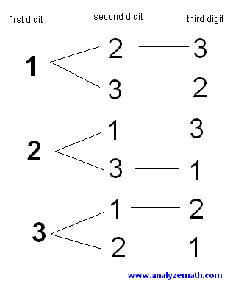

Make 6 numbers using 3 digits and without repetitions of the digits.
Method (2) counting:
LOOK AT THE TREE DIAGRAM ABOVE.
There are 3 choices for the first digit, 2 choices for the second digit and 1 choice for the third digit.
Using the counting principle:
The total number of 3-digit numbers is given by
3 × 2 × 1 = 6
There is a special notation for the product 3 × 2 × 1 = 3! and it is read 3 factorials.
Conclusion:
The permutation and combination concept were applied and the problem of finding the password is solved. The practice in formula is done and gives clear understanding about the variable’s role in the formula.
Concept: Combination and Permutation
Domain: Ethical Hacking
36. How many different pass words for a sensor network can we make using the letters A, B, E and L?
Solution:
We have 4 choices for the first letter, 3 choices for the second letter, 2 choices for the third letter and 1 choice for the fourth letter. Hence the number of words is given by
4 × 3 × 2 × 1 = 4! = 24
Conclusion: The permutation and combination concept were applied and the problem of finding the password is solved. The practice in formula is done and gives clear understanding about the variables role in the formula.
37. Concept: Combination and Permutation
Domain: Ethical Hacking
How many 2-digit pass word can you make using the digits 1, 2, 3 and 4 without repeating the digits for voice control locking system in door?
Solution:
This time we want to use 2 digits at the time to make 2-digit numbers.
For the first digit we have 4 choices and for the second digit we have 3 choices (4 - 1 used already). Using the counting principle, the number of 2-digit numbers that we can make using 4 digits is given by
4 × 3 = 12
The above problem is that of arranging 2 digits out of 4 in a specific order. This is also called permutation.
The most important idea in permutations is that order is important. When you use the digits 3 and 4 to make a number, the number 34 and 43 are different hence the order of the digits 3 and 4 is important.
In general permutation r (2 digits in the above example) items out of a set of n (4 digits in the above example) items is written as _{n} P _{r} and the formula is given by
_{n} P _{r} = n! / (n - r)!
Conclusion: The permutation and combination concept were applied and the problem of finding the password is solved. The practice in formula is done and gives clear understanding about the variables role in the formula.
Concept: Combination and Permutation
Domain: Ethical Hacking
38. A certain password consists of 3 different letters of the alphabet where each letter is used only once. How many different possible passwords are there?
Solution:
Order does matter in a password, and the problem specifies that you cannot repeat letters. So, you need a permutation without repetitions formula.
The number of permutations of 3 letters chosen from 26 is
Conclusion: The permutation and combination concept were applied and the problem of finding the password is solved. The practice in formula is done and gives clear understanding about the variables role in the formula.

Concept: Combination and Permutation
Domain: Ethical Hacking
39.Given an array arr[] of size N, find the number of permutations in the array that follows the given condition: “ If K is the maximum element in the array, then the elements before K in the array should be in the ascending order and the elements after K in the array should be in the descending order”.
Use the following example to understand.
Examples:
Input: arr[] = {1, 2, 3}
Output: 4
Explanation:
There are a total of 6 permutations for the given array {1, 2, 3}. They are:
{1, 2, 3}, {1, 3, 2}, {2, 1, 3}, {2, 3, 1}, {3, 1, 2}, and {3, 2, 1}
Out of the above permutations, only {1, 2, 3}, {1, 3, 2}, {2, 3, 1}, {3, 2, 1} are the arrays which follow the strictly ascending order before the maximum element 3 and strictly descending order after it.
The permutations which do not satisfy this condition are {2, 1, 3}, {3, 1, 2}.
Input: arr[] = {1 1 2}
Output: 1
There are a total of 3 permutations for the given array {1, 1, 2}. They are:
{1 1 2}, {1 2 1} and {2 1 1}
Out of the above permutations, only {1, 2, 1} is the array which follow the strictly ascending order before the maximum element 2 and strictly decsending order after it.
The permutations which do not satisfy this condition are {1, 1, 2}, {2, 2, 1}.
Record your observations and the approach to solve it.
Solution:
Observations: On observing carefully, the following observations can be made:
1. It can be concluded that if any number repeats more than twice, then there will be no permutation which satisfies the given condition. This is because, in all the permutations, this will be seen twice either before the maximum element or after the maximum element thus violating the given condition.
2. The second observation which can be made is that the maximum element in the array should appear only once. If it appears more than once, then the extra copies may be seen before the maximum element thereby violating the given condition.
Approach: When the above two observations are not violated, then the idea is to partition the array into two parts and fill elements in each partition as:
· Since we can partition the array into two parts. One is before the maximum element and the other one is after the maximum element. Therefore, every element has two choices whether to appear either before the maximum element or after the maximum element except the maximum element in the array.
· If any element appears twice in the array, then that element has only one option. It definitely has to appear once before the maximum element and once after the maximum element. For example,

· If arr[] = {1, 2, 2, 3, 4}, the maximum element 4 has only one occurrence and no element occurs more than twice.
· Now, the array can be divided into two parts: { }4{ } with 4 being the maximum element.
· Since 2 is repeated twice, it should be available on both the sides (i.e.) {2}4{2}.
· 1 and 3 both have two choices for the left part and right part. Therefore, there are 2 * 2 = 4 possible permutations.

Therefore, if N is the size of the array and M is the number of elements in the array with its occurrence = 2, then the number of permutations satisfying the condition will be 2^{(N – (2 * X) – 1)}.
Conclusion: The permutation and combination concept were applied and the problem of finding the password is solved. The practice in formula is done and gives clear understanding about the variables role in the formula.
Concept: Combination and Permutation
Domain: Ethical Hacking
40.Given a string ‘s’ and a character ‘c’, find the number of permutations of the string in which all the occurrences of the character ‘c’ will be together (one after another).

Use the following example to understand.
Examples :
Input: Str = “AKA” ch = ‘A’
Output: 2
All the unique permutations of AKA are : AKA, AAK and KAA
‘A’ comes consecutively only twice. Hence, the answer is 2

Input: str= “MISSISSIPPI” ch = ‘S’
Output: 840
Give the mathematical approach to solve the problem and also discuss the efficient approach to solve it.
Solution:
Naive Approach:
· Generate all the permutations of the given string.
· For each permutation check whether all occurrences of the character appear together.
· Count of the permutations from the previous step is the answer.
Efficient Approach:
Let the length of the string be ‘l’ and frequency of the character in the string be ‘n’.
· Store the frequency of every character of the string.
· If the character is not present in the string then the output will be ‘0’.
· Consider all the occurrences of the character as a combined single character.
· So, ‘l’ will become ‘l – occ + 1’ where ‘occ’ is the total occurrence of the given character and ‘l’ is the new length of the string.
· Return ( (Factorial of l) / (Product of the factorials of the no. of occurrences of each character except the given character) )
Conclusion: The permutation and combination concept were applied and the problem of finding the password is solved. The practice in formula is done and gives clear understanding about the variables role in the formula.
41. The travelling Salesman Problem (TSP) is to find the shortest possible route that
Visits every city exactly once and returns to the starting point when a set of cities
and distance between every pair of cities are given.
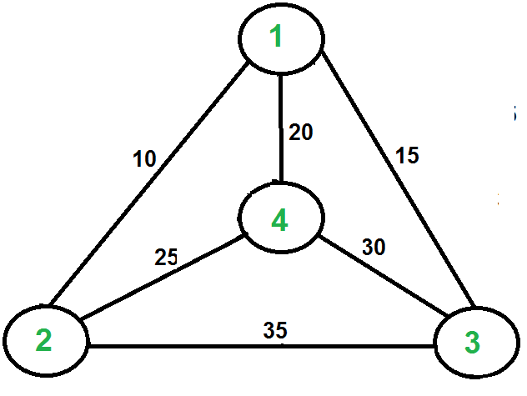
For example, consider the graph shown in figure. A TSP tour in the graph is 1-2-4-3-1. The cost of the tour is 10+25+30+15 which is 80. Explain the naive approach solution and Minimum spanning tree-based algorithm to solve TSP. Draw the MST with node 1 as root and find the shortest route to cover all nodes.
Solution:
Naive Solution:
1) Consider city 1 as the starting and ending point.
2) Generate all (n-1)! Permutations of cities.
3) Calculate cost of every permutation and keep track of minimum cost permutation.
4) Return the permutation with minimum cost.

MST based algorithm.
1) Let 1 be the starting and ending point for salesman.
2) Construct MST from with 1 as root using Prim’s Algorithm.
3) List vertices visited in pre order walk of the constructed MST and add 1 at the end
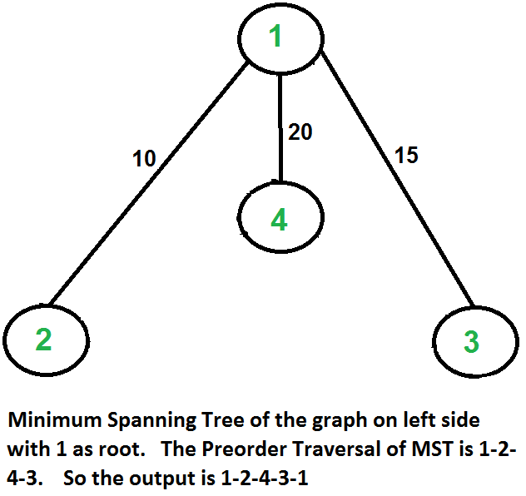.

The second diagram shows MST constructed with 1 as root. The preorder traversal of MST is 1-2-4-3. Adding 1 at the end gives 1-2-4-3-1 which is the output of this algorithm.

Concept: Combination and Permutation
Domain: Ethical Hacking
42. If you want to open your friend’s Gmail account, you know his email id and his password length. The length of the password is 8. You know that his password starts with the first four letters of his name. How will you find his password mathematically? Hint: He uses only alphabets in the password. Explain your solution in brief.
Solution
52 ^ 4 – combination are available to guess the password.
26 – Lowercase alphabets
26 – Uppercase alphabets
4 letters to be guessed and all the four are alphabets.
Hence there are 52^4 possible combinations of characters to be tested to match one password.

Conclusion:
The permutation and combination concept were applied and the problem of finding the password is solved. The practice in formula is done and gives clear understanding about the variable’s role in the formula.
43. Find the time complexity of binary search using recurrence relation.
Concept: Recurrence relation
Domain: Design & Analysis of Algorithms
Explanation:
Recurrence Relation
Recurrence Relation is an equation that defines a sequence based on a rule that gives the next term as a function of previous terms.
Example: Fibonacci sequence
Here F(0)=0 F(1)=1
F(2)=F(0)+F(1)
(i.e) F(n)=F(n-1)+F(n-2)
Solution:
“Binary Search” is an efficient method to return the location of an element in the given array.
Procedure:
In binary search, we first compare the given element ‘X’ with the middle element of the array.
If X matches with the middle element, then it returns the middle index as the answer. Otherwise, we either
recursively search in left or right half of the array. (i.e), We are dividing the array into two halves and then
searching either one half of the array. Finally, we will return the position of the search key X.
At each iteration, the array is divided by half. So let’s say the length of array at any iteration is n
At Iteration 1,
Length of array = n
At Iteration 2,
Length of array = ^{n}⁄₂
At Iteration 3,
Length of array = ^{(n}⁄₂)⁄₂ = ^{n}⁄₂²
Therefore, after Iteration k,
Length of array = ^{n}⁄₂^{k}
Also, we know that after k divisions, the length of array becomes 1.
Hence the recurrence relation is
T(n)=T(n/2)+O(1) and T(1)=1 where n is number of elements in given array.
Time Complexity:
Length of array = ^{n}⁄₂^{k} = 1
=> n = 2^{k}
Applying log function on both sides:
=> log₂ (n) = log₂ (2^{k})
=> log₂ (n) = k log₂ (2)
As (log_{a} (a) = 1)
Therefore,
=> k = log₂(n)
Conclusion:
Thus the recurrence relation is used to find time complexity of binary search technique.
44. Which of the following is the correct recurrence for the worst case of Binary Search?

(A) T(n) = 2T(n/2) + O(1) and T(1) = T(0) = O(1)
(B) T(n) = T(n-1) + O(1) and T(1) = T(0) = O(1)
(C) T(n) = T(n/2) + O(1) and T(1) = T(0) = O(1)
(D) T(n) = T(n-2) + O(1) and T(1) = T(0) = O(1)
Answer: (C) T(n) = T(n/2) + O(1) and T(1) = T(0) = O(1)

45. Find the analysis of merge sort using recurrence relation.
Concept: Recurrence relation
Domain: Design & Analysis of Algorithms
Explanation:
Merge sort is the application of divide and conquer technique.
It divides the input array into two halves, calls itself for both the halves and then merges the two sorted halves.
Solution:
Merge sort is the application of divide and conquer technique.
It divides the input array into two halves, calls itself for both the halves and then merges the two sorted halves.

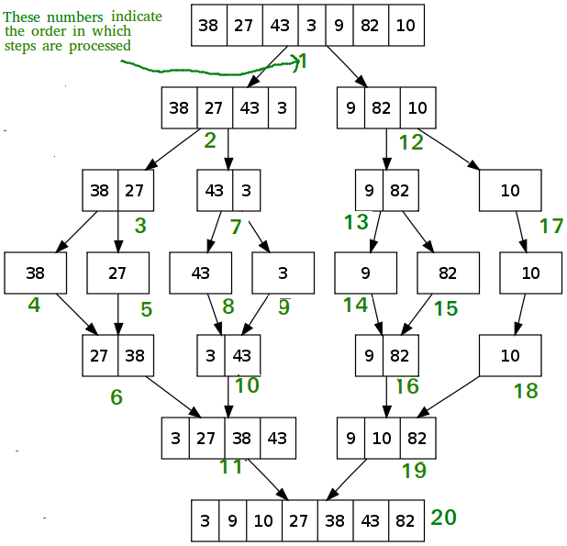
Recurrence Relation:
T(n)=2T(n/2)+O(n) Merging of 2 sorted arrays

Dividing the array into 2 halves
Complexity Analysis of Merge Sort
Merge Sort is quite fast, and has a time complexity of O(n*log n). It is also a stable sort, which means the "equal" elements are ordered in the same order in the sorted list.
And to merge the sub arrays, made by dividing the original array of n elements, a running time of O(n) will be required.
Hence the total time for mergeSort function will become n(log n + 1), which gives us a time complexity of O(n*log n).
Conclusion:
Thus, the recurrence relation is used to find time complexity of Merge Sort.

46. Find the cost of factorial function using recurrence relation.
Concept: Recurrence relation
Domain: Design & Analysis of Algorithms
Explanation:
We know that 3!=3*2*1
For a recursive function, we must specify termination conditions.
For any value, n recursive definition for factorial function is:
N!=(n-1)!*n for n>1
1!=0!=1
Solution:
The number of multiplications required by a recursive version of factorial function for an input of size ‘n’ will be zero, when n=0 or n=1. (Base Case)
And it will be one plus the cost of calling fact on a value of n-1.
Therefore, Recurrence Relation will be
T(n)=T(n-1) +1 for n>1
T(n)=T(n-1) +1 To return value for n>1
Time to find factorial of n-1
T(0) =T(1)=0 // no need to perform multiplication when n=0 or n=1

Conclusion:
Thus the recurrence relation is used to find the cost of factorial function.

47. Identify the recurrence relation for Tower of Hanoi problem.
Concept: Recurrence relation
Domain: Design & Analysis of Algorithms
Explanation:

Rules to solve Tower of Hanoi problem
The mission is to move all the disks to some other tower without violating the sequence of arrangement. A few rules to be followed for Tower of Hanoi are −
- Only one disk can be moved among the towers at any given time.
- Only the "top" disk can be removed.
- No large disk can sit over a small disk.
Let us have 3 disks. To move disks from Tower A to Tower C by using B Tower.
Input : 2
Output : Disk 1 moved from A to B
Disk 2 moved from A to C
Disk 1 moved from B to C
Input : 3
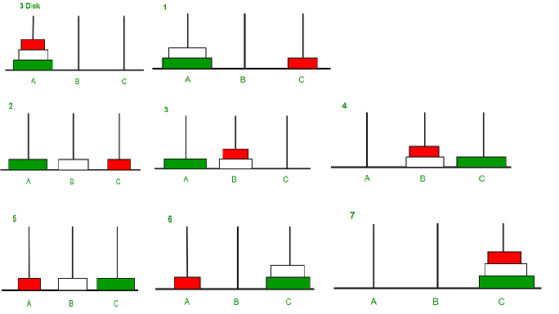
Output : Disk 1 moved from A to C
Disk 2 moved from A to B
Disk 1 moved from C to B
Disk 3 moved from A to C
Disk 1 moved from B to A
Disk 2 moved from B to C
Disk 1 moved from A to C
The steps to follow are −
Step 1 − Move n-1 disks from source to aux
Step 2 − Move nth disk from source to dest
Step 3 − Move n-1 disks from aux to dest

Solution:
Let us apply the general plan.
Step 1:Input size is n(Total number of disks)
Step 2:Moving 1 disk is the basic operation
Step 3:The number of moves M(n) depends on n only.
If n =1 then only one move is sufficient.
If n>1, we need two recursive calls plus one move .
. To move n-1 disks from Tower A to Tower B, the number of moves required =M(n-1)
. To move the last disk(nth disk)from Tower A to Tower C, the number of
moves required =1
· To move n-1 disks from Tower B to Tower C, the number of moves required=M(n-1)
Therefore total number of moves required M(n)=M(n-1)+1+M(n-1)
Hence the recurrence relation is M(n)= 2 M(n-1)+1
This notation represents Movement of “n” disks, from Tower A
to Tower C.
Conclusion:
Using the obtained relation, we can find the final cost through which we can determine the number of steps needed to move the given disks from Source tower to Destination tower.

48. David needs to visit all the cities from a list (a, b,c,d) where distances from cities are known and each city should be visited just once. What is the shortest possible route that he visits each city exactly once and returns to the origin city?

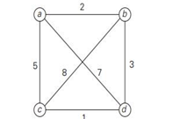

Concept: Permutation
Domain: Design & Analysis of Algorithms
Solution:
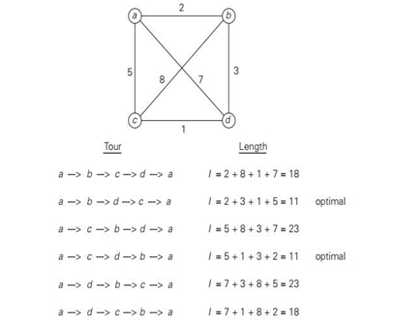

Conclusion:
If we consider the vertices as computer systems/nodes and edges as communication links between systems, this problem can be applied to find the most efficient route for data to travel between various nodes.

49. A thief gets into a home to rob and he carries a knapsack with capacity W. There are fixed number of items in the home each has its own weight and value. He either takes the item or leaves the item. Identify the optimal subset that he can take. (Knapsack Problem)
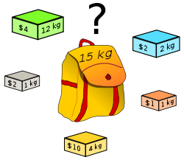

Item | Weight | Value
1 | 4 | 10
2 | 12 | 4
3 | 1 | 1
4 | 1 | 2
5 | 2 | 2

W=15Kg (Knapsack Capacity)
Concept: Combination
Domain: Design & Analysis of Algorithms
Solution:
Subset Total weight Total Value
- $0
1 4 $10
2 12 $4
3 1 $1
4 1 $2
5 2 $2
1,2 16 X (Not Feasible-exceeds W)
1,3 5 $11
1,4 5 $12
1,5 6 $12
1,2,3 17 X (Not Feasible-exceeds W)
1,2,4 17 X (Not Feasible-exceeds W)
1,2,5 18 X (Not Feasible-exceeds W)
1,3,5 7 $13
1,3,4 6 $13
1,2,3,4 18 X (Not Feasible-exceeds W)
1,2,4,5 19 X (Not Feasible-exceeds W)
1,3,4,5 8 $15 (Optimal)
1,2,3,4,5 20 X (Not Feasible-exceeds W)
Conclusion:
Optimal Subset : {1,3,4,5}
Total Profit : $15
50. Given a network with 40 nodes. Find the total number of ways the network can be connected to form completely connected network/graph.
Explanation:
Complete Graph
A simple graph, in which there is exactly one edge between each pair of distinct vertices, is called a complete graph denoted by K_{n.}
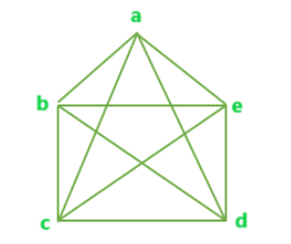
The number of edges in complete graph with n vertices = nC₂or n(n-1)/2.

Solution:
The total number of edges of a complete graph with 40 nodes is calculated using the formula nC₂ = 40C₂ = 40(40-2) / 2
= (40x39) /2
= 780.
51. Given 3 networks A,B,C which are interconnected
a. In how many ways, message can be transmitted from network A to network C?
b. Is there any possibility to back traverse? Justify with how many numbers of ways are there to traverse back in the network.
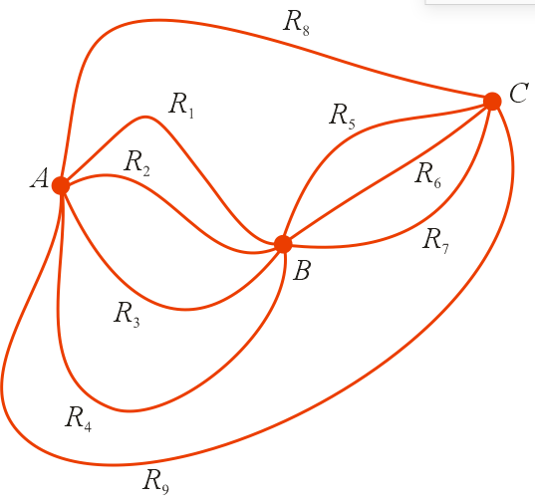
Solution:
Solution:
- Network A to network C, the ways are
AR₈C,AR₉C => 2 ways
AR₁BR₅C,AR₁BR₆C,AR₁BR₇C => 3 ways
AR₂BR₅C,AR₂BR₆C,AR₂BR₇C => 3 ways
AR₃BR₅C,AR₃BR₆C,AR₃BR₇C => 3 ways
AR₄BR₅C,AR₄BR₆C,AR₄BR₇C => 3 ways

Hence there are 2+4x3= 2+12 = 14 ways

- Network A to network C travelling ways are 14 ways .Similarly network C to network A travelling ways are 14 ways.

Hence travelling the round trips from A to C = 14x14=196 ways.

Linear Regression is a machine learning algorithm based on supervised learning. It performs a regression task. Regression models a target prediction value based on independent variables. It is mostly used for finding out the relationship between variables and forecasting. Different regression models differ based on – the kind of relationship between dependent and independent variables, they are considering and the number of independent variables being used.
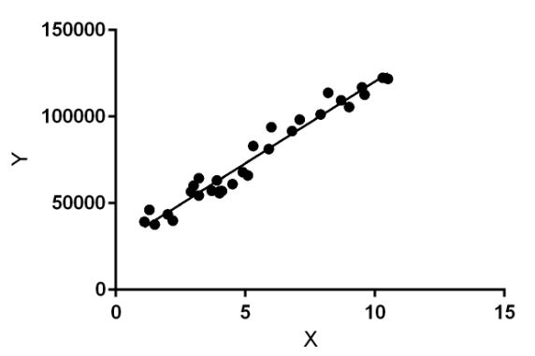
Linear regression performs the task to predict a dependent variable value (y) based on a given independent variable (x). So, this regression technique finds out a linear relationship between x (input) and y(output). Hence, the name is Linear Regression.
In the figure above, X (input) is the work experience and Y (output) is the salary of a person. The regression line is the best fit line for our model.
Hypothesis function for Linear Regression:
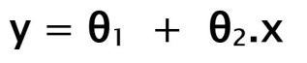
While training the model we are given:
x: input training data (univariate – one input variable(parameter))
y: labels to data (supervised learning)
When training the model – it fits the best line to predict the value of y for a given value of x. The model gets the best regression fit line by finding the best θ₁ and θ₂ values.
θ₁: intercept
θ₂: coefficient of x
Once we find the best θ₁ and θ₂ values, we get the best fit line. So when we are finally using our model for prediction, it will predict the value of y for the input value of x.
Vectorization:
vectorized code replaces the loop for moving through a vector one component at a time.

52. A machine learning model given by the equation, height (cm) = age (yr) x 6.5 + 76 (cm), will be able to predict the height of the children within the age of 2 to 10. Given the age of 5 children as 6, 2,8,3,4, give the steps used by the algorithm in vectorizing the give data for processing.

Solution:

Input=

coefficient cons =

Height can be calculated as
Height= Input * coefficient_const

= $\left[\begin{matrix}76 \\ 6.5\end{matrix}\right]$
=
=$\left[\begin{matrix}\text{76+39} \\ \text{76+13} \\ \text{76+52} \\ \text{76+19.5} \\ \text{76+26}\end{matrix}\right]$

$\left[\begin{matrix}76 \\ 6.5\end{matrix}\right]$=
Conclusion:
Matrix is used to write the algorithm in vectorizing the given data for the processing.

53.The price of the house in Coimbatore has to be predicted using the model, given by the equation “base_price+400* Size”. The base price of the house in Coimbatore is 10,50,000. The size of 5 houses is given as 1050, 2500, 678, 300, 800. Find the price of each house using the loop (write pseudo code) and also by vectorizing. Give the calculated result after vectorizing.
Solution:
Using Loops:
Array size[]= {1050, 2500, 678, 300, 800};
for each element in size
{
Price[i]=1050000 + 400 * size[i];
}
Using Vectorized Code:
Input=

coefficient_const=

Price can be calculated as
Price = Input * coefficient_const

=
=
= $\left[\begin{aligned}&\text{1050000 + 420000} \\ &\text{1050000 + 1000000} \\ &\text{1050000 + 271200} \\ &\text{1050000 + 120000} \\ &\text{1050000 + 320000}\end{aligned}\right]$
=$\left[\begin{matrix}1470000 \\ 2050000 \\ 1321200 \\ 1170000 \\ 1370000\end{matrix}\right]$
Conclusion:
Matrix is used to write the algorithm in vectorizing the given data for the processing.

54. Let be a pairty check matrix.
Find (i) Hamming code generated by H.
(ii) Find the minimum distance of the code.
Solution:
Taking the parity check matrix in the form
The encoding function is.
Now the original message is in 3 digits.
That is
The generator matrix G of the given H is given by
Where I is the identity matrix and A is the matrix formed by first 3 rows of H
The encoded words are given by
(i)
=
We know that set of code words generated by parity matrix is a group code under.
Minimum distance = minimum weight of a non-zero code in the group code = 3

55. Let be the pairty check matrix. Obtain the encoding function
Decode the following received words
(i) 0101
(ii) 1010
Solution:
Decoding table
The original message code is
The generator matrix is
The code word is given by
We know that set of code words generated by parity matrix is a group code under.
Minimum distance = minimum weight of a non-zero code in the group code = 2
Decoding table
0000 | 0110 | 1011 | 1101
1000 | 1110 | 0011 | 0101
1100 | 0010 | 1011 | 1001
0010 | 0100 | 1001 | 1111
0001 | 0111 | 1010 | 1100

Identify the row and column where they received code occur.
(i) 1010 – occur in the 5th row and 3rd column
Weight of the code later is
Transmitted word is the top element of the 3rd column
Transmitted word =1011
That is e (1 0) = 1011
The original message is 10.
(ii) Transmitted word =1101
That is e (1 1) = 1101
The original message is 11.

56. Google Search engine has set of web sites. The websites that contain the information about “best music director in India” has to be listed using TF (Term Frequency) vector space model.
${ W}_{1}$= “The following are notable Indian film music directors AR Rahman, Illayaraja”
${ W}_{2}$= “Illayaraja is one of the best music directors in India”
${ W}_{3}$= “Illayaraja has composed over 7000 songs”
Explanation:
Vector Space model in Computer Science:
Vector space model or term vector model is an algebraic model to representing text documents as vectors of identifiers such as index terms.
Term Frequency:
Term frequency is used in connection with information retrieval and shows how frequently an expression (term, word) occurs in a document.
Google Search Engine:
A search engine is a web-based program that collects and organizes content from all over the internet.
Solution:
Given: Consider three web pages as Documents D = 3
IDF = log ($\frac{D}{d_{fj}})$
Where$d_{fj}$ = number of documents containing term j.
$${COUNTS TF}_{ij} WEIGHTS,W_{1}=TF_{I*J}*ID F_{J}$$

Terms | Q | $$D_{1}$$ | $$D_{2}$$ | $$D_{3}$$ | $$d_{fj}$$ | D/$d_{fj}$ | IDF_{j}=log ($\frac{D}{d_{fj}})$ | Q = (Q*IDF_{j}) | $$D_{1}(IDF*D_{1})$$ | $$D_{2}(IDF*D_{2})$$ | $$D_{3}(IDF*D_{\begin{aligned}3 \\ \end{aligned}})$$
Best | 1 | 0 | 1 | 0 | 1 | 3/1 = 3 | 0.4771 | 0.4771 | 0 | 0.4771 | 0
Notable | 0 | 1 | 0 | 0 | 1 | 3/1 = 3 | 0.4771 | 0 | 0.4771 | 0 | 0
Music | 1 | 1 | 1 | 0 | 2 | 3/2 =1.5 | 0.1760 | 0.1760 | 0.1760 | 0.1760 | 0
Director | 1 | 1 | 1 | 0 | 2 | 3/2 =1.5 | 0.1760 | 0.1760 | 0.1760 | 0.1760 | 0
India | 1 | 1 | 1 | 0 | 2 | 3/2 =1.5 | 0.1760 | 0.1760 | 0.1760 | 0.1760 | 0
following | 0 | 1 | 0 | 0 | 1 | 3/1 = 3 | 0.4771 | 0 | 0.4771 | 0 | 0
Film | 0 | 1 | 0 | 0 | 1 | 3/1 = 3 | 0.4771 | 0 | 0.4771 | 0 | 0
AR Rahman | 0 | 1 | 0 | 0 | 1 | 3/1 = 3 | 0.4771 | 0 | 0.4771 | 0 | 0
Illayaraja | 0 | 1 | 1 | 1 | 3 | 3/3 = 1 | 0 | 0 | 0 | 0 | 0
One of the | 0 | 0 | 1 | 0 | 1 | 3/1 = 3 | 0.4771 | 0 | 0 | 0.4771 | 0
Composed | 0 | 0 | 0 | 1 | 1 | 3/1 = 3 | 0.4771 | 0 | 0 | 0 | 0.4771
7000 | 0 | 0 | 0 | 1 | 1 | 3/1 = 3 | 0.4771 | 0 | 0 | 0 | 0.4771
Songs | 0 | 0 | 0 | 1 | 1 | 3/1 = 3 | 0.4771 | 0 | 0 | 0 | 0.4771

$\left|Q\right|$ = $\sqrt{1^{2}+1^{2}+1^{2}+1^{2}}$ = $\sqrt{4}$ = 2
$\left|D_{1}\right|$ = $\sqrt{1^{2}+1^{2}+1^{2}+1^{2}+1^{2}+1^{2}{+1^{2}+1}^{2}}$ = $\sqrt{8}$ = 2.828
$\left|D_{2}\right|$ = $\sqrt{1^{2}+1^{2}+1^{2}+1^{2}+1^{2}+1^{2}}$= $\sqrt{6}$ = 2.449
$\left|D_{3}\right|$ = $\sqrt{1^{2}+1^{2}+1^{2}+1^{2}}$ = $\sqrt{4}$ = 2

Finding the dot products between term and Query counts
Q.$D_{1}$ = 1*0 + 0*1 + 1*1 + 1*1 + 1*1=3
Q.$D_{2}$ = 1*1 + 1*1 + 1*1 +1*1 + 0*1 + 0*1 = 4
Q.$D_{3}$ = 1*0 + 1*0 +1*0 + 1*0 + 0*1 + 0*1 = 0

By Cosine formula: Cos =

Cosine $θ_{d1}$ = $\frac{Q.D_{1}}{\left|Q\right|\left|D_{1}\right|}$ = $\frac{3}{2×2.828}$= 0.5304
Cosine $θ_{d2}$ = $\frac{Q.D_{2}}{\left|Q\right|\left|D_{2}\right|}$ =$\frac{4}{2×2.449}$= 0.8166
Cosine $θ_{d3}$= $\frac{Q.D_{3}}{\left|Q\right|\left|D_{3}\right|}$ =$\frac{0}{2×2}$ = 0
The webpage 2 has got the higher relevance with the query string and hence the D2 will be ranked first followed by D1 and the D3.

57. A Search Engine has set of three web documents namely D₁, D₂, and D₃. From these we need to find the document that closely matches with the given search keywords: Green Computing Awareness”.
Space model.
${ D}_{1}$= “The Green Computing is taught during October”
${ D}_{2}$= “The Green Computing helps survive”
${ D}_{3}$= “Awareness on Green Computing was given during October Awareness”

Explanation:
Vector Space model in Computer Science:
Vector space model or term vector model is an algebraic model to representing text documents as vectors of identifiers such as index terms.
Term Frequency:
Term frequency is used in connection with information retrieval and shows how frequently an expression (term, word) occurs in a document.
Search Engine:
A search engine is a web-based program that collects and organizes content from all over the internet.
Solution:

Given:
Documents D = 3
IDF = log ($\frac{D}{d_{fj}})$
Where$d_{fj}$ = number of documents containing term j.
$${COUNTS TF}_{ij} WEIGHTS,W_{1}=TF_{I*J}*ID F_{J}$$
Terms | Q | $$D_{1}$$ | $$D_{2}$$ | $$D_{3}$$ |  | $$d_{fj}$$ | D/$d_{fj}$ | IDF_{j} =log ($\frac{D}{d_{fj}})$ | Q=(Q*IDF_{j)} | $$D_{1}(IDF*D_{1})$$ | $$D_{2}(IDF*D_{2})$$ | $$D_{3}(IDF*D_{\begin{aligned}3 \\ \end{aligned}})$$
The | 1 | 1 | 1 |  | 0 | 2 | 3/2=1.5 | 0.1761 | 0.1761 | 0.1761 | 0.1761 | 0
Taught | 0 | 1 | 0 |  | 0 | 1 | 3/1=3 | 0.4771 | 0 | 0.4771 | 0 | 0
During | 0 | 1 | 0 |  | 1 | 2 | 3/2=1.5 | 0.1761 | 0 | 0.1761 | 0 | 0.1761
October | 1 | 1 | 0 |  | 1 | 2 | 3/2=1.5 | 0.1761 | 0.1761 | 0.1761 | 0 | 0.1761
Awareness | 1 | 0 | 0 |  | 2 | 1 | 3/1=3 | 0.4771 | 0.4771 | 0 | 0 | 0.9542
Helps | 0 | 0 | 1 |  | 0 | 1 | 3/1=3 | 0.4771 | 0 | 0 | 0.4771 | 0
Survive | 0 | 0 | 1 |  | 0 | 1 | 3/1=3 | 0.4771 | 0 | 0 | 0.4771 | 0
Given | 0 | 0 | 0 |  | 1 | 1 | 3/1=3 | 0.4771 | 0 | 0 | 0 | 0.4771
Green Computing | 0 | 1 | 1 |  | 1 | 3 | 3/3=1 | 0 | 0 | 0 | 0 | 0

$\left|D_{1}\right|$ = $\sqrt{1^{2}+1^{2}+1^{2}{+1^{2}+1}^{2}}$ = $\sqrt{5}$ = 2.236
$\left|D_{2}\right|$ = $\sqrt{1^{2}+1^{2}{+1^{2}+1}^{2}}$ = $\sqrt{4}$ = 2
$\left|D_{3}\right|$ = $\sqrt{1^{2}+1^{2}+2^{2}{+1^{2}+1}^{2}}$ = $\sqrt{8}$ = 2.828
$\left|Q\right|$= $\sqrt{+1^{2}{+1^{2}+1}^{2}}$ = $\sqrt{3}$ = 1.732
To find the dot products between term and Query counts
Q.$D_{1}$ = 1*1+1*1+1*0=2
Q.$D_{2}$ = 1*1+1*0+1*0=1
Q.$D_{3}$ = 1*1+1*0+1*2=3
By Cosine formula: Cos =
Cosine $θ_{d1}$ = $\frac{Q.D_{1}}{\left|Q\right|\left|D_{1}\right|}$ = $\frac{2}{1.732×2.236}$= 0.5165
Cosine $θ_{d2}$ = $\frac{Q.D_{2}}{\left|Q\right|\left|D_{2}\right|}$ =$\frac{1}{1.732×2}$= 0.2886
Cosine $θ_{d3}$= $\frac{Q.D_{3}}{\left|Q\right|\left|D_{3}\right|}$ =$\frac{3}{1.732×2.828}$ = 0.6124
From the above analysis, we can find that, the document D₃is having number of matched words.

58. Consider, our college has a local server has a three different excel document. From these we need to find keywords: Software file link” using TF (Term Frequency) vector space model.
${ D}_{1}$= “Windows Software”
${ D}_{2}$= “Open source software”
${ D}_{3}$= “File link for all software”

Explanation:
Vector Space model in Computer Science:
Vector space model or term vector model is an algebraic model to representing text documents as vectors of identifiers such as index terms.
Term Frequency:
Term frequency is used in connection with information retrieval and shows how frequently an expression (term, word) occurs in a document.

Applications of Vector Space model:
- Google Search Engine
- Finding a Similarity index value in documents.
- Information Retrieval
- Regression in machine learning
- Optimizations algorithms
- Information filtering
- Classifications
- Image Processing

Solution:

Given:
Documents D = 3
IDF = log ($\frac{D}{d_{fj}})$
Where$d_{fj}$ = number of documents containing term j.
$${COUNTS TF}_{ij} WEIGHTS,W_{1}=TF_{I*J}*ID F_{J}$$
Terms | Q | $$D_{1}$$ | $$D_{2}$$ | $$D_{3}$$ |  | $$d_{fj}$$ | D/$d_{fj}$ | IDF_{j} =log ($\frac{D}{d_{fj}})$ | Q=(Q*IDF_{j)} | $$D_{1}(QD_{1})$$ | $$D_{2}(QD_{2})$$ | $$D_{3}(QD_{\begin{aligned}3 \\ \end{aligned}})$$
Windows | 0 | 1 | 0 |  | 0 | 1 | 3/1=3 | 0.4771 | 0 | 0.4771 | 0 | 0
Software | 1 | 1 | 1 |  | 1 | 3 | 3/3=1 | 0 | 0 | 0.4771 | 0 | 0
Open | 0 | 0 | 1 |  | 0 | 1 | 3/1=3 | 0.4771 | 0 | 0 | 0.4771 | 0
Source | 0 | 0 | 1 |  | 0 | 1 | 3/1=3 | 0.4771 | 0.1761 | 0 | 0.4771 | 0
File | 1 | 0 | 0 |  | 1 | 1 | 3/1=3 | 0.4771 | 0 | 0 | 0 | 0.4771
Link | 1 | 0 | 0 |  | 1 | 1 | 3/1=3 | 0.4771 | 0 | 0 | 0 | 0.4771
For | 0 | 0 | 0 |  | 1 | 1 | 3/1=3 | 0.4771 | 0 | 0 | 0 | 0.4771
All | 0 | 0 | 0 |  | 1 | 1 | 3/1=3 | 0.4771 | 0 | 0 | 0 | 0.4771

$\left|D_{1}\right|$ = $\sqrt{1^{2}+1^{2}+}$ = $\sqrt{2}$ = 1.414
$\left|D_{2}\right|$ = $\sqrt{+1^{2}{+1^{2}+1}^{2}}$ = $\sqrt{3}$ = 1.732
$\left|D_{3}\right|$ = $\sqrt{1^{2}+1^{2}+1^{2}{+1^{2}+1}^{2}}$ = $\sqrt{5}$ = 2.236
$\left|Q\right|$= $\sqrt{+1^{2}{+1^{2}+1}^{2}}$ = $\sqrt{3}$ = 1.732
To find the dot products between term and Query counts
Q.$D_{1}$ = 0*1+1*1+1*0=1
Q.$D_{2}$ = 1*1+1*0+1*0=1
Q.$D_{3}$ = 1*1+1*1+1*1=3
By Cosine formula: Cos =
Cosine $θ_{d1}$ = $\frac{Q.D_{1}}{\left|Q\right|\left|D_{1}\right|}$ = $\frac{1}{1.732×1.414}$= 0.4081
Cosine $θ_{d2}$ = $\frac{Q.D_{2}}{\left|Q\right|\left|D_{2}\right|}$ =$\frac{1}{1.732×1.732}$= 0.3333
Cosine $θ_{d3}$= $\frac{Q.D_{3}}{\left|Q\right|\left|D_{3}\right|}$ =$\frac{3}{1.732×2.236}$= 0.7747
Conclusion: From the above analysis, we can find that, the document D₃is having number of matched words.

Applications of Prime and composite numbers:
- Public key cryptography
- Chinese Reminder Theorem

Applications of Chinese Reminder Theorem (CRT):
- Cryptography
- Secret Sharing

Application of GCD
- Reducing fractions
- Chinese remaindering (using extended Euclidean algorithm)
- Finite field arithmetic (in particular, multiplicative inverses, again using extended Euclidean algorithm)
- RSA crypto (using GCD)
- Factoring integers (Pollard's rho method, elliptic curve method, Shor's algorithm).

Chinese Remainder Theorem
Domain : Cryptography
Concept : RSA Algorithm
Explanation :
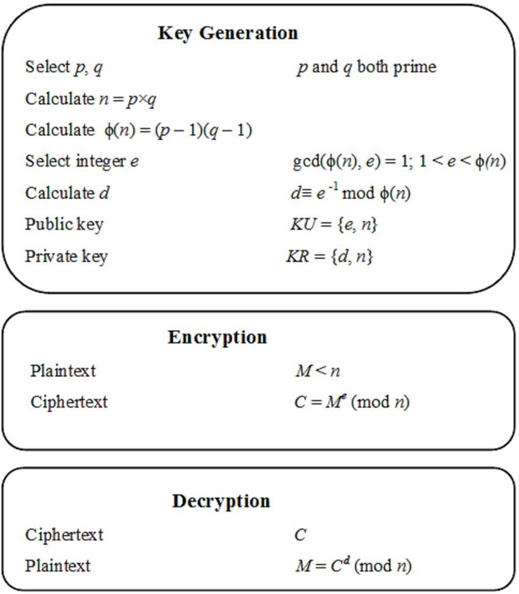
Here,
· P and q are prime numbers
· n- Both sender and receiver know the value
· e- Only sender knows value
· d- Only receiver know the value
· ϕ(n) –Euler totient function
· M is the plain text
· C is the cipher text
· KU is the public key or encryption key
· KR is the private key

59. Prime number is giving more security to transfer a message from source to destination while converting plain text to cipher text (encryption) and cipher text to plain text (Decryption)? Will 97 provide high security while data is transferred from source to destination?
Primes are important because the security of many encryption algorithms are based on the fact that it is very fast to multiply two large prime numbers and get the result, while it is extremely computer-intensive to do the reverse.
Solution:
The floor of sqrt (97) = 9. The primes less that 9 are 2, 3, 5, and 7. We need to see if 97 is divisible by any of these numbers.
97 is not divisible by any of the numbers (2,3,5, & 5). So, 97 said to be a Prime number and it can be used more efficiently for encryption and decryption, which is used in RSA algorithm to covert the plain text to cipher text.

60. Prime number is giving more security to transfer a message from source to destination while converting plain text to cipher text (encryption) and cipher text to plain text(Decryption)? Are 15, 17 and 27 pair-wise relatively prime and provide more security?
Definition: Two integers a and b relatively prime if gcd(a,b)=1.
Solution:
15, 17 and 27 are not relatively prime because gcd(15,27) =3.
Thus, we find gcd(15,27) =3, so it is not a prime number which is used to convert plain text to cipher text.

61. Prime number is giving more security to transfer a message from source to destination while converting plain text to cipher text (encryption) and cipher text to plain text(Decryption)? Are 15, 17 and 28 pair-wise relatively prime and provide more security?
Definition: Two integers a and b relatively prime if gcd(a,b)=1.
Solution:
15,17,28 are relatively prime because
gcd(15 , 17) = 1
gcd(15 , 28) = 1
gcd(17 , 28) = 1.
Thus, we find gcd(15, 17, 28) = 1, so it is a relatively prime number which is used to convert plain text to cipher text in RSA algorithm.

62. Perform encryption and decryption operations using RSA algorithm for sending the information M=5 from source to destination, to perform RSA operations, an encryption key, two prime numbers p and q are required, The values of p, q and encryption key are given as below: p=3,q=11 with the encryptions key e=7
Solution:
Step 1 is done since we are given p and q, such that they are two distinct prime numbers.
Step 2, get n where n = pq
N = p x q = 3 x 11 = 33
Step 3, get ϕ where ϕ (n) = (p - 1)(q - 1)
ϕ(n) = (p-1) x (q-1) = 2 x 10 = 20
Step 4, select e such that e is relatively prime to ϕ (n); gcd(ϕ (n), e) = 1 where 1 < e < ϕ (n)
gcd(ϕ(n), e) = gcd(20, 7) = 1
Step 5, determine d such that d*e % ϕ (n) = 1; d < ϕ (n)
d ≡ e-1(mod ϕ(n))
d x e mod ϕ(n) = 1
7d mod 20 = 1
D = 3
Public Key pu = {e, n} = {7, 33}
Private Key pr = {d, n} = {3, 33}
Encryption:
C = Memod n
C = 57mod 33
C = 14
Decryption:
M = C^{d}mod n
M= 143mod 33
M = 5

Therefore, using the RSA algorithm we perform encryption and decryption process with the help of two prime numbers p and q. The data to be sent from the sender is “5”. When the values are encrypted the result obtained is C = 14. This value is passed on to the destination and at the destination the information is decrypted back to get the original plain text. After decryption the obtained message is M=5, which is the actual message that is being sent from the sender.

63. Perform encryption and decryption operations using RSA algorithm for sending the information M=9 from source to destination, to perform RSA operations, an encryption key, two prime numbers p and q are required, The values of p, q and encryption key are given as below: p=5,q=11 with the encryptions key e=3
Solution:

Step 1 is done since we are given p and q, such that they are two distinct prime numbers.
Step 2, get n where n = pq
n = p x q = 5 x 11 = 55
Step 3, get ϕ where ϕ (n) = (p - 1)(q - 1)
ϕ(n) = (p-1) x (q-1) = 4 x 10 = 40
Step 4, select e such that e is relatively prime to ϕ (n); gcd(ϕ (n), e) = 1 where 1 < e < ϕ (n)
gcd(ϕ(n), e) = gcd(40, 3) = 1
Step 5, determine d such that d*e % ϕ (n) = 1; d < ϕ (n)
d ≡ e-1(mod ϕ(n))
d x e mod ϕ(n) = 1
3d mod 40 = 1
d = 27
Public Key pu = {e, n} = {3, 55}
Private Key pr = {d, n} = {27, 55}
Encryption:
C = Memod n
C = 93mod 55
C = 14
Decryption:
M = C^{d}mod n
M = 1427mod 55
M = 9
Therefore, using the RSA algorithm we perform encryption and decryption process with the help of two prime numbers p and q. The data to be sent from the sender is “9”. When the values are encrypted the result obtained is C = 14. This value is passed on to the destination and at the destination the information is decrypted back to get the original plain text. After decryption the obtained message is M=9, which is the actual message that is being sent from the sender.

64. In a RSA cryptosystem a particular A uses two prime numbers p = 13 and q =17 to generate her public and private keys. If the public key of A is 35. Compute the private key of A.
Explanation:
In an RSA cryptosystem, for public key:
GCD( ϕ(n) , e) = 1
And, for private key: (e * d) mod ϕ(n) = 1
Where,
ϕ(n) = (p -1)*(q – 1) = (13 – 1)(17 – 1) =12*16 = 192
Such that 1 < e, d < ϕ(n)
Therefore, the private key is: (35 * d) mod ϕ(n) = 1,
d = 11
After doing the computation the private key of A is 11.
Therefore, using the RSA algorithm we perform encryption and decryption process with the help of two prime numbers p and q. With the help of the two prime numbers p & q and the public key A, the private key is generated whose value is 11 using mod functions. This private key is used to decrypt the text at the receiver end.

65. Consider the given text ”Hello” as a value 7 and “World” as a value 11 for the variable p and p respectively. Perform encryption and decryption using RSA algorithm for the given two prime numbers p and q, with the encryptions key e=17 and to obtain the plain text M=8.
Solution:
Step 1 is done since we are given p and q, such that they are two distinct prime numbers.
Step 2, get n where n = pq
n = p x q = 7 x 11 = 77
Step 3, get ϕ where ϕ (n) = (p - 1)(q - 1)
ϕ(n) = (p-1) x (q-1) = 6 x 10 = 60
Step 4, select e such that e is relatively prime to ϕ (n); gcd(ϕ (n), e) = 1 where 1 < e < ϕ (n)
gcd(ϕ(n), e) = gcd(60, 17) = 1
Step 5, determine d such that d*e % ϕ (n) = 1; d < ϕ (n)
d ≡ e-1(mod ϕ(n))
d x e mod ϕ(n) = 1
17d mod 60 = 1
d = 53
Public Key pu = {e, n} = {17, 77}
Private Key pr = {d, n} = {53, 77}
Encryption:
C = Memod n
C = 817mod 77
C = 57
Decryption: M = C^{d}mod n
M = 5753mod 77
M = 8
Therefore, using the RSA algorithm we perform encryption and decryption process with the help of two prime numbers p and q. The data to be sent from the sender is “Hello World”. When the values are encrypted the result obtained is C = 57. This value is passed on to the destination and at the destination the information is decrypted back to get the original plain text. After decryption the obtained message is M=8, which is the actual message that is being sent from the sender. Using the RSA algorithm to obtain the decrypted message M=8 (i.e, “Hello”) correctly.

66. In cryptography, how to Euclidean Algorithm is used to determine the GCD of two positive integers as (128, 87)?
Solution:
125 = 1 * 87 + 38
87 = 2 * 38 + 11
38 = 3 * 11 + 5
11 = 2 * 5 + 1
5 = 5 * 1 + 1
Thus, we find gcd(125,87) =1 which is used in RSA Algorithm to convert plain text to cipher text ie, the encryption process.

67. In cryptography, how to use Euclidean Algorithm to determining the GCD of two positive integers as (125, 20)?
Solution:
125 = 6 * 20 + 5
20 = 4 * 5
Thus, we find gcd(125,20) =5 which is used in RSA Algorithm to convert plain text to cipher text ie, the encryption process.

68. In Cryptographic and network security, How to use Euclidean Algorithm to determining the gcd (24140,16762)?
Solution:
24140 = 1* 16762 + 7378 gcd(16762, 7378)
16762 = 2*7378 +2006 gcd(7378,2006)
7378 = 3 * 2006 +1360 gcd(2006,1360)
2006 = 1*1360+646 gcd(646,68)
1360 = 2*646 + 68 gcd(68,34)
646 = 9*68+34 gcd(68,34)
68=2*34+0 gcd(34,0)
Thus, we find gcd(24140, 16762) =34 which is used in RSA Algorithm to convert plain text to cipher text ie, the encryption process.

69. In Cryptographic and network security, when the messages are represented by numerical values, which is being encrypted and transmitted to the receiver, by using divisibility and division algorithm, Which of the following is true??
(1). 77|7 (2). 7|77 (3). 24|24 (4). 0|24 (5).24|0
Solution:
(1). 77|7 : False, because bigger number cannot divide the smaller positive number
(2). 7 | 77 : True, because 77=7 . 11
(3). 24|24 : True, because 24 = 24 . 1
(4). 0 | 23 : False, because only 0 is divisible by 0
(5). 24 | 0 : True because 0 is divisible by every number(0=24 . 0)

70.John wants to send a message to Steve, he used the RSA algorithm to send it in a secure manner and generated the encryption keys in which he generated the private as {23,187} .Then he sent the cipher text to Steve which is 11. Then Steve tries to decrypt the message using the RSA algorithm. How he will decipher the text using the RSA algorithm.
Solution :
For Decryption,
M= C^{d}mod(n)
M=11²³mod 187
11²³mod 187 =[(11¹ mod 187) x (11² mod 187) x (11⁴ mod 187) x (11⁸ mod 187) x (
11⁸mod 187) ] mod 187
11¹ mod 187=11
11² mod 187=121
11⁴ mod 187=14641 mod 187=55
11⁸ mod 187=214358881 mod 187= 33
11²³mod 187=(11 x 121 x 55 x 33 x 33)mod 187
=79,720,245 mod 187
=88
Answer:
Plain text M=88
Conclusion:
John has successfully applied the RSA Algorithm for the decryption i.e., conversion of the cipher text message to plain text message using Chinese Remainder Theorem.

71.The Defence Minister from the Indian government is trying to send a message to the army chief officer in a secure way, his crypt analyst team uses the RSA algorithm to encrypt the message so that any terrorist who tries to find the message will not get it. They use prime numbers p as 3 and q as 11 and the value that is only known by the sender is 7 and the original message is 5. Help them to generate the public and private key.
Explanation:
Formal description of the Euclidean algorithm
Input: Two positive integers, a and b.
Output: The greatest common divisor, g, of a and b.
Internal computation:
  - If a<b, exchange a and b.
  - Divide a by b and get the remainder, r. If r=0, report b as the GCD of a and b.
  - Replace a by b and replace b by r. Return to the previous step.

Solution:
Given:
n= P x q
n=3 x 11 = 33
Calculate ϕ(n)=(P-1) x (q-1)
=(3-1) x (11-1)=2 x 10
ϕ(n)=20
Calculate d using Euclid’s Algorithm
d=e⁻¹modϕ (n)
d=7⁻¹mod 20
d=3
Calculate public key KU={e,n}
KU={7,33}
Calculate private key KR={d,n}
KR={3,33}
Conclusion:
The Defence Minister from the Indian government had sent a message to the army chief officer in a secure way, using the RSA algorithm to encrypt the message so that any terrorist who tries to find the message will not get it. Thus they had generated the public and private key using Euclid’s Algorithm.
72. Indian army chief has sent a secret message to the officer in the Kashmir border, but a terrorist group eavesdrops on the message and they try to decipher the message. They received it as 3¹⁰¹mod 26. They have decided to crack the original message using Euclid’s algorithm. Show how they find out the original message using the Euclidean algorithm.
Solution:
Explanation:
Preface: Euclidean Algorithm
Domain: Cryptography
Concept: RSA Algorithm
Formal description of the Euclidean algorithm
Input: Two positive integers, a and b.
Output: The greatest common divisor, g, of a and b.
Internal computation:
  - If a<b, exchange a and b.
  - Divide a by b and get the remainder, r. If r=0, report b as the GCD of a and b.
  - Replace a by b and replace b by r. Return to the previous step.

Given:
n=26
n=P * q=2 * 13
Calculate ϕ(n)=(P-1) x (q-1)
=(2-1) x (13-1)
=1 x 12
=12
3¹⁰¹mod 26=(3¹² mod 26)⁸ . (3⁵ mod 26)
=1. (3⁵ mod 26)
=(3²)².3 mod 26

(3²)² mod 26 =9² mod 26
=3
(3²)².3 mod 26= 3.3 mod 26
=3 x 3=9
Answer:
Terrorist deciphered it as 9

Conclusion:
Indian army chief has sent a secret message to the officer in the Kashmir border, but a terrorist group eavesdropped the message and they deciphered the message using the Euclidean algorithm.

73.John has decided to send a message to his friend Steve in a secured way .For that he decided to use RSA algorithm for encryption. He selected two prime numbers P and q which are 17 and 11 respectively. The message which he sends to Steve is 88.To transfer the message securely John tries to generate the public and private keys for the encryption process. He chooses e=7 in which it known only by the sender. Help him to generate the public and private keys using RSA algorithm, so that he can securely transfer the message to Steve.
Solution:
Given:
Prime numbers P=17 and q=11,e=7
Step 1:
Calculate n= Pq
n=17 x 11
n=187
Step 2:
Calculate ϕ(n)=(P-1) x (q-1)
=(17-1) x (11-1)=16 x 10
ϕ(n)=160

Step 3:
Calculate d using Euclid’s Algorithm
d=e⁻¹modϕ (n)
d=7⁻¹mod 160
d=23
Step 4: Calculate public key KU={e,n}
KU={7,187}
Step 5: Calculate private key KR={d,n}
KR={23,187}
Conclusion:
John has successfully generated the public and private keys using the RSA algorithm, and he has securely transferred the message to Steve.

74.John has generated the encryption keys using RSA algorithm. The message which he sends to Steve is 88. and now he is trying to convert the plain text to cipher text where the value known by the sender is 7, convert the message to cipher text using RSA algorithm.
Solution:
Given M=88
Calculate C=Memod(n) using Chinese Remainder Theorem
C= 88⁷ mod 187
88⁷ mod 187 = [(88⁴ mod 187) x (88² mod 187) x (88¹ mod 187)] mod 187
88¹ mod 187 = 88
88² mod 187 = 7744 mod 187 = 77
88⁴ mod 187 = 59,969536 mod 187 = 132
Therefore,
88⁷ mod 187 = (88 x 77 x 132) mod 187
= 894,432 mod 187
= 11
Answer:
Cipher text =11
Conclusion:
John has successfully applied the RSA Algorithm for the conversion of the plain text message to cipher text message using Chinese Remainder Theorem.

75. Alice and bob are connected but in different network, therefore, they shared the keys in a public key cryptosystem. Consider, in a public key cryptosystem, Alice has a public key e=7 find out the private key using Euclidean algorithm. In addition, perform the encryption and decryption for the input message M=88. For this case, p, q values are 17, 11 respectively.

Solution:

Public key cryptography (PKC) is an encryption technique that uses a paired public and private key (or asymmetric key) algorithm for secure data communication. A message sender uses a recipient's public key to encrypt a message. To decrypt the sender's message, only the recipient's private key may be used
Given Two Prime numbers: p=17, q=11.
Public key e=7.
- Select two prime numbers, p = 17 and q = 11.
- Calculate n = pq= 17 * 11 = 187.
- Calculate f(n) = (p - 1)(q - 1) = 16 * 10 = 160.
- Select e such that e is relatively prime to f(n) = 160 and less than f(n); we
choose e = 7.
- Determine d such that de K 1 (mod 160) and d 6 160. The correct value is
d = 23, because 23 * 7 = 161 = (1 * 160) + 1; d can be calculated using the
extended Euclid’s algorithm.
- The resulting keys are public key PU = {7, 187} and private key PR = {23, 187}.
The example shows the use of these keys for a plaintext input of M = 88. For
encryption, we need to calculate C = 887 mod 187. Exploiting the properties of
modular arithmetic, we can do this as follows.
Encryption
887 mod 187 = [(884 mod 187) * (882 mod 187) * (881 mod 187)] mod 187
88¹ mod 187 = 88
88² mod 187 = 7744 mod 187 = 77
88⁴ mod 187 = 59,969,536 mod 187 = 132
88⁷ mod 187 = (88 * 77 * 132) mod 187 = 894,432 mod 187 = 11
For decryption, we calculate M = 1123 mod 187:
1123 mod 187 = [(111 mod 187) * (112 mod 187) * (114 mod 187) * (118 mod 187) * (118 mod 187)] mod 187
11¹ mod 187 = 11
11² mod 187 = 121
11⁴ mod 187 = 14,641 mod 187 = 55
11⁸ mod 187 = 214,358,881 mod 187 = 33
1123 mod 187 = (11 * 121 * 55 * 33 * 33) mod 187
= 79,720,245 mod 187
M= 88

