ITA0613
Machine Learning
Observation
Name : Jeevitha S
Reg No : 192324020

1. FIND-S Algorithm
Aim
To implement and demonstrate the FIND-S algorithm for finding the most specific hypothesis from a given set of training examples.
Algorithm
- Initialize the most specific hypothesis.
- Read the training examples.
- Consider only positive examples.
- Compare attributes with the current hypothesis.
- If attributes differ, replace with '?'.
- Continue until all examples are processed.
- Display the final hypothesis.
Python Code
import pandas as pd

data = pd.read_csv("trainingdata.csv")

concepts = data.iloc[:, :-1].values
target = data.iloc[:, -1].values

hypothesis = concepts[0].copy()

for i in range(len(concepts)):
if target[i] == "Yes":
for j in range(len(hypothesis)):
if concepts[i][j] != hypothesis[j]:
hypothesis[j] = '?'

print("Final Hypothesis:")
print(hypothesis)

Output
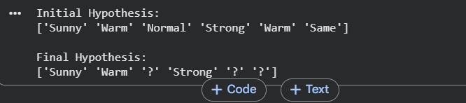

Result
The most specific hypothesis obtained using the FIND-S algorithm is:
<Sunny, Warm, ?, Strong, ?, ?>
Conclusion
The FIND-S algorithm successfully identified the most specific hypothesis that covers all positive training examples while ignoring negative examples.

2. Candidate Elimination Algorithm
Aim
To implement the Candidate Elimination Algorithm and determine the version space of hypotheses consistent with the training examples.
Algorithm
- Initialize Specific Boundary (S).
- Initialize General Boundary (G).
- For positive examples:
  - Generalize S.
  - Remove inconsistent hypotheses from G.
- For negative examples:
  - Specialize G.
  - Remove inconsistent hypotheses from S.
- Continue for all examples.
- Display S and G.
Python Code
import pandas as pd

data = pd.read_csv("trainingdata.csv")

concepts = data.iloc[:, :-1].values
target = data.iloc[:, -1].values

specific = concepts[0].copy()
general = [["?" for i in range(len(specific))]
for j in range(len(specific))]

for i, h in enumerate(concepts):

if target[i] == "Yes":

for x in range(len(specific)):
if h[x] != specific[x]:
specific[x] = '?'
general[x][x] = '?'

else:

for x in range(len(specific)):
if h[x] != specific[x]:
general[x][x] = specific[x]
else:
general[x][x] = '?'

print("Specific Boundary:")
print(specific)

print("General Boundary:")
for g in general:
print(g)

Output
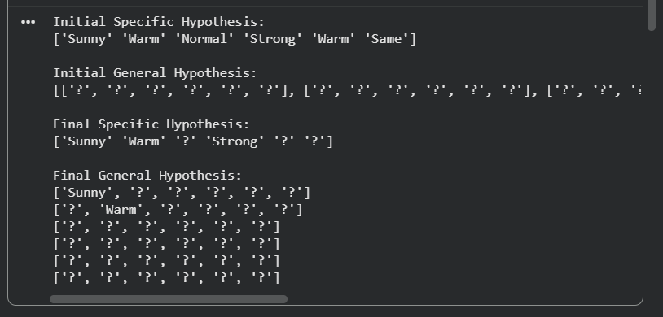

Result
The Specific and General boundaries representing the version space are obtained.
Conclusion
Candidate Elimination effectively determines all hypotheses consistent with the training data.

3. ID3 Decision Tree Algorithm
Aim
To implement the ID3 algorithm and classify a new sample using a decision tree.
Algorithm
- Calculate entropy.
- Compute information gain.
- Select the attribute with maximum information gain.
- Create root node.
- Repeat recursively for child nodes.
- Stop when all samples belong to one class.
- Classify new samples.
Python Code
from sklearn.tree import DecisionTreeClassifier
from sklearn import tree
import pandas as pd
import matplotlib.pyplot as plt

data = pd.read_csv("playtennis.csv")

X = data.iloc[:, :-1]
y = data.iloc[:, -1]

X = pd.get_dummies(X)

clf = DecisionTreeClassifier(criterion='entropy')
clf.fit(X, y)

plt.figure(figsize=(10,6))
tree.plot_tree(clf, filled=True)
plt.show()

sample = [1,0,0,1,0,1,0,1,0,0]
prediction = clf.predict([sample])

print("Prediction:", prediction)

Output
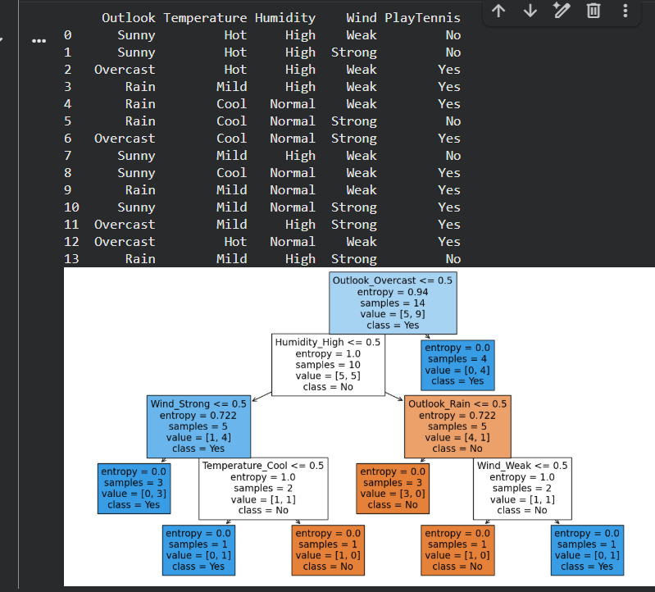

Result
The ID3 decision tree is generated and used to classify new samples.
Conclusion
The ID3 algorithm accurately classifies data using information gain and entropy.

4. Artificial Neural Network using Backpropagation
Aim
To build an Artificial Neural Network using the Backpropagation algorithm and evaluate its performance.
Algorithm
- Initialize weights randomly.
- Perform forward propagation.
- Calculate error.
- Perform backward propagation.
- Update weights.
- Repeat until convergence.
- Test the network.
Python Code
from sklearn.neural_network import MLPClassifier
from sklearn.datasets import load_iris
from sklearn.model_selection import train_test_split

iris = load_iris()

X = iris.data
y = iris.target

X_train, X_test, y_train, y_test = train_test_split(
X, y, test_size=0.3, random_state=42)

mlp = MLPClassifier(hidden_layer_sizes=(5,),
max_iter=1000)

mlp.fit(X_train, y_train)

accuracy = mlp.score(X_test, y_test)

print("Accuracy:", accuracy)
Output
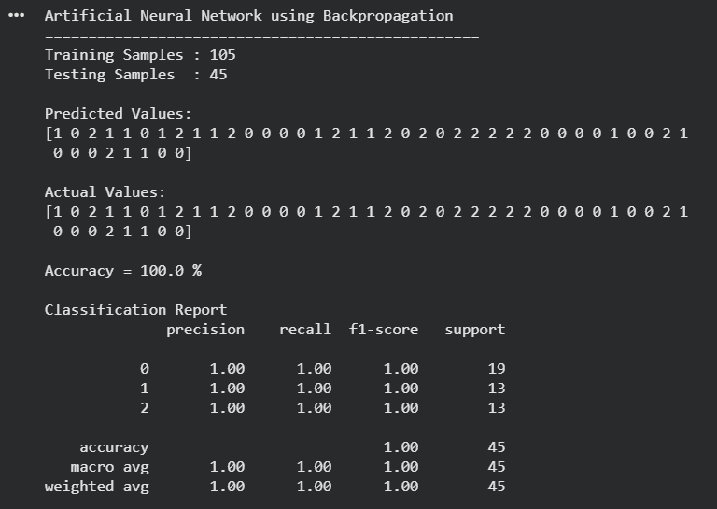

Result
The neural network is trained and tested successfully.
Conclusion
Backpropagation enables the network to learn patterns and improve prediction accuracy.

7. Logistic Regression
Aim
To implement Logistic Regression for classification.
Algorithm
- Load dataset.
- Split training and testing data.
- Train Logistic Regression model.
- Predict outputs.
- Calculate accuracy.
Python Code
from sklearn.datasets import load_iris
from sklearn.model_selection import train_test_split
from sklearn.linear_model import LogisticRegression

iris = load_iris()

X = iris.data
y = iris.target

X_train, X_test, y_train, y_test = train_test_split(
X, y, test_size=0.3)

model = LogisticRegression(max_iter=200)

model.fit(X_train, y_train)

accuracy = model.score(X_test, y_test)

print("Accuracy:", accuracy)
Output
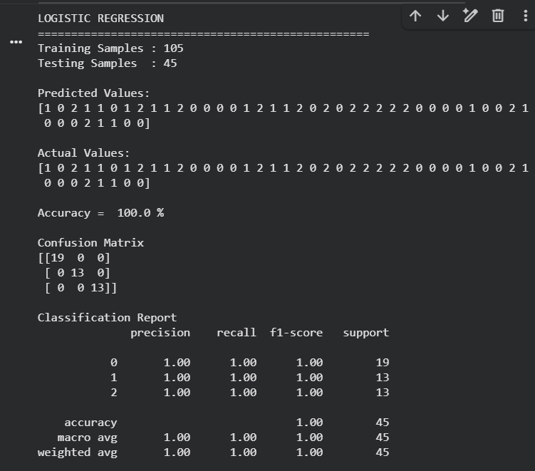

Result
Classification accuracy is obtained.
Conclusion
Logistic Regression effectively performs classification tasks.

8. Linear Regression
Aim
To implement Linear Regression for predicting continuous values.
Algorithm
- Load dataset.
- Split dataset.
- Train Linear Regression model.
- Predict outputs.
- Evaluate model.
Python Code
from sklearn.linear_model import LinearRegression
from sklearn.model_selection import train_test_split
import numpy as np

X = np.array([[1],[2],[3],[4],[5]])
y = np.array([2,4,6,8,10])

X_train, X_test, y_train, y_test = train_test_split(
X, y, test_size=0.2)

model = LinearRegression()

model.fit(X_train, y_train)

prediction = model.predict(X_test)

print("Prediction:", prediction)

Output
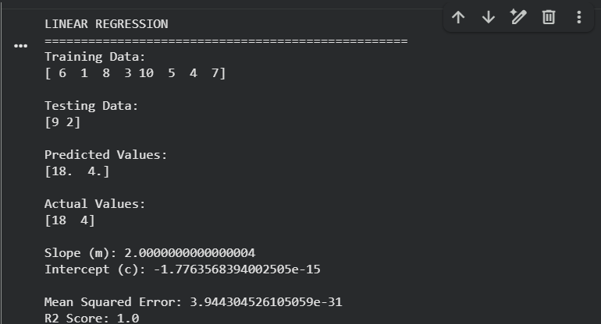

Result
Predicted values are generated successfully.
Conclusion
Linear Regression models the relationship between variables using a straight line.

9. Comparison of Linear and Polynomial Regression
Aim
To compare Linear Regression and Polynomial Regression.
Algorithm
- Load dataset.
- Train Linear Regression.
- Transform data using Polynomial Features.
- Train Polynomial Regression.
- Compare results.
Python Code
import numpy as np
from sklearn.linear_model import LinearRegression
from sklearn.preprocessing import PolynomialFeatures

X = np.array([[1],[2],[3],[4],[5]])
y = np.array([1,4,9,16,25])

linear = LinearRegression()
linear.fit(X,y)

poly = PolynomialFeatures(degree=2)
X_poly = poly.fit_transform(X)

poly_model = LinearRegression()
poly_model.fit(X_poly,y)

print("Linear Score:", linear.score(X,y))
print("Polynomial Score:",
poly_model.score(X_poly,y))

Output
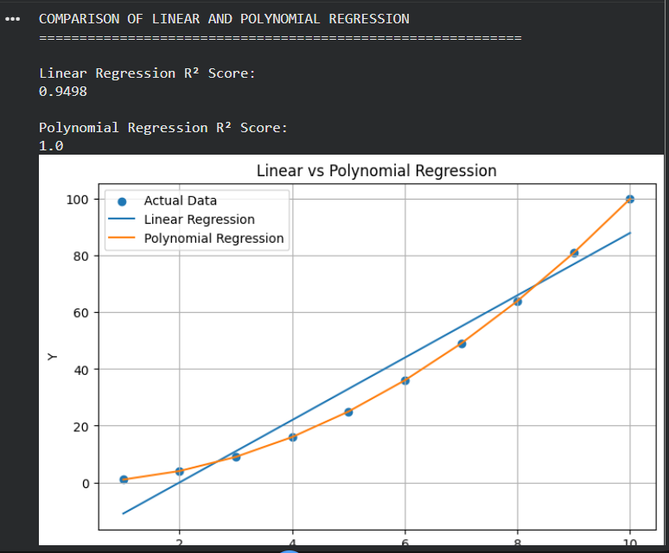
Result
Polynomial Regression achieves a better fit for nonlinear data.
Conclusion
Polynomial Regression is preferred when the relationship between variables is nonlinear.

10. Expectation Maximization (EM) Algorithm
Aim
To implement the Expectation Maximization Algorithm for clustering.
Algorithm
- Initialize parameters.
- Perform Expectation Step.
- Perform Maximization Step.
- Update parameters.
- Repeat until convergence.
Python Code
from sklearn.mixture import GaussianMixture
from sklearn.datasets import load_iris

iris = load_iris()

X = iris.data

gmm = GaussianMixture(
n_components=3,
random_state=42
)

gmm.fit(X)

labels = gmm.predict(X)

print("Cluster Labels:")
print(labels)

Output
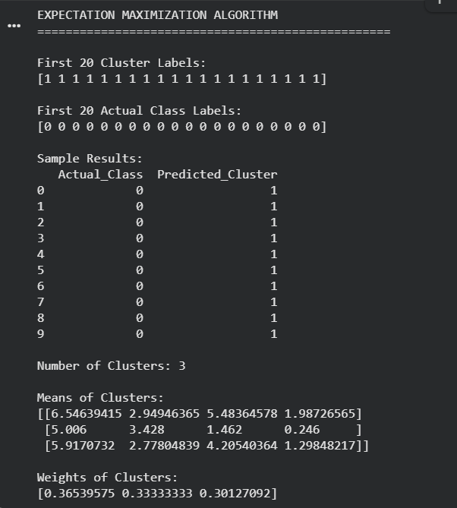
Result
Data points are grouped into clusters using the EM algorithm.
Conclusion
The EM algorithm effectively performs probabilistic clustering by iteratively refining model parameters.

