GITHUB URL:

https://github.com/jeevitha700/capstoneproject.git

**Docker Image name:** myreactapp

**Tag:** latest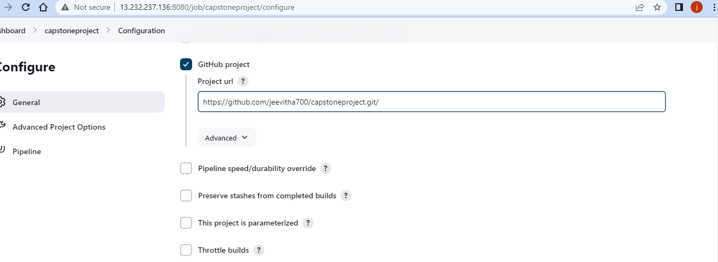

Deployed site URL

http://13.233.106.6

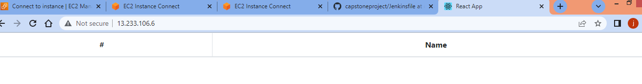

JENKINS:

http://13.232.237.136/8080

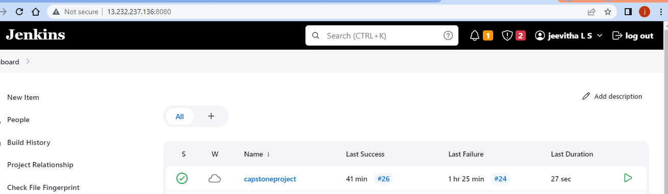

Configurations:

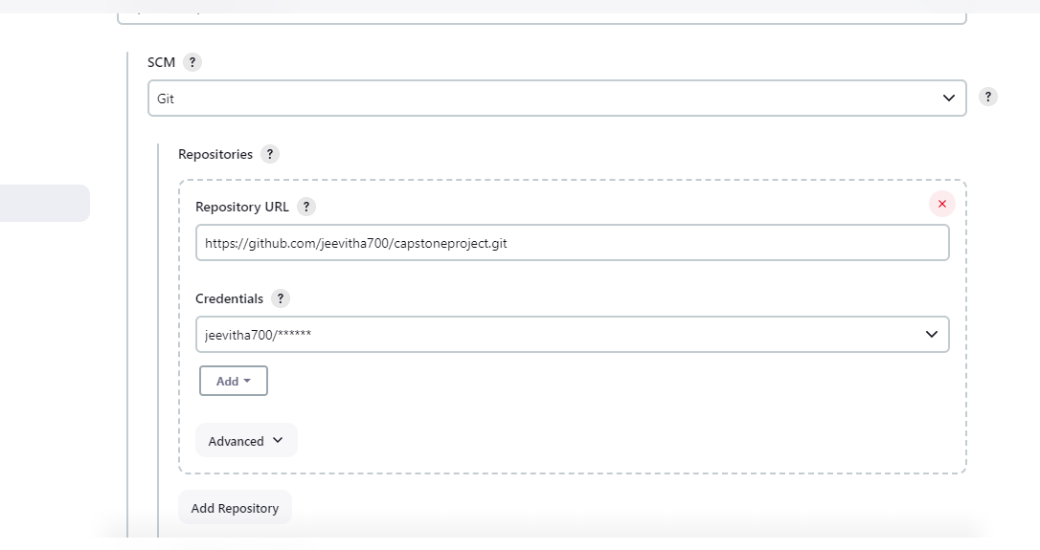

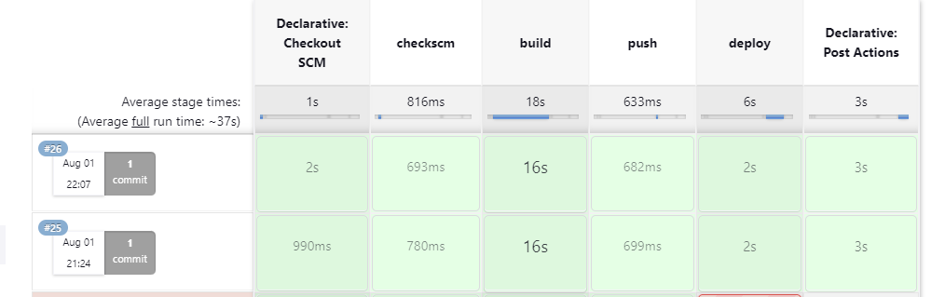

Credentials:

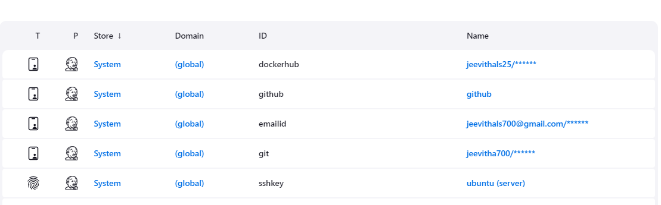

System configuration

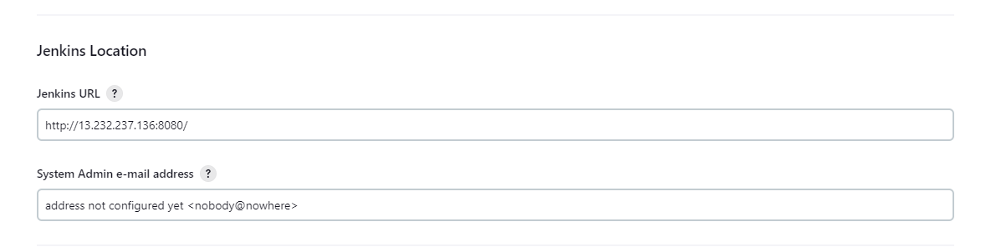

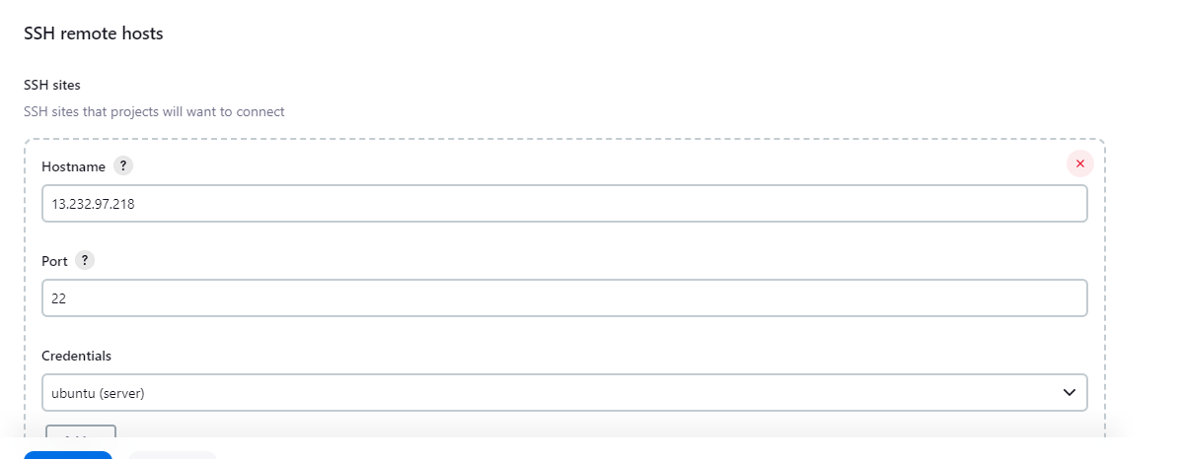

EC2 instance:

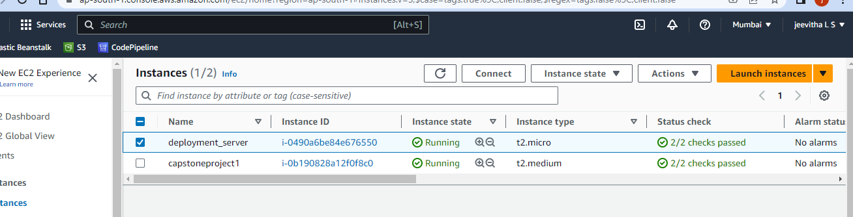

Security Group 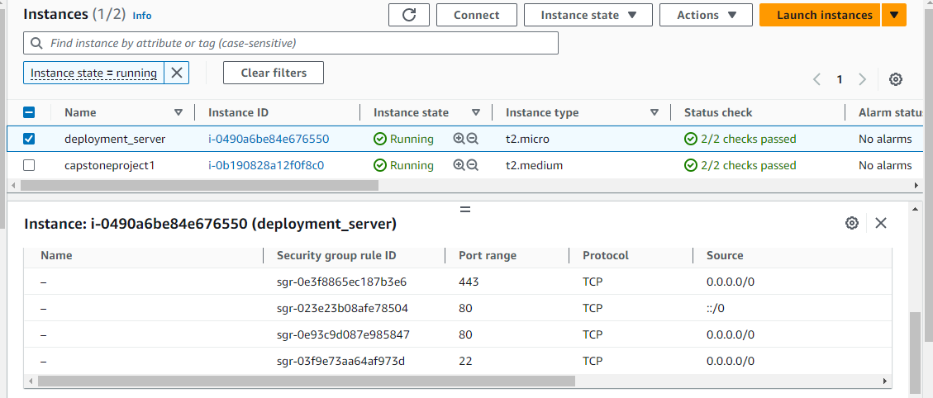

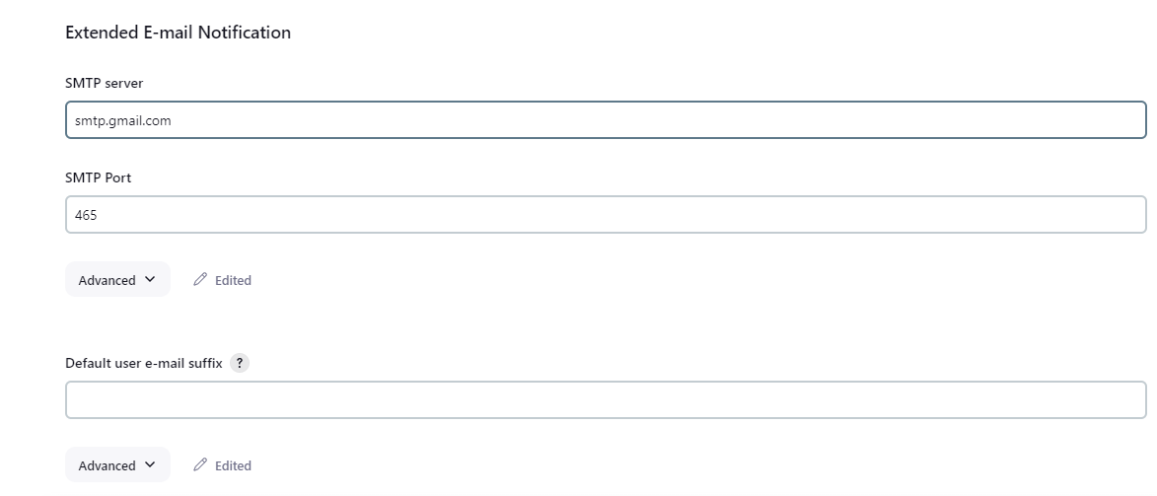

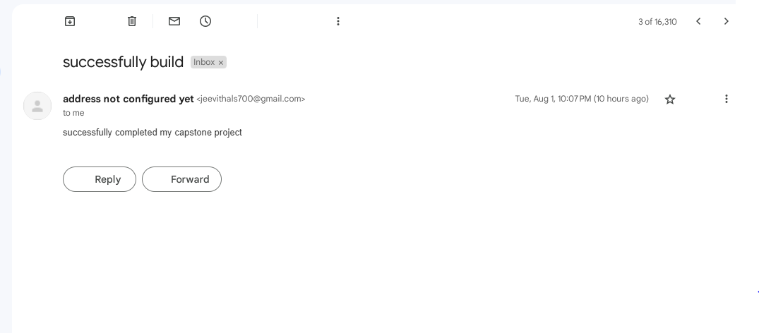

Docker HUB Repo:

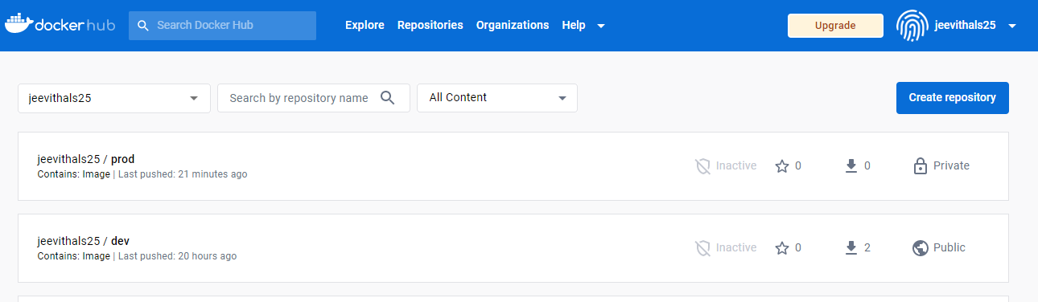

Dev repo:

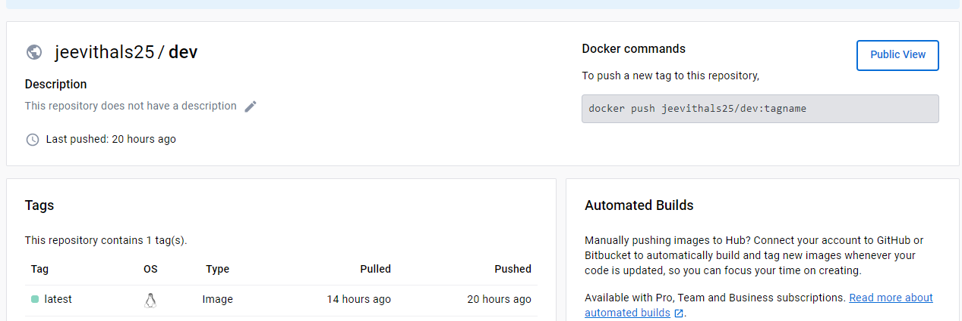

Prod Repo:

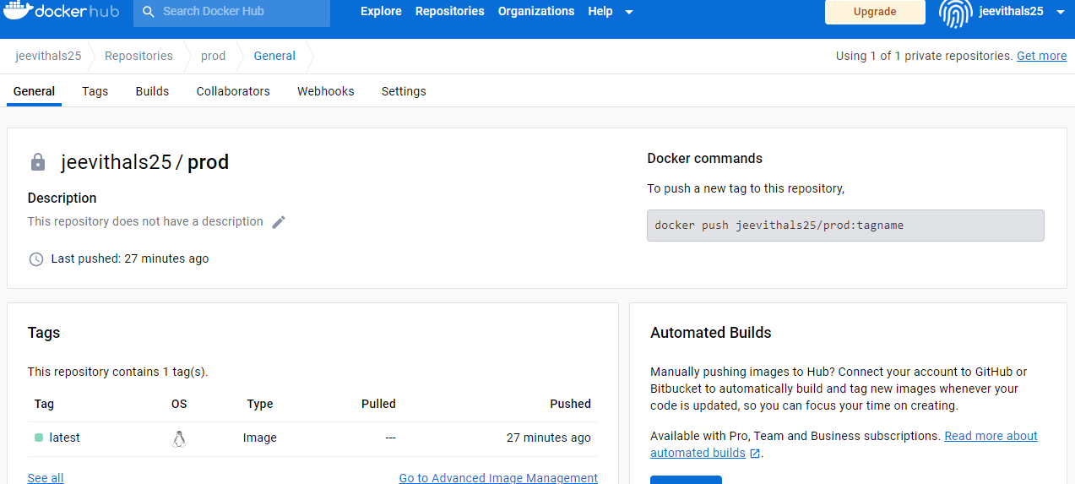

Deployed Site page:



Monitoring:

