**Task Allocation with Kubernetes and Infrastructure as Code (IaC)**

Your DevOps team manages a Kubernetes cluster using Infrastructure as Code (IaC) with

Terraform. You need to allocate a task to scale the application based on increased traffic.

Question:

How would you allocate the task of scaling the application in the Kubernetes cluster using

Terraform and ensure it's implemented efficiently?

**Task 1: Explain how to identify the need for scaling based on traffic metrics or other indicators.**

**Responsible Team Member**: Monitoring and DevOps Team

**Implementation Strategy:**

* 1.Monitor Key Metrics:
  + Utilize monitoring tools like Prometheus, Grafana, or Kubernetes-native monitoring to gather key metrics related to your application's performance, such as CPU usage, memory usage, request latency, and the number of requests.
* 2.Set Thresholds and Alerts:
  + Define appropriate thresholds for the monitored metrics. These thresholds should indicate when scaling is needed. For example, you might set a threshold to scale up when CPU usage exceeds 70%.
* 3.Analyze Metrics Trends:
  + Analyze historical and real-time trends of the monitored metrics. Look for patterns and consistent increases in usage that might necessitate scaling.
* 4.Observe Traffic Patterns:
  + Study the traffic patterns to your application. Sudden spikes in traffic can overload the existing resources, requiring scaling to handle the increased load.
* 5.Evaluate Response Times:
  + Monitor the response times of your application. If response times consistently exceed acceptable levels, scaling may be needed to distribute the load and improve performance.
* 6.Utilize Autoscaling Features:
  + Leverage Kubernetes Horizontal Pod Autoscaler (HPA) to automatically adjust the number of pods in a deployment based on observed CPU or memory utilization. Configure the HPA with appropriate scaling policies to align with your application's requirements.
* 7.Consider Custom Metrics:
  + If the default metrics aren't sufficient, consider implementing custom metrics based on application-specific indicators. For example, you could create a custom metric based on the number of messages processed per second.
* 8.Regularly Review and Adjust:
  + Continuously review the scaling thresholds and policies to ensure they remain effective and aligned with your application's growth and usage patterns. Adjust the thresholds and policies as needed to optimize performance and resource usage.

**Task 2: Describe the process of creating or updating Terraform code to adjust the desired**

**replica count of the application.**

**Responsible Team Member**: Infrastructure and Deployment Team

**Implementation Strategy:**

Adjusting the desired replica count of an application in a Kubernetes cluster using Terraform involves modifying the Kubernetes manifest files and updating the Terraform configuration to reflect the desired changes. Here's a step-by-step process to achieve this:

* Access Terraform Configuration:
  + Open the Terraform configuration file (typically a .tf file) that defines the Kubernetes resources, such as deployments or replica sets.
* Identify the Kubernetes Resource:
  + Locate the Kubernetes resource (e.g., Deployment, ReplicaSet) for the application you want to scale. This is where you'll specify the replica count.
* Add or Update Replica Count:
  + Within the Kubernetes resource block, find or add the spec section and set the replicas field to the desired replica count. For example

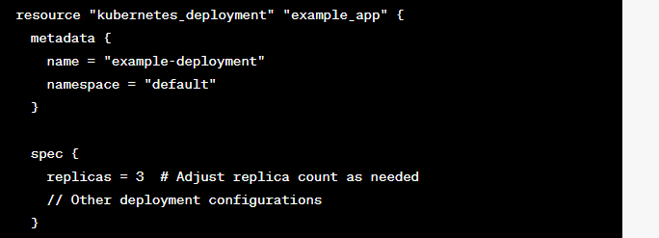

Plan and Apply the Changes:

* + Run terraform plan to preview the changes and ensure the desired replica count is accurately reflected.
  + Run terraform apply to apply the changes and update the Kubernetes resources in the cluster.
* Verify the Scaling:
  + Check the Kubernetes cluster using kubectl get deployments to confirm that the replica count for the specified application has been adjusted to the desired value.
* Ensure Consistency and Reusability:
  + Consider using variables or parameterizing the replica count in your Terraform configuration to enhance reusability and ease of maintenance. For example:

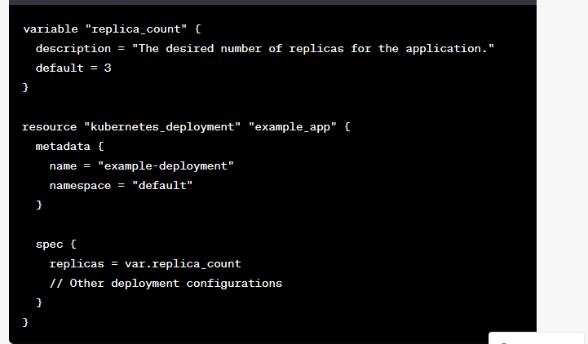

* Now, you can easily adjust the replica count by changing the variable value.
* Commit Changes to Version Control:
  + After verifying the changes, commit the updated Terraform configuration to version control (e.g., Git) to maintain an organized and traceable history of modifications.

**3.Provide guidelines for testing the scaling changes and deploying them to the**

**Kubernetes cluster while minimizing downtime.**

* **Responsible Team Member:** DevOps and Deployment Team
* **Implementation Strategy:**

To effectively test scaling changes and deploy them to a Kubernetes cluster while minimizing downtime, follow these guidelines:

1. Automated Testing and Continuous Integration (CI/CD):

* Implement automated testing as part of your CI/CD pipeline to ensure that scaling changes do not introduce errors or issues. Include unit tests, integration tests, and performance tests specific to the scaling behavior.

2. Staging Environment:

* Use a staging environment that closely mimics your production environment to test scaling changes in a controlled setting. This allows you to validate the changes and their impact on the application's behavior and performance.

3. Gradual Rollout and Canary Deployment:

* Gradually roll out the scaling changes to a subset of the production environment using a canary deployment approach. Start with a small percentage of traffic being directed to the new, scaled-up version to monitor its behavior and performance.

4. Monitoring and Metrics:

* Utilize monitoring tools and metrics to observe the behavior of the application during and after scaling. Monitor key performance indicators (KPIs) such as response times, error rates, and resource utilization to ensure that the scaling changes are effective and do not negatively impact the application.

5. Rolling Deployments:

* Implement rolling deployments to update the application with minimal downtime. Kubernetes supports this by updating pods in a controlled manner, one at a time, ensuring the application remains available throughout the deployment.

6. Graceful Scaling:

* Configure your application to handle scaling events gracefully. Ensure that the application can seamlessly adapt to an increase in the number of replicas without causing disruptions or errors.

7. Health Checks and Readiness Probes:

* Set up health checks and readiness probes for your application to allow Kubernetes to understand its health status. These probes ensure that only healthy instances receive traffic, reducing the risk of routing requests to unhealthy or partially scaled instances.

8. Traffic Shifting and Blue-Green Deployments:

* Utilize traffic shifting or blue-green deployments to gradually direct traffic to the newly scaled version. This approach helps to minimize downtime and provides a smooth transition to the updated application.

9. Rollback Strategy:

* Define a clear rollback strategy in case issues arise during or after the scaling deployment. This should include automated or manual mechanisms to quickly revert to the previous stable version of the application.

10. Communication and Coordination:

* Communicate the scaling deployment plan and schedule with the operations and development teams involved. Ensure everyone is aware of the changes and is prepared to act according to the defined deployment plan.

11. Post-Deployment Verification and Monitoring:

* After the deployment, continue monitoring the application in the production environment to ensure that the scaling changes are functioning as expected and meeting the desired performance and efficiency goals.