

**B.Sc., CARDIAC PERFUSION TECHNOLOGY**

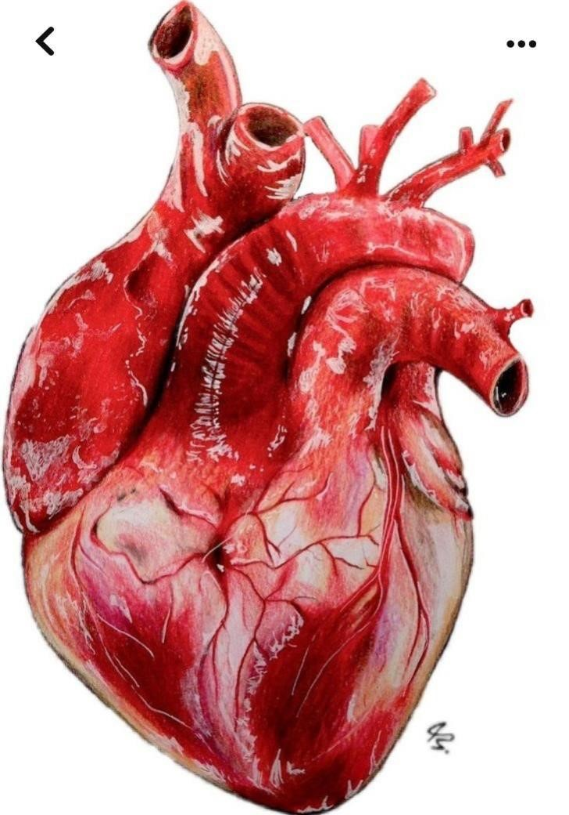

**By :**

**JEEVITHA.B**

**206011105045**



FACULTY OF ALLIED HEALTH SCIENCES

 PERFUSION RECORD

**B.SC., CARDIAC PERFUSION TECHNOLOGY**

**NAME : HARIBALAKRISHNAN G**

**…………………………………………………………………....**

**REGISTER NUMBER : 206011105035**

**………………………………………............................................**



FACULTY OF ALLIED HEALTH SCIENCES



**B.Sc., CARDIAC PERFUSION TECHNOLOGY**

## CERTIFICATE

**Register Number : 206011105035**

Certified that this is a bonafide record of work done by **MR. Haribalakrishnan.g**  in **B.Sc., Cardiac Perfusion Technology** during the academic year **2023– 24**

### PRINCIPAL