PRACTICAL 3
AIM : Analyzing the Physical image using Autopsy to extract evidence.
3.1 Autopsy
Autopsy is a digital forensics platform and graphical interface to The Sleuth Kit and other digital forensics tools. It is used by law enforcement, military, and corporate examiners to investigate what happened on a computer. You can even use it to recover photos from your camera’s memory card. Basically, the autopsy is a free open-source tool that supports a wide range of other digital forensics modules and tools. The tool is largely maintained by Basis Technology Corp. With the assistance of programmers from the community. The Autopsy is computer software that makes it simpler to deploy many of the open-source programs and plugins used in The Sleuth Kit.

3.2 Features of Autopsy
- Timeline Analysis:- Displays system events in a graphical interface to help identify activity.
- Keyword Search: Text extraction and index searched modules enable you to find files that mention specific terms and find regular expression patterns.
- Web Artifacts-: Extracts web activity from common browsers to help identify user activity.
- Registry Analysis:-Uses Reg Ripper to identify recently accessed documents and USB devices.
- Email Analysis: Parses MBOX format messages, such as Thunderbird.
- EXIF: Extracts geo location and camera information from JPEG files.
- Robust File System Analysis: Support for common file systems, including NTFS, FAT12/FAT16/FAT32/ExFAT, HFS+, ISO9660 (CD-ROM), Ext2/Ext3/Ext4, Yaffs2
- Unicode Strings Extraction: Extracts strings from unallocated space and unknown filetypes in many languages
- File Type Detection based on signatures and extension mismatch detection.
- Interesting Files Module will flag files and folders based on name and path.
- Android Support: Extracts data from SMS, call logs, contacts, Tango, Words with Friends, and more.
- Multi-User Cases: Collaborate with fellow examiners on large cases. λ LNK File Analysis:- Identifies shortcuts and accessed documents

3.3 Procedure
1. Downloading and Installing Autopsy
Autopsy should be downloaded from their official website which is given below.
https://www.autopsy.com/download/
2. Open Autopsy .
3. Click on create a new case.
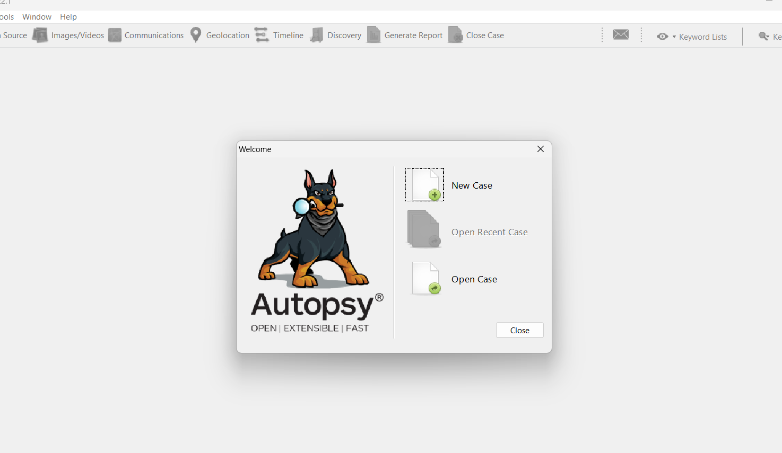

4. Fill the case details.
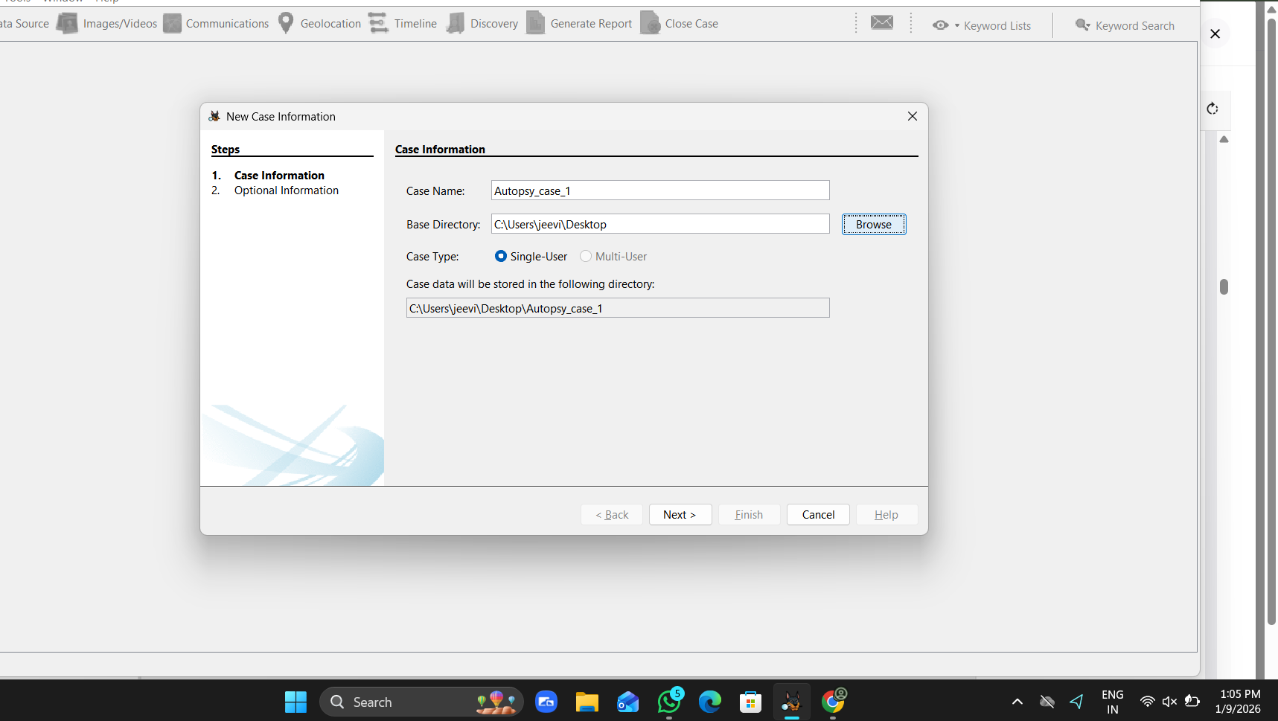

5. On the select host screen, leave it default.
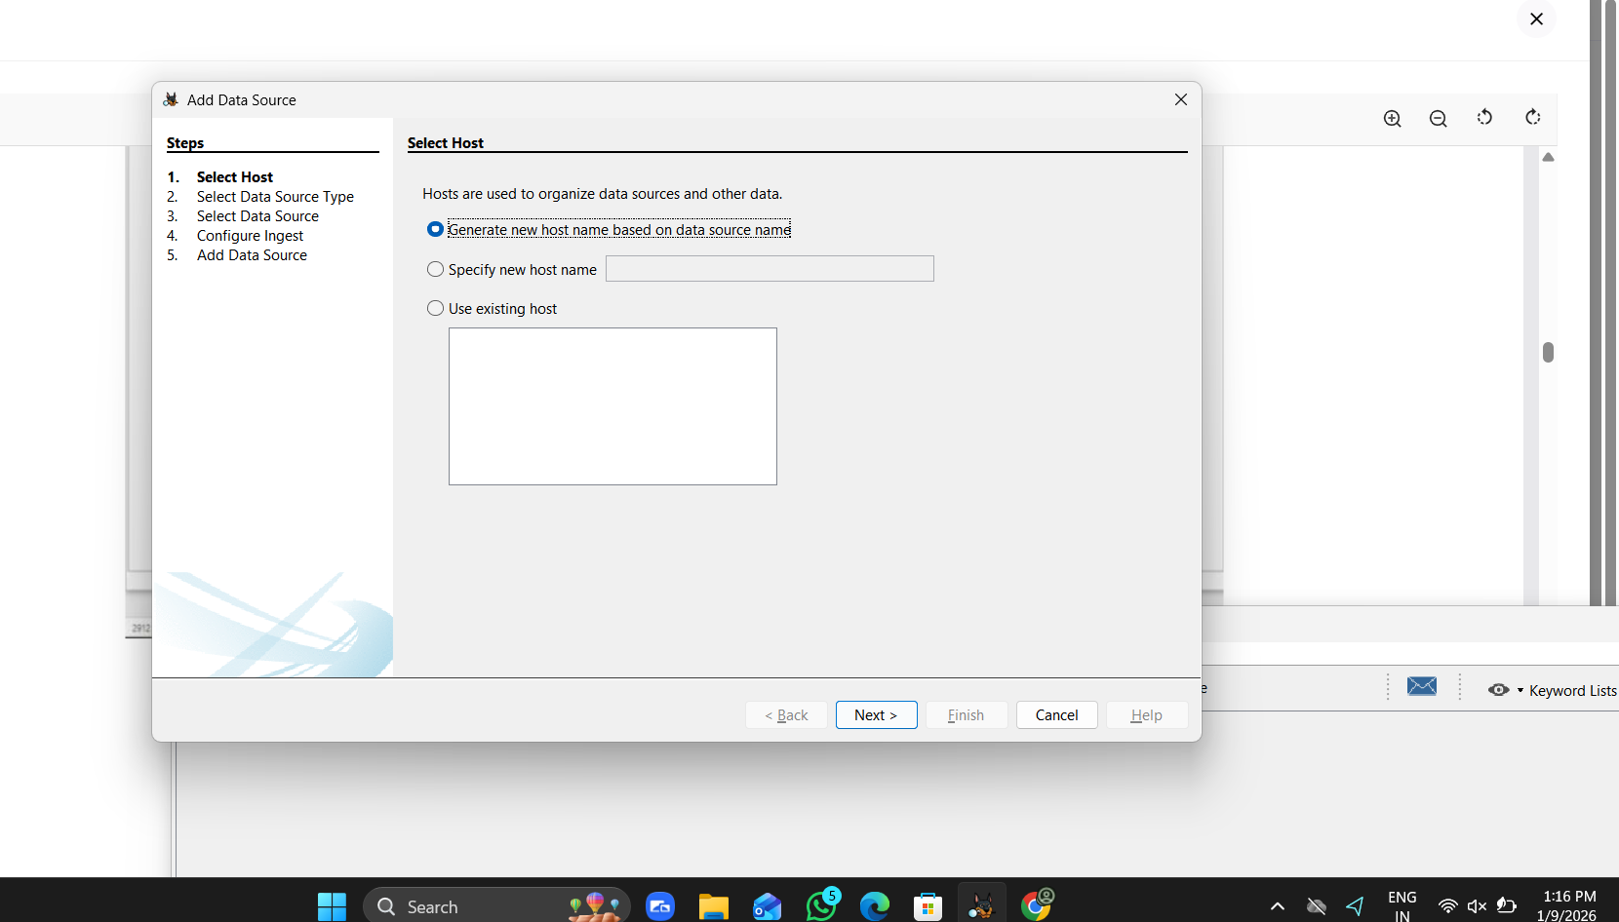
6. Select the data source type.
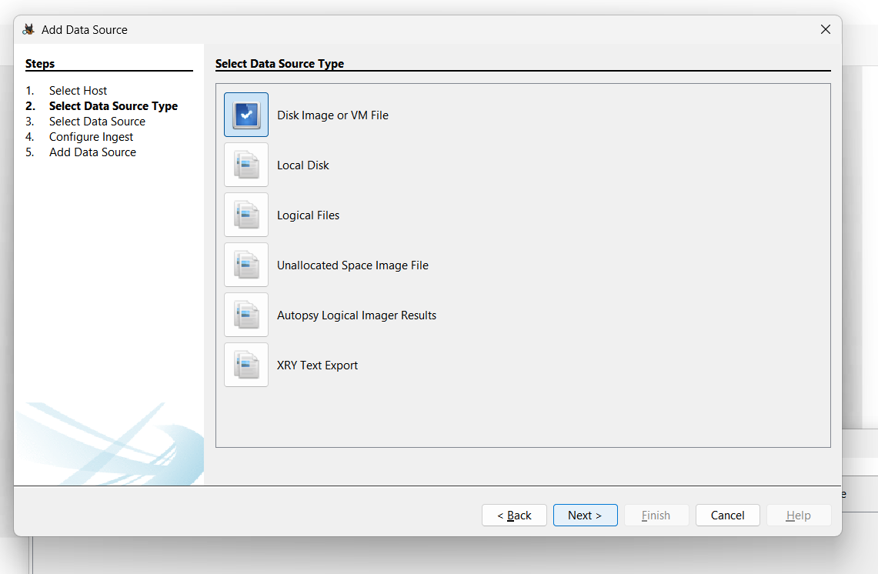

7. Select the data source.
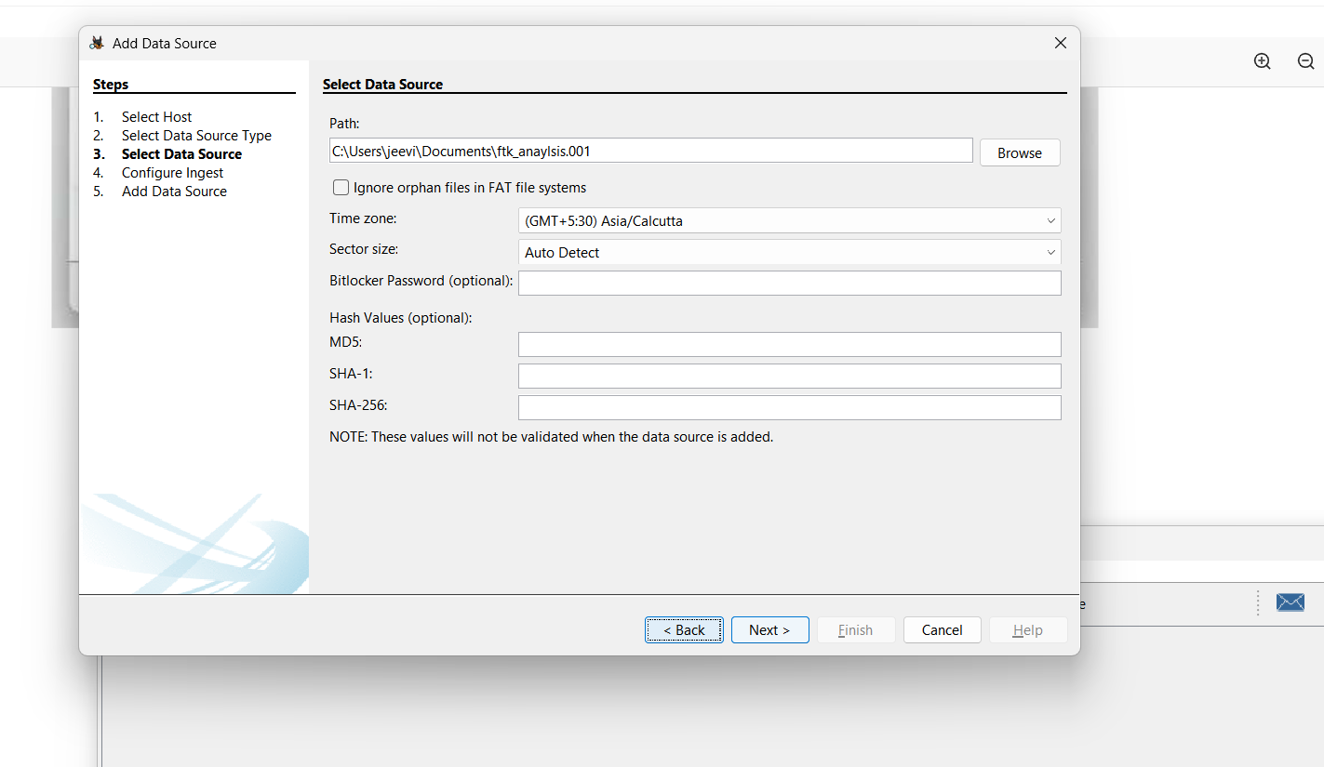

8. Configure the ingest - In this panel, we have to select the ingest or modules or the things we have to extract from the image files. and click next.
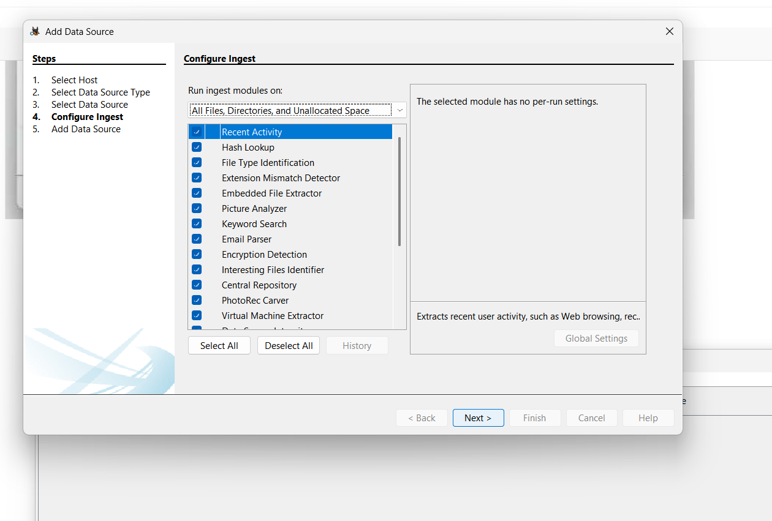

9. Click on Next. Autopsy will add the Data source as a New case and will start to analyse the ingest.
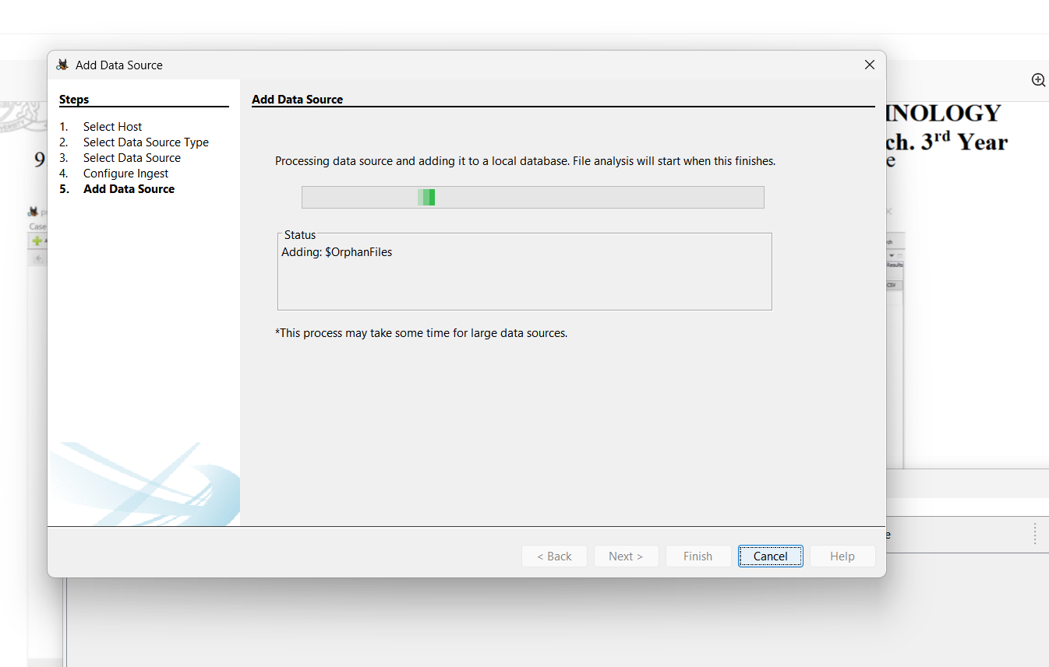

10. After the analysis, on the left side of the screen an evidence tree will be produced from which you can view whichever data you want to analyse.

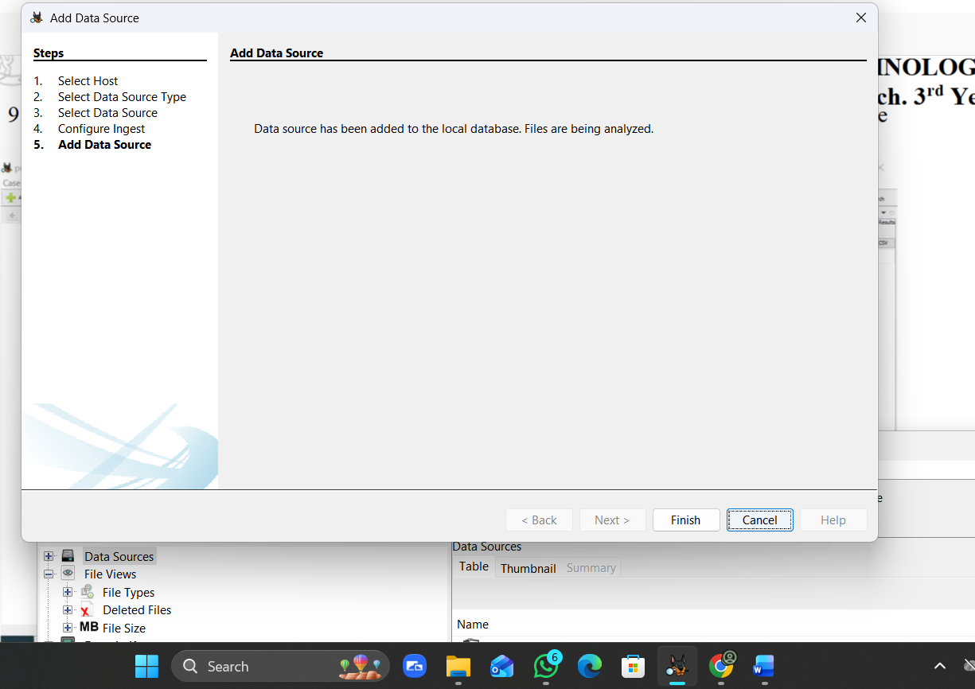

11. To create a report of the analysis, There is an option called “Generate Report”. Click on that and select the type o report we want to generate.

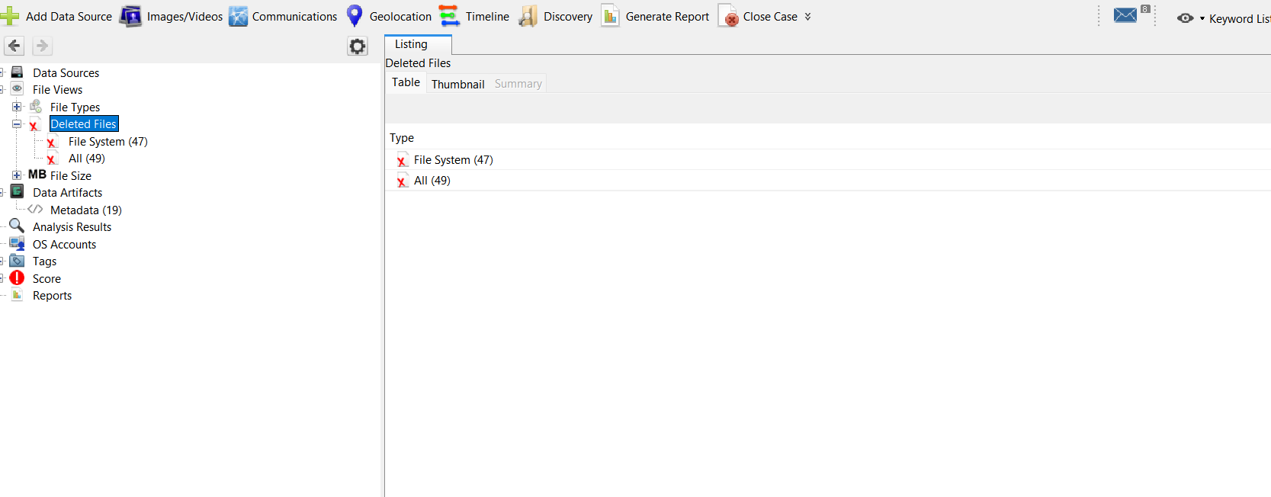

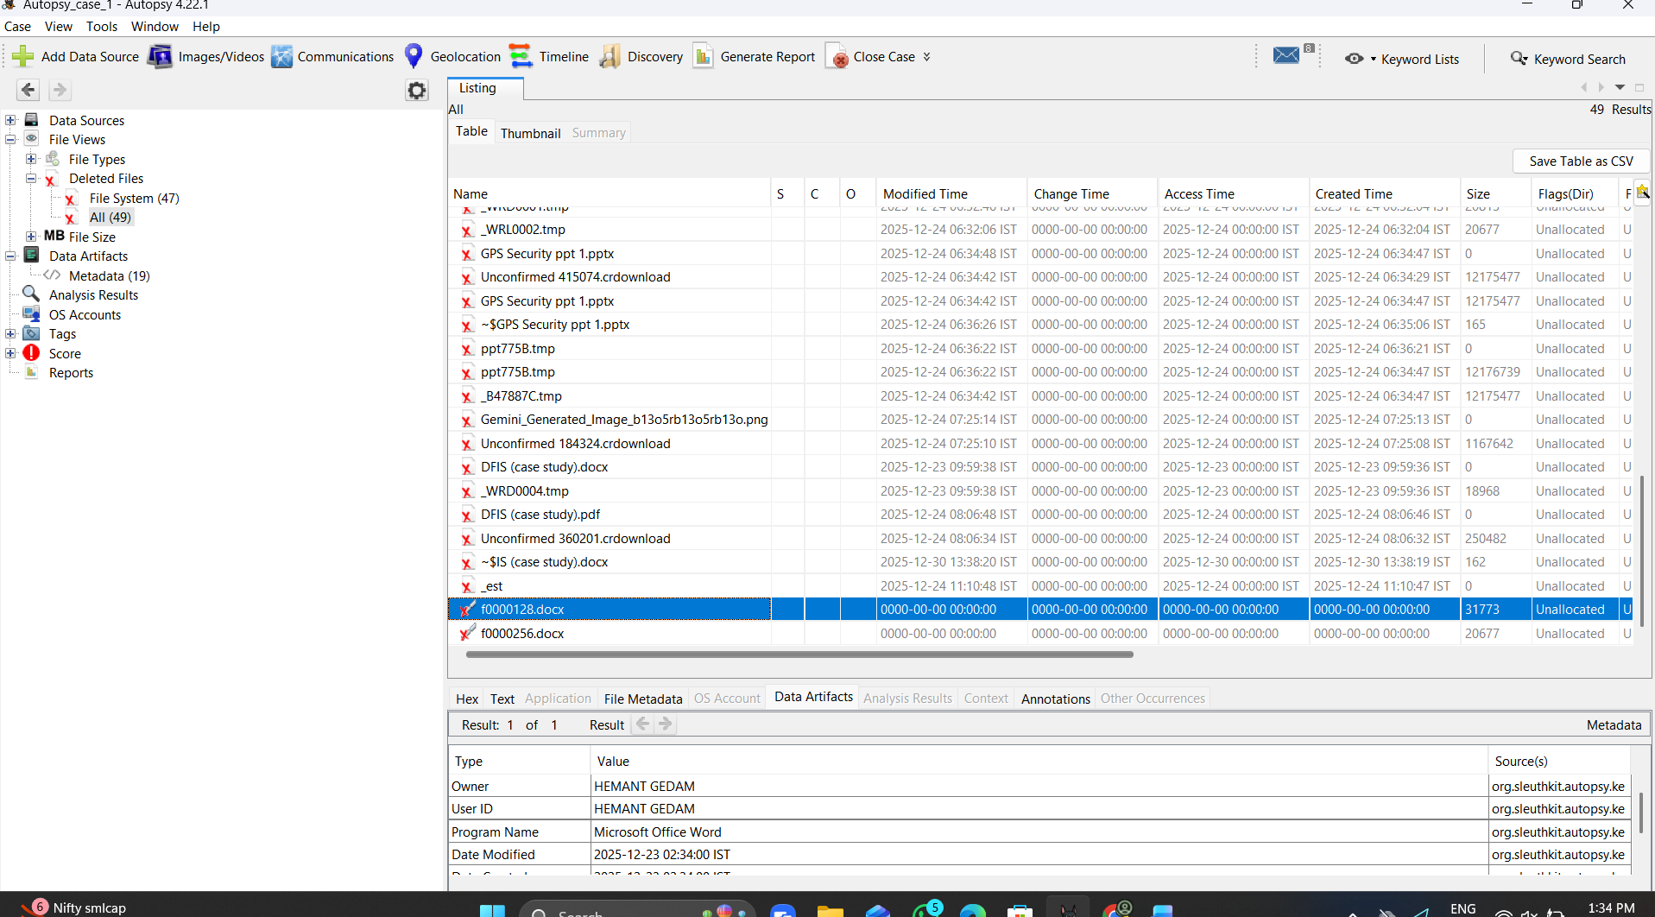
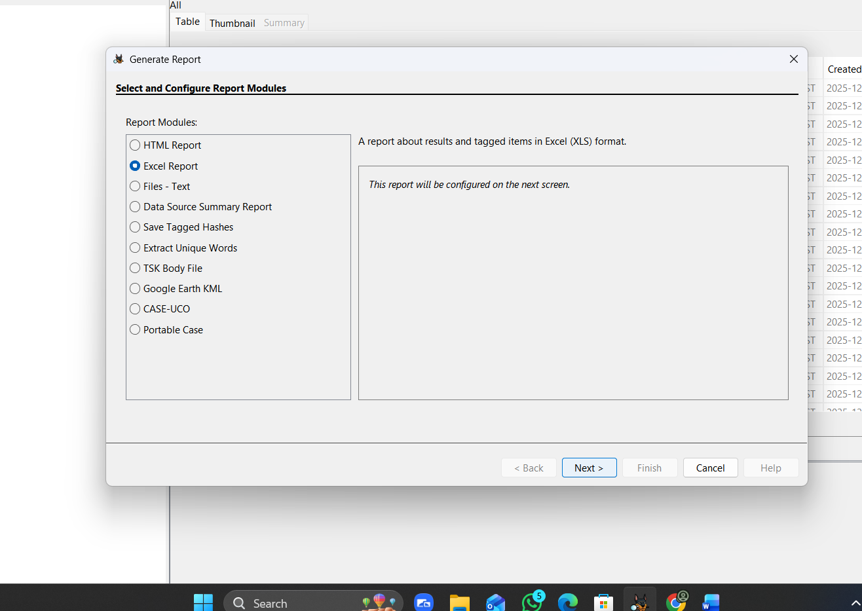
Result: Analysis of the Physical image using Autopsy to extract evidence has been successfully performed.

