Subodh Dhakal

Jeevan Gyawali

Phase 4

**HONOR CODE**

I pledge, on my honor, to uphold UT Arlington's tradition of academic integrity, a tradition

that values hard work and honest effort in the pursuit of academic excellence.

I promise that I will submit only work that I personally create or that I contribute to group

collaborations, and I will appropriately reference any work from other sources. I will follow

the highest standards of integrity and uphold the spirit of the Honor Code.

Table of Contents

TASK 1: Create View GOAL_INFO 3

SCREENSHOT 3

ACTION OUTPUT RESPONSE 4

TASK 3 4

Screenshot 4

SQL WORKBENCH SCREENSHOT 4

WEBSITE SCREENSHOT 5

Action Output Response 5

TASK 4 6

Screenshot 6

SQL WORKBENCH SSCREENSHOT 6

WEBSITE SCREENSHOT 7

Action Output Response 7

# TASK 1: Create View GOAL_INFO

CREATE OR REPLACE VIEW GOAL_INFO

AS

SELECT G.GameID as "Game ID", T.team as "Team Name", P.PName as "Player Name", P.ShirtName as "Player Shirt Name", P.Club as "Player Club", P.Position as "Player Position", count(GO.Penalty) as "Number of Goals"

FROM GAME as G, PLAYER as P, TEAM as T, GOALS as GO

WHERE GO.TeamID = P.TeamID

AND GO.PNo = P.PNo

AND GO.TeamID = T.TeamID

AND G.GameID = GO.GameID

GROUP BY GO.PNo, GO.TeamID

ORDER BY COUNT(PENALTY) DESC;

*SELECT * FROM GOAL_INFO;*

## SCREENSHOT

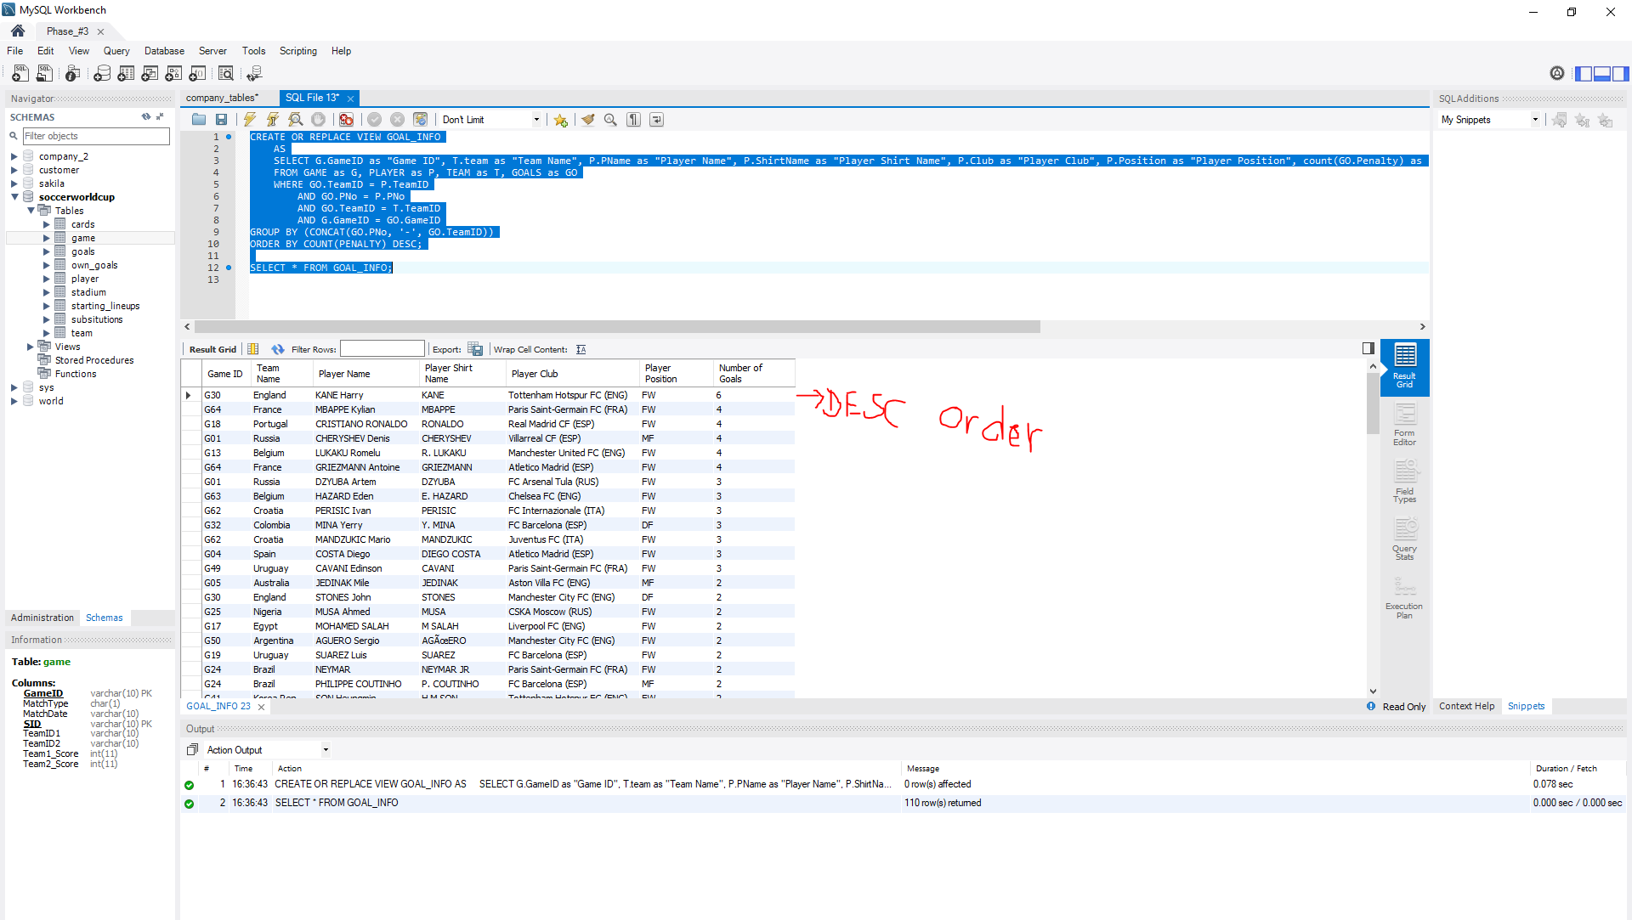

## ACTION OUTPUT RESPONSE

**Action:** SELECT * FROM GOAL_INFO **Response:** 110 row(s) returned

# TASK 3

SELECT `Game ID`, `Team Name`, `Player Name`, `Player Club`, `Number of Goals`

FROM goal_info

WHERE `Player Name` LIKE '$player_name%'

GROUP BY `Game ID`, `Team Name`, `Player Name`, `Player Club`, `Number of Goals`

ORDER BY `Player Name`

## Screenshot

### SQL WORKBENCH SCREENSHOT

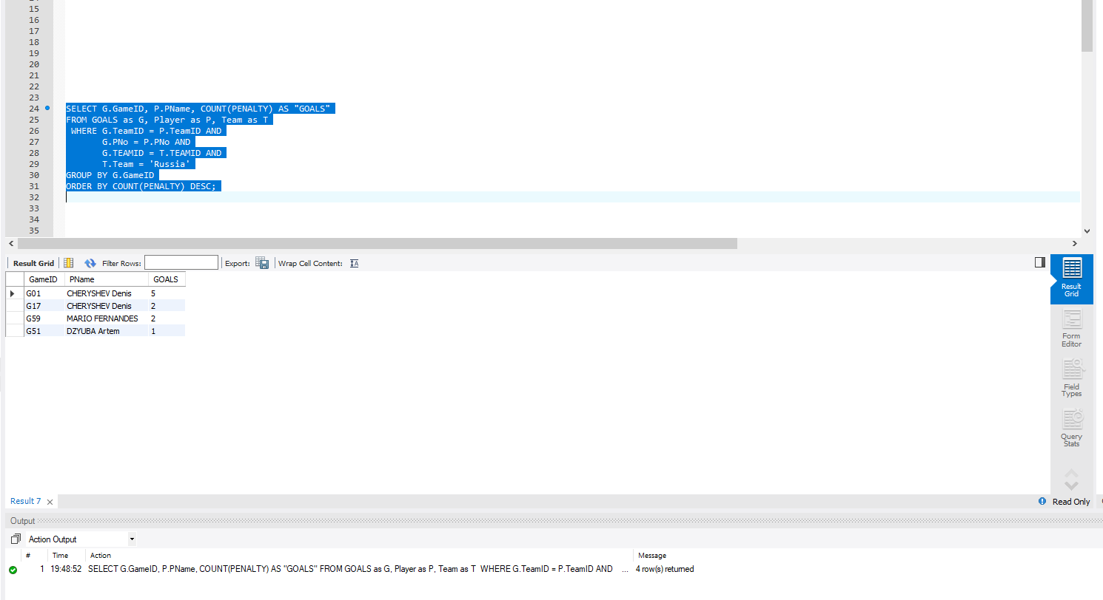

### WEBSITE SCREENSHOT

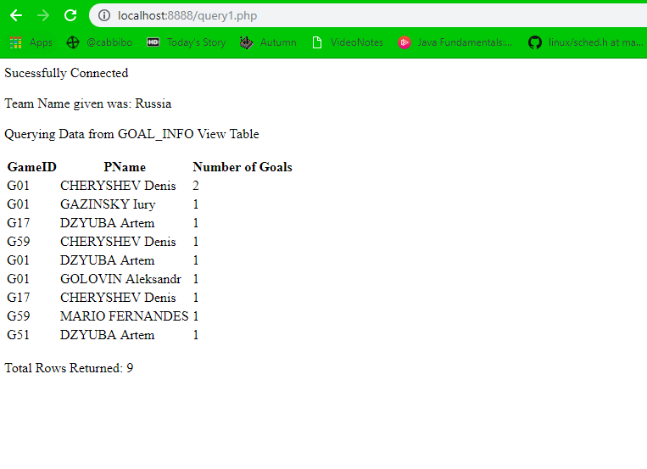

# Action Output Response

**Action:**

SELECT G.GameID, P.PName, COUNT(PENALTY) AS "GOALS"

FROM GOALS as G, Player as P, Team as T

WHERE G.TeamID = P.TeamID AND

G.PNo = P.PNo AND

G.TEAMID = T.TEAMID AND

T.Team = 'Russia'

GROUP BY G.GameID

ORDER BY COUNT(PENALTY) DESC;

**Response:** 4 row(s) returned

# TASK 4

SELECT DISTINCT `Game ID`,`Player Name`, `Number of Goals`

FROM goal_info

WHERE `Team Name` = '$team_name'

GROUP BY `Game ID`, `Player Name`, `Number of Goals`

ORDER BY `Number of Goals` DESC

## Screenshot

### SQL WORKBENCH SSCREENSHOT

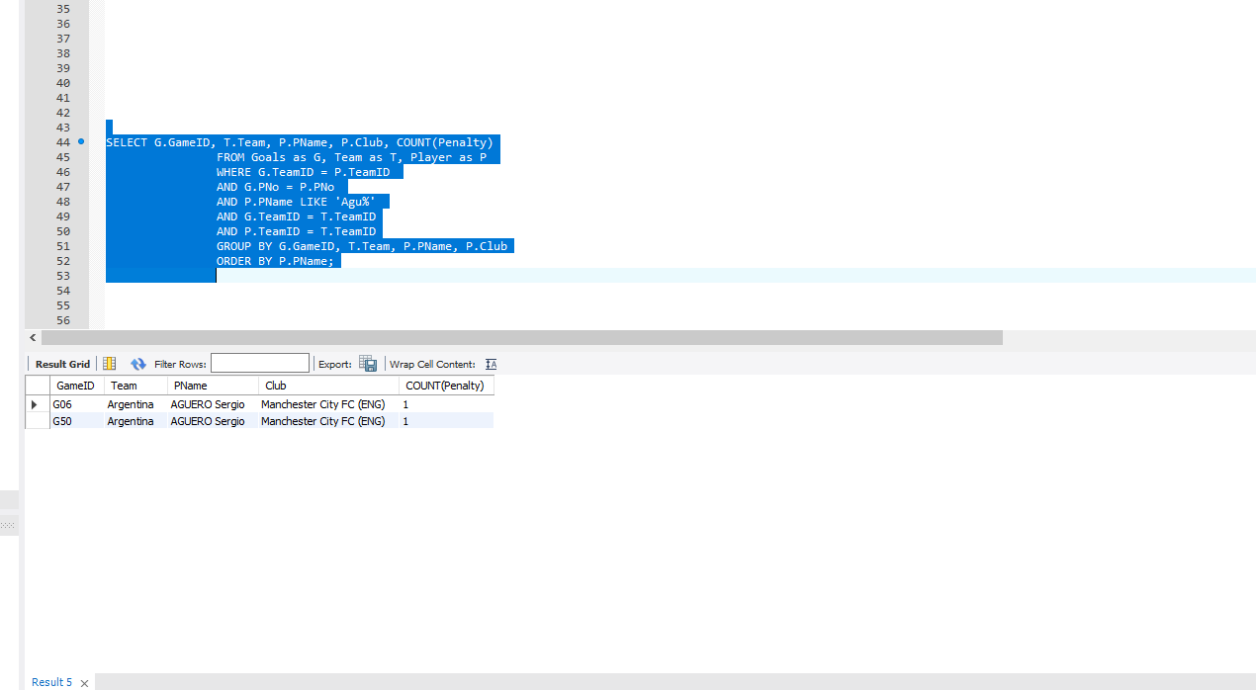

### WEBSITE SCREENSHOT

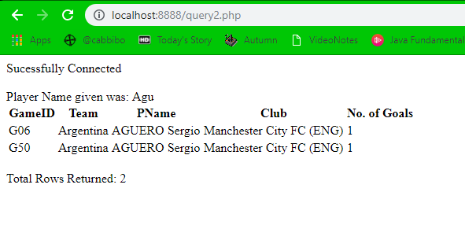

## Action Output Response

**Action:**

SELECT G.GameID, T.Team, P.PName, P.Club, COUNT(Penalty)

FROM Goals as G, Team as T, Player as P

WHERE G.TeamID = P.TeamID

AND G.PNo = P.PNo

AND P.PName LIKE 'Agu%'

AND G.TeamID = T.TeamID

AND P.TeamID = T.TeamID

GROUP BY G.GameID, T.Team, P.PName, P.Club

ORDER BY P.PName;

**Response**: 2 row(s) returned