ANLY3339 In-Class Activity 3
Jeeya Tanna
2026-02-23
- Load Dataset
data(mtcars)
dim(mtcars)
## [1] 32 11
- Variables Response = mpg Predictor = hp, wt, cyl
- Analysis
# Correlation matrix (mpg vs predictors)
round(cor(mtcars[, c("mpg", "hp", "wt", "cyl")]), 2)
## mpg hp wt cyl
## mpg 1.00 -0.78 -0.87 -0.85
## hp -0.78 1.00 0.66 0.83
## wt -0.87 0.66 1.00 0.78
## cyl -0.85 0.83 0.78 1.00
# Scatterplot matrix to visualize relationships
pairs(mtcars[, c("mpg", "hp", "wt", "cyl")], pch = 19, col = "blue")
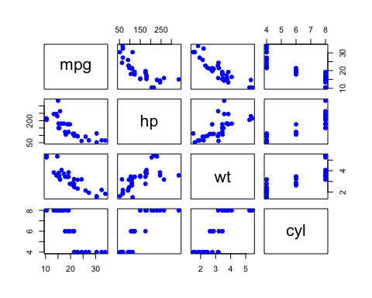
- Train-Test Split
set.seed(123) # For reproducible split
n <- nrow(mtcars)
train_idx <- sample(1:n, size = round(0.7 * n))
train <- mtcars[train_idx, ] # 70% training
test <- mtcars[-train_idx, ] # 30% testing
# Report size of each set
nrow(train)
## [1] 22
nrow(test)
## [1] 10
- Regression Model
model_mtcars <- lm(mpg ~ hp + wt + cyl, data = train)
summary(model_mtcars)
##
## Call:
## lm(formula = mpg ~ hp + wt + cyl, data = train)
##
## Residuals:
## Min 1Q Median 3Q Max
## -3.8082 -1.2841 -0.6813 0.9826 5.3706
##
## Coefficients:
## Estimate Std. Error t value Pr(>|t|)
## (Intercept) 40.43936 2.14756 18.830 2.72e-13 ***
## hp -0.01405 0.01435 -0.979 0.34048
## wt -3.15015 0.91001 -3.462 0.00278 **
## cyl -1.30409 0.68511 -1.903 0.07310 .
## ---
## Signif. codes: 0 '***' 0.001 '**' 0.01 '*' 0.05 '.' 0.1 ' ' 1
##
## Residual standard error: 2.699 on 18 degrees of freedom
## Multiple R-squared: 0.8595, Adjusted R-squared: 0.8361
## F-statistic: 36.72 on 3 and 18 DF, p-value: 7.008e-08
- Goodness of Fit R2 = 0.8595 Adjusted R2 = 0.8361
- Model Assumptions
# Linearity and Constant Variance (Homoscedasticity)
plot(model_mtcars$fitted.values, resid(model_mtcars),
xlab = "Fitted values", ylab = "Residuals", main = "Residuals vs Fitted")
abline(h = 0, col = "red", lwd = 2)
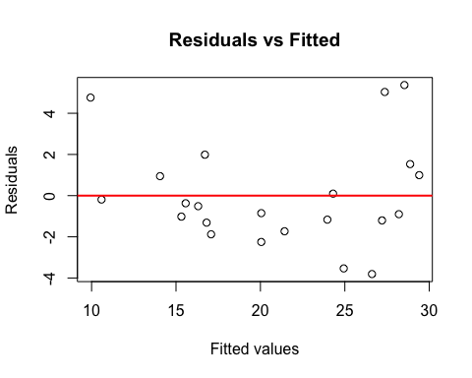
# Normality Check (Q-Q Plot and Shapiro-Wilk)
qqnorm(rstandard(model_mtcars))
qqline(rstandard(model_mtcars))
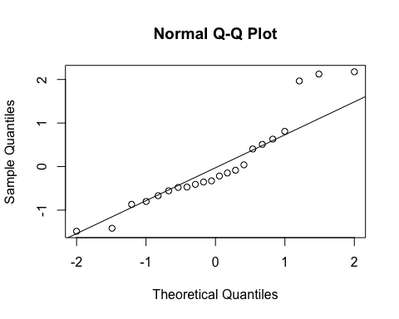
shapiro.test(rstandard(model_mtcars))
##
## Shapiro-Wilk normality test
##
## data: rstandard(model_mtcars)
## W = 0.89688, p-value = 0.02576
- Prediction on Test Data
# Predictions on TEST set
pred_test <- predict(model_mtcars, newdata = test)
# Error metrics
mse <- mean((test$mpg - pred_test)^2)
rmse <- sqrt(mse)
mae <- mean(abs(test$mpg - pred_test))
# Report metrics
data.frame(MSE = mse, RMSE = rmse, MAE = mae)
## MSE RMSE MAE
## 1 5.152415 2.269893 1.877027

