Group 8 Combined
Ethne, Jeeya, Jolisia, Rachel, Sophia
2026-05-05
I. Descriptive Statistics - Rachel
nba <- read.csv("/Users/jeeya/Downloads/TeamSummaries_raw.csv")
head(nba)
## season lg team abbreviation playoffs age w l pw pl mov
## 1 2026 NBA Atlanta Hawks ATL FALSE 25.2 43 33 42 34 1.95
## 2 2026 NBA Boston Celtics BOS FALSE 26.9 50 25 53 22 7.08
## 3 2026 NBA Brooklyn Nets BRK FALSE 23.4 18 58 18 58 -9.42
## 4 2026 NBA Chicago Bulls CHI FALSE 25.4 29 46 27 48 -4.73
## 5 2026 NBA Charlotte Hornets CHO FALSE 24.0 40 36 49 27 4.68
## 6 2026 NBA Cleveland Cavaliers CLE FALSE 27.1 47 29 47 29 4.05
## sos srs o_rtg d_rtg n_rtg pace f_tr x3p_ar ts_percent e_fg_percent
## 1 -0.14 1.81 115.8 113.9 1.9 101.6 0.234 0.429 0.583 0.552
## 2 -0.44 6.64 120.0 112.6 7.4 94.7 0.209 0.466 0.578 0.547
## 3 0.59 -8.83 109.0 118.7 -9.7 96.9 0.273 0.458 0.560 0.521
## 4 0.44 -4.29 113.3 117.9 -4.6 102.2 0.244 0.447 0.582 0.550
## 5 -0.61 4.07 119.2 114.4 4.8 97.0 0.249 0.483 0.589 0.552
## 6 -0.14 3.91 119.0 115.0 4.0 99.9 0.263 0.444 0.593 0.559
## tov_percent orb_percent ft_fga opp_e_fg_percent opp_tov_percent drb_percent
## 1 12.2 24.1 0.182 0.546 13.9 74.2
## 2 11.1 29.2 0.168 0.521 11.4 75.6
## 3 14.4 24.2 0.212 0.567 13.1 73.8
## 4 13.2 23.0 0.190 0.551 10.9 75.8
## 5 13.6 30.5 0.204 0.539 11.5 77.0
## 6 12.2 26.8 0.204 0.543 13.3 74.2
## opp_ft_fga arena attend attend_g
## 1 0.206 State Farm Arena 635822 16303
## 2 0.191 TD Garden 708772 19156
## 3 0.229 Barclays Center 644709 17425
## 4 0.190 United Center 766222 20164
## 5 0.191 Spectrum Center 708523 18645
## 6 0.213 Rocket Arena 738416 19432
mean(nba$f_tr)
## [1] NA
mean(nba$f_tr)
## [1] NA
mean(nba$x3p_ar)
## [1] NA
#plot(nba$f_tr ~ nba$f_tr, nba$x3p_ar, data = nba)
#hist(nba$f_tr ~ nba$f_tr, nba$x3p_ar, data = nba)
plot(nba$f_tr)
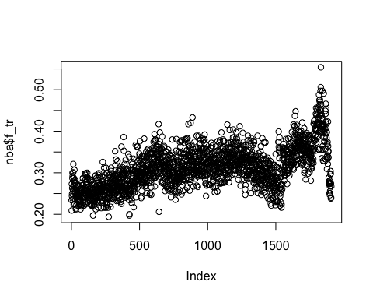
barplot(nba$f_tr)
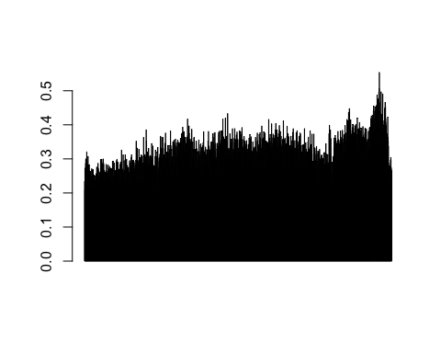
plot(nba$x3p_ar)
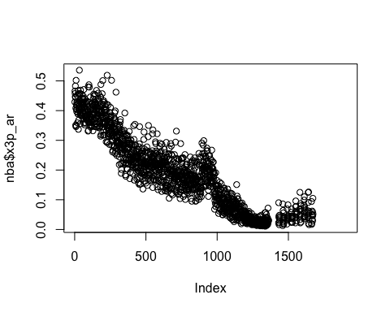
hist(nba$x3p_ar)
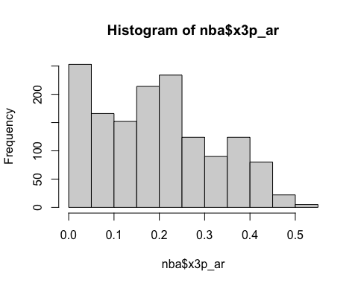
hist(nba$f_tr)
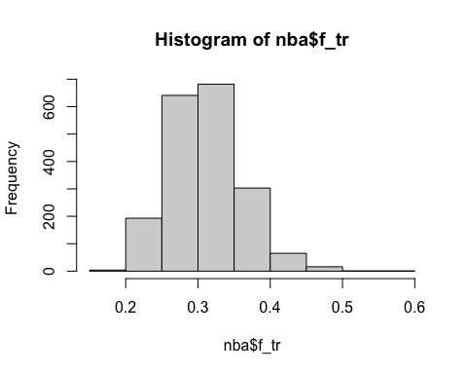
mean(nba$n_rtg)
## [1] NA
#print(mean(na.omit(nba$n_rtg))
mode(nba$n_rtg)
## [1] "numeric"
mean(nba$n_rtg)
## [1] NA
nrtga <- na.omit(nba$n_rtg)
median(nrtga)
## [1] 0.2
mean(nrtga)
## [1] 5.652911e-05
hist(nba$n_rtg, main="Distribution of Net Rating", xlab="Net Rating", col="pink")
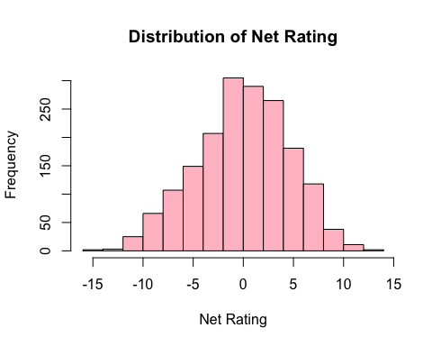
plot(nba$f_tr, nba$n_rtg, main="",
xlab="Offensive Rating", ylab="Defensive Rating")
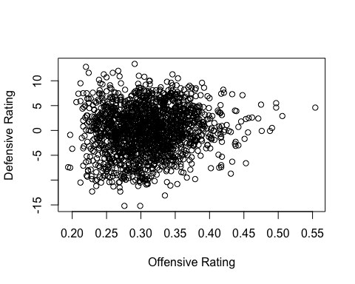
cor(nba$f_tr, nba$n_rtg, use = "complete.obs")
## [1] 0.1031428
barplot(nba$ts_percent)
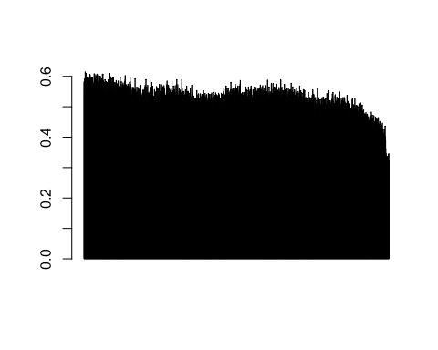
library ( ggplot2 )
library ( tidyr )
boxplot(nba$ts_percent)
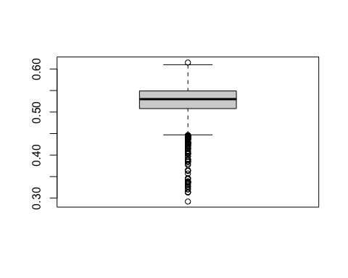
data_counts <- table(nba$playoffs, nba$team)
pie(data_counts)
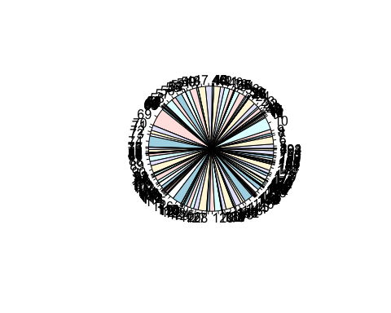
#pie(nba$team)
boxplot(nba$e_fg_percent)
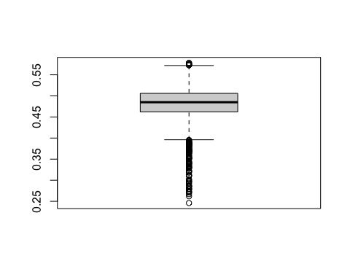
barplot(nba$e_fg_percent)
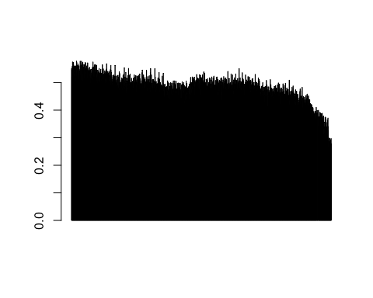
#pie(nba$e_fg_percent)
pie(data_counts)
barplot(data_counts)
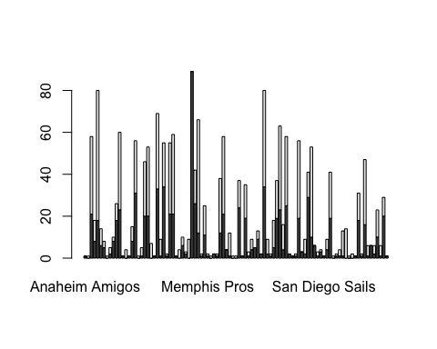
#ggplot(data_counts)
data_counts_df <- as.data.frame(data_counts)
#ggplot(data = data_counts_df, aes(x = Var2, fill = Var1)) +
#geom_bar(position = "dodge") +
#labs(title = "",
#x = "",
#y = "") +
#theme_minimal()
ball <-table(nba$team, nba$tov_percent)
pie(ball)
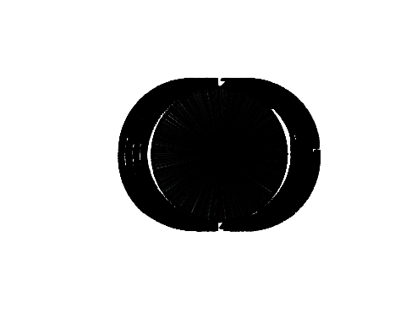
#levels(factor(ball))
barplot(ball)
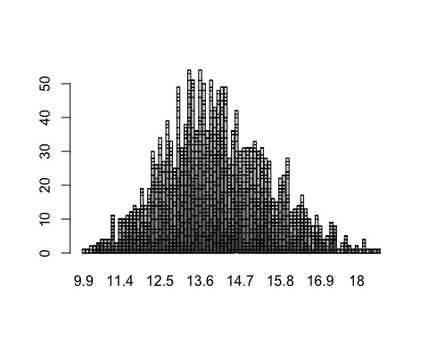
#pie(nba$playoffs)
barplot(nba$tov_percent)
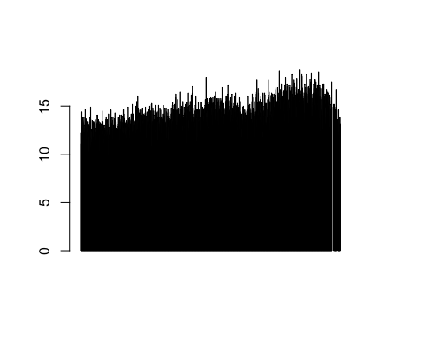
#ggplot(nba$playoffs)
balll<- table(nba$playoffs, nba$team)
pie (balll, labels = nba$team,
main = " Diamonds by Cut ( Pie ) " ,
col = rainbow ( length ( nba$team ))
+theme_minimal())
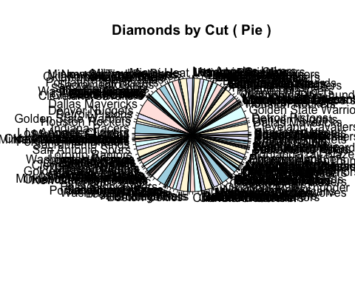
library(dplyr)
##
## Attaching package: 'dplyr'
## The following objects are masked from 'package:stats':
##
## filter, lag
## The following objects are masked from 'package:base':
##
## intersect, setdiff, setequal, union
top_5 <- head(balll, 5)
pie(top_5)
sorted_teamss <- sort(table(nba$team), decreasing = TRUE)
top_5 <- head(sorted_teamss, 5)
pie(top_5, main ="Teams that made the playoffs the most times" )
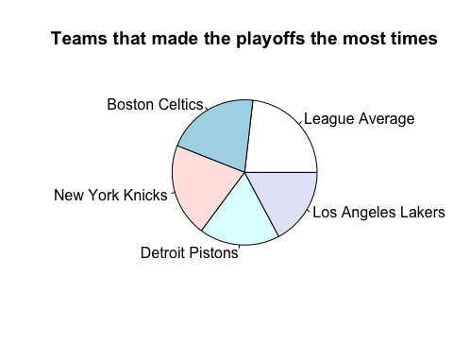
pct <- round (100 * top_5 / sum ( top_5 ) , 1)
lbls <- paste ( names ( top_5) , paste0 ( pct , " % " ))
pie(top_5, labels = lbls, main = "Teams that made the playoffs the most times
")
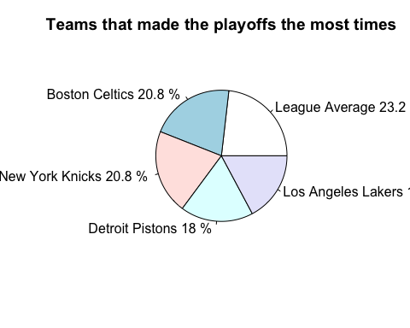
sd(nba$ts_percent)
## [1] NA
sd(nba$f_tr)
## [1] NA
sd(nba$e_fg_percent)
## [1] NA
mean(nba$n_rtg)
## [1] NA
net <-na.omit(nba$n_rtg)
mean(net)
## [1] 5.652911e-05
plot(net)
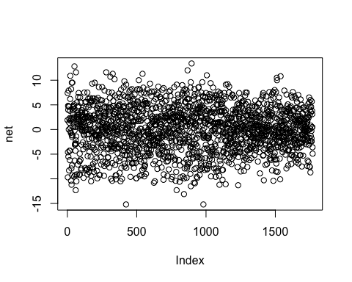
median(net)
## [1] 0.2
hist(net)
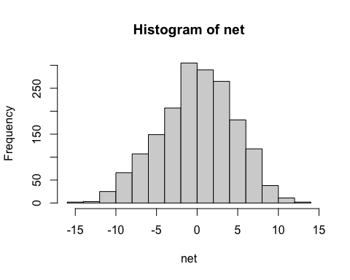
mode(nba$tov_percent)
## [1] "numeric"
median(nba$tov_percent)
## [1] NA
hist(nba$tov_percent)
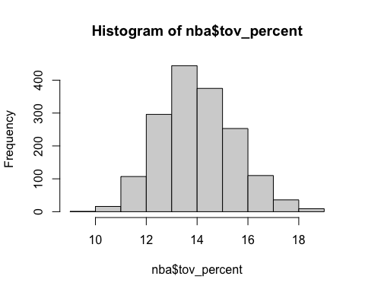
mean(nba$tov_percent)
## [1] NA
median(nba$season)
## [1] 1995
mode(nba$team)
## [1] "character"
team <- table(nba$team)
pie(team)
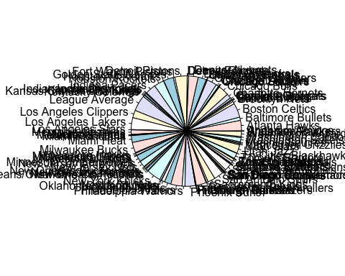
basket <- read.csv("/Users/jeeya/Downloads/TeamSummaries_raw.csv")
mean(basket$age)
## [1] NA
age <- na.omit(basket$age)
mean(age)
## [1] 26.63299
#hist(basket$w ~ basket$l)
lose <- na.omit(basket$l)
win <- na.omit(basket$w)
boxplot(win, lose, names = c("win","Lose"))
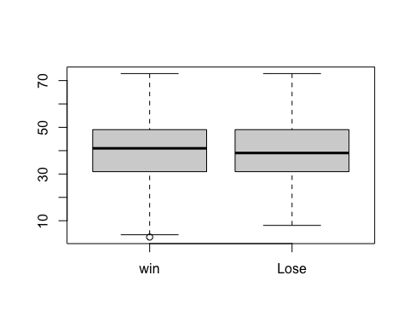
pw <- na.omit(basket$pw)
pl <- na.omit(basket$pl)
boxplot(pw, pl, names= c("p wins","p loses"))
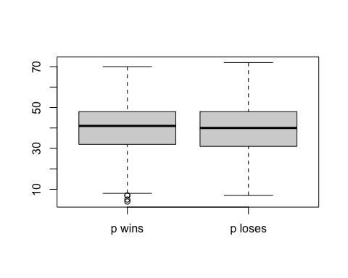
hist(basket$mov, xlab = "margin of victory")
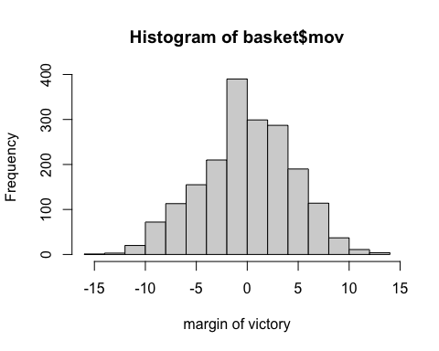
median(basket$sos)
## [1] NA
sos <- na.omit(basket$sos)
median(sos)
## [1] 0
mean(sos)
## [1] -0.0007187828
hist(sos)
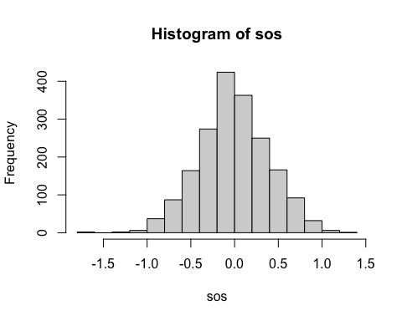
sd(basket$srs)
## [1] NA
srs <- na.omit(basket$srs)
sd(srs)
## [1] 4.282016
off <- na.omit(basket$o_rtg)
mean(off)
## [1] 104.8076
mean(basket$pace)
## [1] NA
pace <-na.omit(basket$pace)
mean(pace)
## [1] 99.51311
median(pace)
## [1] 98
orb <- na.omit(basket$orb_percent)
mode(orb)
## [1] "numeric"
mean(orb)
## [1] 28.72751
drb <- na.omit(basket$drb_percent)
boxplot(orb, drb, names = c("offensive rebound %","defensiverebound%"))
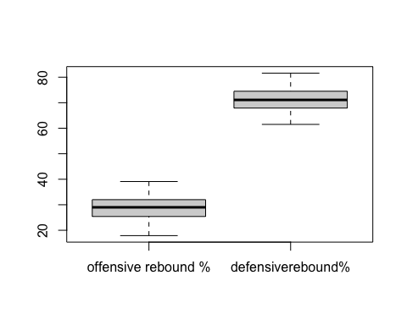
sd(basket$opp_e_fg_percent)
## [1] NA
opp <- na.omit(basket$opp_e_fg_percent)
sd(opp)
## [1] 0.02848313
hist(opp)
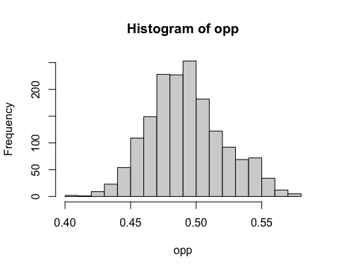
tov<- na.omit(basket$opp_tov_percent)
ft <- na.omit(basket$opp_ft_fga)
hist(tov)
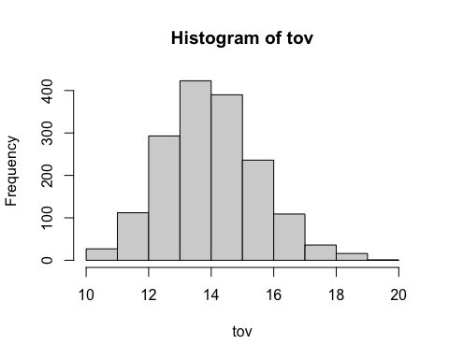
median(tov)
## [1] 14
hist(ft)
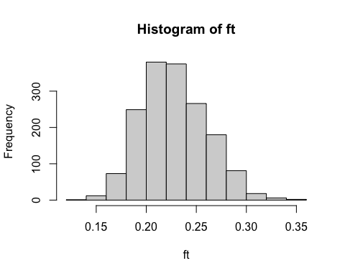
median(ft)
## [1] 0.226
mean(basket$ft_fga)
## [1] NA
fga <- na.omit(basket$ft_fga)
mean(fga)
## [1] 0.2335105
hist(fga)
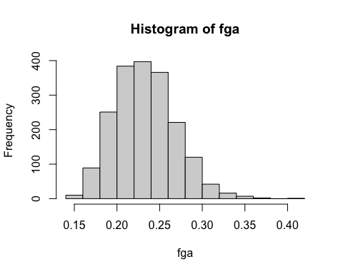
#medain(fga)
median(fga)
## [1] 0.231
att <- na.omit(basket$attend_g)
hist(att, xlab= "game attandance")
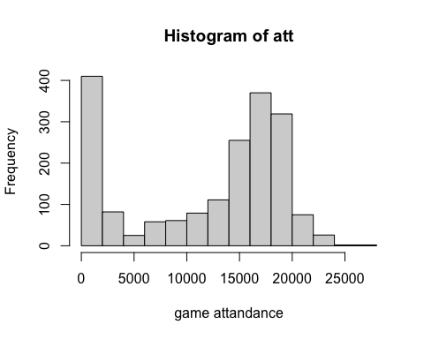
median(att)
## [1] 15018
- Regression
- Multiple Linear Regression - Jolisia
Loading the Dataset
library(tidyverse)
## ── Attaching core tidyverse packages ──────────────────────── tidyverse 2.0.0 ──
## ✔ forcats 1.0.0 ✔ readr 2.1.5
## ✔ lubridate 1.9.4 ✔ stringr 1.5.1
## ✔ purrr 1.1.0 ✔ tibble 3.3.0
## ── Conflicts ────────────────────────────────────────── tidyverse_conflicts() ──
## ✖ dplyr::filter() masks stats::filter()
## ✖ dplyr::lag() masks stats::lag()
## ℹ Use the conflicted package (<http://conflicted.r-lib.org/>) to force all conflicts to become errors
library(caret)
## Loading required package: lattice
##
## Attaching package: 'caret'
##
## The following object is masked from 'package:purrr':
##
## lift
TeamData_raw <- read.csv("/Users/jeeya/Downloads/TeamSummaries_raw.csv")
TeamData_Clean <- TeamData_raw %>%
filter(season >= 2021 & season <= 2026) %>%
select(season, team, w, o_rtg, d_rtg, ts_percent) %>%
drop_na()
head(TeamData_Clean)
## season team w o_rtg d_rtg ts_percent
## 1 2026 Atlanta Hawks 43 115.8 113.9 0.583
## 2 2026 Boston Celtics 50 120.0 112.6 0.578
## 3 2026 Brooklyn Nets 18 109.0 118.7 0.560
## 4 2026 Chicago Bulls 29 113.3 117.9 0.582
## 5 2026 Charlotte Hornets 40 119.2 114.4 0.589
## 6 2026 Cleveland Cavaliers 47 119.0 115.0 0.593
str(TeamData_Clean)
## 'data.frame': 180 obs. of 6 variables:
## $ season : int 2026 2026 2026 2026 2026 2026 2026 2026 2026 2026 ...
## $ team : chr "Atlanta Hawks" "Boston Celtics" "Brooklyn Nets" "Chicago Bulls" ...
## $ w : int 43 50 18 29 40 47 24 48 55 36 ...
## $ o_rtg : num 116 120 109 113 119 ...
## $ d_rtg : num 114 113 119 118 114 ...
## $ ts_percent: num 0.583 0.578 0.56 0.582 0.589 0.593 0.563 0.615 0.58 0.584 ...
summary(TeamData_Clean)
## season team w o_rtg
## Min. :2021 Length:180 Min. :14.00 Min. :103.5
## 1st Qu.:2022 Class :character 1st Qu.:31.00 1st Qu.:111.3
## Median :2024 Mode :character Median :41.00 Median :114.5
## Mean :2024 Mean :39.63 Mean :114.1
## 3rd Qu.:2025 3rd Qu.:48.00 3rd Qu.:116.7
## Max. :2026 Max. :68.00 Max. :123.2
## d_rtg ts_percent
## Min. :106.9 Min. :0.5270
## 1st Qu.:112.2 1st Qu.:0.5647
## Median :113.8 Median :0.5770
## Mean :114.1 Mean :0.5760
## 3rd Qu.:116.0 3rd Qu.:0.5890
## Max. :122.2 Max. :0.6150
Correlation Matrix
round(cor(TeamData_Clean[, c("w", "o_rtg", "d_rtg", "ts_percent")]), 4)
## w o_rtg d_rtg ts_percent
## w 1.0000 0.7766 -0.6608 0.6804
## o_rtg 0.7766 1.0000 -0.1551 0.8502
## d_rtg -0.6608 -0.1551 1.0000 -0.1317
## ts_percent 0.6804 0.8502 -0.1317 1.0000
Multiple Linear Regression Plots
model_mlr <- lm(w ~ o_rtg + d_rtg + ts_percent, data = TeamData_Clean)
summary(model_mlr)
##
## Call:
## lm(formula = w ~ o_rtg + d_rtg + ts_percent, data = TeamData_Clean)
##
## Residuals:
## Min 1Q Median 3Q Max
## -11.2422 -2.3775 0.2608 2.6103 10.8600
##
## Coefficients:
## Estimate Std. Error t value Pr(>|t|)
## (Intercept) 18.95437 14.70505 1.289 0.199
## o_rtg 2.02095 0.14327 14.106 <2e-16 ***
## d_rtg -2.08485 0.08915 -23.387 <2e-16 ***
## ts_percent 48.47808 29.54080 1.641 0.103
## ---
## Signif. codes: 0 '***' 0.001 '**' 0.01 '*' 0.05 '.' 0.1 ' ' 1
##
## Residual standard error: 3.723 on 176 degrees of freedom
## Multiple R-squared: 0.9037, Adjusted R-squared: 0.9021
## F-statistic: 550.8 on 3 and 176 DF, p-value: < 2.2e-16
plot(model_mlr$fitted.values,
resid(model_mlr),
xlab = "Fitted Values",
ylab = "Residuals",
main = "Residuals vs Fitted")
abline(h = 0, col = "red", lwd = 2)
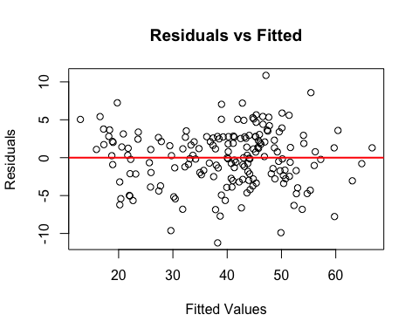
hist(rstandard(model_mlr),
col = "orange",
main = "Histogram of Standardized Residuals",
xlab = "Standardized Residuals")
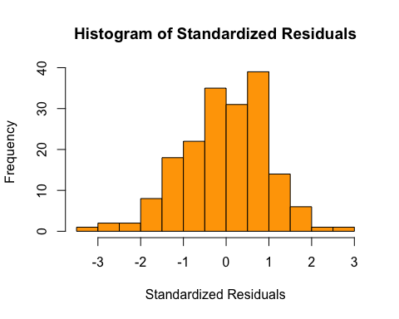
qqnorm(rstandard(model_mlr))
qqline(rstandard(model_mlr), col = "red", lwd = 2)
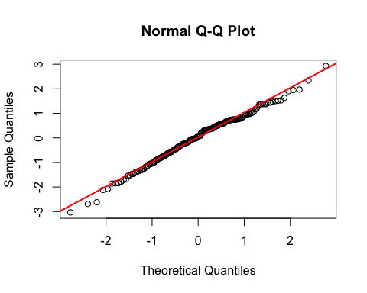
res <- rstandard(model_mlr)
shapiro.test(res)
##
## Shapiro-Wilk normality test
##
## data: res
## W = 0.9913, p-value = 0.3495
- Polynomial Regression - Jolisia
Train-Test Split
set.seed(123)
n <- nrow(TeamData_Clean)
train_idx <- sample(1:n, size = round(0.7 * n))
train <- TeamData_Clean[train_idx, ]
test <- TeamData_Clean[-train_idx, ]
model_Tr <- lm(w ~ o_rtg + d_rtg + ts_percent, data = train)
summary(model_Tr)
##
## Call:
## lm(formula = w ~ o_rtg + d_rtg + ts_percent, data = train)
##
## Residuals:
## Min 1Q Median 3Q Max
## -10.9052 -2.6770 0.3594 2.7456 10.8926
##
## Coefficients:
## Estimate Std. Error t value Pr(>|t|)
## (Intercept) 8.9475 18.6617 0.479 0.632
## o_rtg 2.1533 0.1848 11.650 <2e-16 ***
## d_rtg -2.0848 0.1178 -17.703 <2e-16 ***
## ts_percent 39.3793 36.6680 1.074 0.285
## ---
## Signif. codes: 0 '***' 0.001 '**' 0.01 '*' 0.05 '.' 0.1 ' ' 1
##
## Residual standard error: 4.034 on 122 degrees of freedom
## Multiple R-squared: 0.8918, Adjusted R-squared: 0.8892
## F-statistic: 335.3 on 3 and 122 DF, p-value: < 2.2e-16
Train-Test Model Plot and Error Metrics
plot(model_Tr$fitted.values,
resid(model_Tr),
xlab = "Fitted Values",
ylab = "Residuals",
main = "Residuals vs Fitted - Training Model")
abline(h = 0, col = "blue", lwd = 2)
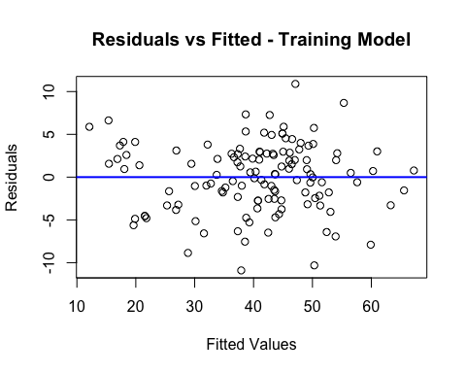
pred_test <- predict(model_Tr, newdata = test)
mse <- mean((test$w - pred_test)^2)
rmse <- sqrt(mse)
mae <- mean(abs(test$w - pred_test))
mse
## [1] 8.904388
rmse
## [1] 2.984022
mae
## [1] 2.439166
Polynomial Regression Plot
x <- TeamData_Clean$o_rtg
y <- TeamData_Clean$w
fit_lin <- lm(w ~ o_rtg, data = TeamData_Clean)
fit_quad <- lm(w ~ poly(o_rtg, 2, raw = TRUE), data = TeamData_Clean)
fit_cub <- lm(w ~ poly(o_rtg, 3, raw = TRUE), data = TeamData_Clean)
summary(fit_lin)
##
## Call:
## lm(formula = w ~ o_rtg, data = TeamData_Clean)
##
## Residuals:
## Min 1Q Median 3Q Max
## -19.160 -5.150 -0.272 4.735 22.592
##
## Coefficients:
## Estimate Std. Error t value Pr(>|t|)
## (Intercept) -245.1503 17.3243 -14.15 <2e-16 ***
## o_rtg 2.4962 0.1518 16.45 <2e-16 ***
## ---
## Signif. codes: 0 '***' 0.001 '**' 0.01 '*' 0.05 '.' 0.1 ' ' 1
##
## Residual standard error: 7.516 on 178 degrees of freedom
## Multiple R-squared: 0.6031, Adjusted R-squared: 0.6009
## F-statistic: 270.5 on 1 and 178 DF, p-value: < 2.2e-16
summary(fit_quad)
##
## Call:
## lm(formula = w ~ poly(o_rtg, 2, raw = TRUE), data = TeamData_Clean)
##
## Residuals:
## Min 1Q Median 3Q Max
## -19.0363 -5.2124 -0.3043 4.6171 22.7048
##
## Coefficients:
## Estimate Std. Error t value Pr(>|t|)
## (Intercept) -1.253e+02 3.885e+02 -0.323 0.747
## poly(o_rtg, 2, raw = TRUE)1 3.798e-01 6.854e+00 0.055 0.956
## poly(o_rtg, 2, raw = TRUE)2 9.332e-03 3.021e-02 0.309 0.758
##
## Residual standard error: 7.535 on 177 degrees of freedom
## Multiple R-squared: 0.6033, Adjusted R-squared: 0.5989
## F-statistic: 134.6 on 2 and 177 DF, p-value: < 2.2e-16
summary(fit_cub)
##
## Call:
## lm(formula = w ~ poly(o_rtg, 3, raw = TRUE), data = TeamData_Clean)
##
## Residuals:
## Min 1Q Median 3Q Max
## -19.3141 -5.0511 -0.6345 4.3464 22.2122
##
## Coefficients:
## Estimate Std. Error t value Pr(>|t|)
## (Intercept) 1.789e+04 7.905e+03 2.264 0.0248 *
## poly(o_rtg, 3, raw = TRUE)1 -4.779e+02 2.097e+02 -2.279 0.0239 *
## poly(o_rtg, 3, raw = TRUE)2 4.236e+00 1.852e+00 2.287 0.0234 *
## poly(o_rtg, 3, raw = TRUE)3 -1.244e-02 5.450e-03 -2.282 0.0237 *
## ---
## Signif. codes: 0 '***' 0.001 '**' 0.01 '*' 0.05 '.' 0.1 ' ' 1
##
## Residual standard error: 7.447 on 176 degrees of freedom
## Multiple R-squared: 0.6147, Adjusted R-squared: 0.6082
## F-statistic: 93.61 on 3 and 176 DF, p-value: < 2.2e-16
xg <- seq(min(TeamData_Clean$o_rtg),
max(TeamData_Clean$o_rtg),
length.out = 200)
p_lin <- predict(fit_lin,
newdata = data.frame(o_rtg = xg))
p_quad <- predict(fit_quad,
newdata = data.frame(o_rtg = xg))
p_cub <- predict(fit_cub,
newdata = data.frame(o_rtg = xg))
plot(x, y,
pch = 16,
cex = 0.9,
xlab = "Offensive Rating",
ylab = "Wins",
main = "Polynomial Regression: Wins vs Offensive Rating")
lines(xg, p_lin, lwd = 2, col = "blue")
lines(xg, p_quad, lwd = 2, lty = 2, col = "red")
lines(xg, p_cub, lwd = 2, lty = 3, col = "green4")
legend("topright",
legend = c("Linear", "Quadratic", "Cubic"),
lwd = 2,
lty = c(1, 2, 3),
col = c("blue", "red", "green4"),
bty = "n")
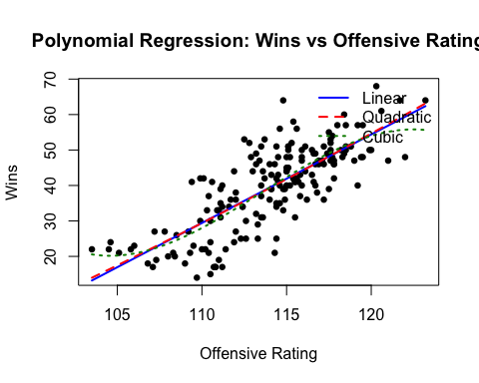
AIC and BIC Comparison
AIC(fit_lin, fit_quad, fit_cub)
## df AIC
## fit_lin 3 1240.937
## fit_quad 4 1242.840
## fit_cub 5 1239.591
BIC(fit_lin, fit_quad, fit_cub)
## df BIC
## fit_lin 3 1250.516
## fit_quad 4 1255.612
## fit_cub 5 1255.556
- Principal Component Regression (PCR) - Ethne
Loading and Cleaning Data
library(ISLR2)
library(ggplot2)
data <- read.csv("/Users/jeeya/Downloads/TeamSummaries_raw.csv")
teams_data <- na.omit(data[, c("mov","sos","pace","f_tr","x3p_ar","ts_percent","e_fg_percent","tov_percent","orb_percent","ft_fga","opp_e_fg_percent","opp_tov_percent","drb_percent","opp_ft_fga")])
PCR Split
library(pls)
## Warning: package 'pls' was built under R version 4.4.3
##
## Attaching package: 'pls'
## The following object is masked from 'package:caret':
##
## R2
## The following object is masked from 'package:stats':
##
## loadings
set.seed(123)
n <- nrow(teams_data)
train_idx <- sample(1:n, size = round(0.7*n))
train <- teams_data[train_idx, ]
test <- teams_data[-train_idx, ]
dim(train)
## [1] 991 14
dim(test)
## [1] 425 14
Fit PCR on Train Data
pcr_train <- pcr(mov ~ .-mov, data = train, scale = TRUE, validation = "CV")
summary(pcr_train)
## Data: X dimension: 991 13
## Y dimension: 991 1
## Fit method: svdpc
## Number of components considered: 13
##
## VALIDATION: RMSEP
## Cross-validated using 10 random segments.
## (Intercept) 1 comps 2 comps 3 comps 4 comps 5 comps 6 comps
## CV 4.532 4.511 3.96 3.424 3.073 3.072 3.076
## adjCV 4.532 4.511 3.96 3.423 3.072 3.070 3.075
## 7 comps 8 comps 9 comps 10 comps 11 comps 12 comps 13 comps
## CV 2.405 2.007 1.586 0.6172 0.6154 0.5890 0.5890
## adjCV 2.404 1.994 1.587 0.6161 0.6148 0.5884 0.5884
##
## TRAINING: % variance explained
## 1 comps 2 comps 3 comps 4 comps 5 comps 6 comps 7 comps 8 comps
## X 46.539 59.93 70.87 78.60 84.26 88.50 91.63 94.45
## mov 1.269 24.10 43.23 54.61 54.77 54.93 72.71 81.33
## 9 comps 10 comps 11 comps 12 comps 13 comps
## X 97.06 98.76 99.72 100.00 100.00
## mov 88.18 98.20 98.22 98.37 98.37
validationplot(pcr_train, val.type = "MSEP")
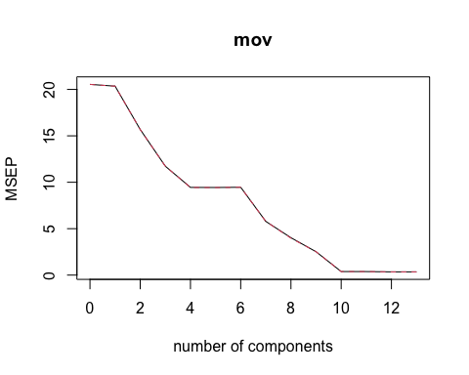
PCR on Test Data & RMSE
pred_pcr <- predict(pcr_train, test, ncomp = 10)
RMSE <- function(y, yhat) sqrt(mean((y - yhat)^2))
test_rmse_pcr <- RMSE(test$mov, pred_pcr)
test_rmse_pcr
## [1] 0.5869366
OLS Fit
ols_fit <- lm(mov ~ .-mov, data = train)
summary(ols_fit)
##
## Call:
## lm(formula = mov ~ . - mov, data = train)
##
## Residuals:
## Min 1Q Median 3Q Max
## -3.3484 -0.3515 0.0044 0.3389 1.9516
##
## Coefficients:
## Estimate Std. Error t value Pr(>|t|)
## (Intercept) -4.639e+01 2.269e+00 -20.446 < 2e-16 ***
## sos -2.185e-01 5.405e-02 -4.042 5.71e-05 ***
## pace -8.432e-03 4.483e-03 -1.881 0.060289 .
## f_tr -2.891e+00 7.273e+00 -0.398 0.691041
## x3p_ar 1.949e+00 3.783e-01 5.152 3.11e-07 ***
## ts_percent 1.204e+02 3.352e+01 3.593 0.000343 ***
## e_fg_percent 3.277e+01 2.974e+01 1.102 0.270777
## tov_percent -1.350e+00 2.005e-02 -67.300 < 2e-16 ***
## orb_percent 4.667e-01 7.653e-03 60.984 < 2e-16 ***
## ft_fga 1.083e+01 1.494e+01 0.725 0.468618
## opp_e_fg_percent -1.435e+02 1.100e+00 -130.385 < 2e-16 ***
## opp_tov_percent 1.339e+00 1.903e-02 70.388 < 2e-16 ***
## drb_percent 3.966e-01 8.761e-03 45.266 < 2e-16 ***
## opp_ft_fga -2.753e+01 7.943e-01 -34.659 < 2e-16 ***
## ---
## Signif. codes: 0 '***' 0.001 '**' 0.01 '*' 0.05 '.' 0.1 ' ' 1
##
## Residual standard error: 0.582 on 977 degrees of freedom
## Multiple R-squared: 0.9837, Adjusted R-squared: 0.9835
## F-statistic: 4539 on 13 and 977 DF, p-value: < 2.2e-16
- Induction Tree - Ethne
library(ISLR2)
library(rpart)
library(rpart.plot)
## Warning: package 'rpart.plot' was built under R version 4.4.3
data <- read.csv("/Users/jeeya/Downloads/TeamSummaries_raw.csv")
data <- na.omit(data)
set.seed(123)
n <-nrow(data)
train_idx <- sample(1:n, 0.7 * n)
train <- data[train_idx, ]
test <- data[-train_idx, ]
tree_model <- rpart(w ~ pace + o_rtg + d_rtg + ts_percent + sos,
data = train, method = "anova",
control = rpart.control(cp = 0.01))
rpart.plot(tree_model, type = 4, extra = 1,
clip.right.labs = FALSE,
varlen = 0, faclen = 3)
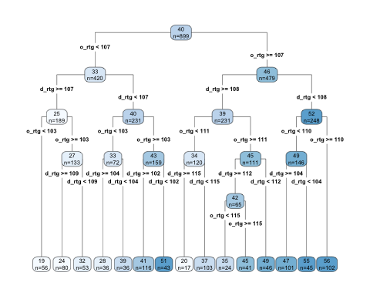
printcp(tree_model)
##
## Regression tree:
## rpart(formula = w ~ pace + o_rtg + d_rtg + ts_percent + sos,
## data = train, method = "anova", control = rpart.control(cp = 0.01))
##
## Variables actually used in tree construction:
## [1] d_rtg o_rtg
##
## Root node error: 138996/899 = 154.61
##
## n= 899
##
## CP nsplit rel error xerror xstd
## 1 0.254535 0 1.00000 1.00300 0.038183
## 2 0.178055 1 0.74547 0.78168 0.033083
## 3 0.141658 2 0.56741 0.61212 0.028400
## 4 0.044589 3 0.42575 0.46448 0.021307
## 5 0.036849 4 0.38116 0.41023 0.018988
## 6 0.027751 5 0.34431 0.37815 0.017366
## 7 0.023583 6 0.31656 0.34978 0.016289
## 8 0.021294 7 0.29298 0.32558 0.015577
## 9 0.018449 8 0.27169 0.31447 0.015021
## 10 0.017459 9 0.25324 0.30399 0.014696
## 11 0.015497 10 0.23578 0.28726 0.014315
## 12 0.015300 11 0.22028 0.28013 0.014164
## 13 0.010367 12 0.20498 0.25872 0.013613
## 14 0.010000 14 0.18425 0.24662 0.013082
plotcp(tree_model)
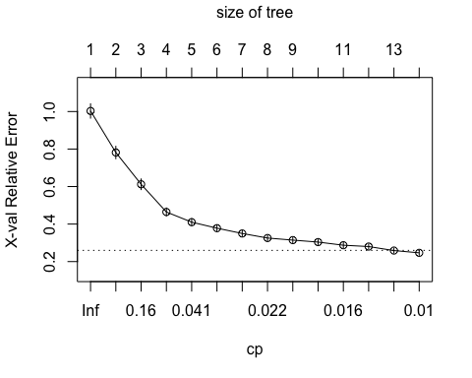
Fit Pruned Tree
fit_pr <- prune(tree_model, cp = 0.017459)
rpart.plot(fit_pr, type = 4, extra = 1, fallen.leaves = TRUE,
digits = 3, varlen = 0, faclen = 3)
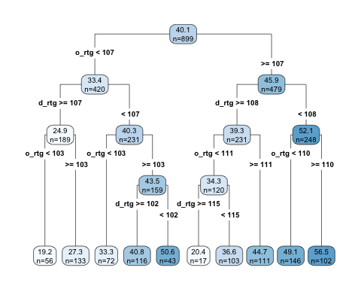
Predict and Compare
pred <- predict(fit_pr, test)
head(data.frame(Actual = test$w, Predicted = pred))
## Actual Predicted
## 1 43 44.67568
## 3 18 20.35294
## 4 29 44.67568
## 7 24 20.35294
## 12 17 20.35294
## 14 50 44.67568
rmse <- function(y, yhat) sqrt(mean((y-yhat)^2))
test_rmse_tree <- rmse(test$w, pred)
test_rmse_tree
## [1] 7.650622
- Classification - Jeeya
Loading and Cleaning Data
library(tidyverse)
library(caret)
library(e1071)
## Warning: package 'e1071' was built under R version 4.4.3
library(rpart)
library(rpart.plot)
set.seed(123)
nba <- read.csv("/Users/jeeya/Downloads/TeamSummaries_raw.csv")
nba_clean <- nba %>%
filter(lg == "NBA", season >= 2021, season <= 2026) %>%
select(season, team, w, mov, srs, o_rtg, d_rtg, n_rtg, pace,
ts_percent, e_fg_percent, tov_percent, orb_percent,
drb_percent, opp_e_fg_percent, opp_tov_percent, ft_fga) %>%
drop_na()
nba_clean$good_team <- ifelse(nba_clean$w > median(nba_clean$w, na.rm = TRUE), "Yes", "No")
nba_clean$good_team <- as.factor(nba_clean$good_team)
table(nba_clean$good_team)
##
## No Yes
## 91 89
Split Data into Training and Test Sets
train_index <- createDataPartition(nba_clean$good_team, p = 0.70, list = FALSE)
train <- nba_clean[train_index, ]
test <- nba_clean[-train_index, ]
nrow(train)
## [1] 127
nrow(test)
## [1] 53
- Logistic Regression
model_log <- glm(good_team ~ mov + srs + o_rtg + d_rtg + n_rtg + pace +
ts_percent + e_fg_percent + tov_percent + orb_percent +
drb_percent + opp_e_fg_percent + opp_tov_percent + ft_fga,
data = train,
family = binomial)
summary(model_log)
##
## Call:
## glm(formula = good_team ~ mov + srs + o_rtg + d_rtg + n_rtg +
## pace + ts_percent + e_fg_percent + tov_percent + orb_percent +
## drb_percent + opp_e_fg_percent + opp_tov_percent + ft_fga,
## family = binomial, data = train)
##
## Coefficients: (1 not defined because of singularities)
## Estimate Std. Error z value Pr(>|z|)
## (Intercept) 145.8093 89.3764 1.631 0.1028
## mov 4.0165 12.4193 0.323 0.7464
## srs 2.5130 2.1291 1.180 0.2379
## o_rtg -7.1661 12.0547 -0.594 0.5522
## d_rtg 3.4274 11.8901 0.288 0.7731
## n_rtg NA NA NA NA
## pace -0.2633 0.3024 -0.871 0.3840
## ts_percent 517.5049 459.1408 1.127 0.2597
## e_fg_percent -10.7841 247.8757 -0.044 0.9653
## tov_percent -3.2680 2.8343 -1.153 0.2489
## orb_percent 1.3149 1.0037 1.310 0.1902
## drb_percent -0.9311 0.5158 -1.805 0.0711 .
## opp_e_fg_percent 222.0198 143.2282 1.550 0.1211
## opp_tov_percent -1.8719 1.1329 -1.652 0.0985 .
## ft_fga -22.3120 57.4684 -0.388 0.6978
## ---
## Signif. codes: 0 '***' 0.001 '**' 0.01 '*' 0.05 '.' 0.1 ' ' 1
##
## (Dispersion parameter for binomial family taken to be 1)
##
## Null deviance: 176.052 on 126 degrees of freedom
## Residual deviance: 44.454 on 113 degrees of freedom
## AIC: 72.454
##
## Number of Fisher Scoring iterations: 9
prob_log <- predict(model_log, test, type = "response")
pred_log <- ifelse(prob_log > 0.5, "Yes", "No")
pred_log <- factor(pred_log, levels = levels(test$good_team))
conf_log <- table(Predicted = pred_log, Actual = test$good_team)
conf_log
## Actual
## Predicted No Yes
## No 25 2
## Yes 2 24
accuracy_log <- mean(pred_log == test$good_team)
misclass_log <- 1 - accuracy_log
accuracy_log
## [1] 0.9245283
misclass_log
## [1] 0.0754717
- Classification Tree
model_tree <- rpart(good_team ~ mov + srs + o_rtg + d_rtg + n_rtg + pace +
ts_percent + e_fg_percent + tov_percent + orb_percent +
drb_percent + opp_e_fg_percent + opp_tov_percent + ft_fga,
data = train,
method = "class")
rpart.plot(model_tree)
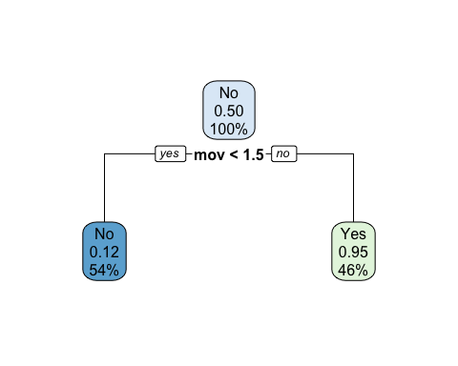
pred_tree <- predict(model_tree, test, type = "class")
conf_tree <- table(Predicted = pred_tree, Actual = test$good_team)
conf_tree
## Actual
## Predicted No Yes
## No 26 3
## Yes 1 23
accuracy_tree <- mean(pred_tree == test$good_team)
misclass_tree <- 1 - accuracy_tree
accuracy_tree
## [1] 0.9245283
misclass_tree
## [1] 0.0754717
- Naive Bayes - Sophia
model_nb <- naiveBayes(good_team ~ mov + srs + o_rtg + d_rtg + n_rtg + pace +
ts_percent + e_fg_percent + tov_percent + orb_percent +
drb_percent + opp_e_fg_percent + opp_tov_percent + ft_fga,
data = train)
model_nb
##
## Naive Bayes Classifier for Discrete Predictors
##
## Call:
## naiveBayes.default(x = X, y = Y, laplace = laplace)
##
## A-priori probabilities:
## Y
## No Yes
## 0.503937 0.496063
##
## Conditional probabilities:
## mov
## Y [,1] [,2]
## No -3.555156 4.141139
## Yes 3.864444 2.609116
##
## srs
## Y [,1] [,2]
## No -3.445469 3.966509
## Yes 3.725238 2.498119
##
## o_rtg
## Y [,1] [,2]
## No 111.8453 3.279999
## Yes 116.2635 2.364748
##
## d_rtg
## Y [,1] [,2]
## No 115.3859 3.044165
## Yes 112.3540 2.358432
##
## n_rtg
## Y [,1] [,2]
## No -3.540625 4.126327
## Yes 3.909524 2.637124
##
## pace
## Y [,1] [,2]
## No 99.30156 1.979778
## Yes 98.36349 1.790143
##
## ts_percent
## Y [,1] [,2]
## No 0.565875 0.01548220
## Yes 0.585746 0.01226188
##
## e_fg_percent
## Y [,1] [,2]
## No 0.5307031 0.01580203
## Yes 0.5519841 0.01331564
##
## tov_percent
## Y [,1] [,2]
## No 12.69844 0.9330769
## Yes 12.27937 0.8743954
##
## orb_percent
## Y [,1] [,2]
## No 23.85156 2.666130
## Yes 24.60476 3.006575
##
## drb_percent
## Y [,1] [,2]
## No 75.47656 2.155520
## Yes 76.40794 1.619668
##
## opp_e_fg_percent
## Y [,1] [,2]
## No 0.5475000 0.01264409
## Yes 0.5335556 0.01151686
##
## opp_tov_percent
## Y [,1] [,2]
## No 12.41094 1.046251
## Yes 12.51905 1.058888
##
## ft_fga
## Y [,1] [,2]
## No 0.1969687 0.01832335
## Yes 0.1976032 0.01791336
pred_nb <- predict(model_nb, test)
conf_nb <- table(Predicted = pred_nb, Actual = test$good_team)
conf_nb
## Actual
## Predicted No Yes
## No 24 2
## Yes 3 24
accuracy_nb <- mean(pred_nb == test$good_team)
misclass_nb <- 1 - accuracy_nb
accuracy_nb
## [1] 0.9056604
misclass_nb
## [1] 0.09433962
- Support Vector Machine (SVM) - Sophia
model_svm <- svm(good_team ~ mov + srs + o_rtg + d_rtg + n_rtg + pace +
ts_percent + e_fg_percent + tov_percent + orb_percent +
drb_percent + opp_e_fg_percent + opp_tov_percent + ft_fga,
data = train,
kernel = "radial",
scale = TRUE)
model_svm
##
## Call:
## svm(formula = good_team ~ mov + srs + o_rtg + d_rtg + n_rtg + pace +
## ts_percent + e_fg_percent + tov_percent + orb_percent + drb_percent +
## opp_e_fg_percent + opp_tov_percent + ft_fga, data = train, kernel = "radial",
## scale = TRUE)
##
##
## Parameters:
## SVM-Type: C-classification
## SVM-Kernel: radial
## cost: 1
##
## Number of Support Vectors: 63
pred_svm <- predict(model_svm, test)
conf_svm <- table(Predicted = pred_svm, Actual = test$good_team)
conf_svm
## Actual
## Predicted No Yes
## No 24 3
## Yes 3 23
accuracy_svm <- mean(pred_svm == test$good_team)
misclass_svm <- 1 - accuracy_svm
accuracy_svm
## [1] 0.8867925
misclass_svm
## [1] 0.1132075
Model Comparison
comparison <- data.frame(
Model = c("Logistic Regression", "Naive Bayes", "Classification Tree", "SVM"),
Accuracy = c(accuracy_log, accuracy_nb, accuracy_tree, accuracy_svm),
Misclassification_Rate = c(misclass_log, misclass_nb, misclass_tree, misclass_svm)
)
comparison
## Model Accuracy Misclassification_Rate
## 1 Logistic Regression 0.9245283 0.07547170
## 2 Naive Bayes 0.9056604 0.09433962
## 3 Classification Tree 0.9245283 0.07547170
## 4 SVM 0.8867925 0.11320755
Visualizations Bar Plot of Good vs Not Good Teams
ggplot(nba_clean, aes(x = good_team, fill = good_team)) +
geom_bar() +
scale_fill_manual(values = c("Yes" = "orange", "No" = "black")) +
labs(title = "Distribution of Good vs Not Good Teams",
x = "Good Team",
y = "Number of Teams") +
theme_minimal()
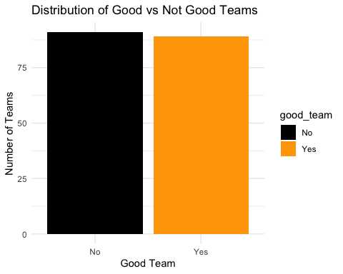
Model Accuracy Comparison Plot
ggplot(comparison, aes(x = Model, y = Accuracy, fill = Model)) +
geom_col() +
scale_fill_manual(values = c("steelblue", "orange", "purple", "darkred")) +
labs(title = "Accuracy Comparison Across Classification Models",
x = "Classification Model",
y = "Accuracy") +
ylim(0,1) +
theme_minimal() +
theme(legend.position = "none")
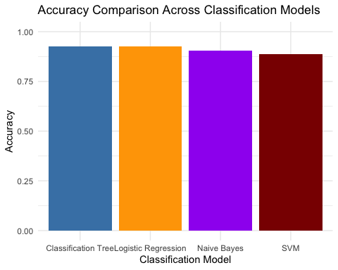
Wins by Good Team Classification
ggplot(nba_clean, aes(x = good_team, y = w, fill = good_team)) +
geom_boxplot() +
scale_fill_manual(values = c("Yes" = "orange", "No" = "black")) +
labs(title = "Wins by Good Team Classification",
x = "Good Team",
y = "Wins") +
theme_minimal()
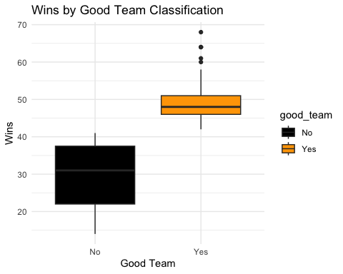
- K Means Clustering - Ethne
Elbow Plot
data <- read.csv("/Users/jeeya/Downloads/TeamSummaries_raw.csv")
data_omit <- na.omit(data)
tot.withinss<- vector(mode="numeric", length = 10)
set.seed(123)
for(i in 1:10){
teamsElbow <- kmeans(data_omit[, c("o_rtg", "d_rtg", "pace", "ts_percent",
"x3p_ar", "tov_percent", "orb_percent")], centers = i, nstart = 25)
tot.withinss[i] <- teamsElbow$tot.withinss}
plot(1:length(tot.withinss), tot.withinss,
type = "b", pch = 19,
main = "Elbow Plot",
ylab = "Total Within SS",
xlab = "Number of Centers (clusters)")
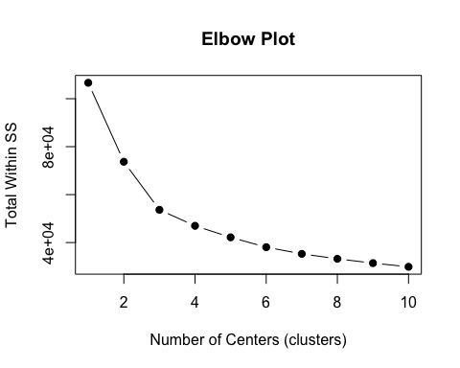
Cluster Plot
library(cluster)
set.seed(123)
teamsCluster <- kmeans(x = data_omit[, c("o_rtg", "d_rtg","ts_percent",
"pace", "x3p_ar", "tov_percent", "orb_percent")],centers = 4, nstart = 25)
teamsCluster
## K-means clustering with 4 clusters of sizes 349, 299, 256, 381
##
## Cluster means:
## o_rtg d_rtg ts_percent pace x3p_ar tov_percent orb_percent
## 1 104.4989 103.6679 0.5242865 90.46046 0.18124069 14.21461 29.23754
## 2 107.6495 107.3910 0.5372408 100.27291 0.06204348 14.57759 33.22107
## 3 113.3988 112.8680 0.5739687 99.08320 0.38240625 12.54297 23.90273
## 4 106.8299 108.0496 0.5397690 93.87060 0.23493701 13.48268 26.16745
##
## Clustering vector:
## 1 2 3 4 5 6 7 8 9 10 11 12 13 14 15 16
## 3 3 3 3 3 3 3 3 3 3 3 3 3 3 3 3
## 17 18 19 20 21 22 23 24 25 26 27 28 29 30 32 33
## 3 3 3 3 3 3 3 3 3 3 3 3 3 3 3 3
## 34 35 36 37 38 39 40 41 42 43 44 45 46 47 48 49
## 3 3 3 3 3 3 3 3 3 3 3 3 3 3 3 3
## 50 51 52 53 54 55 56 57 58 59 60 61 63 64 65 66
## 3 3 3 4 3 3 3 3 3 3 3 3 3 3 3 3
## 67 68 69 70 71 72 73 74 75 76 77 78 79 80 81 82
## 3 3 3 3 3 3 3 3 3 3 3 3 3 3 3 3
## 83 84 85 86 87 88 89 90 91 92 94 95 96 97 98 99
## 3 3 3 3 3 3 3 3 3 3 3 3 3 3 3 3
## 100 101 102 103 104 105 106 107 108 109 110 111 112 113 114 115
## 3 3 3 3 3 3 3 3 3 3 3 3 3 3 3 3
## 116 117 118 119 120 121 122 123 125 126 127 128 129 130 131 132
## 3 3 3 3 3 3 3 3 3 3 3 3 3 3 3 3
## 133 134 135 136 137 138 139 140 141 142 143 144 145 146 147 148
## 3 3 3 3 3 3 3 3 3 3 3 4 4 4 3 3
## 149 150 151 152 153 154 156 157 158 159 160 161 162 163 164 165
## 3 3 3 3 3 3 3 3 3 3 3 4 3 3 3 3
## 166 168 169 170 172 173 174 175 177 178 179 180 182 183 184 185
## 3 3 4 3 3 3 3 4 3 3 3 3 3 3 3 3
## 187 188 189 190 191 192 193 194 195 196 197 198 199 200 201 202
## 3 3 3 4 4 3 3 3 3 3 3 3 3 3 3 3
## 203 204 205 206 207 208 209 210 211 212 213 214 215 216 218 219
## 3 3 3 4 3 3 3 3 3 3 3 3 3 3 3 3
## 220 221 222 223 224 225 226 227 228 229 230 231 232 233 234 235
## 3 3 3 3 3 3 4 3 3 4 3 3 4 4 3 3
## 236 237 238 239 240 241 242 243 244 245 246 247 249 250 251 252
## 3 3 3 4 3 3 3 3 3 3 3 3 4 4 3 4
## 253 254 255 256 257 258 259 260 261 262 263 264 265 266 267 268
## 3 3 4 3 4 3 3 4 3 4 4 4 3 3 3 4
## 269 270 271 272 273 274 275 276 277 278 280 281 282 283 284 285
## 4 4 4 4 4 4 4 3 4 4 4 3 4 4 4 3
## 286 287 288 289 290 291 292 293 294 295 296 297 298 299 300 301
## 4 3 4 3 3 4 3 4 4 4 4 4 4 4 4 4
## 302 303 304 305 306 307 308 309 311 312 313 314 315 316 317 318
## 4 3 3 4 4 4 4 3 4 4 4 4 4 4 4 4
## 319 320 321 322 323 324 325 326 327 328 329 330 331 332 333 334
## 4 3 4 4 4 4 4 4 4 4 4 4 2 4 4 4
## 335 336 337 338 339 340 342 343 344 345 346 347 348 349 350 351
## 4 4 4 4 1 4 4 4 4 4 1 4 4 4 4 4
## 352 353 354 355 356 357 358 359 360 361 362 363 364 365 366 367
## 4 1 4 4 1 4 1 4 4 4 4 4 1 4 4 4
## 368 369 370 371 373 374 375 376 377 378 379 380 381 382 383 384
## 4 4 1 1 4 4 4 4 1 4 4 4 4 4 4 1
## 385 386 387 388 389 390 391 392 393 394 395 396 397 398 399 400
## 4 4 1 4 4 4 4 4 4 4 4 4 4 4 4 4
## 401 402 404 405 406 407 408 409 410 411 412 413 414 415 416 417
## 4 4 4 4 1 4 1 4 4 2 1 4 4 1 1 4
## 418 419 420 421 422 423 424 425 426 427 428 429 430 431 432 433
## 1 4 4 1 4 4 4 4 1 4 4 4 4 4 1 1
## 435 436 437 438 439 440 441 442 443 444 445 446 447 448 449 450
## 1 1 4 1 1 1 4 1 4 1 1 1 1 1 1 4
## 451 452 453 454 455 456 457 458 459 460 461 462 463 464 466 467
## 4 4 1 1 1 1 1 4 4 4 4 1 1 1 4 1
## 468 469 470 471 472 473 474 475 476 477 478 479 480 481 482 483
## 4 1 4 4 4 4 4 4 4 4 1 1 4 1 4 4
## 484 485 486 487 488 489 490 491 492 493 494 495 497 498 499 500
## 1 3 4 1 4 4 1 4 4 4 4 4 4 4 1 1
## 501 502 503 504 505 506 507 508 509 510 511 512 513 514 515 516
## 4 4 4 4 3 4 4 4 4 4 1 1 4 4 4 4
## 517 518 519 520 521 522 523 524 525 526 528 529 530 531 532 533
## 4 4 4 3 4 4 4 3 4 4 4 1 1 4 1 4
## 534 535 536 537 538 539 540 541 542 543 544 545 546 547 548 549
## 4 1 3 1 4 4 4 4 4 4 4 4 4 4 4 4
## 550 551 552 553 554 555 556 557 559 560 561 562 563 564 565 566
## 1 3 1 4 4 4 4 4 4 1 4 4 1 4 4 1
## 567 568 569 570 571 572 573 574 575 576 577 578 579 580 581 582
## 3 1 4 4 4 4 4 4 4 4 4 4 4 1 3 4
## 583 584 585 586 587 588 590 591 592 593 594 595 596 597 598 599
## 4 1 4 4 4 4 1 1 4 1 1 1 4 1 4 1
## 600 601 602 603 604 605 606 607 608 609 610 611 612 613 614 615
## 1 1 4 4 1 4 4 4 1 1 1 1 3 4 4 1
## 616 617 618 619 621 622 623 624 625 626 627 628 629 630 631 632
## 4 4 4 4 4 4 4 1 1 1 4 1 4 1 1 1
## 633 634 635 636 637 638 639 640 641 642 643 644 645 646 647 648
## 1 1 4 4 1 1 1 4 1 4 4 4 4 1 4 4
## 649 650 652 653 654 655 656 657 658 659 660 661 662 663 664 665
## 1 4 1 4 1 1 1 4 1 1 4 1 1 1 4 1
## 666 667 668 669 670 671 672 673 674 675 676 677 678 679 680 681
## 1 4 1 1 1 4 4 4 3 1 4 1 4 4 1 4
## 683 684 685 686 687 688 689 690 691 692 693 694 695 696 697 698
## 1 1 1 1 4 1 1 1 1 1 1 1 1 1 1 1
## 699 700 701 702 703 704 705 706 707 708 709 710 711 713 714 715
## 1 1 1 4 1 1 1 4 1 4 1 1 1 1 1 1
## 716 717 718 719 720 721 722 723 724 725 726 727 728 729 730 731
## 1 4 1 1 2 1 1 1 1 4 1 4 1 1 1 4
## 732 733 734 735 736 737 738 739 740 741 743 744 745 746 747 748
## 4 1 1 1 1 1 1 1 1 1 1 1 1 1 1 4
## 749 750 751 752 753 754 755 756 757 758 759 760 761 762 763 764
## 1 1 2 1 1 1 1 1 1 4 1 1 1 4 1 1
## 765 766 767 768 769 770 771 773 774 775 776 777 778 779 780 781
## 1 1 1 1 1 1 1 1 1 1 1 1 4 1 1 1
## 782 783 784 785 786 787 788 789 790 791 792 793 794 795 796 797
## 1 1 1 1 1 4 1 1 1 1 1 1 1 1 1 1
## 798 799 800 801 803 804 805 806 807 808 809 810 811 812 813 814
## 1 1 1 1 1 1 1 1 1 4 1 4 1 1 4 4
## 815 816 817 818 819 820 821 822 823 824 825 826 827 828 829 830
## 1 1 4 1 4 1 1 1 1 1 2 1 1 1 1 1
## 831 833 834 835 836 837 838 839 840 841 842 843 844 845 846 847
## 1 1 1 1 1 1 1 4 1 1 1 1 1 1 1 1
## 848 849 850 851 852 853 854 855 856 857 858 859 860 861 863 864
## 1 1 1 1 1 1 1 1 1 1 1 1 1 1 1 1
## 865 866 867 868 869 870 871 872 873 874 875 876 877 878 879 880
## 1 1 1 1 1 1 1 4 1 4 1 1 1 4 1 1
## 881 882 883 884 885 886 887 888 889 890 891 893 894 895 896 897
## 1 1 1 1 1 1 1 1 1 4 1 1 4 4 1 1
## 898 899 900 901 902 903 904 905 906 907 908 909 910 911 912 913
## 1 4 1 4 1 1 1 1 1 1 1 2 1 1 2 4
## 914 915 916 917 918 919 920 921 923 924 925 926 927 928 929 930
## 1 1 1 1 1 1 1 1 1 4 4 1 1 2 1 1
## 931 932 933 934 935 936 937 938 939 940 941 942 943 944 945 946
## 2 4 1 4 4 1 4 4 1 1 4 4 4 1 4 4
## 947 948 949 950 951 953 954 955 956 957 958 959 960 961 962 963
## 1 4 1 1 4 1 2 4 1 1 2 4 4 2 4 1
## 964 965 966 967 968 969 970 971 972 973 974 975 976 977 978 979
## 4 4 4 4 4 1 1 2 1 3 2 1 4 2 4 4
## 981 982 983 984 985 986 987 988 989 990 991 992 993 994 995 996
## 1 4 4 1 1 1 1 4 2 1 1 2 2 2 4 4
## 997 998 999 1000 1001 1002 1003 1004 1005 1006 1007 1009 1010 1011 1012 1013
## 2 1 2 4 2 2 2 1 2 1 4 2 4 2 2 4
## 1014 1015 1016 1017 1018 1019 1020 1021 1022 1023 1024 1025 1026 1027 1028 1029
## 2 2 2 2 4 2 2 2 4 4 4 2 1 2 4 2
## 1030 1031 1032 1033 1034 1035 1037 1038 1039 1040 1041 1042 1043 1044 1045 1046
## 2 2 4 2 2 4 2 2 2 2 4 4 2 1 2 4
## 1047 1048 1049 1050 1051 1052 1053 1054 1055 1056 1057 1058 1059 1060 1061 1062
## 2 2 4 2 2 4 2 1 2 4 2 2 2 2 2 2
## 1063 1065 1066 1067 1068 1069 1070 1071 1072 1073 1074 1075 1076 1077 1078 1079
## 4 2 2 4 2 4 4 2 1 2 2 2 2 2 2 2
## 1080 1081 1082 1083 1084 1085 1086 1087 1088 1089 1090 1091 1093 1094 1095 1096
## 2 2 4 2 4 2 2 4 2 2 4 2 2 2 4 2
## 1097 1098 1099 1100 1101 1102 1103 1104 1105 1106 1107 1108 1109 1110 1111 1112
## 4 4 2 2 3 2 3 2 2 2 2 1 2 2 2 2
## 1113 1114 1115 1116 1117 1118 1119 1121 1122 1123 1124 1125 1126 1127 1128 1129
## 2 2 4 2 2 2 2 2 2 2 2 2 4 2 2 2
## 1130 1131 1132 1133 1134 1135 1136 1137 1138 1139 1140 1141 1142 1143 1144 1145
## 2 2 2 2 2 2 2 2 2 2 2 2 2 2 2 2
## 1147 1148 1149 1150 1151 1152 1153 1154 1155 1156 1157 1158 1159 1160 1161 1162
## 2 3 2 2 2 2 2 2 2 2 2 2 2 2 2 2
## 1163 1164 1165 1166 1167 1168 1169 1171 1172 1173 1174 1175 1176 1177 1178 1179
## 2 2 2 2 2 2 2 2 2 2 2 2 2 2 2 2
## 1180 1181 1182 1183 1184 1185 1186 1187 1188 1189 1190 1191 1192 1193 1195 1196
## 2 2 2 2 2 2 2 2 2 2 2 2 2 2 2 2
## 1197 1198 1199 1200 1201 1202 1203 1204 1205 1206 1207 1208 1209 1210 1211 1212
## 2 2 2 2 2 2 2 2 2 2 2 2 2 2 2 2
## 1213 1214 1215 1216 1217 1219 1220 1221 1222 1223 1224 1225 1226 1227 1228 1229
## 2 2 2 2 2 2 2 2 2 2 2 2 2 2 2 2
## 1230 1231 1232 1233 1234 1235 1236 1237 1238 1240 1241 1243 1244 1245 1246 1247
## 2 2 2 2 2 2 2 2 2 2 2 2 2 2 2 2
## 1248 1249 1250 1251 1252 1253 1254 1255 1256 1257 1258 1259 1260 1261 1262 1264
## 2 2 2 2 2 2 2 2 2 2 2 2 2 2 2 2
## 1265 1267 1268 1269 1270 1271 1272 1273 1274 1275 1276 1277 1278 1279 1280 1281
## 2 2 2 2 2 2 2 2 2 2 2 2 2 2 2 1
## 1282 1283 1284 1285 1286 1288 1289 1291 1292 1293 1294 1295 1296 1297 1298 1299
## 2 2 2 2 2 2 1 1 2 2 2 2 2 2 2 2
## 1300 1301 1302 1303 1304 1305 1306 1307 1308 1309 1310 1312 1313 1315 1316 1317
## 2 2 2 2 2 2 2 2 2 2 2 2 2 2 2 2
## 1318 1319 1320 1321 1322 1323 1324 1325 1326 1327 1328 1329 1330 1331 1332 1333
## 2 2 2 2 2 2 2 2 2 2 2 2 2 2 2 2
## 1334 1336 1337 1340 1349
## 2 4 2 2 2
##
## Within cluster sum of squares by cluster:
## [1] 12804.757 11919.783 9548.234 12715.283
## (between_SS / total_SS = 55.9 %)
##
## Available components:
##
## [1] "cluster" "centers" "totss" "withinss" "tot.withinss"
## [6] "betweenss" "size" "iter" "ifault"
clusplot(x=data_omit[, c("o_rtg", "d_rtg", "pace", "ts_percent", "x3p_ar",
"tov_percent", "orb_percent")],
teamsCluster$cluster,
main = "Cluster Plot",
color = TRUE,
shade = TRUE,
labels = 0,
lines = 0)
