Grp 8 Classification
Jeeya Tanna
2026-04-25

Load Libraries
library(tidyverse)
## ── Attaching core tidyverse packages ──────────────────────── tidyverse 2.0.0 ──
## ✔ dplyr 1.1.4 ✔ readr 2.1.5
## ✔ forcats 1.0.0 ✔ stringr 1.5.1
## ✔ ggplot2 3.5.2 ✔ tibble 3.3.0
## ✔ lubridate 1.9.4 ✔ tidyr 1.3.1
## ✔ purrr 1.1.0
## ── Conflicts ────────────────────────────────────────── tidyverse_conflicts() ──
## ✖ dplyr::filter() masks stats::filter()
## ✖ dplyr::lag() masks stats::lag()
## ℹ Use the conflicted package (<http://conflicted.r-lib.org/>) to force all conflicts to become errors
library(caret)
## Loading required package: lattice
##
## Attaching package: 'caret'
##
## The following object is masked from 'package:purrr':
##
## lift
library(e1071)
## Warning: package 'e1071' was built under R version 4.4.3
library(rpart)
library(rpart.plot)
## Warning: package 'rpart.plot' was built under R version 4.4.3

Load and Prepare Data
set.seed(123)
nba <- read.csv("/Users/jeeya/Downloads/TeamSummaries_raw.csv")
nba_clean <- nba %>%
filter(lg == "NBA", season >= 2021, season <= 2026) %>%
select(season, team, w, mov, srs, o_rtg, d_rtg, n_rtg, pace,
ts_percent, e_fg_percent, tov_percent, orb_percent,
drb_percent, opp_e_fg_percent, opp_tov_percent, ft_fga) %>%
drop_na()
nba_clean$good_team <- ifelse(nba_clean$w > median(nba_clean$w, na.rm = TRUE), "Yes", "No")
nba_clean$good_team <- as.factor(nba_clean$good_team)
table(nba_clean$good_team)
##
## No Yes
## 91 89

Split Data into Training and Test Sets
train_index <- createDataPartition(nba_clean$good_team, p = 0.70, list = FALSE)
train <- nba_clean[train_index, ]
test <- nba_clean[-train_index, ]
nrow(train)
## [1] 127
nrow(test)
## [1] 53

Logistic Regression Model
model_log <- glm(good_team ~ mov + srs + o_rtg + d_rtg + n_rtg + pace +
ts_percent + e_fg_percent + tov_percent + orb_percent +
drb_percent + opp_e_fg_percent + opp_tov_percent + ft_fga,
data = train,
family = binomial)
summary(model_log)
##
## Call:
## glm(formula = good_team ~ mov + srs + o_rtg + d_rtg + n_rtg +
## pace + ts_percent + e_fg_percent + tov_percent + orb_percent +
## drb_percent + opp_e_fg_percent + opp_tov_percent + ft_fga,
## family = binomial, data = train)
##
## Coefficients: (1 not defined because of singularities)
## Estimate Std. Error z value Pr(>|z|)
## (Intercept) 145.8093 89.3764 1.631 0.1028
## mov 4.0165 12.4193 0.323 0.7464
## srs 2.5130 2.1291 1.180 0.2379
## o_rtg -7.1661 12.0547 -0.594 0.5522
## d_rtg 3.4274 11.8901 0.288 0.7731
## n_rtg NA NA NA NA
## pace -0.2633 0.3024 -0.871 0.3840
## ts_percent 517.5049 459.1408 1.127 0.2597
## e_fg_percent -10.7841 247.8757 -0.044 0.9653
## tov_percent -3.2680 2.8343 -1.153 0.2489
## orb_percent 1.3149 1.0037 1.310 0.1902
## drb_percent -0.9311 0.5158 -1.805 0.0711 .
## opp_e_fg_percent 222.0198 143.2282 1.550 0.1211
## opp_tov_percent -1.8719 1.1329 -1.652 0.0985 .
## ft_fga -22.3120 57.4684 -0.388 0.6978
## ---
## Signif. codes: 0 '***' 0.001 '**' 0.01 '*' 0.05 '.' 0.1 ' ' 1
##
## (Dispersion parameter for binomial family taken to be 1)
##
## Null deviance: 176.052 on 126 degrees of freedom
## Residual deviance: 44.454 on 113 degrees of freedom
## AIC: 72.454
##
## Number of Fisher Scoring iterations: 9

Evaluate Logistic Regression
prob_log <- predict(model_log, test, type = "response")
pred_log <- ifelse(prob_log > 0.5, "Yes", "No")
pred_log <- factor(pred_log, levels = levels(test$good_team))
conf_log <- table(Predicted = pred_log, Actual = test$good_team)
conf_log
## Actual
## Predicted No Yes
## No 25 2
## Yes 2 24
accuracy_log <- mean(pred_log == test$good_team)
misclass_log <- 1 - accuracy_log
accuracy_log
## [1] 0.9245283
misclass_log
## [1] 0.0754717

Naive Bayes Model
model_nb <- naiveBayes(good_team ~ mov + srs + o_rtg + d_rtg + n_rtg + pace +
ts_percent + e_fg_percent + tov_percent + orb_percent +
drb_percent + opp_e_fg_percent + opp_tov_percent + ft_fga,
data = train)
model_nb
##
## Naive Bayes Classifier for Discrete Predictors
##
## Call:
## naiveBayes.default(x = X, y = Y, laplace = laplace)
##
## A-priori probabilities:
## Y
## No Yes
## 0.503937 0.496063
##
## Conditional probabilities:
## mov
## Y [,1] [,2]
## No -3.555156 4.141139
## Yes 3.864444 2.609116
##
## srs
## Y [,1] [,2]
## No -3.445469 3.966509
## Yes 3.725238 2.498119
##
## o_rtg
## Y [,1] [,2]
## No 111.8453 3.279999
## Yes 116.2635 2.364748
##
## d_rtg
## Y [,1] [,2]
## No 115.3859 3.044165
## Yes 112.3540 2.358432
##
## n_rtg
## Y [,1] [,2]
## No -3.540625 4.126327
## Yes 3.909524 2.637124
##
## pace
## Y [,1] [,2]
## No 99.30156 1.979778
## Yes 98.36349 1.790143
##
## ts_percent
## Y [,1] [,2]
## No 0.565875 0.01548220
## Yes 0.585746 0.01226188
##
## e_fg_percent
## Y [,1] [,2]
## No 0.5307031 0.01580203
## Yes 0.5519841 0.01331564
##
## tov_percent
## Y [,1] [,2]
## No 12.69844 0.9330769
## Yes 12.27937 0.8743954
##
## orb_percent
## Y [,1] [,2]
## No 23.85156 2.666130
## Yes 24.60476 3.006575
##
## drb_percent
## Y [,1] [,2]
## No 75.47656 2.155520
## Yes 76.40794 1.619668
##
## opp_e_fg_percent
## Y [,1] [,2]
## No 0.5475000 0.01264409
## Yes 0.5335556 0.01151686
##
## opp_tov_percent
## Y [,1] [,2]
## No 12.41094 1.046251
## Yes 12.51905 1.058888
##
## ft_fga
## Y [,1] [,2]
## No 0.1969687 0.01832335
## Yes 0.1976032 0.01791336

Evaluate Naive Bayes
pred_nb <- predict(model_nb, test)
conf_nb <- table(Predicted = pred_nb, Actual = test$good_team)
conf_nb
## Actual
## Predicted No Yes
## No 24 2
## Yes 3 24
accuracy_nb <- mean(pred_nb == test$good_team)
misclass_nb <- 1 - accuracy_nb
accuracy_nb
## [1] 0.9056604
misclass_nb
## [1] 0.09433962

Classification Tree Model
model_tree <- rpart(good_team ~ mov + srs + o_rtg + d_rtg + n_rtg + pace +
ts_percent + e_fg_percent + tov_percent + orb_percent +
drb_percent + opp_e_fg_percent + opp_tov_percent + ft_fga,
data = train,
method = "class")
rpart.plot(model_tree)
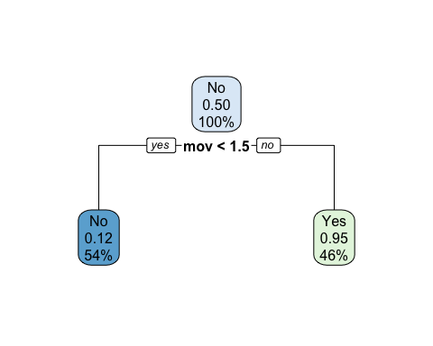

Evaluate Classification Tree
pred_tree <- predict(model_tree, test, type = "class")
conf_tree <- table(Predicted = pred_tree, Actual = test$good_team)
conf_tree
## Actual
## Predicted No Yes
## No 26 3
## Yes 1 23
accuracy_tree <- mean(pred_tree == test$good_team)
misclass_tree <- 1 - accuracy_tree
accuracy_tree
## [1] 0.9245283
misclass_tree
## [1] 0.0754717

SVM Model
model_svm <- svm(good_team ~ mov + srs + o_rtg + d_rtg + n_rtg + pace +
ts_percent + e_fg_percent + tov_percent + orb_percent +
drb_percent + opp_e_fg_percent + opp_tov_percent + ft_fga,
data = train,
kernel = "radial",
scale = TRUE)
model_svm
##
## Call:
## svm(formula = good_team ~ mov + srs + o_rtg + d_rtg + n_rtg + pace +
## ts_percent + e_fg_percent + tov_percent + orb_percent + drb_percent +
## opp_e_fg_percent + opp_tov_percent + ft_fga, data = train, kernel = "radial",
## scale = TRUE)
##
##
## Parameters:
## SVM-Type: C-classification
## SVM-Kernel: radial
## cost: 1
##
## Number of Support Vectors: 63

Evaluate SVM
pred_svm <- predict(model_svm, test)
conf_svm <- table(Predicted = pred_svm, Actual = test$good_team)
conf_svm
## Actual
## Predicted No Yes
## No 24 3
## Yes 3 23
accuracy_svm <- mean(pred_svm == test$good_team)
misclass_svm <- 1 - accuracy_svm
accuracy_svm
## [1] 0.8867925
misclass_svm
## [1] 0.1132075

Model Comparison
comparison <- data.frame(
Model = c("Logistic Regression", "Naive Bayes", "Classification Tree", "SVM"),
Accuracy = c(accuracy_log, accuracy_nb, accuracy_tree, accuracy_svm),
Misclassification_Rate = c(misclass_log, misclass_nb, misclass_tree, misclass_svm)
)
comparison
## Model Accuracy Misclassification_Rate
## 1 Logistic Regression 0.9245283 0.07547170
## 2 Naive Bayes 0.9056604 0.09433962
## 3 Classification Tree 0.9245283 0.07547170
## 4 SVM 0.8867925 0.11320755

Visualizations

Bar Plot of Good vs Not Good Teams
ggplot(nba_clean, aes(x = good_team, fill = good_team)) +
geom_bar() +
scale_fill_manual(values = c("Yes" = "darkgreen", "No" = "tomato")) +
labs(title = "Distribution of Good vs Not Good Teams",
x = "Good Team",
y = "Number of Teams") +
theme_minimal()
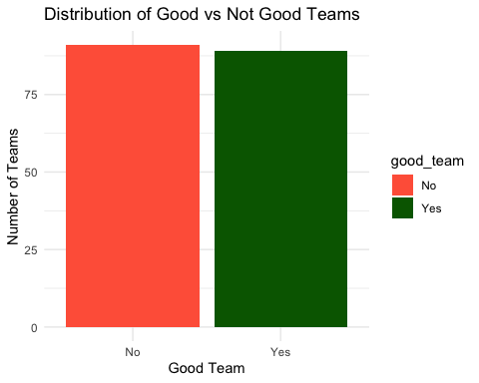

Model Accuracy Comparison Plot
ggplot(comparison, aes(x = Model, y = Accuracy, fill = Model)) +
geom_col() +
scale_fill_manual(values = c("steelblue", "orange", "purple", "darkred")) +
labs(title = "Accuracy Comparison Across Classification Models",
x = "Classification Model",
y = "Accuracy") +
ylim(0,1) +
theme_minimal() +
theme(legend.position = "none")
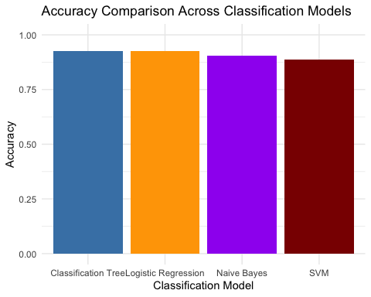

Wins by Good Team Classification
ggplot(nba_clean, aes(x = good_team, y = w, fill = good_team)) +
geom_boxplot() +
scale_fill_manual(values = c("Yes" = "gold", "No" = "skyblue")) +
labs(title = "Wins by Good Team Classification",
x = "Good Team",
y = "Wins") +
theme_minimal()
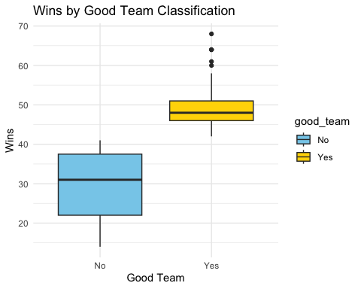

Classification Interpretation
For this classification section, a new response variable called good_team was created. Teams with wins above the median were classified as “Yes,” while teams at or below the median were classified as “No.” This allowed the models to predict whether an NBA team was a strong-performing team based on performance and shooting-efficiency variables.
The four classification models used were logistic regression, Naive Bayes, classification tree, and SVM. The best model is the model with the highest accuracy and lowest misclassification rate. This means it made the most correct predictions when classifying teams as good or not good.

Comparison of Classification vs other Statistical Methods
The overall project goal is to determine which NBA team is most likely to win using team performance and shooting-efficiency statistics. Different modeling approaches answer different types of questions.
If the goal is to predict the exact number of wins, regression methods such as Multiple Linear Regression or Principal Component Regression are generally more appropriate because the response variable w (wins) is continuous. Regression models usually perform better when estimating a numeric outcome.
If the goal is to predict whether a team is a strong-performing team or not, classification methods are more appropriate. In this section, teams were classified as good_team = Yes if wins were above the median and No otherwise. This converts the response into a binary outcome suitable for classification models.
Among the classification models tested, Support Vector Machine (SVM) is expected to perform best because it handles complex relationships well. Logistic Regression is typically close behind and is easier to interpret. Classification Trees provide visual decision rules, while Naive Bayes may perform lower because many NBA predictors are correlated.
Overall, classification is not automatically the best method for the full project. It is best for predicting categories, while regression is best for predicting the actual number of wins.

