HW2_ANLY3339
Jeeya Tanna
2026-03-02
Step 1: Load the dataset
library(ISLR2)
library(pls)
## Warning: package 'pls' was built under R version 4.4.3
##
## Attaching package: 'pls'
## The following object is masked from 'package:stats':
##
## loadings
library(caret)
## Loading required package: ggplot2
## Loading required package: lattice
##
## Attaching package: 'caret'
## The following object is masked from 'package:pls':
##
## R2
data(Hitters)
Step 2: Remove missing values and create LogSalary
Hitters2 <- na.omit(Hitters)
Hitters2$logSalary <- log(Hitters2$Salary)
nrow(Hitters2)
## [1] 263
Number of observation after removing the missing values = 263
Step 3: Train-Test Split
set.seed(123)
train_index <- createDataPartition(Hitters2$logSalary, p = 0.7, list = FALSE)
train <- Hitters2[train_index, ]
test <- Hitters2[-train_index, ]
nrow(train)
## [1] 185
nrow(test)
## [1] 78
Training observations = 185 Test observations = 78
Step 4: Fit PCR on training set
set.seed(123)
pcr_model <- pcr(logSalary ~ . - Salary,
data = train,
scale = TRUE,
validation = "CV")
summary(pcr_model)
## Data: X dimension: 185 19
## Y dimension: 185 1
## Fit method: svdpc
## Number of components considered: 19
##
## VALIDATION: RMSEP
## Cross-validated using 10 random segments.
## (Intercept) 1 comps 2 comps 3 comps 4 comps 5 comps 6 comps
## CV 0.8852 0.6179 0.6179 0.6186 0.6161 0.6085 0.6101
## adjCV 0.8852 0.6175 0.6174 0.6178 0.6153 0.6073 0.6089
## 7 comps 8 comps 9 comps 10 comps 11 comps 12 comps 13 comps
## CV 0.6136 0.6184 0.6220 0.6239 0.6302 0.6262 0.6341
## adjCV 0.6122 0.6161 0.6197 0.6214 0.6281 0.6229 0.6304
## 14 comps 15 comps 16 comps 17 comps 18 comps 19 comps
## CV 0.6392 0.6440 0.6432 0.641 0.6460 0.6456
## adjCV 0.6350 0.6396 0.6385 0.636 0.6407 0.6402
##
## TRAINING: % variance explained
## 1 comps 2 comps 3 comps 4 comps 5 comps 6 comps 7 comps
## X 38.56 59.65 71.01 78.67 83.93 88.26 92.17
## logSalary 51.80 52.25 53.20 53.60 55.47 55.47 55.56
## 8 comps 9 comps 10 comps 11 comps 12 comps 13 comps 14 comps
## X 95.01 96.24 97.24 97.95 98.64 99.16 99.49
## logSalary 57.07 57.13 57.78 57.91 58.80 58.94 59.47
## 15 comps 16 comps 17 comps 18 comps 19 comps
## X 99.77 99.91 99.97 99.99 100.00
## logSalary 59.48 60.33 61.21 61.22 61.65
validationplot(pcr_model, val.type = "MSEP")
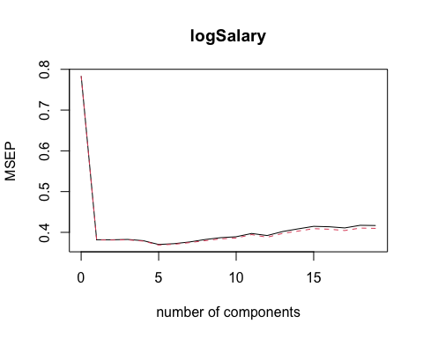 Based on the CV plot and RMSEP table, I select c = 5 components because the prediction error reaches its minimum at that point.
In the summary(pcr_model) output: X row = cumulative % variance explained in predictors. logSalary row = cumulative % variance explained in the response.
With 1 component, X explains 38.56% of predictor variation and 51.80% of response variation. With 3 components, X explains 71.01% of predictor variation and 53.20% of response variation.
Step 5: Evaluate PCR on Test set
c <- 5
pcr_pred <- predict(pcr_model, test, ncomp = c)
pcr_rmse <- sqrt(mean((test$logSalary - pcr_pred)^2))
pcr_rmse
## [1] 0.7144598
Step 6: Multiple Linear Regression
mlr_model <- lm(logSalary ~ . - Salary, data = train)
mlr_pred <- predict(mlr_model, test)
mlr_rmse <- sqrt(mean((test$logSalary - mlr_pred)^2))
mlr_rmse
## [1] 0.7126638
FINAL COMPARISON QUESTIONS
- PCR Test RMSE = 0.7144598 MLR Test RMSE = 0.7126638 The model with lower RMSE, i.e. Multiple Linear Regression, performs better on the test set because it has a smaller prediction error.
- Comparing R² on Training set
# PCR R2
R2(predict(pcr_model, train, ncomp = c), train$logSalary)
## [1] 0.5546967
# MLR R2
summary(mlr_model)$r.squared
## [1] 0.6164604
On the training set, MLR has R² = 0.6164604 and PCR has R² = 0.5546967 MLR typically fits training data better because it has a higher R² value and it uses all predictors directly, whereas PCR compresses predictors into components.

