In-Class Activity 10
Jeeya Tanna
2026-04-22
- Exploring the data
- Display the first few rows
url <- "https://raw.githubusercontent.com/fammediavilla2/datasets/main/toothpaste.csv"
toothpaste <- read.table(file = url, header = TRUE, sep = ",")
head(toothpaste)
## v1 v2 v3 v4 v5 v6 age age.cat gender
## 1 7 3 6 4 2 4 50 > 40 Female
## 2 1 3 2 4 5 4 27 < 30 Female
## 3 6 2 7 4 1 3 24 < 30 Female
## 4 4 5 4 6 2 5 21 < 30 Female
## 5 1 2 2 3 6 2 34 30 to 39 Female
## 6 6 3 6 4 2 4 39 30 to 39 Female
- Number of rows and columns
dim(toothpaste)
## [1] 60 9
- Columns for clustering
toothpaste[,1:6]
## v1 v2 v3 v4 v5 v6
## 1 7 3 6 4 2 4
## 2 1 3 2 4 5 4
## 3 6 2 7 4 1 3
## 4 4 5 4 6 2 5
## 5 1 2 2 3 6 2
## 6 6 3 6 4 2 4
## 7 5 3 6 3 4 3
## 8 6 4 7 4 1 4
## 9 3 4 2 3 6 3
## 10 2 6 2 6 7 6
## 11 6 4 7 3 2 3
## 12 2 3 1 4 5 4
## 13 7 2 6 4 1 3
## 14 4 6 4 5 3 6
## 15 1 3 2 2 6 4
## 16 6 4 6 3 3 4
## 17 5 3 6 3 3 4
## 18 7 3 7 4 1 4
## 19 2 4 3 3 6 3
## 20 3 5 3 6 4 6
## 21 1 3 2 3 5 3
## 22 5 4 5 4 2 4
## 23 2 2 1 5 4 4
## 24 4 6 4 6 4 7
## 25 6 5 4 2 1 4
## 26 3 5 4 6 4 7
## 27 4 4 7 2 2 5
## 28 3 7 2 6 4 3
## 29 4 6 3 7 2 7
## 30 2 3 2 4 7 2
## 31 7 3 6 4 2 4
## 32 1 3 2 4 5 4
## 33 6 2 7 4 1 3
## 34 4 5 4 6 2 5
## 35 1 2 2 3 6 2
## 36 6 3 6 4 2 4
## 37 5 3 6 3 4 3
## 38 6 4 7 4 1 4
## 39 3 4 2 3 6 3
## 40 2 6 2 6 7 6
## 41 6 4 7 3 2 3
## 42 2 3 1 4 5 4
## 43 7 2 6 4 1 3
## 44 4 6 4 5 3 6
## 45 1 3 2 2 6 4
## 46 6 4 6 3 3 4
## 47 5 3 6 3 3 4
## 48 7 3 7 4 1 4
## 49 2 4 3 3 6 3
## 50 3 5 3 6 4 6
## 51 1 3 2 3 5 3
## 52 5 4 5 4 2 4
## 53 2 2 1 5 4 4
## 54 4 6 4 6 4 7
## 55 6 5 4 2 1 4
## 56 3 5 4 6 4 7
## 57 4 4 7 2 2 5
## 58 3 7 2 6 4 3
## 59 4 6 3 7 2 7
## 60 2 3 2 4 7 2
- Elbow Plot
tot.withinss <- vector(mode = "numeric", length = 10)
set.seed(123)
for (i in 1:10) {
irisCluster <- kmeans(toothpaste[,1:6], centers = i, nstart = 10)
tot.withinss[i] <- irisCluster$tot.withinss
}
plot(1:10, tot.withinss, type = "b", pch = 19,
main = "Elbow Plot",
ylab = "Total Within SS",
xlab = "Number of Clusters")
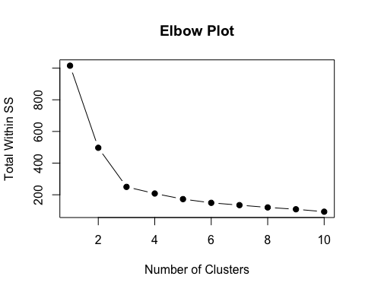
- K-means Clustering
set.seed(123)
kmeans_result <- kmeans(toothpaste[,1:6], centers = 3, nstart = 10)
kmeans_result
## K-means clustering with 3 clusters of sizes 18, 16, 26
##
## Cluster means:
## v1 v2 v3 v4 v5 v6
## 1 1.666667 3.000000 1.888889 3.444444 5.555556 3.222222
## 2 3.375000 5.750000 3.250000 6.000000 3.750000 5.875000
## 3 5.846154 3.384615 6.153846 3.384615 1.923077 3.769231
##
## Clustering vector:
## [1] 3 1 3 2 1 3 3 3 1 2 3 1 3 2 1 3 3 3 1 2 1 3 1 2 3 2 3 2 2 1 3 1 3 2 1 3 3 3
## [39] 1 2 3 1 3 2 1 3 3 3 1 2 1 3 1 2 3 2 3 2 2 1
##
## Within cluster sum of squares by cluster:
## [1] 57.77778 90.50000 101.53846
## (between_SS / total_SS = 75.4 %)
##
## Available components:
##
## [1] "cluster" "centers" "totss" "withinss" "tot.withinss"
## [6] "betweenss" "size" "iter" "ifault"
- Distance Matrix
dist_matrix <- dist(toothpaste[,1:6])
- Complete linkage dendrogram
hc_complete <- hclust(dist_matrix, method = "complete")
plot(hc_complete)
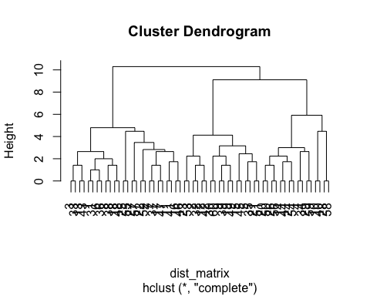 c) Cut tree (complete linkage)
cutree(hc_complete, k = 3)
## [1] 1 2 1 3 2 1 1 1 2 3 1 2 1 3 2 1 1 1 2 3 2 1 2 3 1 3 1 3 3 2 1 2 1 3 2 1 1 1
## [39] 2 3 1 2 1 3 2 1 1 1 2 3 2 1 2 3 1 3 1 3 3 2
- Single Linkage dendrogram
hc_single <- hclust(dist_matrix, method = "single")
plot(hc_single)
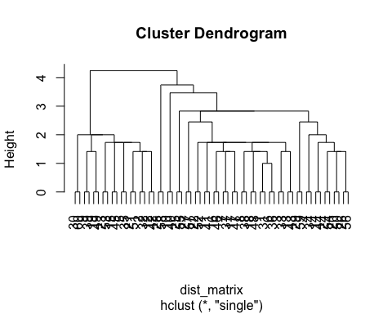
- Cut Tree
cutree(hc_single, k = 2)
## [1] 1 2 1 1 2 1 1 1 2 1 1 2 1 1 2 1 1 1 2 1 2 1 2 1 1 1 1 1 1 2 1 2 1 1 2 1 1 1
## [39] 2 1 1 2 1 1 2 1 1 1 2 1 2 1 2 1 1 1 1 1 1 2

