InClassActivity5
Jeeya Tanna
2026-03-11
Step 1 Loading Dataset
library(splines)
data(airquality)
aq <- na.omit(airquality[, c("Ozone","Temp")])
head(aq)
## Ozone Temp
## 1 41 67
## 2 36 72
## 3 12 74
## 4 18 62
## 6 28 66
## 7 23 65
Step 2 Train-Test Split
set.seed(1)
n <- nrow(aq)
train_index <- sample(1:n, size = 0.7*n)
train <- aq[train_index, ]
test <- aq[-train_index, ]
nrow(train)
## [1] 81
nrow(test)
## [1] 35
Step 3
cor(train$Ozone, train$Temp)
## [1] 0.6902236
plot(train$Temp, train$Ozone,
xlab="Temperature",
ylab="Ozone",
main="Ozone vs Temperature")
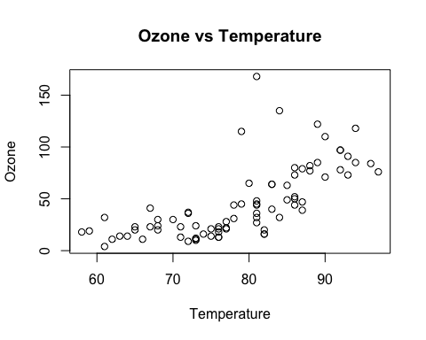
Step 4
lm_model <- lm(Ozone ~ Temp, data=train)
summary(lm_model)
##
## Call:
## lm(formula = Ozone ~ Temp, data = train)
##
## Residuals:
## Min 1Q Median 3Q Max
## -38.094 -18.183 -2.976 8.965 116.391
##
## Coefficients:
## Estimate Std. Error t value Pr(>|t|)
## (Intercept) -149.6929 23.2520 -6.438 8.68e-09 ***
## Temp 2.4852 0.2931 8.478 1.02e-12 ***
## ---
## Signif. codes: 0 '***' 0.001 '**' 0.01 '*' 0.05 '.' 0.1 ' ' 1
##
## Residual standard error: 25.06 on 79 degrees of freedom
## Multiple R-squared: 0.4764, Adjusted R-squared: 0.4698
## F-statistic: 71.88 on 1 and 79 DF, p-value: 1.017e-12
plot(lm_model$fitted.values, lm_model$residuals,
xlab="Fitted Values",
ylab="Residuals",
main="Residuals vs Fitted")
abline(h=0)
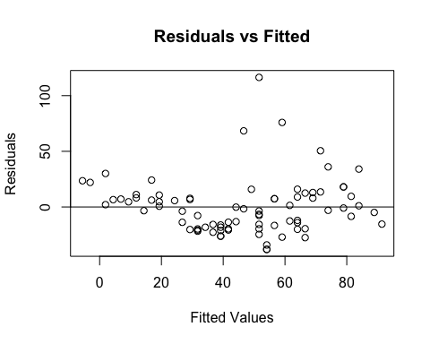
AIC(lm_model)
## [1] 755.7132
Step 5
poly_model <- lm(Ozone ~ poly(Temp,2), data=train)
summary(poly_model)
##
## Call:
## lm(formula = Ozone ~ poly(Temp, 2), data = train)
##
## Residuals:
## Min 1Q Median 3Q Max
## -34.125 -14.222 -3.109 10.486 121.778
##
## Coefficients:
## Estimate Std. Error t value Pr(>|t|)
## (Intercept) 46.025 2.697 17.063 < 2e-16 ***
## poly(Temp, 2)1 212.497 24.276 8.753 3.25e-13 ***
## poly(Temp, 2)2 60.506 24.276 2.492 0.0148 *
## ---
## Signif. codes: 0 '***' 0.001 '**' 0.01 '*' 0.05 '.' 0.1 ' ' 1
##
## Residual standard error: 24.28 on 78 degrees of freedom
## Multiple R-squared: 0.515, Adjusted R-squared: 0.5026
## F-statistic: 41.42 on 2 and 78 DF, p-value: 5.53e-13
AIC(poly_model)
## [1] 751.506
Step 6
quad_spline <- lm(Ozone ~ bs(Temp, degree=2), data=train)
AIC(quad_spline)
## [1] 751.506
Step 7
cubic_spline <- lm(Ozone ~ bs(Temp, degree=3), data=train)
AIC(cubic_spline)
## [1] 751.0481
Step 8
natural_spline <- lm(Ozone ~ ns(Temp), data=train)
AIC(natural_spline)
## [1] 755.7132
Step 9 Smoothing Spline models
spline_gcv <- smooth.spline(train$Temp, train$Ozone)
RSS_gcv <- sum((train$Ozone - predict(spline_gcv, train$Temp)$y)^2)
df_gcv <- spline_gcv$df
AIC_gcv <- nrow(train) * log(RSS_gcv / nrow(train)) + 2 * df_gcv
spline_df6 <- smooth.spline(train$Temp, train$Ozone, df=6)
RSS_df6 <- sum((train$Ozone - predict(spline_df6, train$Temp)$y)^2)
df6 <- spline_df6$df
AIC_df6 <- nrow(train) * log(RSS_df6 / nrow(train)) + 2 * df6
spline_df10 <- smooth.spline(train$Temp, train$Ozone, df=10)
RSS_df10 <- sum((train$Ozone - predict(spline_df10, train$Temp)$y)^2)
df10 <- spline_df10$df
AIC_df10 <- nrow(train) * log(RSS_df10 / nrow(train)) + 2 * df10
AIC_gcv
## [1] 518.0631
AIC_df6
## [1] 518.6785
AIC_df10
## [1] 519.5451
Step 10 Evaluate models on Test Data
rmse <- function(actual, predicted) {
sqrt(mean((actual - predicted)^2))
}
pred_lm <- predict(lm_model, newdata=test)
pred_poly <- predict(poly_model, newdata=test)
pred_quad <- predict(quad_spline, newdata=test)
## Warning in bs(Temp, degree = 2L, knots = numeric(0), Boundary.knots = c(58L, :
## some 'x' values beyond boundary knots may cause ill-conditioned bases
pred_cubic <- predict(cubic_spline, newdata=test)
## Warning in bs(Temp, degree = 3L, knots = numeric(0), Boundary.knots = c(58L, :
## some 'x' values beyond boundary knots may cause ill-conditioned bases
pred_ns <- predict(natural_spline, newdata=test)
pred_spline_gcv <- predict(spline_gcv, test$Temp)$y
pred_spline_df6 <- predict(spline_df6, test$Temp)$y
pred_spline_df10 <- predict(spline_df10, test$Temp)$y
rmse_lm <- rmse(test$Ozone, pred_lm)
rmse_poly <- rmse(test$Ozone, pred_poly)
rmse_quad <- rmse(test$Ozone, pred_quad)
rmse_cubic <- rmse(test$Ozone, pred_cubic)
rmse_ns <- rmse(test$Ozone, pred_ns)
rmse_spline_gcv <- rmse(test$Ozone, pred_spline_gcv)
rmse_spline_df6 <- rmse(test$Ozone, pred_spline_df6)
rmse_spline_df10 <- rmse(test$Ozone, pred_spline_df10)
rmse_lm
## [1] 20.59966
rmse_poly
## [1] 18.17453
rmse_quad
## [1] 18.17453
rmse_cubic
## [1] 19.10977
rmse_ns
## [1] 20.59966
rmse_spline_gcv
## [1] 18.13169
rmse_spline_df6
## [1] 18.09552
rmse_spline_df10
## [1] 19.13715

