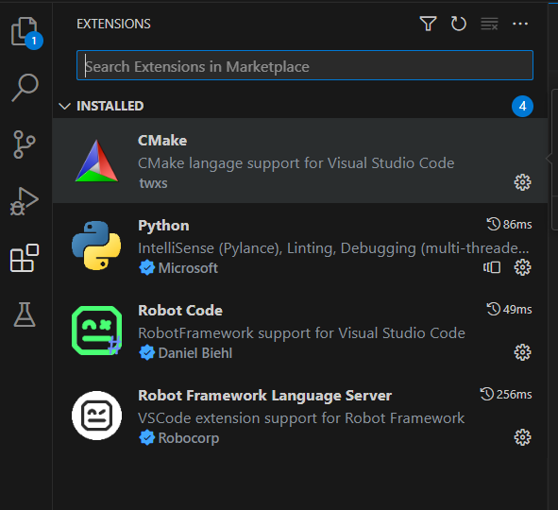

pip install robotframework

pip install --upgrade robotframework-seleniumlibrary

pip install pyYAML

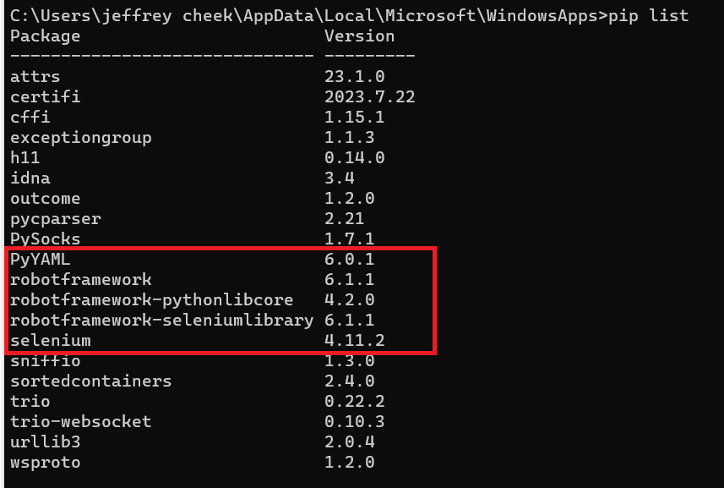

Create a work folder (any name) where the robot script, chrome driver, customer.yaml are to be placed

Get Chrome driver (depending on the Chrome version used) from

https://chromedriver.chromium.org/downloads/version-selection

Unzip the file and place chromedriver.exe in the same folder as the robot script

Download Assessment.robot and customer.yaml files from git repository provided and place them in the folder

