Deploy LAMP Stack using Docker

Installed packages on EC2:
- Git
- Docker Compose (+ epel + python-pip)
- cURL

WorkFlow:
- Clone the Git Project
- Instantiate the containers using docker-compose
- Connect to the mysql container
- Create table and fill it
- Exit mysql container
- cURL apache server (localhost:80) from the EC2 instance; or EC2_IP_ADDRESS:80 from browser

Architecture:
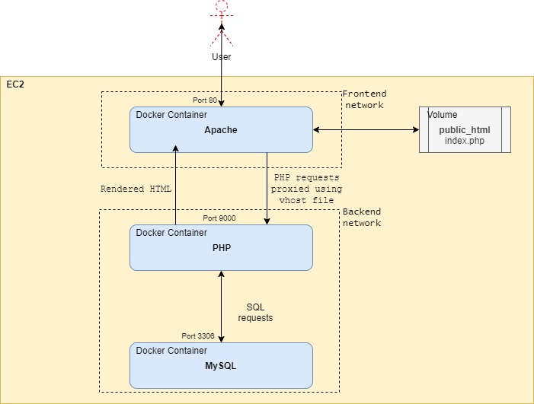

With RDS instead of MySQL docker
Create RDS
Change RDS SG with EC2 private IP as Source.
In the system docker.service file, add the following line:
DOCKER_OPTS="—dns 10.0.0.2 --dns 8.8.8.8 --dns 8.8.4.4"
Where 10.0.0.2 is the VPC’s DNS server IP address.
This has to be done because the requests from within the container hit the public ip of the RDS rather than the private (which is how the security groups work). It looks like the DNS inside the docker container was using the 8.8.8.8 google dns and that wouldn't turn the rds endpoint into the private ip.
http://blog.thestateofme.com/2015/09/01/forwarding-dns-queries-to-aws-vpc-resolvers/

