Supplementary material
What does a vortex-generator retrofit cost the drivetrain? Fleet evidence for the load price of an energy gain at an operating wind farm
Yi Wang

Table S1. Share of 10-minute records kept by the normal-operation filter (%), per turbine and year
Turbine | 2020 | 2021 | 2022 | 2023
T01 | 84.0 | 78.1 | 72.7 | 70.5
T02 | 80.5 | 76.8 | 66.4 | 68.4
T03 | 84.9 | 77.8 | 71.5 | 72.9
T04 | 84.7 | 78.0 | 74.3 | 72.4
T05 | 83.7 | 79.6 | 70.5 | 68.6
T06 | 74.7 | 43.9 | 44.6 | 66.4
T07 | 85.7 | 80.3 | 74.3 | 74.4
T08 | 83.9 | 78.2 | 74.5 | 70.8
T09 | 83.0 | 79.4 | 73.6 | 72.8
T10 | 80.0 | 74.1 | 71.3 | 66.2
T11 | 84.3 | 78.2 | 78.9 | 67.7
T12 | 86.2 | 80.7 | 75.9 | 74.3
T13 | 86.4 | 80.7 | 78.3 | 74.9
T14 | 85.3 | 80.5 | 77.5 | 76.5
T15 | 78.6 | 74.5 | 57.9 | 64.2
T16 | 18.4 | 22.2 | 12.9 | 25.2
T17 | 34.2 | 52.8 | 47.1 | 47.5
T18 | 75.2 | 65.9 | 59.5 | 63.7
T19 | 80.8 | 74.8 | 68.8 | 65.0
T20 | 83.7 | 75.8 | 71.2 | 69.5
T21 | 85.2 | 78.9 | 74.9 | 71.7
Kept = shutdown duration zero, P > 0, power set-point ≥ 2290 kW and main-shaft speed > 0.3 rad/s. All turbines: 77.3% (2020), 71.9% (2021), 66.6% (2022), 66.9% (2023).

Supplementary figures
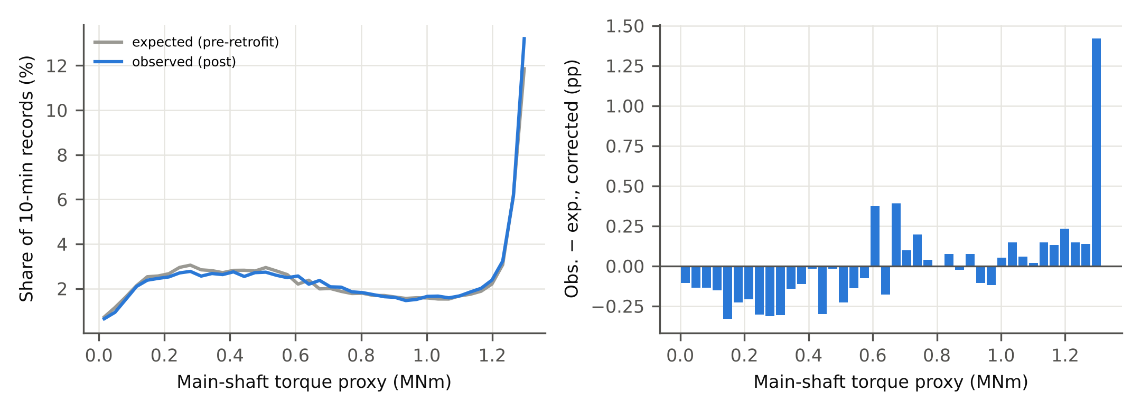 Fig. S1. T13 torque spectrum after the retrofit, observed versus expected from pre-retrofit cells (a), and the drift-corrected difference (b).
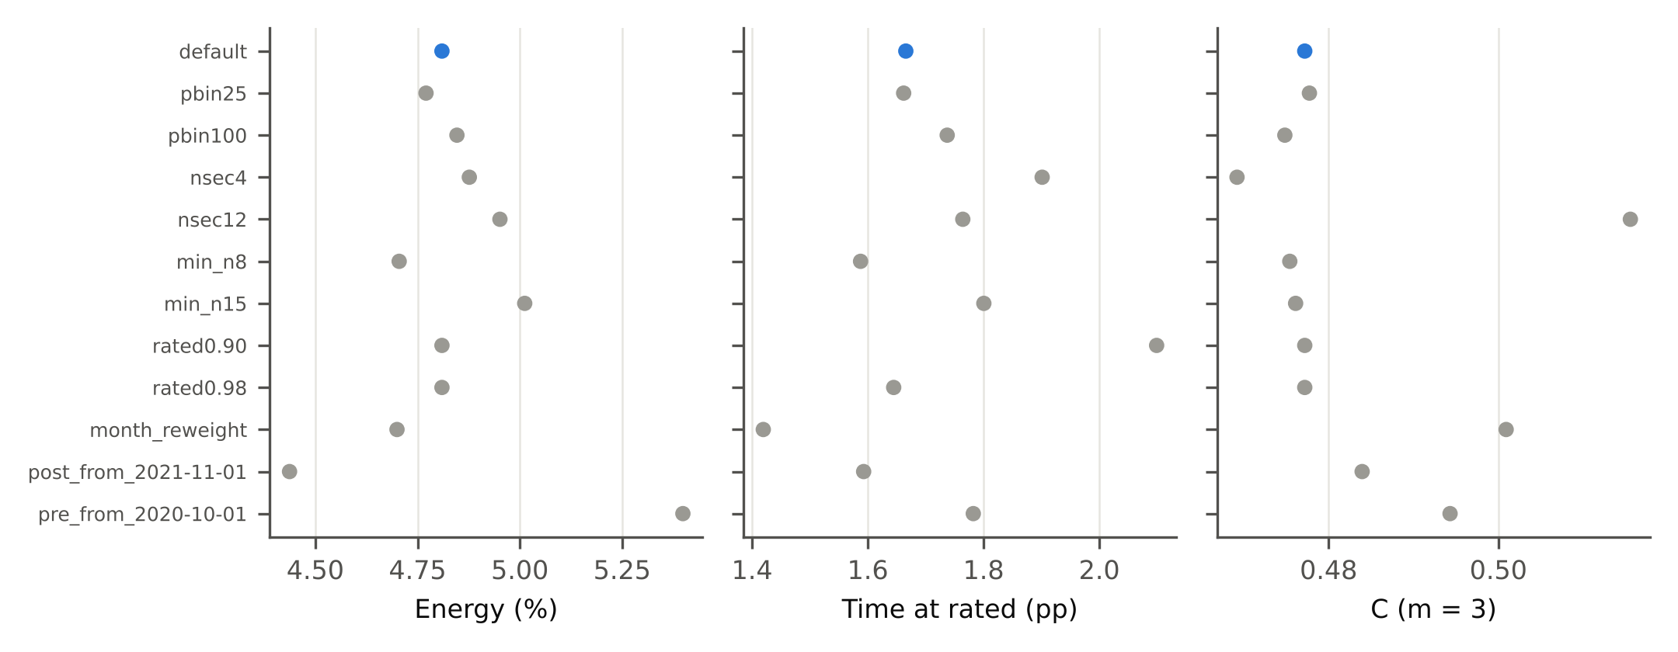 Fig. S2. Sensitivity of the drift-corrected T13 effects to one-at-a-time changes of the specification.
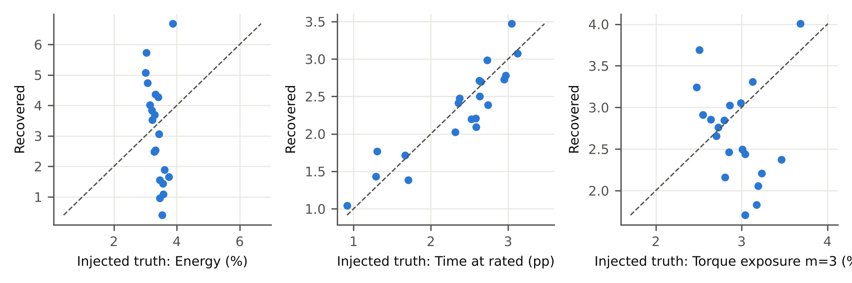 Fig. S3. Known-truth check: +4% power (capped) injected into each unmodified turbine; recovered versus injected values. The median is recovered without bias; the spread across turbines reflects each turbine’s own null drift.
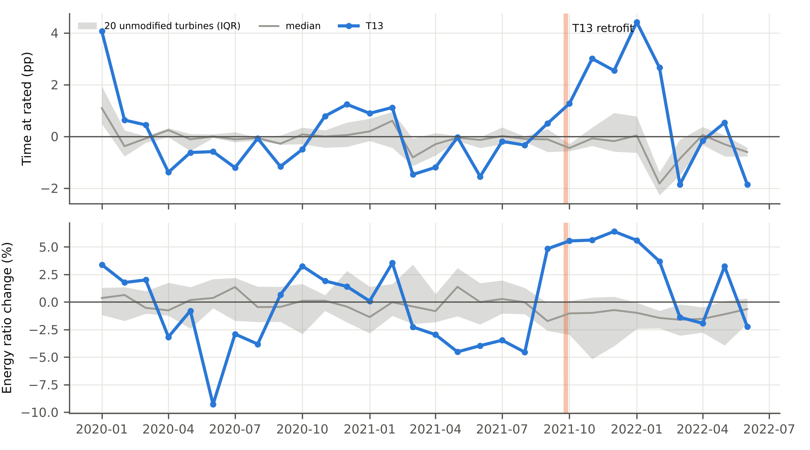 Fig. S4. Monthly effects relative to the pre-retrofit cells for T13 (blue) and the unmodified turbines (median and interquartile range). Pre-retrofit months are in-sample and show T13’s own seasonal deviation from the fleet.
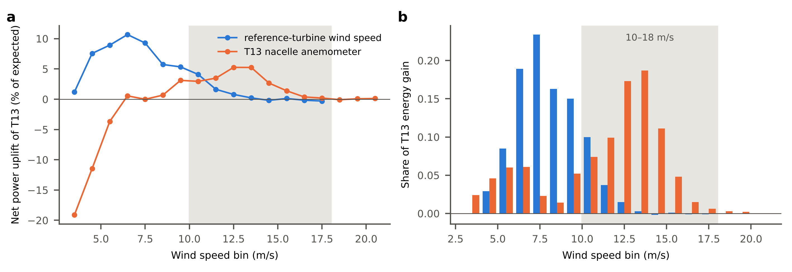 Fig. S5. T13’s drift-corrected effect by 1 m/s wind-speed bin, binned on the mean nacelle wind speed of the reference turbines (blue) and on T13’s own nacelle anemometer (orange). (a) Net power uplift relative to expected power; (b) share of T13’s total net energy gain. Bins holding less than 0.5% of records are omitted. Shaded: 10–18 m/s, where [20] locates most of the gain.

