# Overview

The Jeffro Tools Suite is an Eclipse plug-in that provides useful utilities to the users. Once installed, you will see a new toolbar in Eclipse that looks like this:



The functionality provided by each button can be found below.

# Jeffro Plugin Preferences

This button launches the Eclipse preference page for the plugin.

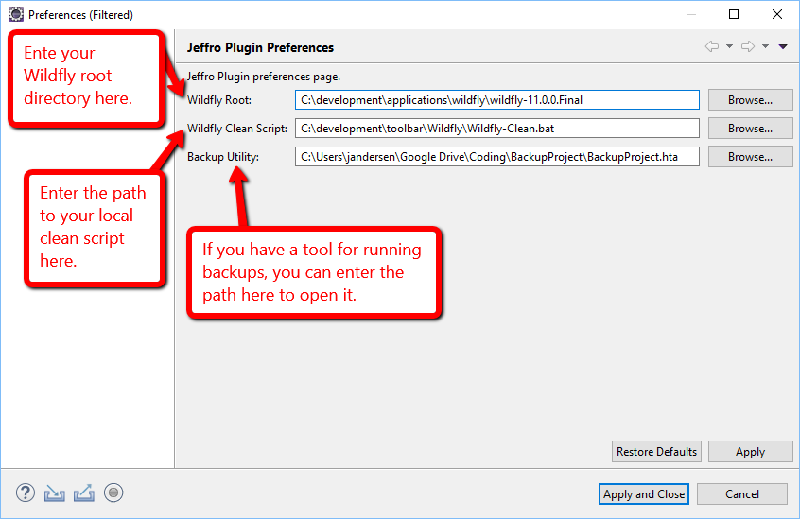

|  |  |
| --- | --- |
| Preference | Used By |
| Wildfly Root |  |
| Wildfly Clean Script |  |
| Backup Utility |  |

# Wildfly Deep Clean

The Wildfly Deep Clean button is used to launch your local clean script for deep cleaning Wildfly.

If you haven’t defined the location of the local script file yet, clicking the button will result in an error indicating the preference hasn’t been set and, after clicking Ok, opens the Jeffro Plugin Preferences dialog.

# Wildfly configuration Directory

This “Wildfly configuration Directory” button will open your configuration directory in Windows File Explorer.

If you haven’t defined the location of the Wildfly root, clicking the button will result in an error indicating the preference hasn’t been set and, after clicking Ok, opens the Jeffro Plugin Preferences dialog.

# Wildfly deployment Directory

This “Wildfly deployment Directory” button will open your deployment directory in Windows File Explorer.

If you haven’t defined the location of the Wildfly root, clicking the button will result in an error indicating the preference hasn’t been set and, after clicking Ok, opens the Jeffro Plugin Preferences dialog.

# Wildfly standalone Directory

This “Wildfly standalone Directory” button will open your standalone directory in Windows File Explorer.

If you haven’t defined the location of the Wildfly root, clicking the button will result in an error indicating the preference hasn’t been set and, after clicking Ok, opens the Jeffro Plugin Preferences dialog.

# Wildfly “standalone.xml” File

The “Wildfly ‘Standalone.xml’ File” button will open your standalone.xml file in the Eclipse XML editor.

If you haven’t defined the location of the Wildfly root, clicking the button will result in an error indicating the preference hasn’t been set and, after clicking Ok, opens the Jeffro Plugin Preferences dialog.

# Backup Utility

The “Backup Utility” button will open the backup utility that you’ve defined.

If you haven’t defined the location of the backup utility, clicking the button will result in an error indicating the preference hasn’t been set and, after clicking Ok, opens the Jeffro Plugin Preferences dialog.

# Open Eclipse Workspace Directory

The “Open Eclipse Workspace Directory” button will open your current workspace in Windows File Explorer.

# Installing

To install the plugin, simply use the following update site:

<https://raw.githubusercontent.com/jeff-a-andersen/JeffroPlugin/master/JeffroUpdateSite>

NOTE: You will get a 404 error if you attempt to load the URL above into your browser. It will still work in Eclipse as depicted below:

