Title

Jeff Goldsmith

2018-06-18 14:13:21

## R Markdown

The time and date is 2018-06-18 14:13:21.

This is an R Markdown document. Markdown is a simple formatting syntax for authoring HTML, PDF, and MS Word documents. For more details on using R Markdown see <http://rmarkdown.rstudio.com>.

When you click the **Knit** button a document will be generated that includes both content as well as the output of any embedded R code chunks within the document. You can embed an R code chunk like this:

# this is a comment  
summary(cars)

## speed dist   
## Min. : 4.0 Min. : 2.00   
## 1st Qu.:12.0 1st Qu.: 26.00   
## Median :15.0 Median : 36.00   
## Mean :15.4 Mean : 42.98   
## 3rd Qu.:19.0 3rd Qu.: 56.00   
## Max. :25.0 Max. :120.00

x = 7

The value of x is 7.

## Including Plots

You can also embed plots, for example:

plot(pressure)

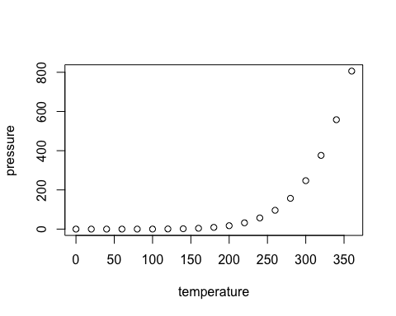

Note that the echo = FALSE parameter was added to the code chunk to prevent printing of the R code that generated the plot.