## New Free Campaign Generator for SparkPost

## Yes Free

I’m happy to say that a new free application has been created to fill this whole. The application, “[Campaign Generator for SparkPost” (CG)](http://www.geekwithapersonality.com/cgi-bin/cgKey.php) takes a nifty approach of using your own API Key’s in a web hosted application so there is NO install or set-up unless you want to download the application from a GitHub site at <https://github.com/jeff-goldstein/CampaignGeneratorSparkPost> and use the application on premise.

CG is not competition for a full campaign manager system like those that supports segmentation, data management and reporting; this is a lite weight campaign generator that has some fairly cool capabilities that you won’t see anywhere else. Before getting started on details about the application, as [one of the architects] the architect of the application I want to tell you about one of the founding principles of the application, “keep no data”. As it will be described below, the user will enter in a SparkPost API key in order for the application to obtain SparkPost account information like stored template names, recipient lists, sending domain names, etc. What is does not do is store information about your account on the CG server. To be clear, it will not store your API Key or User Data at all. We welcome feature enhancement requests as-long-as it can be done leveraging the SparkPost API’s and does not involve storing any data on the CG server.

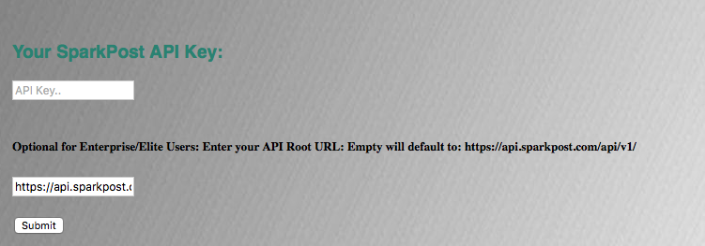OK, with that out of the way, let’s talk about the application feature set in some detail. The landing page for the application is at <http://www.geekwithapersonality.com/cgi-bin/cgKey.php>. If you are a SparkPost.com users, all you have to do is enter a SparkPost API Key that has the following rights: 'Recipient Lists: Read/Write, Templates: Read/Write, Transmissions: Read/Write and Sending Domains: Read'.

If you are a SparkPost Elite/Enterprise customer, you need to enter your API root URL as well. That’s it! The CG system will now be able to schedule and cancel campaigns on your behalf.

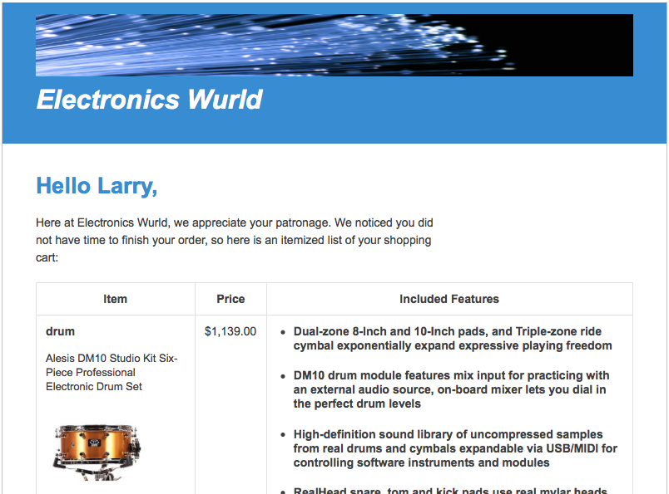For Campaign Generation, the system allows for two different approaches, one where you leverage both stored templates and stored recipients and the other where you can paste in your own CSV or JSON list of recipients along with their substitution data. Most of the fields and features for both approaches are the same. They both use stored templates, allow for campaigns to be immediately kicked off or scheduled for up to one month out (SparkPost limitation), create a campaign name, set open and click tracking flags and create up to 5 metadata key/value pairs.

Both approaches also allow for the user to preview what the email may look like. The CG system takes the template and the data from the **first** recipient and merges them together to show you what the email would look like for that user.

While this goes a long way in helping the user to see if they have the right set of data for this particular template, the CG system goes further and tries to match the template substitution data to the recipients substitution data to see how many fields

match.

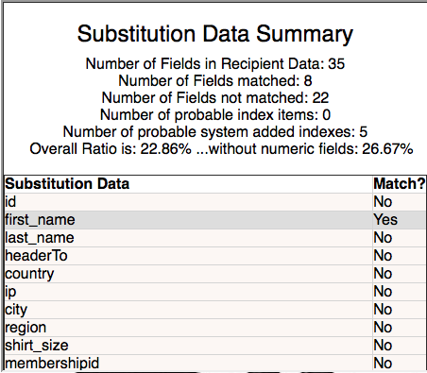

The [CG documentation/help](http://www.geekswithapersonality.com/cgi-bin/cgHelp.php#validate) will walk you through what each summary number means but in general, what we see here is that we found 35 data fields for the first recipient in the recipient list and only 8 of those fields are being used in the selected template. Now that might be exactly what they user expected if they tend to store extra data for each recipient. That approach can save development a lot of time by not coding a bunch of branches in order to store only specific data that each template is expected to use. This may also help the template writer if they know that a given set of data will always be available. The CG system also does the reverse comparison, where it starts with the template, scan’s to see all of the substitution fields that are used and then compares it to the first recipient. I know, way cool.

While on the subject of missing data I want to point out a trick you can use in a template in order to stop the email from being generated if certain data is missing. In the above preview picture you see a picture of a drum; the supporting data for that row and other corresponding product rows is an array of products called ‘ProductList’. If ProductList does not exist I don’t want the email to go out, so at the end of the template I have added the following entry:

{{if !ProductList}} <h5 class="hidden">MISSING KEY DATA</h5> {{if crash(onpurpose) }}{{end}}{{end}}

What this is doing, is calling a non-existent function ‘crash(onpurpose)’ if ProductList does not exist. This will cause the campaign generator to fail, and gracefully stop the generation of that single email. In this example, “MISSING KEY DATA’ text is a way to document what is going on; it is not needed for actual use.

The reason I point this out is that CG is coded to look for the error message “attempt to call non-existent macro” that is produced when a bad function is called during the preview process. So if that first recipient which is used in the email preview doesn’t have the validated data, CG will throw up an alert box and set the submit button to a state where the campaign can not be sent until the issue is fixed. If you know that the first user will fail in this way, and you want to use that template/recipient list combo, just don’t do a preview before hitting the submit button.

Now that we have that info, lets dig further into how recipient data is used and entered into the CG system. As described, the first approach is to simply use one of the stored recipient lists for your account. But if you don’t have stored recipients or you want to use the CG system with a list that is not already stored, you can enter them into the CG system either by CSV list or a JSON structure. Most people know what a Comma Separated Value list is and how to work them. Because SparkPost doesn’t understand the CSV format, the CSV list must be converted into a JSON structure in order to be used; which it can do for you. That means the CG system needs to impose some rules to the CSV file:

* The only field that MUST be in the list is the “address” field that holds the users email address for the email; all other fields are optional.
* The first row is a list of the field names.
* All following rows are for data.
* If you are using recipient level substitution data, you MUST have a field called “substitution”, and it’s corresponding data will be an underscore in each data row.

For further info, please see the [CG Help Text](http://www.geekswithapersonality.com/cgi-bin/cgHelp.php#CSVJSON). You can enter up to 700k of data, so you can enter in a lot of recipients. The ‘Convert to JSON’ button will take that CSV list and convert the data into a structure that SparkPost understands, JSON; and place the output in the field directly below the CSV data entry field. Another output of the convert process is the number of rows converted; check to make sure it’s in the ballpark you were expecting ☺. If you wish to enter JSON directly without going through CSV, you may do so.

Some of you may be saying, but what about global data? Well that is supported in both Campaign Generation approaches. There is a data entry field that is displayed when you press the ‘Show Global Sub’ button. In that field, you can enter up to 70k of global substitution data! That data will not only be used in the email, but is used in the Preview and the Template/Data comparisons.

Earlier we talked about the ability to create five key/value metadata pairs. This is how many of you will set binding or ip_pools or any information that you want to capture throughout the web hook events. I picked that number out of thin air so if more is needed, please send me some feedback.

I’m not going to say this was a short blog but in the interest of wrapping this up, I’m now going to tell you of one last feature; the ability to cancel a campaign. The ‘Manage Scheduled Campaigns’ tab will take you to a table showing you a list of your scheduled campaigns. All you need to do is to copy one of the Campaign Id’s and

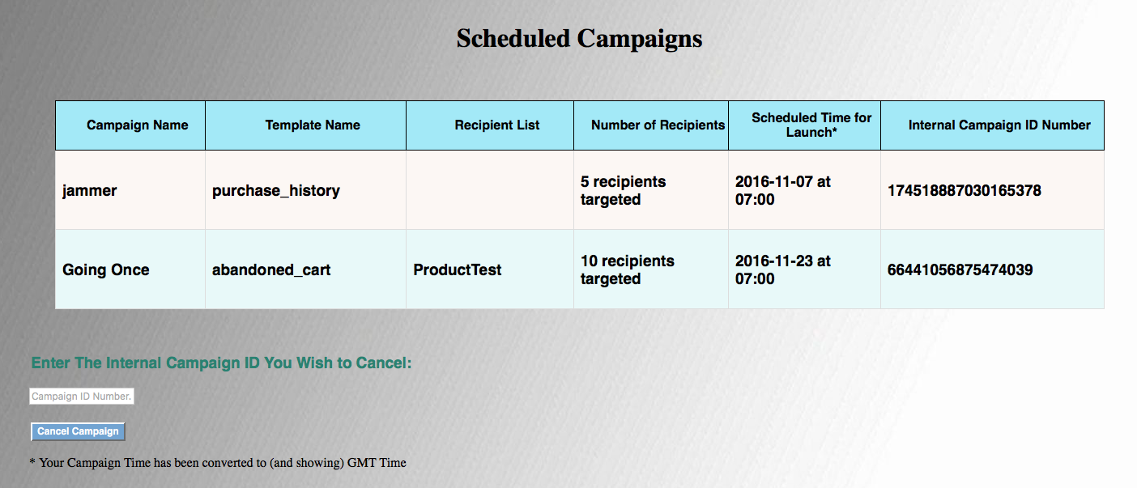

paste it into the field at the bottom of the page, then press the ‘Cancel Campaign’ button. Right now, any Campaign that has 10 minutes before it’s scheduled time can be cancelled.

OK, so wrapping this up. Campaign Generator for SparkPost is free, and ready for you to use. Because it does NOT hold any data and uses your API Keys, you won’t see anyone else’s data and they won’t see yours. Please hit the ‘Contact’ link at the top if you have any questions, find any bugs, or have any enhancement requests. This is open sourced so if you want to fix something or add something, please feel free, all help is appreciated.