2024 Adobe Summit Recap: Adobe Commerce

Adobe Summit 2024 was a remarkable event, bringing together the Adobe Commerce community, including industry-leading customers, visionary partners, and our Adobe Commerce team to connect, explore, and learn. All of the content featuring sessions with Hanesbrands, Coca-Cola, Nestle, Unilever, Canon, and more are now available on demand!

Here were some top highlights from Adobe Summit 2024.

Adobe Commerce Roadmap Session

We kicked off the conference with an innovation-packed Adobe Commerce Roadmap session where we showcased how Adobe Commerce is empowering companies to innovate faster and accelerate sales with an experience-led platform.

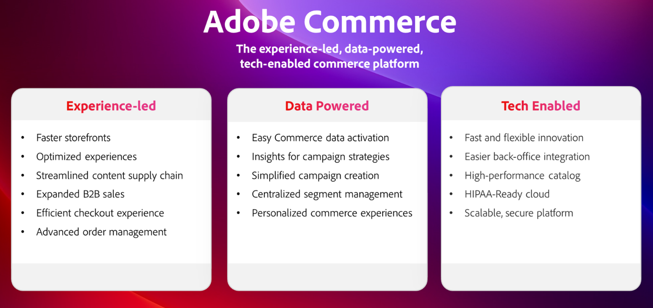

Watch this session to learn how Adobe Commerce is delivering:
- Faster storefront experiences: Our new high-performance storefront architecture, Edge Delivery Services, boosts site speed, SEO rankings, and organic traffic. Plus, a new integration with Adobe Experience Manager Assets streamlines your content supply chain with access to GenAI content development and workflow management.
- Hyper-personalized buying journeys: Automatically collect and share real-time storefront clicks, backend order history, and now, customer profile data with other Adobe Experience Cloud solutions. Automate omni-channel campaign set-up with Use Case Playbooks and personalize commerce mobile apps and upsell/cross-sell offers using Adobe Real-Time CDP audiences.
- Simplified composable development: Innovate faster with lower costs using Adobe Developer App Builder. Simplify integrations to your ERP and other backend systems with the new back-office integration starter kit. Configure webhooks and customize the Admin UI through a unified developer experience including API orchestration, event management, and serverless extensibility.
- Advanced B2B Commerce and Order Management: Boost B2B sales with advanced quoting tools and parent-child account configuration to support large, global accounts and B2B2X use cases. Connect to IBM Sterling Order Management faster than ever with our new pre-built integration to maximize operational efficiency with real-time inventory management, automated order fulfillment, returns management, and a full set of dashboards and workflows.

Powerful Customer & Partner Sessions

Our innovative community of Adobe Commerce customers and partners also shared their strategies, best practices, and learnings.

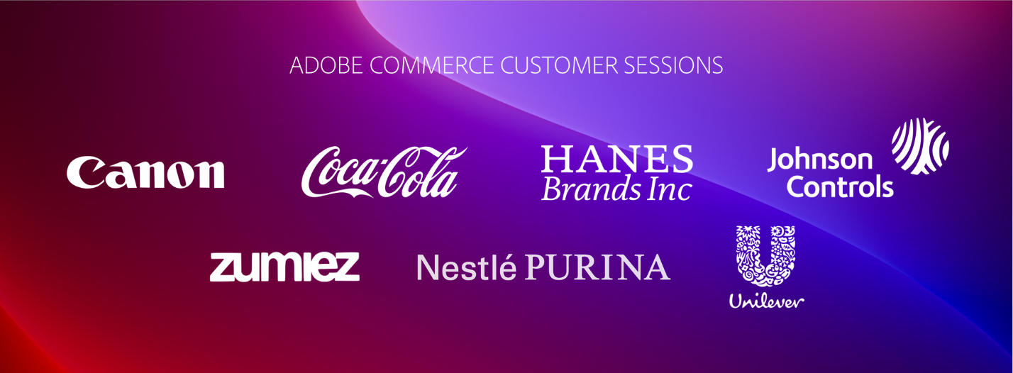

Explore the full slate of Commerce sessions here and check out some of the hottest sessions below:
- How Unilever Digitized Its Distributive Trade Route to Market Globally with Prashaant Huria, VP & CTO, Unilever; Prashant was selected as Experience Maker of the Year in APAC
- E-Comm Masterclass: Hanesbrands Creates the World’s Fastest Storefront with Emmylou Jordan, Sr. Manager Global Business Insights and Data Analytics, Hanesbrands
- Coca-Cola: Unlocking Data to Create Consumer-Centric Commerce Experiences with Vinay Gopinath, Director of Global Adtech/Martech Platforms, The Coca-Cola Company
- How Canon Increased Conversion Rates and Traffic Using Adobe Commerce with Matthew Mandato, Manager of Martech Engagement Ops, Canon USA
- Nestle Purina: Build a Composable Platform for Business Agility with Adobe Commerce with Ben Robie, Sr. Technical Manager D2C, Nestle Purina

Innovation Showcase with Adobe Commerce Rockstars

Every year, we shine a light on what the most innovative customer and partner developers are creating with Adobe Commerce. Check out the Adobe Commerce Rockstar Showcase where we heard from the Top 3 submissions, selected from over 65:
- Storefront Innovation with Edge Delivery Services and Luma Bridge
Martin Altmann, Principal Consultant & Adobe Practice Lead, Comwrap Reply
- App Builder Integrations for Lean Order Management
Shikha Raina, Architect, Bounteous
- Master GPT GenAI Recommended Product Content Creation
Yaroslav Rogoza, CTO, Atwix

See who was crowned the 2024 Adobe Commerce Rockstar!

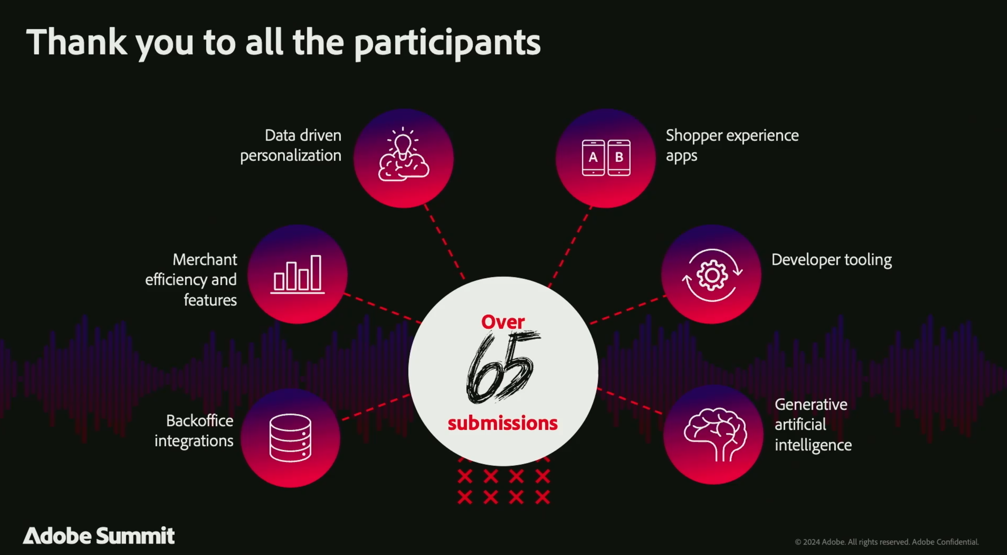

Relive all the great sessions by diving into the on-demand content and always stay up-to-date on the latest innovations for Adobe Commerce on Experience League.

