# Maxwell’s Maze

## Summary

This is a board puzzle maze with 3 balls you use the controls to tilt the maze to move the balls to the end goals. A time continues to count up until all the balls are moved into the final positions at the end of the maze. Once all 3 balls are in the final positions the game ends. You can play again to try to beat your time or end the game.

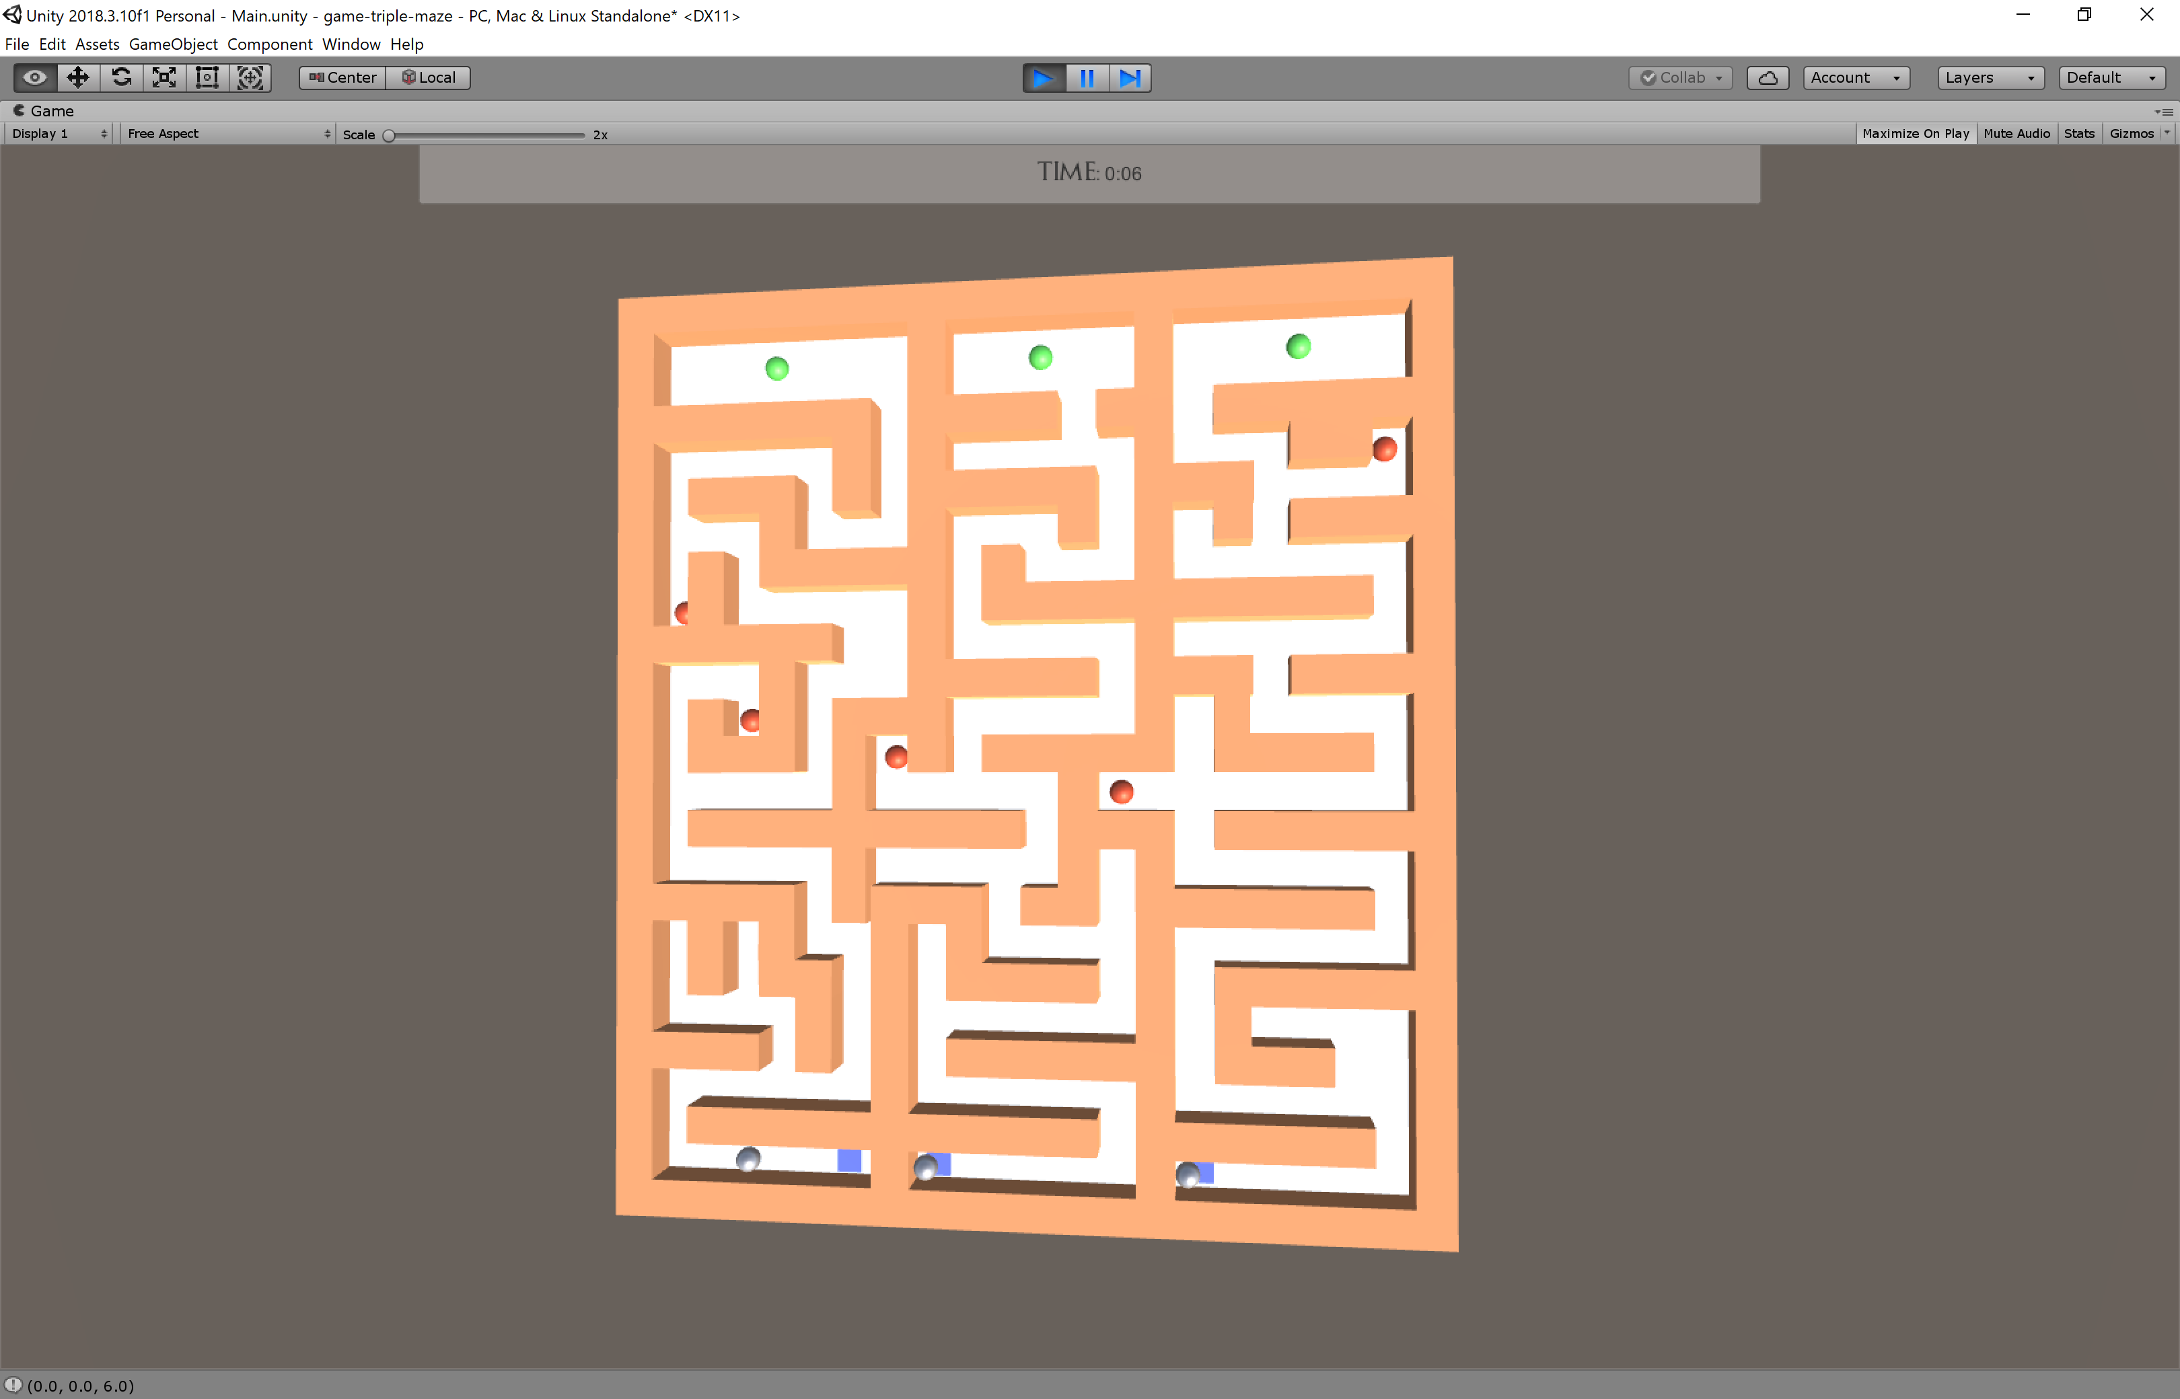

* **Blue Squares** – Starting points for the balls.
* **Silver Balls** – 3 game balls that move through the maze.
* **Red Holes** – Reset the ball back to the starting point.
* **Green Holes** – Finish holes for the end of the game.