Collared Pika Distance Sampling Analysis

Jeff Wagner

This is a breakdown of an analysis of collared pika *(Ochotona collaris)* data collected by the Alaska Center for Conservation Science in 2018-2019. The data was collected following a spatially-explicit distance sampling approach (Royle et al. 2004). Analysis was conducted in Program R (version 4.2.0) with package *unmarked* (version 1.2.5) and predictors were compiled via an ArcGIS Pro Python installation (version 3.6+).

### **Top Model Set:**

AICc model selection table

|  | Model | K | AICc | Delta AICc | Model Likelihood | AICc Weight | Log Likelihood | Cumulative Weight |
| --- | --- | --- | --- | --- | --- | --- | --- | --- |
| 6 | climate & productivity | 8 | 717.5533 | 0.000000 | 1.0000000 | 0.5530377 | -350.1221 | 0.5530377 |
| 2 | climate | 7 | 718.1131 | 0.559722 | 0.7558888 | 0.4180350 | -351.5520 | 0.9710726 |
| 4 | climate & topography | 10 | 724.1778 | 6.624476 | 0.0364345 | 0.0201497 | -351.0704 | 0.9912223 |
| 5 | productivity | 6 | 726.6358 | 9.082469 | 0.0106602 | 0.0058955 | -356.9429 | 0.9971178 |
| 1 | null | 4 | 728.3336 | 10.780211 | 0.0045615 | 0.0025227 | -359.9913 | 0.9996405 |
| 3 | topography | 7 | 732.2302 | 14.676900 | 0.0006501 | 0.0003595 | -358.6106 | 1.0000000 |

### *Climate & Productivity Model*

##### Summary and Parameter Estimates

##   
## Call:  
## distsamp(formula = ~scale(search.speed) ~ scale(precip) + scale(summerWarmth) +   
## scale(logs) + scale(wetness), data = umf, keyfun = "hazard",   
## output = "density", unitsOut = "kmsq")  
##   
## Density (log-scale):  
## Estimate SE z P(>|z|)  
## (Intercept) 3.3709 0.187 18.002 1.87e-72  
## scale(precip) 0.2546 0.132 1.935 5.30e-02  
## scale(summerWarmth) -0.1125 0.131 -0.862 3.89e-01  
## scale(logs) -0.3369 0.144 -2.341 1.92e-02  
## scale(wetness) 0.0572 0.092 0.622 5.34e-01  
##   
## Detection (log-scale):  
## Estimate SE z P(>|z|)  
## (Intercept) 1.807 0.302 5.99 2.13e-09  
## scale(search.speed) -0.919 0.139 -6.60 4.08e-11  
##   
## Hazard-rate(scale) (log-scale):  
## Estimate SE z P(>|z|)  
## 0.645 0.144 4.47 7.67e-06  
##   
## AIC: 716.2442   
## Number of sites: 119  
## optim convergence code: 0  
## optim iterations: 66   
## Bootstrap iterations: 0   
##   
## Survey design: line-transect  
## Detection function: hazard  
## UnitsIn: m  
## UnitsOut: kmsq

## 0.025 0.975  
## lam(Int) 3.003864741 3.73785253  
## lam(scale(precip)) -0.003322409 0.51251299  
## lam(scale(summerWarmth)) -0.368336709 0.14337161  
## lam(scale(logs)) -0.618936678 -0.05488722  
## lam(scale(wetness)) -0.123144545 0.23755487

##### Plot

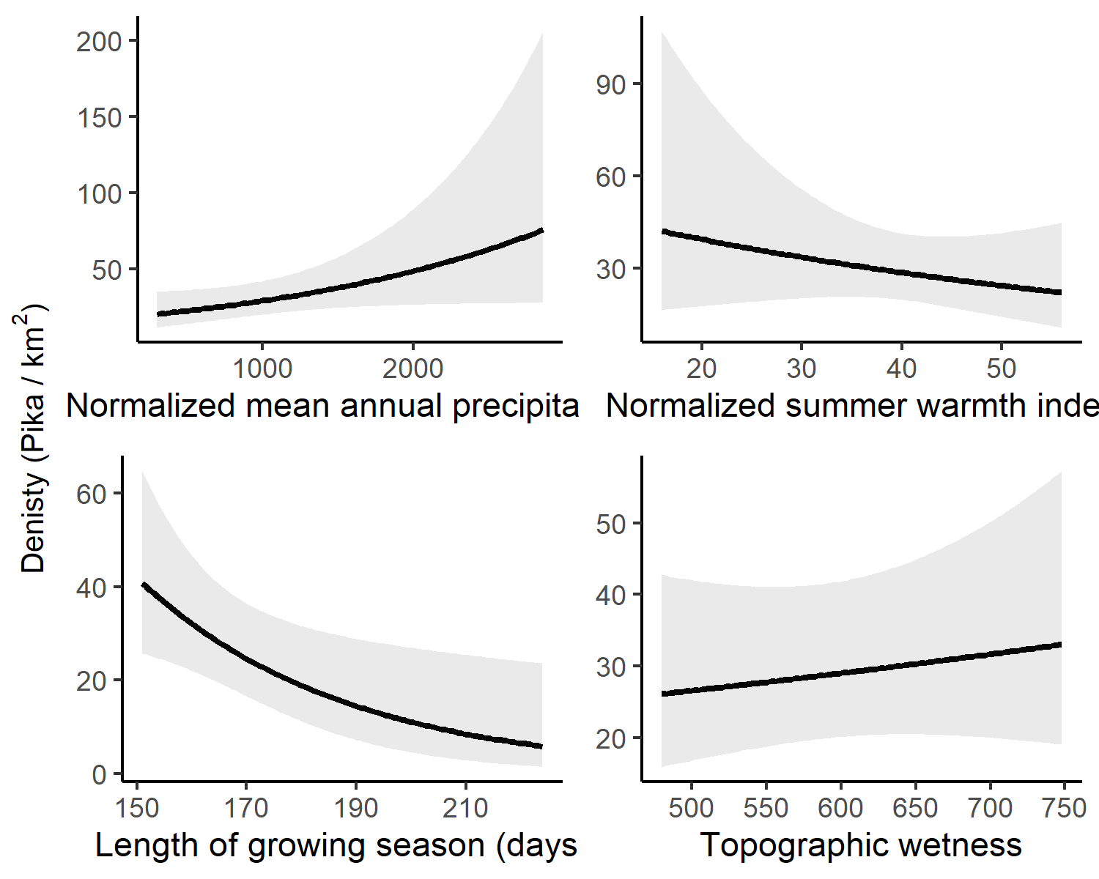

### *Climate Model*

##### Summary and Parameter Estimates

##   
## Call:  
## distsamp(formula = ~scale(search.speed) ~ scale(precip) + scale(summerWarmth) +   
## scale(januaryMinTemp), data = umf, keyfun = "hazard", output = "density",   
## unitsOut = "kmsq")  
##   
## Density (log-scale):  
## Estimate SE z P(>|z|)  
## (Intercept) 3.375 0.1808 18.66 9.56e-78  
## scale(precip) 0.147 0.1042 1.41 1.59e-01  
## scale(summerWarmth) -0.314 0.1165 -2.69 7.11e-03  
## scale(januaryMinTemp) -0.203 0.0972 -2.09 3.68e-02  
##   
## Detection (log-scale):  
## Estimate SE z P(>|z|)  
## (Intercept) 1.868 0.285 6.55 5.91e-11  
## scale(search.speed) -0.875 0.131 -6.67 2.61e-11  
##   
## Hazard-rate(scale) (log-scale):  
## Estimate SE z P(>|z|)  
## 0.668 0.143 4.68 2.93e-06  
##   
## AIC: 717.1041   
## Number of sites: 119  
## optim convergence code: 0  
## optim iterations: 43   
## Bootstrap iterations: 0   
##   
## Survey design: line-transect  
## Detection function: hazard  
## UnitsIn: m  
## UnitsOut: kmsq

## 0.025 0.975  
## lam(Int) 3.02045512 3.72922671  
## lam(scale(precip)) -0.05730811 0.35119781  
## lam(scale(summerWarmth)) -0.54211845 -0.08528593  
## lam(scale(januaryMinTemp)) -0.39341201 -0.01239293

##### Plot

