Tributes to Alaskan Wildlifers and Friends
Sigurd T. “Sig” Olson
Sigurd T. Olson, long-time resident of Douglas, Alaska and renowned Alaskan wildlife biologist passed away at the Juneau Pioneers Home, December 21, 2008 at the age of 85.
Sig was born in Ely, Minnesota, September 15, 1923 — the eldest son of internationally famous conservationist Sigurd F. Olson and wife Elizabeth Dorothy Olson. Sig's father (1899–1982) was one of the first advocates of establishing the Boundary Waters Canoe Area on the Superior National Forest in northern Minnesota and the author of many books and articles on conservation practices, wilderness, and the BWCA.
Sig followed in his father's footsteps and during his graduate studies as a Wildlife Biologist authored a thesis on his studies of the loon, which remains an important research publication of that species.
Sig was a combat veteran of WWII, serving in the US Army Mountain Ski Division. He was serving in Italy at the time of its liberation from the dictatorship of Benito Mussolini, who was captured and hanged by Italian civilians fairly near where Sig was in service.
Sig's wife, Esther was also born in Ely, Minnesota. Sig and Esther were married in Austin, Texas in 1944. After WWII and graduation from college, Sig and Esther moved to Alaska, settling in Douglas in 1959. They later lived in Anchorage for six years and returned to Douglas in 1978. Sig and Esther had two sons, Greg and Robert, and several grand children.
After Sig came to Alaska, he first worked as a biologist for the U.S. Fish and Wildlife Service and later with the U.S. Forest Service. Sig not only served as Director of Wildlife and Sport Fisheries programs with the USFS, but also served on the state-wide team evaluating all of Alaska's lands for Alaska National Interest land designations by the Congress and President.
After retirement from the US Forest Service, Sig remained active with various wildlife and fisheries professional organizations, but he and Esther were able to devote more time to hiking, skiing, canoeing, and gardening and to various programs in the Douglas Methodist Church. Sig remained an active leader in the development and operation of the Eaglecrest Ski area until he moved from his home to Indian Cove and the Juneau Pioneers Home earlier this year.
Sig's many friends throughout the community always enjoyed his exuberant love of Alaska, his visits to Eaglecrest, and the daily walks on the Sandy Beach and Treadwell trails. Everyone appreciated Sig's sense of humor and fond memories of the Boundary Waters in Minnesota and vast array of experiences throughout Alaska. Sig was a skilled writer and poet and enjoyed recalling rhymes he learned as a youth. "Be the labor great or small — do it well or not at all!" was an admonition he shared within various organizations in which he served.
Sigurd T. Olson's outstanding lifetime of service to his country during WWII; his eminent career as a wildlife biologist; and his personal life as an Alaskan husband, father, sportsman, skier, and faithful member of the Douglas Community and Methodist Church will forever be remembered by his family, co-workers, and friends. — John Sandor
Additional memories of Sig:
Sig Olson was one of Alaska's pioneer wildlife biologists. He lived and worked in southeast Alaska for many years and was involved in early deer research. Those of us who knew Sig remember him as a true gentleman who loved wildlife and the outdoors. — John Schoen
Besides his interest in wildlife, Sig was an avid skier and served many years on the Juneau Ski Patrol. He was among the hearty Juneau skiers who spent countless hours developing the ski area at Dan Moeller (just above the bridge on Douglas Island) and later was actively involved in the development of Juneau's Eaglecrest ski area. — Doug Larsen
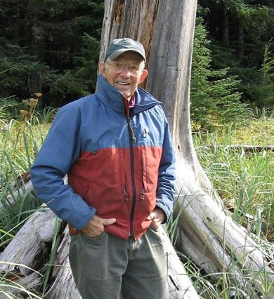
Photo by Greg Olson
Michele "Shelly" Szepanski
Fairbanks resident, Michele "Shelly" Szepanski, died peacefully in Minnesota on Dec. 4, 2008, after a courageous four-year battle with melanoma. Like us, many of you knew Shelly as a friend and professional colleague. She contributed substantially in her short life to the conservation of Alaska’s wildlife and she will be greatly missed.
Shelly was born in Minneapolis on Feb. 4, 1967, and lived in Juneau, Anchorage, McGrath, and Fairbanks for most of her 41 years. She graduated from Juneau-Douglas High School in 1985 and was a member of the All-State Girls' High School basketball team her junior and senior years.
Shelly was fascinated with the outdoors and its wildlife resources throughout her life. She received a B.S. in Biological Sciences from the University of Alaska, Fairbanks (UAF) and a M.S. in Wildlife Resources from the University of Idaho. Her M.S. research involved the study of marine resources in the diet of the Alexander Archipelago wolf using stable isotope analysis. She spent one summer working under Dr. David Mech in Northern Minnesota on wolf and deer population dynamics, and three years with the U.S. Forest Service in Juneau, working on habitat assessment projects for ungulates, sea birds, and marine mammals. Shelly developed long-lasting relationships with many ADF&G biologists while working on a variety of research projects in Juneau, Anchorage, and Fairbanks. In 2001 she became the Assistant Area Wildlife Biologist in McGrath. She was instrumental in the successful undertaking of field operations during the McGrath predator control project, assisting with bear, wolf, and moose calf captures and necropsies, and data management and analyses. She returned to Fairbanks in January, 2004 to begin a Ph.D. project through UAF, measuring large-scale dynamics of moose nutrition across Interior and Southwest Alaska.
While battling cancer, Shelly continued to work on her doctorate degree and also earned her pilot's license. She purchased a plane, flew cross-country flights from Fairbanks to McGrath and Anchorage, and enjoyed a solo fly-in caribou hunt. During her time in Minnesota, she began taking dressage lessons and was an increasingly proficient rider. Throughout her life, Shelly maintained her love for the outdoors and Alaska. Her positive, self-confident nature was an inspiration to her friends and colleagues.
Shelly is survived by her parents, Lynn and Bill Szepanski of Anoka, Minnesota; her sister and brother-in-law, Jennifer and Steve Mendive of Palmer; grandmother, Lorraine Waller of Minnesota; and her good friends, Kalin Kellie, Heather Wilson, and Caroline Brown of Alaska.
Shelly's cremains will be spread at various Alaska locations, according to her wishes. For more about Shelly and her inspiring life, please visit http://shellyszepanski.blogspot.com/.
It’s often said that we, in the natural resources profession, are a family. We believe this to be true. As we unite in grieving the loss of our close friend and “family member”, we respectfully ask that we also unite in celebrating the love of life and the many contributions Shelly made to many of us, personally, as well as to the natural resources we all care so passionately about. Let’s ensure Shelly’s life remains a legacy for all of us to aspire to. —Kalin Kellie and Doug Larsen
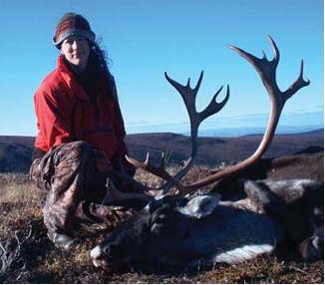
Photo provided by Kalin Kellie

