Resources

Intensive Management in Alaska Overview
- Stories of Success - Alaska's intensive management programs incorporate science and action to benefit Alaskans.

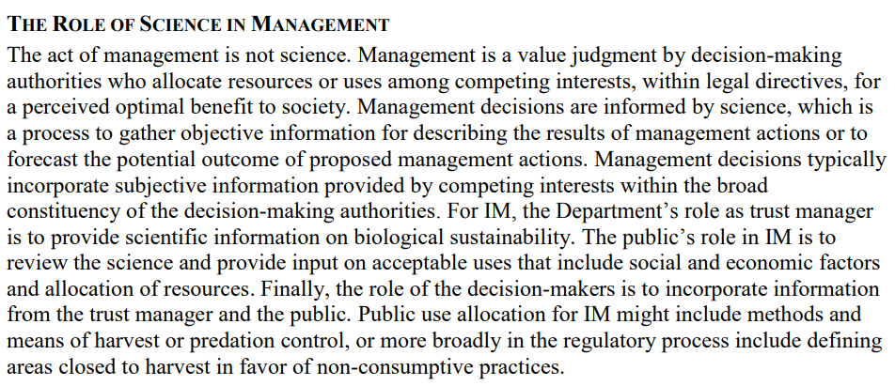

Audience
BOG copy to commissioner DVL, copy to governor

What is our ask of them?
pull the plug? require benchmarks?
directly address they ignore the NRC report?
in light of… ask for clarity on how they got here?
prioritize finishing existing research, and publishing under peer review lit

Introduction
The Wildlife Society (TWS) was founded in 1937 and is a non-profit scientific and educational association …

Background
Mulchatna Caribou on the decline, yadda yadda yadda
Predator prey dynamics intro

Predator Control, Ungulate Management, and Science
Failure to adhere to recommendations made in the NRC review
- Literally could not have followed it because nothing was known about range quality (i.e., predator control will NOT work if adequate range doesn’t exist) and bog never considered habitat, well, at all.
- also, without knowing anything defensible about bear density, how could adfg know when “enough” of them had been killed (following NRC recommendations)?
- 2009 ADFG set parameters for IM to follow, these include: blah blah blah identify a need, make a plan, “intense research, public opinion, and the law”
- transparent process guided by law and public input.

Legal Concerns/public involvement

what was the plan? did ADFG follow a plan? benchmarks? nothing?
- no public involvement
- no analysis and recommendation by the state (could this be a requirement?)
- effectively a new proposal, “amended” old proposal to completely change species, area, technique, existing data
- overtly ignored the best available science (bring in quotes from Demma/Renae’s presentation?)
- No part of the IM plan was followed. Not the area affected, not the number of predators killed, not the harvest of carcasses, no samples for disease monitoring were collected first year, nor the monitoring of effects, nor calf survival monitoring (first year; 3 caught, one died from it)

Recommendations?
if you do this, treat it like an experiment, gather data, have thresholds and benchmarks, be transparent, etc
as you know, alaska is big on saying science first–work that in somewhere

Things to keep in mind
- “population has crashed” which implies there’s a right place to be. vs. its a low point in the cycle
- if you do this, treat it like an experiment, gather data, have thresholds and benchmarks, be transparent, etc
- Hoffman's comment at ~1:46:15 remaining says a lot. "Every predator is making a HUGE impact right now."
- Ryan's comments about "a myriad of factors" and "a combination of a lot of things that are happening" (~1:44:00) is interesting. Also, Huntington's comment (~1:37:30) that this was the best talk he's ever seen was nice - but went nowhere, obviously.
- This is what I have for original budgets, not all of which were spent out. That would take more work than I care to do right now. And, again, these won't include every expense, such as admin time. Obviously S&I expenses aren't included here, either.
  - MCH calf study: $722,082
  - GMU 17 wolves: $992,089
  - MCH herd health: $595,788

- calf:cow ratios isn’t the end all be all
- 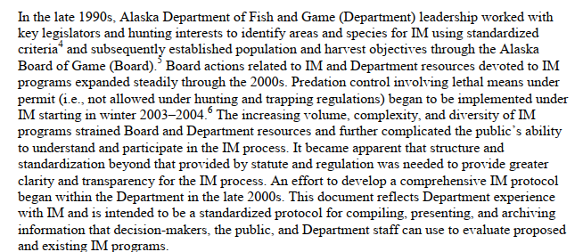

Feasibility assessment (does this exist? not available anywhere)
If done properly, would we even have landed on approving IM
Operational plan: operational plan for intensive management
Department report: Annual Report to the Alaska Board of Game on Intensive Management for Mulchatna Caribou with Wolf and Bear Predation Control in Game Management Unit

