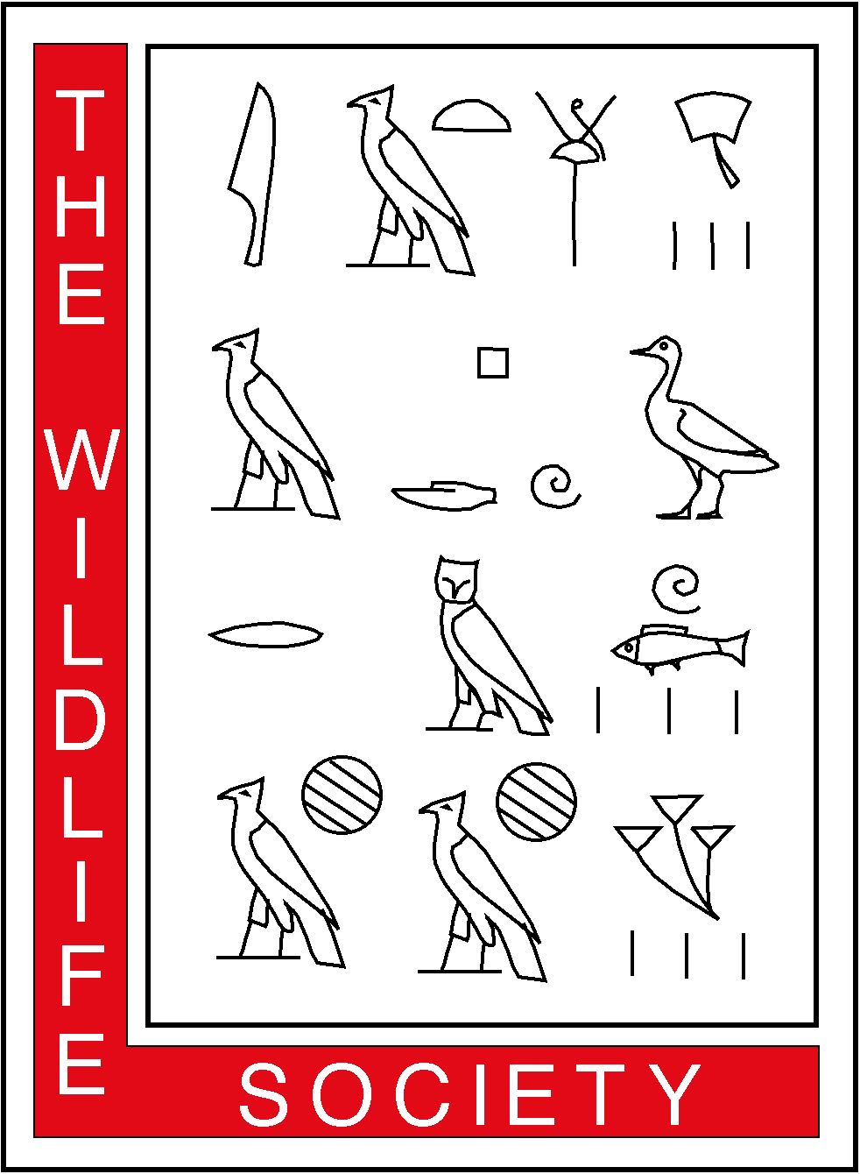
15 January 2006
THE WILDLIFE SOCIETY
ALASKA CHAPTER
P.O. Box 242454
Anchorage, Alaska 99524-2454

Senator ___________________
State Capitol, Room _________
Juneau, Alaska 99801-1182

Dear Senator_______________:

I am writing to introduce The Wildlife Society (TWS) and offer the professional experience and expertise of the TWS Alaska Chapter on issues related to wildlife conservation and management in Alaska. TWS was founded in 1937 by a group of scientists and managers; today, the Society has over 8,000 members in 90 universities, 50 states, and 60 countries (please see www.wildlife.org). In addition to The Journal of Wildlife Management, Wildlife Monographs, and the Wildlife Society Bulletin, TWS publishes the benchmark manual, Techniques for Wildlife Investigations and Management. TWS also conducts and publishes technical reviews of specific topics, including the recent release of Global Climate Change and Wildlife in North America.

The Alaska Chapter of TWS was founded in 1971 and today includes over 200 wildlife professionals employed by state, federal, and local fish and game agencies, academic institutions, non-governmental conservation organizations, and private industry. The Alaska Chapter is dedicated to excellence in wildlife stewardship through science and education. Our mission is to enhance the ability of wildlife professionals to conserve biological diversity, sustain productivity, and ensure responsible and sustainable use of wildlife resources in Alaska for the benefit of society.

The TWS Alaska Chapter has helped state and federal legislators and others evaluate complex wildlife management and habitat conservation issues via technical reviews and expert witnesses. In 2002, the Alaska Chapter TWS published the technical review entitled Reintroducing Wood Bison to the Upper Yukon Valley, Alaska: A Feasibility Assessment. The Alaska Chapter is currently conducting technical reviews on three aspects of brown and black bear management: population control, baiting, and the sale of parts. Our membership includes wildlife professionals with recognized expertise in population biology, habitat ecology, predator-prey management, climate change, and wildlife disease. In summary, the Alaska Chapter TWS can provide expertise and develop/assess science-based alternatives for the conservation and management of wildlife and habitat in Alaska.

Current information on the TWS Alaska Chapter including newsletters, position statements, and executive board members is available under Sections and Chapters at www.wildlife.org. If you have questions, or if you would like to discuss any wildlife conservation issue, please contact me at 301-897-9770 or eric@wildlife.org. Please note I am currently on detail to The Wildlife Society in Bethesda, Maryland through September 2006.

Sincerely,
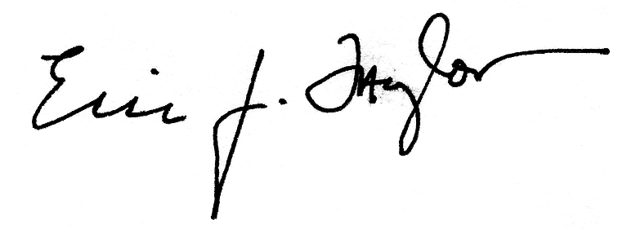

Eric J. Taylor
President, TWS Alaska Chapter

