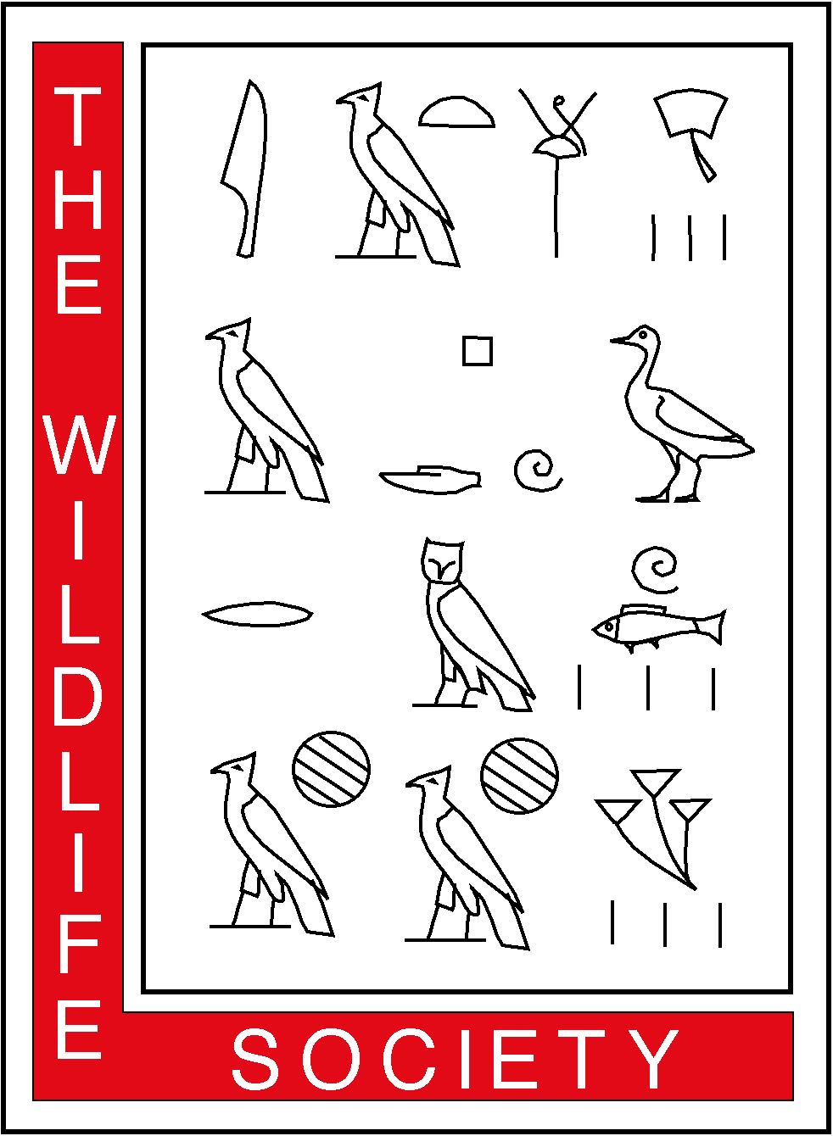
THE WILDLIFE SOCIETY
ALASKA CHAPTER
1910 Glacier Avenue • Juneau, AK 99801

October 30, 2003

NE NPR-A Amendment Planning Team
Bureau of Land Management (930)
Alaska State Office
222 West 7th Avenue
Anchorage, AK 99513-7599

Dear NE NPR-A Planning Team:

On behalf of the Alaska Chapter of The Wildlife Society, I am writing to provide scoping comments on the proposed amended Northeast National Petroleum Reserve-Alaska Plan and Environmental Impact Statement. The Alaska Chapter of the Wildlife Society is an organization of professional wildlife biologists and managers affiliated with the National parent Society and dedicated to responsible wildlife stewardship through science and education. A goal of the Society is to promote the use of sound biological information in wildlife policy decisions. To this end, we request the Bureau of Land Management (BLM) consider these recommendations.

The NE NPR-A supports significant fish, wildlife, and habitat resources, including staging, nesting, brood-rearing, and molting habitat for hundreds of thousands of waterfowl and shorebirds; the most important cliff-nesting habitat for raptors in Arctic Alaska; the most important goose-molting area in Arctic North America; maternal den habitat for polar bears; denning and foraging habitat for grizzly bears, and calving and insect relief habitat for the Teshekpuk Lake Caribou Herd. In 1977, the Secretary of the Interior recognized and designated the Teshekpuk Lake and Colville River Special Areas because of their extraordinary importance to migratory birds, caribou, and subsistence. In 1998, the Secretary of the Interior made available approximately 87 percent of the 4.6 million acre NE NPR-A planning area for oil and gas leasing. However, the Secretary established the Teshekpuk Lake Surface Protection Area and the Colville River Special Area to maintain appropriate environmental protection for fish, wildlife, and habitat resources.

The area of the Arctic Coastal Plain north and east of Teshekpuk Lake is comprised of oriented, low-relief, thaw lakes that provide molting habitat for tens of thousands of black brant, greater white-fronted geese, Canada geese, and snow geese. Approximately 37,000 black brant (30% of the entire population) molted near Teshekpuk Lake in 2001 (U.S. Fish and Wildlife Service, unpubl. data). The national and international importance of the Teshekpuk Lake area for failed-breeding and non-breeding geese has been well-documented in the scientific literature. In addition to providing habitat for molting geese, the Teshekpuk Lake area is used during calving and insect relief periods by the Teshekpuk Lake caribou herd. The Teshekpuk Lake caribou herd, currently estimated at over 40,000 individuals (Alaska Department of Fish and Game, unpubl. data), depends upon shorelines, barren dunes, and ridges between Teshekpuk Lake and the Beaufort Sea to provide relief during the summer insect harassment period.

The Colville River Special Area was established to protect raptor and passerine nesting habitats and important foraging areas for moose, grizzly bears, and wolves. The Colville River provides numerous cliff-nesting sites for raptors and a mosaic of habitats that support abundant mammalian and avian prey for raptors. As a result, the drainage contains a density and diversity of nesting raptors unique within the Nearctic. Over 60 pairs of arctic peregrine falcons (previously endangered but delisted in 1994), 10 to 30 pairs of gyrfalcons, and more than 100 pairs of rough-legged hawks nest along the Colville River (U.S. Fish and Wildlife Service, unpubl. data). Adjacent tributaries of the Colville River provide additional habitat for nesting raptors.

The Alaska Chapter of The Wildlife Society provides the following recommendations:

- The Bureau of Land Management should retain the Teshekpuk Lake Surface Protection Area and the Colville River Special Area as established in the 1998 Record of Decision;

- The Alaska Chapter of the Wildlife Society is unaware of scientific information published since the 1998 NE NPR-A Record of Decision that clearly demonstrates that molting geese in the Teshekpuk Lake Surface Protection Area will not be negatively impacted by oil development. The Society requests the BLM review and cite scientific information that may prove otherwise.

- The Alaska Chapter of the Wildlife Society is unaware of scientific information published since the 1998 NE NPR-A Record of Decision that clearly demonstrates that oil development in the Teshekpuk Lake area will not result in the displacement of the Teshekpuk Lake Caribou Herd from traditional calving grounds. The Society requests the BLM review and cite scientific literature that may prove otherwise.

The Society believes the unique and irreplaceable wildlife and habitat resources in the NE NPR-A must be adequately protected concurrent with any oil exploration and development. BLM has not followed through on the 1998 Record of Decision (NPR-A Northeast, Integrated
Activity Plan / Environmental Impact Statement) for a research advisory team to ensure “monitoring will be undertaken to determine the status of the various resources in the planning area...and to measure the effectiveness of protective measures” (p. 21). Given these facts, the Society recommends that the BLM retain the current protection measures afforded by the Teshekpuk Lake Surface Protection Area and the Colville River Special Area.

The Society appreciates the opportunity to provide comments to the Bureau of Land Management regarding the Intent to Amend the Northeast National Petroleum Reserve-Alaska Plan and to develop an Environmental Impact Statement. We look forward to the draft Environmental Impact Statement to provide a more thorough review and assessment. If you have any questions regarding these comments, please call me at 907-465-5277.

Sincerely,

Douglas N. Larsen, President

Alaska Chapter of the Wildlife Society

