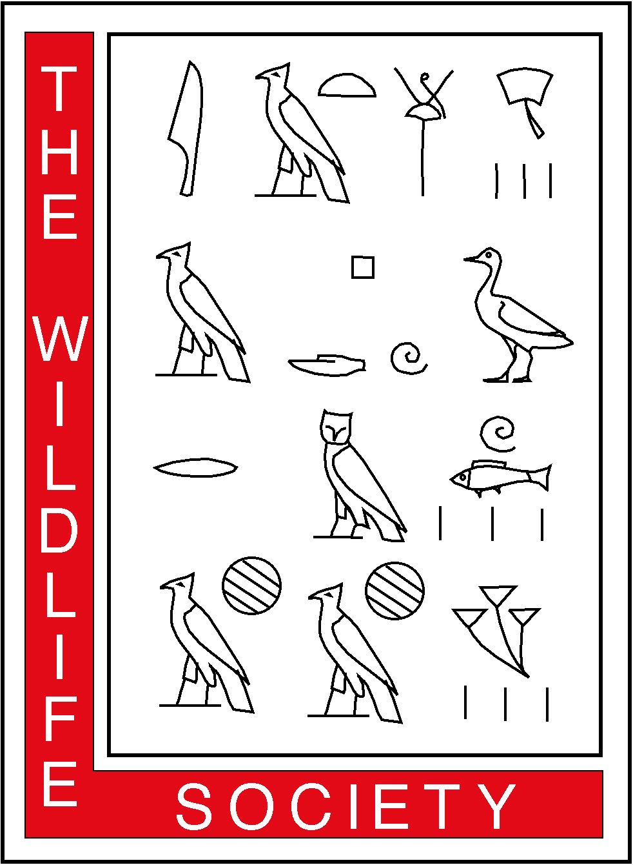
THE WILDLIFE SOCIETY
ALASKA CHAPTER
1910 Glacier Avenue • Juneau, AK 99801

August 22, 2002

USDA FS Tongass NF
Content Analysis Team
PO Box 9079
Missoula, MT 59807

To Whom it May Concern,

Please accept the following comments on the Draft Supplemental Environmental Impact Statement (DSEIS) on Roadless Area Evaluation for Wilderness Recommendations in the Tongass Land Management Revision.

These comments were prepared and reviewed by biologists with the Alaska Chapter of the Wildlife Society, and approved on behalf of the Chapter by a majority of its 7-member Executive Committee. Please feel free to contact me at 907-465-5277 if you have any questions.

Sincerely,

Doug Larsen
President, Alaska Chapter

Cc: Dennis Bschor, Regional Forester, Alaska Region
Thomas Franklin, Conservation Director, TWS

Alaska Chapter, The Wildlife Society
Comments on:

The Draft Supplemental Environmental Impact Statement (DSEIS) on Roadless Area Evaluation for Wilderness Recommendations in the Tongass Land Management Plan Revision.

Background:
The Alaska Chapter of the Wildlife Society is a professional society whose members include wildlife researchers, managers, administrators, educators, and students who work in Alaska. The Alaska chapter has maintained a long and active involvement in Forest planning on the Tongass. Our Chapter comments regularly on forest plans and Environmental Impact Statements (EISs) of statewide or national significance, and we welcome the opportunity to comment on this draft SEIS (DSEIS). These comments were drafted and reviewed by members of the Alaska Chapter, and endorsed by the Chapter’s Executive Committee.

Conservation of biological diversity, including wildlife, is a goal of both the U.S. Forest Service and the Wildlife Society. One of the means by which this has traditionally been accomplished is through the creation of reserves, or wilderness areas, where wildlife is free from the generally harmful effects of roads and associated habitat change. In the lower 48 states, most of the reserves on public land are concentrated at higher elevations and on unproductive soils. On the Tongass, there still exists the opportunity to capture representative ecosystems in reserves, and conserve associated biodiversity and dependent wildlife.

Our primary focus in reviewing this DSEIS is not on the merits of individual roadless areas (Appendix C), but rather on the process and assumptions used in the analysis. For expediency, we will assume the knowledgeable reader is familiar with certain key Forest Service reports and scientific publications. Readers wishing for more information on these reports can refer to the footnotes and obtain copies from appropriate agencies or libraries.

Conclusion:
Although we appreciate the large amount of work this DSEIS represents, we found a number of deficiencies that we’d like to see corrected in the Final SEIS. We believe the DSEIS fails to fully evaluate eligible roadless areas in terms of important “ecological, geological, or other features of scientific…value”, as required by the 1964 Wilderness Act. The main deficiency is using ecological indicators and analytical scales that are unduly coarse and uninformative. By measuring the wrong things, at the wrong scale, the DSEIS fails to identify important ecological features that have been degraded by past logging, and misses opportunities to provide needed protection for forest wildlife and biodiversity.

Specific Comments and Recommendations:
As directed by the 1964 Wilderness act, the EIS must identify and describe any unique scenic, ecological, geological, cultural, or scientific or educational opportunities or resources that could be lost if the area were not designated wilderness (C1-3). Which resources the Forest Service considers ecologically unique, and how they choose to display or represent them, therefore, has direct bearing on the tests of “capability, availability, and need” that must be met for any Wilderness recommendation. The thresholds and spatial scales the Forest Service adopts in these analyses are ill suited to Southeast Alaska’s environment and needs. Specific discussion points follow.

Choice of Spatial Scale for Analysis
The DSEIS adopts poorly defined, overly large Ecological Units in its analyses. For example, the DSEIS assumes that the Tongass is composed of just two “ecoregions”: Northern Pacific Coastal Forest, and Ice fields/Tundra. This is a coarse classification drawn from a reference that describes broad ecosystems across North America . The Forest Service has funded far more rigorous ecosystem classification work here in Southeast Alaska. For example, Region 10 recently published a well-received reference work describing the principal ecosystems of Southeast Alaska. This peer-reviewed report defines and maps land areas that: “embody similar ecological characteristics and provide a practical basis for ecosystem management, planning, and research.” The increased spatial resolution afforded by the Nowacki et al. (2001) classification (> 70 types instead of just 2) would permit far more robust and informative analyses, and would likely identify important gaps in Wilderness protection that the coarse analyses missed.

The DSEIS also analyzes the Tongass at the sale of the Biogeographic province (N=21). At this scale of resolution, 3 of the 21 provinces have less than 12% in reserves under the preferred alternative. Although provinces provide intermediate resolution between eco-regions and ecological subsections, their boundaries tend to be subjective and inconsistent. Some reflect vegetative discontinuities; others reflect weather; others reflect species distributions; and others reflect combinations of the above. The increased scientific rigor and resolution afforded by the ecological subsections weighs in their favor for this particular spatial analysis.

Choice of threshold value
The Forest Service adopts 12% as a target for gauging whether adequate Wilderness currently exists in each ecoregion. The origin of this number is a 1987 report issued by the World Commission on Environment and Development that estimated 4% of the world was in conservation reserves. The authors suggested that the amount of land in reserves would have to be tripled to achieve a representative sample of global diversity—thus the 12% figure. It is not valid to assume, from this, that 12% is a meaningful benchmark for the Tongass. Delevice and Martin (2001) suggest 12% may be too low as an absolute target. They cite Noss and Cooperrider (1994) who, based on an extensive review of published work, found 25 to 75% of a region must be in reserves for adequate representation. The FSEIS should utilize Table 5.2 in Noss and Cooperrider (1994) to arrive at a number that makes sense for Southeast Alaska. The threshold value is a key number for evaluating the sufficiency of federally designated Wilderness on the Tongass. It should not be arbitrarily or selectively plucked from the literature, but rather should result from a careful examination of factors germane to the United States and Southeast Alaska.

Choice of ecological indicators
Scott et al. (2001) examined how well ecosystems are represented in reserves nationwide. They found that reserve locations were heavily biased by social and political factors, and were concentrated at higher elevations and on unproductive soils. The Wildlife Society, Congress, and conservation groups have long voiced concerns that the more productive forestlands on the Tongass have similarly been targeted for logging, whereas the scenic but unproductive lands are earmarked for Wilderness . The FSEIS should respond to this concern by including a thorough analysis of how Wilderness and non-Wilderness lands in Southeast Alaska compare (circa 1954 conditions). How that is done is important, because certain ecological indicators are obviously more illustrative of purported high-grading patterns than others. For example, an analysis of landscape conditions on southeastern Chichagof Island revealed that even though only 8% of the land had been logged, old-growth spruce had been reduced by 44%, and the mean old-growth patch size had been reduced by 61%. Neither of these trends would have been evident from the DSEIS analysis.

The FSEIS should select indicators that accurately portray forest productivity, including: mean volume, mean tree diameter, percent spruce, percent big-tree stands (see below), and percent alluvial and colluvial soils. Rather than avoid such analyses, the Forest Service should highlight these trends because they point out where protective measures may be needed to slow or halt the loss of biological diversity.

Big tree stands.-- Once referred to by the Forest Service and others as “Volume Class 6 and 7”, these stands are now more accurately referred to as “big tree stands”, or “large-diameter, coarse-canopy stands”. There is a long history of concern over the status and disposition of big-tree stands. In 1979, the Alaska Chapter of the Wildlife Society adopted a position statement calling on the Forest Service to conserve the remaining Volume Class 6 and 7 stands. Conservation groups and others rallied around this issue, protesting the loss of these rare habitat types in timber sales, and seeking to have remaining examples preserved in Wilderness or roadless designations. In 1990, Congress passed the Tongass Timber Reform Act, including language that forbade the Forest Service from disproportionately logging Volume Class 6 and 7 stands (a requirement no longer recognized by the Forest Service).

This history notwithstanding, the Forest Service does not acknowledge the existence of such stands in EISs, or respond to agency and public requests for their conservation. This DSEIS is no different. The Forest Service instead reports acres of “high volume old growth”, assigning the high-volume name to a generic forest type. Although we appreciate that something more specific than “old growth” is being summarized, we request that the FSEIS include some discussion of “big tree stands” and their disposition on the forest.

Reporting the number of acres that currently exist on the forest by volume class or elevation (Tables 3-2.9 and Table 3-2.10) for each biogeographic province is acceptable, but it is important to show how much has been logged as well. . Currently, the DSEIS only reports acres of productive old growth logged. The FSEIS should report the acres and percent of low elevation big-tree stands logged to date, and the acres and percentage scheduled through 2120. These statistics should be summarized by ecological subsection. The amount of large-diameter, big tree old-growth forest remaining in year 2120 should be expressed as a percentage of the original amount and summarized for each alternative in a format similar to Table 3.2-13.

As a side note, Table 3.2-13 shows existing Wilderness areas having 100% of the original (1954) productive old growth remaining in year 2120. This is incorrect. Many Wilderness areas that contained highly productive old growth were previously logged. For example, on Admiralty Island, thousands of acres have been clear-cut at Winning Cove, Pybus Bay, Eliza Harbor, Herring Bay, Whitewater Bay, Hood Bay, Chaik Bay, and Mitchell Bay (among others). This was not minor A-frame or beach logging, but sales that in some cases exceeded 1000 acres and included roads. Although these clearcuts represent a small amount of the total productive old –growth forest on Admiralty Island, they represent a relatively high percentage of the large-diameter big tree old growth in some ecological subsections (e.g., South Admiralty Volcanics). Because past logging has targeted relatively productive forest types, which are rare, that history needs to be accurately portrayed in the FEIS.

Comparing Large with Small Areas
The Forest Service used a Geographic Information System (GIS) to identify 115 eligible roadless areas that qualify as potential Wilderness additions. These areas range in size from 5000 acres to over 1 million acres. The DSEIS presents reasonably good resource information on each area (Appendix C), but the areas themselves differ tremendously in size. This leads to problems when scores for large areas are compared with small areas. For example, a single 10,000-acre area might possess outstanding Wilderness values, but when combined with a very large tract, it’s independent value is lost.

There is no “all or none” clause in the Wilderness Act regulations. As long as they meet the specific size and character requirements, portions of roadless areas should be eligible for inclusion as Wilderness and evaluated on their individual merit. If the Forest Service does not analyze their potential at this finer spatial scale, important qualifying areas will be lost.

On the Tongass, the smallest scale at which forest-wide inventory information is gathered and summarized is the Value Comparison Unit (VCU), which averages 18,000 acres in size. Although most VCUs are larger than 5,000 acres, treating each VCU (or smaller) area as a discrete unit for evaluation as Wilderness would be a step in the right direction. Not only would fewer important areas be overlooked, but the analysis also could draw on a wealth of existing resource information already collected and summarized at the VCU level.

Noss and Kranz. 2001. Ecological issues in conservation. Invited Feature. Ecological Applications 11:945-946.
Trombulak, S.C., and C.A. Frissell. 2000. Review of ecological effects of roads on terrestrial and aquatic communities. Conservation Biology 14:18-30.
Scott, J. M., F. W. Davis, R. Gavin McGhie, R. G. Wright, C. Groves, and J. Estes. 2001. Nature reserves: do they capture the full range of America’s biological diversity? Ecological Applications 11(4):999-1007.
Schoen, J. W. and E. W. West. 1994. The Alaskan Opportunity. Defenders. 69(2):33-35.
Schoen J. W., M. D. Kirchhoff, and J. H. Hughes. 1988. Wildlife and old-growth forests in southeastern Alaska. Natural Areas Journal 8(3):138-142.
Ricketts, T.H., Dinerstein, E. Olson, and C.J. Loucks et al. 1999. Terrestrial ecoregions of North America: A conservation assessment. Island press. Washington D.C.
Nowacki, G. J., M. Shephard, W. Pawuk, G. Fisher, J. Baichtal, D. Brew, E. Kissinger, and T. Brock. 2001. Ecological subsections of southeast Alaska and neighboring areas of Canada. USDA Forest Service, Alaska Region. Technical Publication No. R0-TP-75. Juneau, Alaska. October 2001.
Delevice, R. L. and J. R. Martin. 2001. Assessing the extent to which roadless areas complement the conservation of biological diversity. Ecological applications 11(4) 1008-1018.
Noss, R. F. and A. Y. Cooperrider. 1994. Saving Nature’s Legacy: Protecting and Restoring Biodiversity. Island Press. Washington D.C.
Scott, J. M., F. W. Davis, R. Gavin McGhie, R. G. Wright, C. Groves, and J. Estes. 2001. Nature reserves: do they capture the full range of America’s Biological Diversity? Ecological Applications 11(4):999-1007.
Kirchhoff, M. D. 1989. Patterns of old-growth harvest in Southeast Alaska—implications for wildlife. Abstract of a paper presented at the Society for Conservation Biology Annual meeting, Toronto, Canada. 6-10 August 1989.
The Wildlife Society, Alaska Chapter. 1979. Position Statement: Forest Practices in Alaska. 3pp.
The Wilderness Society 1986. America’s vanishing rainforest: a report on federal timber management in southeast Alaska. Wilderness Society, Washington DC. 215 pp.
Kiester, A. R. and C. Eckhardt. 1994. A review of Wildlife Management and Conservation Biology on the Tongass National Forest: A synthesis with recommendations. PNW Research Station. USDA Forest Service, Corvallis, OR. 282 pp.
Shephard, M., L. A. Winn, B. Flynn, R. Myron, J. Winn, G. Killinger, J. Silbaugh, T. Suminski, K. Barkhau, E. Ouderkirk, and J. Thomas. 1999. Southeast Chichagof landscape analysis. USDA Forest Service, R10-TP-68.
Caouette, J. P., M. G. Kramer, and G. J. Nowacki. 2000. Deconstructing the timber volume paradigm in management of the Tongass National Forest. USDA Forest Service, PNW Station, PNW-GTR-482.
Caouette, J. P. and G DeGayner, in review. Mapping Components of forest structure in temperate rainforest of southeast Alaska. USDA Forest Service, PNW Station, PNW-GTR-___
Caouette, J. P., E. J. DeGayner, and J. M. Russell, in review. Crab Bay, a landscape-level analysis of forest structure stratification for southeast Alaska. USDA Forest Service, PNW Station, Technical Paper PNW-TP-____
This requirement was included in the long-term contract section of the legislation. When the contracts were cancelled in 1994 (APC) and 1997 (LPK), the Forest Service dropped their plans to implement this provision. Today, the Forest Service does not make any specific effort to describe, map or conserve these specific stands.
Letter from ADF&G Commissioner Frank Rue to Forest Supervisor, Tom Puchlerz, April 24, 2002.
Prior to 1997, ‘high-volume old growth’ referred to Volume Classes 6 and 7, or the most productive 12% of the forest. After 1997, the Forest Service added most Volume class 5 stands to this category, “growing” the category to include 41% of the productive old growth. This bookkeeping change does not alter the underlying concerns.

