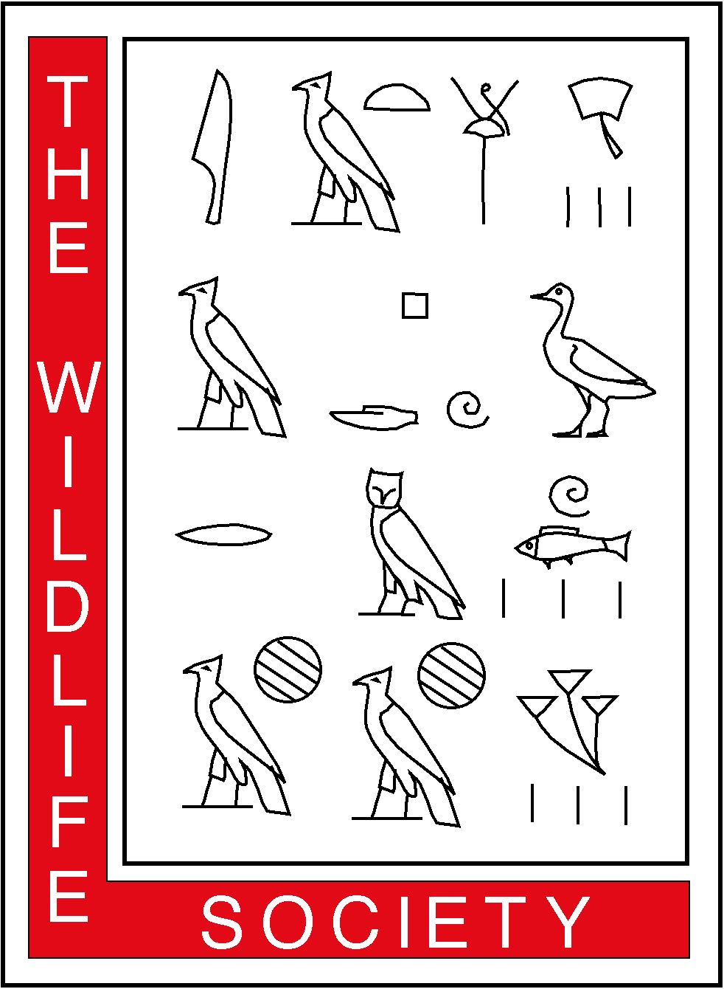
February 24, 2006
THE WILDLIFE SOCIETY
ALASKA CHAPTER
P.O. Box 242454
Anchorage, Alaska 99524-2454

Representative _________
House of Representatives
State Capitol
Juneau, Alaska 99801-1182
Re: Senate Bill 85
Off-Road Vehicle Use on Dalton Highway
Dear Representative ______:

The Alaska Chapter of The Wildlife Society opposes Senate Bill 85 (SB 85) that if passed, would repeal Alaska Statute 19.40, Section 19.40.210: “Prohibition of off-road vehicles. Off-road vehicles are prohibited on land within five miles of the right-of-way of the [Dalton] highway.”

The Alaska Chapter of The Wildlife Society (Alaska Chapter) is a professional society founded in 1971 comprised of over 200 wildlife biologists and managers employed by state, federal, and borough resource agencies, academic institutions, non-governmental conservation organizations, and private industry. Our mission is to enhance the ability of wildlife professionals to conserve biological diversity, sustain productivity, and ensure responsible use of wildlife resources in Alaska for the benefit of society.

SB 85 is a poorly conceived and unfunded bill that if passed, will:

▪ nullify a law that represents one of the most important habitat protection statutes tied directly to the exploration, development, production, and transportation of petroleum resources in Alaska;

▪ result in unacceptable disturbance and displacement of wildlife and degradation of wildlife habitat;

▪ change the fundamental nature of a unique and irreplaceable highway corridor where the public may see muskox, Dall sheep, grizzly bears, caribou, and other wildlife;

▪ remove an effective mitigative measure for petroleum development within the range of the nationally scrutinized Central Arctic caribou herd;

▪ fail to provide critical financial support to state and federal agencies to:

- implement a public-planning process to assure protection of the public and fish, wildlife, and habitat resources;

- allow development of management plans that reflect consideration of a suite of alternatives and the preferred alternative determined by Alaska residents;

- enforce regulatory measures designed to ensure public safety and the protection of natural resources; and,

- initiate environmental monitoring and adaptive management plans to avoid unnecessary degradation of wildlife populations and wildlife habitat.

The existing Dalton Highway Corridor Management Area has provided for both public access and protection of habitat and wildlife for three decades.

SB 85 would repeal a law that has effectively provided wildlife habitat protection for ungulates, grizzly bears, Dall sheep, and migratory birds for 30 years, concurrent with allowing recreational and subsistence hunting and world-class wildlife viewing to the public. SB 85 will increase the number of hunters by allowing mechanized transport via off-road vehicles (ORVs) and snow machines to access lands open to rifle hunting beyond the Dalton Highway corridor. ORV access will result in significant scarring and erosion of both tundra and wetland habitats as seen near the Denali, Steese, and Taylor highways. Importantly, the public currently has access to these lands for hunting and scenic viewing opportunities.

ORV access will disturb and displace wildlife in and adjacent to the Dalton Highway Corridor Management Area (hereafter, Dalton Corridor), particularly on coastal tundra habitats. During winter, human-caused disturbance can cause critical energy loss in ungulates during direct flight, displacement from preferred habitat, or indirect physiological stress. Severe disturbance that reduces fat reserves in pregnant cows in the Central Arctic, Ray Mountain, and Teshekpuk Lake caribou herds could lower productivity due to higher calf mortality and susceptibility of adults to predation. Cumulative effects of increased disturbance from ORVs, potential increased harvest, adverse weather, and disturbance from current and proposed oil and gas development could lead to a population decline in the Central Arctic Herd, likely subverting years of careful management to maintain the herd within population objectives that allow a sustainable harvest.

The Dalton Corridor provides world-class viewing opportunities for wildlife, particularly in open terrain north of the Brooks Range. The Arctic Interagency Visitor Center in Coldfoot reported a 22% increase in Dalton Highway travelers since 1994, with 31% of the 8,600 visitors in 2004 on commercial guided tours. It is likely that several thousand visitors continue north to Deadhorse each summer to view arctic scenery and wildlife. The Dalton Highway provides the unique opportunity to view wild muskoxen, as well as grizzly bears, wolves, wolverines, caribou, moose, Dall sheep, and arctic-breeding waterbirds and raptors. The Alaska Chapter believes the risk of ORVs displacing wildlife and degrading this viewing resource for residents and visitors to Alaska is unacceptable.

The current Dalton Highway Management Plan allows hunting opportunities beyond compare to any other region in the State or Nation.

Hunters have been accessing the Dalton Highway corridor for archery hunting and areas beyond the corridor for rifle hunting without the use of motorized vehicles since the early 1980s. Allowing motorized access to these lands will disrupt bowhunters within the corridor and increase competition for those already accessing hunting areas outside of the corridor by foot, ski, dog team, horse, aircraft, and boats on navigable rivers.

Archery hunting for caribou is popular in the Dalton Corridor because of a long season, liberal bag limit, and lack of competition from hunters on ORVs and snowmachines. The harvest objective for the Central Arctic Herd is 600–800 caribou. In 2004-05, 965 hunters hunted in Game Management Units 26B-C, and harvested 613 caribou. Bowhunters accounted for 36% of reported harvest. We predict the long-term and net effect of increasing motorized access through the Dalton Corridor will be restricted seasons and bag limits adjacent to the corridor to ensure sustained yield of these populations.

In summary, The Alaska Chapter opposes SB 85 because of the unacceptable risks of disturbance and displacement of wildlife and degradation of wildlife habitat, the unrealistic time frame to develop adequate planning, and because of the absence of funding provisions required to enforce regulations and implement adaptive management to protect wildlife and habitat resources. We appreciate the opportunity to comment. If you have questions regarding any of the comments in this letter, please contact me at 301-897-9770 or via electronic mail at eric@wildlife.org.

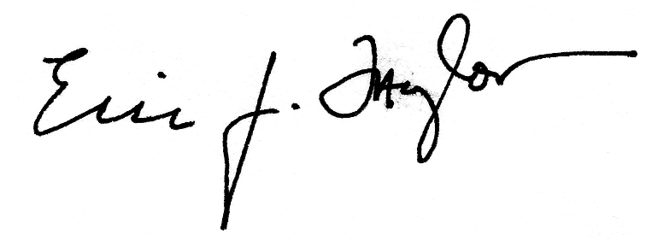
Sincerely,

Eric J. Taylor, Ph.D.
President, Alaska Chapter of The Wildlife Society
cc.

Edward Itta, Mayor, North Slope Borough
Henri Bisson, State Director, U.S. Bureau of Land Management
Rowan Gould, Regional Director, U.S. Fish and Wildlife Service
Michael Menge, Commissioner, Alaska Department of Natural Resources
McKie Campbell, Commissioner, Alaska Department of Fish and Game
Mike Barton, Commissioner, Alaska Department of Transportation and Public Facilities
Brian Barnes, Director, Institute of Arctic Biology, University of Alaska Fairbanks

