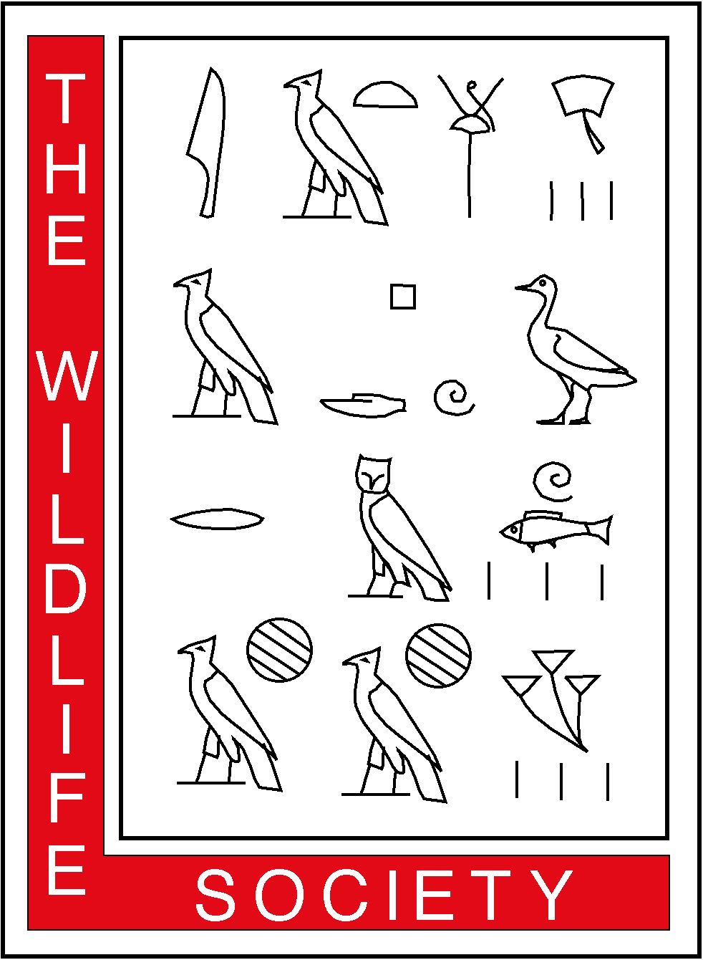
THE WILDLIFE SOCIETY
ALASKA CHAPTER
1910 Glacier Avenue • Juneau, AK 99801

Re: Exempting the Tongass and Chugach National Forests from the Roadless Areas Conservation Rule (RACR)

August 8, 2003

Dale N. Bosworth
Roadless ANPR
USFS Content Analysis Team
P.O. Box 22777
Salt Lake City, Utah, 84122

Dear Mr. Bosworth:

The Alaska Chapter of the Wildlife Society is a professional society of wildlife managers, researchers, administrators, and educators in Alaska. We appreciate the opportunity to provide comments on the proposed rulemaking.

Position:
The Alaska Chapter of the Wildlife Society opposes exempting the Tongass and Chugach National Forests from the Roadless Areas Conservation Rule. We find that the Forest Service has not adequately described the effects of this proposed action on important wildlife species and their habitats, and has not provided adequate opportunity for public involvement. Until these deficiencies are corrected, we ask that the Tongass and Chugach National Forests in Alaska not be exempted from the Roadless Areas Conservation Rule.

Reasons:
1. Roadless areas on the Tongass and Chugach National Forests provide important habitat for wildlife. A number of wildlife species that occur in the Tongass and Chugach National Forests, including brown bears, black bears, wolves, eagles, marten, wolverines, and mountain goats are much reduced on their historic range in the lower 48 states. Their secure status in Alaska is due, in part, to the existence of large, unroaded areas that minimize contact with people, and minimize direct mortality from both legal and illegal harvest. There is abundant scientific literature detailing the population-level effects of roads and access on bears, wolves, and other wildlife (e.g., Mattson et al. 1987, Peek et al. 1987, Berger and Daneke 1988, McLellan and Shakelton 1988, Mattson and Knight 1991, Titus and Beier 1991 [Figure 1], Mattson 1993, Mace et al. 1996, Person et al. 1996). These and other studies were not considered in the Forest Service’s Roadless Area Evaluation (FSEIS R10-MB-481A).

The Forest Service has asserted that the Tongass and Chugach Forest Plans adequately address concerns for the viability of wildlife species and that further protection for roadless areas is not needed. We believe that claim grossly overstates the scientific certainty associated with any of the standards and guidelines or provisions made for wildlife in the plans and the rigor with which they are implemented. With respect to the Tongass Forest Plan, peer-reviewers of the conservation strategy for wildlife used in the plan stated that it was inadequate with respect to the number, size, and connectivity of unroaded, old-growth forest reserves (Kiester and Eckhardt 1994). Further, some key standards and guidelines in the Tongass Forest Plan are not consistent with recommendations made in the science assessments on which the plan is purportedly based. For example, the road density guideline for wolves states that concerns about excessive wolf mortality exist when a density of 0.7 miles of open road per square mile of area is reached. The actual recommendation in the science assessment for wolves commissioned by the Forest Service during development of the plan stated that a density of 0.7 miles of all roads per square mile of land below 370 meters elevation was a cause for concern (Person et al. 1996).

Anadromous species of fish, most notably salmon, are an important food source for several species of wildlife in coastal Alaska, including bald eagles, black and brown bears, Steller sea lions, harbor seals, wolves, otters, marten, and mink. The effects of roads and roadbuilding on the spawning habitats of anadromous fish, and their implications for a host of dependent wildlife, should be more thoroughly explored in the context of this ruling. Clearly, the Tongass Forest Plan is a large exercise in trial and error in both concept and implementation. Providing protection for currently unroaded areas will assure that more options exist in the future for the conservation of wildlife resources as we learn more about the forest ecosystems and the consequences of timber harvesting and development. We respectfully request that the Forest Service conduct a quantitative analysis of the potential impacts of proposed roadbuilding on potentially sensitive wildlife species. At a minimum, we recommend these analyses be done for black bears, brown bears, and furbearers (e.g., marten) on the Tongass and Chugach Forests prior to implementing any changes to existing rules and conditions.
- The Forest Service understates potential environmental impacts of the proposed exemption. For example, in defending the proposed exemption, the Forest Service states in its 15 July notice:
“Timber harvest will continue to be prohibited on more than 95% of Alaska National Forests as required under existing Forest Plans. Exempting the Tongass National Forest from application of the roadless rule would make approximately 300,000 roadless acres available for forest management—slightly more than 3% of the 9.3 million roadless acres in the Tongass.”

The potential impacts of roads and timber harvest units in the Tongass Forest extend beyond the footprint of the roadbed and the harvest units. Moreover, the loss of relatively small percentages of land areas may have disproportionate impacts on wildlife if the removed land areas include high percentages of critically important habitats. We explained this in our 22 August, 2002 comments on the DSEIS on Roadless Area Evaluation. Rather than recast those points here, we have attached an excerpt from our previous comments. We respectfully request that the Forest Service conduct a quantitative analysis of the effects of proposed roadbuilding on relatively rare and already impacted forest types (including at a minimum, lowland spruce stands, alluvial fans, karst, and coarse-canopy large-diameter trees) on the Tongass and Chugach Forests. This analysis should be completed and presented to the public before adopting the proposed exemption.

- Public involvement in this decision has been inadequate. The Wildlife Society was a participant on the Forest Roads Working Group, a coalition of organizations representing conservationists, sportspersons, and members of the forest products and recreation industries. The group was convened with the encouragement and support of the Forest Service. In their final report, issued 26 March 2003, the group recommended that:

- the existing Roadless Areas Conservation Rule provides an acceptable basis for national management of inventoried roadless areas, and should be implemented while adjustments are considered,
- the Forest Service should refrain from making adjustments to the existing Roadless Areas Conservation Rule without data gathering, dialogue, and the full development of existing stakeholder recommendations on whether and how to implement these or any other modifications, and
- the Forest Service should establish a formal, deliberative process to consider guidance for implementation of, and, if necessary, improvements to, the Roadless Areas Conservation Rule.

We believe the Forest Service has failed to adequately consider these recommendations as it considers exempting the Tongass and Chugach National Forests from the roadless ruling. Rather than implementing a deliberative public process to evaluate prudent adjustments, it appears to us that the public comment period has been truncated in this instance, and that public hearings have been foregone. Exempting the Tongass and Chugach National Forests would eliminate protection of one quarter of all Forest Service inventoried roadless land in the U.S. This represents a significant action affecting a public resource that is important to many people (over 726,000 comments were received from across the country on the original proposed rulemaking). We believe an action of this magnitude should not be based on a private settlement agreement between the state of Alaska and the Forest Service without the necessary data gathering, public dialogue, and consideration of stakeholder recommendations.

Summary:
The Alaska Chapter of the Wildlife Society requests that the Forest Service provide the public with an analysis of how the proposed rule would affect wildlife species and natural forest diversity on the Tongass and Chugach National Forests. Of special concern are the effects of proposed logging and roadbuilding in current roadless areas on bear, wolf, and furbearer populations. The Forest Service should also describe how the proposed logging would likely alter forest diversity on the Tongass, especially the disposition of relatively rare high volume stands of trees. This information should be provided to the public, and their full participation in the decision-making process encouraged. We believe these are essential ingredients of informed, environmentally responsible public policy.

Sincerely,

Douglas N. Larsen
President, Alaska Chapter of the Wildlife Society
(on behalf of the Chapter’s Executive Committee)

cc: Tom Franklin
Caitlin Burke

Literature Cited
Berger, J. and D. Daneke. 1988. Effects of agricultural, industrial, and recreational expansion on frequency of wildlife law violations in the central Rocky Mountains, USA. Conservation Biology 2(3):283-289.
Keister, A.R., and C. Eckhardt. 1994. Review of wildlife management and conservation biology on the Tongass National Forest: a synthesis with recommendations. USDA Forest Service Pacific Northwest Research Station, 3200 SW Jefferson Way, Corvallis, OR 97331.
Mace, R.K., J. Waller, T. Manley, L.J. Lyon, and H. Zuring. 1996. Relationships among grizzly bears, roads, and habitat in the Swan Mountains, Montana. Journal of Applied Ecology.
Mattson, D., R. Knight, and B. Blanchard. 1987. The effects of development and primary roads on grizzly bear habitat use in the Yellowstone National Park, Wyoming. Int. Conf. Bear Res. and Manage. 7:259-273
Mattson, D.J., and R. Knight. 1991. Effects of access on human-caused mortality of Yellowstone Grizzly Bears. USDI National Park Service, Interagency Grizzly Bear Study Team Report, Bozeman, MT.
Mattson, David J. 1993. Grizzly bear responses to human activities: A review and summary. Interagency Grizzly Bear Study Team, Forest Sciences Labs, Montana State University, Bozeman, MT.
McLellan, B. and D. M. Shackleton. 1988. Grizzly bears and resource-extraction industries: effects of roads on behavior, habitat use and demography. J. Appl. Eco. 25:451-460.
Peek, J., M. Pelton, H. Picton, J. Schoen, and P. Zager. 1987. Grizzly bear conservation and management: a review. Wildl. Soc. Bull. 15:160-169.
Person, David K.; Kirchhoff, Matthew; Van Ballenberghe, Victor; Iverson, George C.; Grossman, Edward. 1996. The Alexander Archipelago wolf: a conservation assessment. Gen. Tech. Rep. PNW-GTR-384. Portland, OR: U.S. Department of Agriculture, Forest Service, Pacific Northwest Research Station. 42p.
Titus, K. and L Beier. 1991. Population and habitat ecology of brown bears on Admiralty and Chichagof Islands. Alaska Fish and Game Fed. Aid in Wildl. Rest. Res. Proj. Rep. 4.22. 32pp.

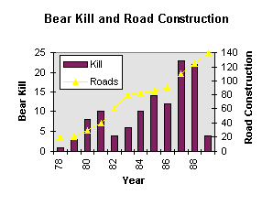
Figure 1. Data showing the relationship between roads and bear mortality on NE Chichagof Island 1978-1989. Roads were closed to hunting in 1989 due to concerns about excessive bear mortality. (Figure from Titus and Beier 1991.)

Excerpt from the Alaska Chapter’s comments on the DSEIS on Roadless Area Evaluation for Wilderness Recommendations in the Tongass Land Management Plan.

….The Wildlife Society, Congress, and conservation groups have long voiced concerns that the more productive forestlands on the Tongass have similarly been targeted for logging, whereas the scenic but unproductive lands are earmarked for Wilderness . The FSEIS should respond to this concern by including a thorough analysis of how Wilderness and non-Wilderness lands in Southeast Alaska compare (circa 1954 conditions). How that is done is important, because certain ecological indicators are obviously more illustrative of purported high-grading patterns than others. For example, an analysis of landscape conditions on southeastern Chichagof Island revealed that even though only 8% of the land had been logged, old-growth spruce had been reduced by 44%, and the mean old-growth patch size had been reduced by 61%. Neither of these trends would have been evident from the DSEIS analysis.

The FSEIS should select indicators that accurately portray forest productivity, including: mean volume, mean tree diameter, percent spruce, percent big-tree stands (see below), and percent alluvial and colluvial soils. Rather than avoid such analyses, the Forest Service should highlight these trends because they point out where protective measures may be needed to slow or halt the loss of biological diversity….

Conservation of biological diversity, including wildlife, is a goal of both the U.S. Forest Service and the Wildlife Society. One of the means by which this has traditionally been accomplished is through the creation of reserves, or wilderness areas, where wildlife is free from the generally harmful effects of roads and associated habitat change. In the lower 48 states, most of the reserves on public land are concentrated at higher elevations and on unproductive soils. On the Tongass, there still exists the opportunity to capture representative ecosystems in reserves, and conserve associated biodiversity and dependent wildlife.

Kirchhoff, M. D. 1989. Patterns of old-growth harvest in Southeast Alaska—implications for wildlife. Abstract of a paper presented at the Society for Conservation Biology Annual meeting, Toronto, Canada. 6-10 August 1989.
The Wildlife Society, Alaska Chapter. 1979. Position Statement: Forest Practices in Alaska. 3pp.
The Wilderness Society 1986. America’s vanishing rainforest: a report on federal timber management in southeast Alaska. Wilderness Society, Washington DC. 215 pp.
Kiester, A. R. and C. Eckhardt. 1994. A review of Wildlife Management and Conservation Biology on the Tongass National Forest: A synthesis with recommendations. PNW Research Station. USDA Forest Service, Corvallis, OR. 282 pp.
Shephard, M., L. A. Winn, B. Flynn, R. Myron, J. Winn, G. Killinger, J. Silbaugh, T. Suminski, K. Barkhau, E. Ouderkirk, and J. Thomas. 1999. Southeast Chichagof landscape analysis. USDA Forest Service, R10-TP-68.
Noss and Kranz. 2001. Ecological issues in conservation. Invited Feature. Ecological Applications 11:945-946.
Trombulak, S.C., and C.A. Frissell. 2000. Review of ecological effects of roads on terrestrial and aquatic communities. Conservation Biology 14:18-30.
Scott, J. M., F. W. Davis, R. Gavin McGhie, R. G. Wright, C. Groves, and J. Estes. 2001. Nature reserves: do they capture the full range of America’s biological diversity? Ecological Applications 11(4):999-1007.
Schoen, J. W. and E. W. West. 1994. The Alaskan Opportunity. Defenders. 69(2):33-35.
Schoen J. W., M. D. Kirchhoff, and J. H. Hughes. 1988. Wildlife and old-growth forests in southeastern Alaska. Natural Areas Journal 8(3):138-142.

