1. When I click Current Category, EAV was crashed.

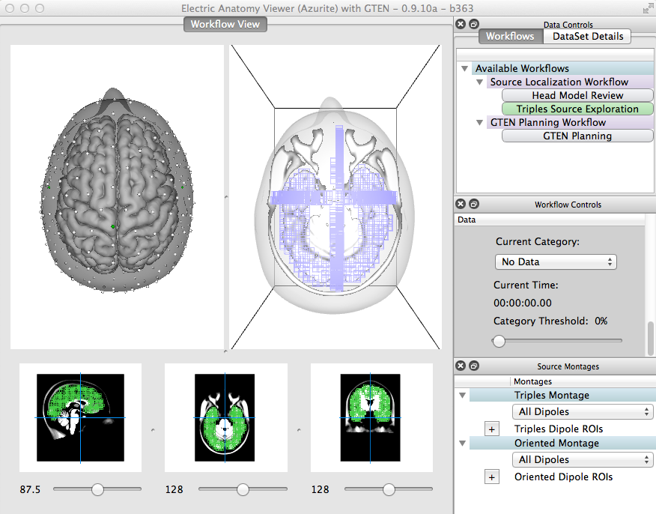

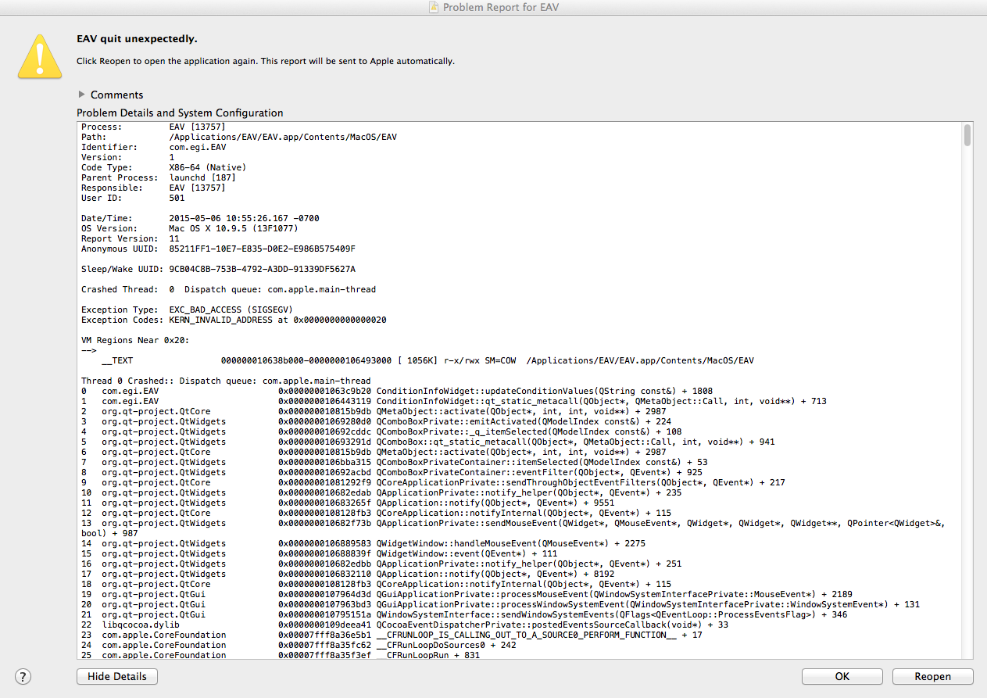

2. Could you remove the green boundary of each voxel?

3. For sagittal slice view, could you change face viewing left?

4. Triple is not correct.

For lead field matrix, channel by dipole

(1,1_x) (1,1_y) (1,1_z) (1,2_x) (1,2_y) (1,2_z) . . .(1,nV_x) (1,nV_y) (1,nV _z) (2,1_x) (2,1_y) (2,1_z) (2,2_x) (2,2_y) (2,2_z) . . .(2,nV_x) (2,nV_y) (2,nV _z) (3,1_x) (3,1_y) (3,1_z) (3,2_x) (3,2_y) (3,2_z) . . .(3,nV_x) (3,nV_y) (3,nV _z)

. . . . . . . . . . . . . . .

. . . . . . . . . . . . . . .

(nC,1_x) (nC,1_y) (nC,1_z) (nC,2_x) (nC,2_y). . . (nC,nV_x) (nC,nV_y) (nC,nV _z)

For source waveforms, dipole by time

(1_x,1) (1_x,2) . . . . . . . . (1_x,nT)

(1_y,1) (1_y,2) . . . . . . . . (1_y,nT)

(1_z,1) (1_z,2) . . . . . . . . (1_z,nT)

(2_x,1) (2_x,2) . . . . . . . . (2_x,nT)

(2_y,1) (2_y,2) . . . . . . . . (2_y,nT)

(2_z,1) (2_z,2) . . . . . . . . (2_z,nT)

. . . . . . . . . . . . . . .

. . . . . . . . . . . . . . .

. . . . . . . . . . . . . . .

(nV_x,1) (nV_x,2) . . . . . . .(nV_x,nT)

(nV_y,1) (nV_y,2) . . . . . . .(nV_y,nT)

(nV_z,1) (nV_z,2) . . . . . . .(nV_z,nT)

But in Rabbitmq, ╥sendTriplesData╙ read the triple as

(1_x)

(2_x)

.

.

.

(nV_x)

(1_y)

(2_y)

.

.

.

(nV_y)

(1_z)

(2_z)

.

.

.

(nV _z)

from RabbitMQ import Connection

c = Connection.Connection('localhost')

c.connect()

c.sendTriplesData(Dip1, "Triples", "vgt")

c.disconnect()

5.”Set View to Superior, Inferior, Left and Right” are not working.