**PRACTICAL-1**

**Project development approach and justification**

**Sound Beat Box**

**Project Summary**:

Many of us were hoping to learn how to play different different kind of instruments in any stage of our life also most of us would like to sing their favorite songs but the problem with this both situation is difficulty of finding proper mechanism which will help you with instruments and also singing.So this projects all about this where you guys can choice which instruments you would like to add in your music and using repetitive loop it will keep playing in background while you can sing a song and overlap with it so it can be explained as soft and small version of a FL studio machine but it is easy to buy and install this software rather then buying and setting up whole FL studio machine and also with this software you can save your music and also you can share this with your friends having this software installed.

**Purpose:**

To make an easy way for those who like to sing and compose their own music and like to share it with their friends and colleagues.With this software you can also add a little description about what you have made.You can also open your previously saved task and work on it again.

**Scope:**

Any one who seek a solution for their singing hobby or profession can use this software.Even available for small kids! Just selecte the options and kids can sing all day along!

**Objective:**

As the available FL studio machines are expencive and require knowledge of how to use it, this software will eliminate all that hectic work and make a very easy path to work as fine as a FL studio machine.

**Model used**: Iterative Waterfall Model

**Justification**:

Iterative waterfall model is used for the development of “Sound BeatBox” application’s development .It is used because we are very clear with our requirements and in case of any changes,backtracking can be easily done and relatively changes can be made by backtracking into any of the 6 stages of iterative waterfall model.

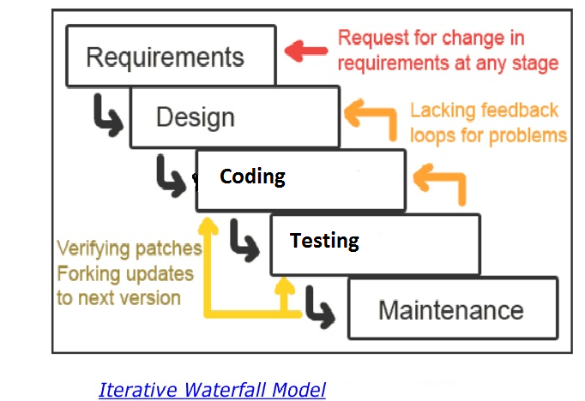

**Project plan**

The development of the Sound Beat Box application’s development would be completed in round about 4 months. The cost of this project would be as specified in the budget or as per decided earlier.