# Product Tour Web Component

## Architecture Review Board Documentation Package

Version 1.0 | Date: November 21, 2024

### Executive Summary

The Product Tour Web Component provides a standardized solution for implementing product tours across SAP applications and general best practice for vanilla js web component development and deployment. This solution enables content authors to create and maintain tours through familiar tools while ensuring consistent delivery through modern web technologies.

### 1. Architecture Change Request

**Project Details** - Name: Product Tour Web Component - Department: UDEx Team - Implementation Timeline: Immediate - Status: Approved (CPIT CE3 Solution Architecture)

**Business Case** The current product tour implementation requires significant developer intervention and lacks consistency across products. This solution standardizes the approach while empowering content authors through familiar tools.

**Technical Overview** - Implementation Type: Web Component - Content Management: SharePoint/Word + Adobe EDS - Delivery: UDEx CDN - Client Runtime: Shadow DOM + Custom Events

### 2. Architecture Principles Compliance

#### Enterprise Architecture Alignment

✓ Modular Design - Independent web component architecture - Clear separation of concerns between content and presentation - Standardized interfaces for integration

✓ Scalability - CDN-based delivery ensures global scale - Stateless component design - Content-driven architecture minimizes maintenance

✓ Reusability - Framework-agnostic implementation - Standardized content structure - Configurable through HTML attributes

#### Technical Standards Compliance

**Performance** - Lazy loading of assets - Shadow DOM for style encapsulation - Efficient DOM updates

**Security** - Content served via HTTPS - No external dependencies - Sandboxed component implementation

**Integration** - Standard web component APIs - Event-based communication - Clear integration documentation

### 3. Technical Implementation

#### Component Architecture

[Previous component-architecture diagram]

#### Runtime Flow

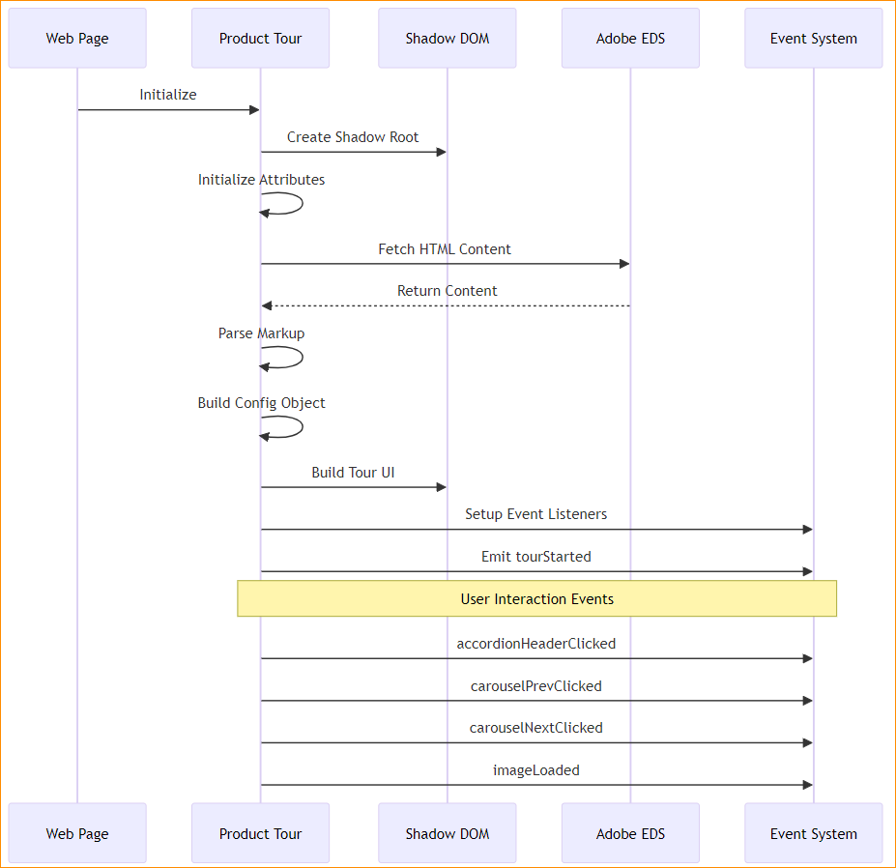

[Previous runtime-sequence diagram]

#### Data Flow

[Previous data-flow diagram]

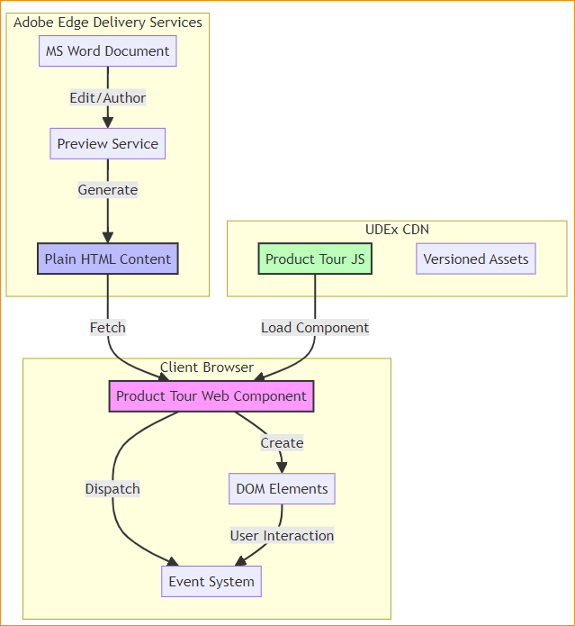

#### Deployment Architecture

[SVG deployment diagram]

#### Component Lifecycle

[Previous component-lifecycle diagram]

### 4. Implementation Guidelines

#### Content Authoring

1. Access the SharePoint Word template
2. Edit content following the structured format
3. Preview using Adobe EDS sidekick
4. Publish when ready

#### Integration Steps

<product-tour   
 data-config="[content-url]"  
 data-url-prefix="[domain]">  
</product-tour>

#### Event System

document.addEventListener('tourStarted', (event) => {  
 console.log('Tour started:', event.detail);  
});

### 5. Risk Assessment

| Risk | Likelihood | Impact | Mitigation |
| --- | --- | --- | --- |
| Content authoring complexity | Low | Medium | Detailed documentation and templates |
| Browser compatibility | Low | High | Progressive enhancement approach |
| Performance impact | Low | Medium | Lazy loading and optimization. SAP CDN CI/CD |

### 6. Testing Requirements

* Unit tests for component functionality
* Integration tests for content flow
* Performance benchmarks
* Accessibility compliance (WCAG 2.1)
* Cross-browser compatibility

### 7. Deployment Strategy

#### Phase 1: Initial Release

* Basic functionality
* Core event system
* Essential analytics

#### Phase 2: Enhancement

* Advanced analytics
* Additional customization options
* Performance optimizations

### 8. Support and Maintenance

**Documentation** - Technical specification - Integration guide - Content authoring guide - Troubleshooting guide

**Monitoring** - Performance metrics - Usage analytics - Error tracking

### 9. ARB Decision

**Status: Approved**

The Architecture Review Board approves this design based on: - Alignment with enterprise architecture - Technical standards compliance - Clear implementation strategy - Comprehensive risk management

### 10. Appendix

#### A. Reference Implementation

[Previous React demo implementation]

#### B. Technical Specifications

* Browser Support: Modern browsers (Chrome, Firefox, Safari, Edge)
* Performance Targets: Load time < 2s, Time to Interactive < 3s
* Accessibility: WCAG 2.1 AA compliance

#### C. Related Documents

* Content Authoring Guide
* Integration Documentation
* API Reference