# Architectural Review Board (ARB) Documentation Package

## SAP Experience Fragment: Web Component - Product-Tour Example

## System Architecture

### 1. System Context Diagram

This diagram shows how the ProductTour component fits into the broader system.

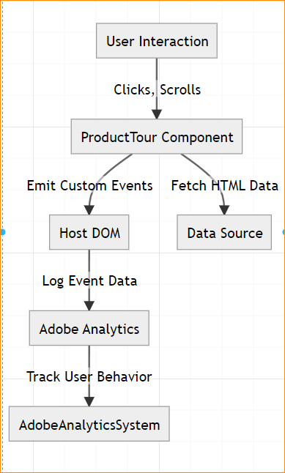

graph TD  
 A[User Interaction]  
 B[ProductTour Component]  
 C[Host DOM]  
 D[Adobe Analytics]  
 E[Data Source]  
   
 A -->|Clicks, Scrolls| B  
 B -->|Fetch HTML Data| E  
 B -->|Emit Custom Events| C  
 C -->|Log Event Data| D  
 D -->|Track User Behavior| AdobeAnalyticsSystem

### 2. Component Architecture Diagram

This shows the internal structure of the ProductTour web component, including its methods and dependencies.

graph TD  
 A[ProductTour Class] --> B[fetchHTML Method]  
 A --> C[parseMarkUp Method]  
 A --> D[buildTour Method]  
 A --> E[dispatchEvent Method]  
 A --> F[logEvent Method]  
   
 B -->|Fetch Data| G[Data Source]  
 C -->|Parse HTML| H[Structured JSON Object]  
 D -->|Render Tour| I[Shadow DOM]  
 E -->|Emit Events| J[Host DOM]  
 F -->|Log Debug Info| K[Console]

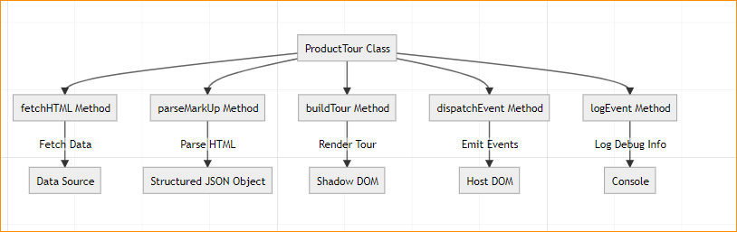

### 3. Data Flow Diagram

This diagram illustrates the flow of data from fetching HTML content to rendering the product tour.

flowchart TD  
 A[Data Source] -->|Fetch HTML| B[ProductTour Component]  
 B -->|Parse Data| C[Structured JSON]  
 C -->|Generate UI| D[Shadow DOM]  
 B -->|Emit Events| E[Host DOM]  
 E -->|Process Events| F[Adobe Analytics]

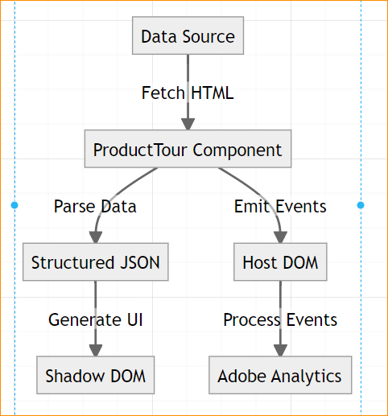

### 4. Event Propagation Diagram

This sequence diagram details the lifecycle of events from the ProductTour component to the host application.

sequenceDiagram  
 participant User  
 participant ProductTour  
 participant HostDOM  
 participant AdobeAnalytics  
  
 User->>ProductTour: Interacts with Tour  
 ProductTour->>HostDOM: Dispatch Event (e.g., tourStarted)  
 HostDOM->>AdobeAnalytics: Log Event Data  
 AdobeAnalytics-->>HostDOM: Acknowledge Event

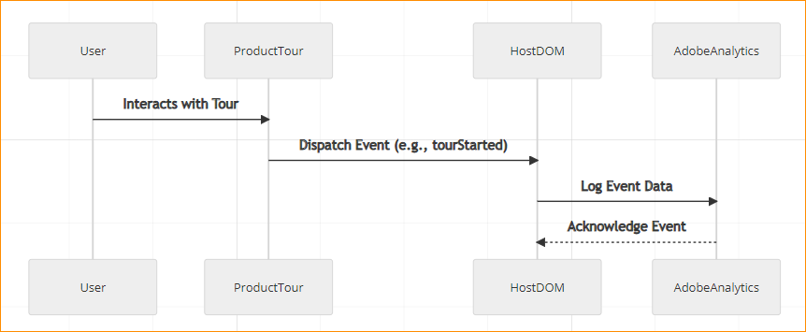

### 5. State Management Diagram

This diagram explains how state transitions are managed within the ProductTour component.

stateDiagram-v2  
 [*] --> Uninitialized  
 Uninitialized --> FetchingData : Fetch HTML  
 FetchingData --> ParsingData : Parse HTML Content  
 ParsingData --> ConfiguringState : Build JSON Configuration  
 ConfiguringState --> Rendering : Render Accordion/Carousel  
 Rendering --> EventListening : Setup Event Listeners  
 EventListening --> [*]

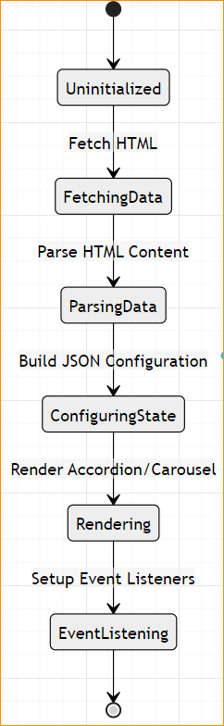

## Documentation

### 1. Executive Summary

* **Project Overview**:
  + The ProductTour web component dynamically generates interactive product tours by fetching and rendering structured data.
* **Key Decisions**:
  + Use of CustomEvent for event propagation.
  + Integration with Adobe Analytics for tracking user interactions.
* **Risk Assessment**:
  + Network delays in fetching external HTML data.
  + Compatibility issues across browsers.
* **Timeline/Resources**:
  + Development: 3 weeks.
  + Testing: 1 week.
  + Deployment: 1 week.

### 2. Technical Documentation

* **Design Specifications**:
  + HTML parsing and rendering in shadow DOM.
  + Event logging and Adobe Analytics integration.
* **Component Interactions**:
  + ProductTour component emits custom events for interactivity.
  + Host DOM captures and processes events.
* **Security/Performance**:
  + Optimized for minimal resource usage.
  + Secure handling of external resources and data.

### 3. Implementation Guide

* **Setup/Configuration**:
  + Include product-tour.js in the host application.
  + Pass data-config and data-url-prefix attributes to configure data sources.
* **Integration Patterns**:
  + Capture events in events.js using event delegation.
  + Populate Adobe Analytics data layer for tracking.
* **Deployment Model**:
  + Host the component on a CDN or embed it within the application.

## Review Checklist

* **Architecture Compliance**:
  + Ensures compatibility with micro-frontend architecture.
* **Security Requirements**:
  + Validates cross-origin requests and secure event propagation.
* **Performance Benchmarks**:
  + Tests for load time under 2 seconds.
* **Integration Testing**:
  + Verifies event propagation and Analytics integration.
* **Production Readiness**:
  + Validates browser compatibility and accessibility.

## Glossary of Terms

1. **ProductTour**: A custom web component for creating interactive product tours.
2. **Shadow DOM**: Encapsulation mechanism used for scoping styles and structure within a web component.
3. **CustomEvent**: An API for creating and dispatching custom DOM events.
4. **Adobe Analytics**: A service used for tracking user interactions and analyzing data.