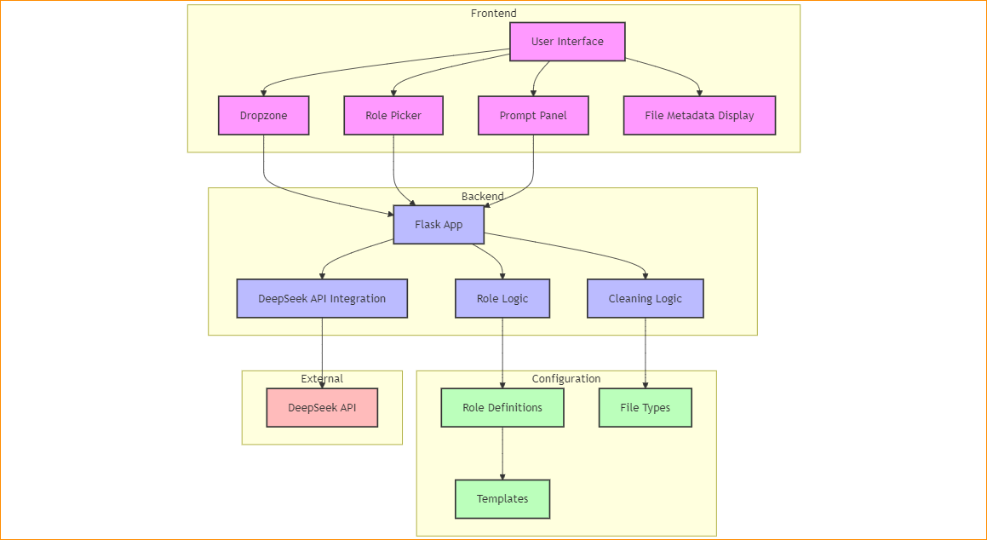

graph TD

    subgraph Frontend

        UI[User Interface]

        DZ[Dropzone]

        RP[Role Picker]

        PP[Prompt Panel]

        FM[File Metadata Display]

    end

    subgraph Backend

        FL[Flask App]

        CL[Cleaning Logic]

        RL[Role Logic]

        API[DeepSeek API Integration]

    end

    subgraph Configuration

        RC[Role Definitions]

        FT[File Types]

        TM[Templates]

    end

    subgraph External

        DA[DeepSeek API]

    end

    UI --> DZ

    UI --> RP

    UI --> PP

    UI --> FM

    DZ --> FL

    RP --> FL

    PP --> FL

    FL --> CL

    FL --> RL

    FL --> API

    RL --> RC

    CL --> FT

    API --> DA

    RC --> TM

    classDef frontend fill:#f9f,stroke:#333,stroke-width:2px

    classDef backend fill:#bbf,stroke:#333,stroke-width:2px

    classDef config fill:#bfb,stroke:#333,stroke-width:2px

    classDef external fill:#fbb,stroke:#333,stroke-width:2px

    class UI,DZ,RP,PP,FM frontend

    class FL,CL,RL,API backend

    class RC,FT,TM config

    class DA external

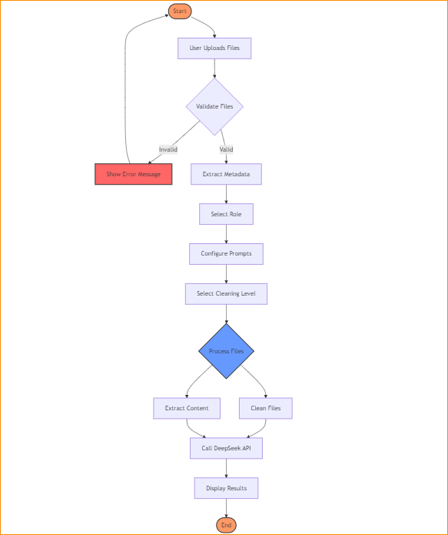

flowchart TD

    Start([Start]) --> Upload[User Uploads Files]

    Upload --> ValidateFiles{Validate Files}

    ValidateFiles -->|Invalid| Error[Show Error Message]

    ValidateFiles -->|Valid| ExtractMeta[Extract Metadata]

    ExtractMeta --> SelectRole[Select Role]

    SelectRole --> SelectPrompt[Configure Prompts]

    SelectPrompt --> SelectCleaning[Select Cleaning Level]

    SelectCleaning --> Process{Process Files}

    Process --> CleanFiles[Clean Files]

    Process --> ExtractContent[Extract Content]

    CleanFiles --> CallAPI[Call DeepSeek API]

    ExtractContent --> CallAPI

    CallAPI --> DisplayResults[Display Results]

    DisplayResults --> End([End])

    Error --> Start

    style Start fill:#f96,stroke:#333,stroke-width:2px

    style End fill:#f96,stroke:#333,stroke-width:2px

    style Error fill:#f66,stroke:#333,stroke-width:2px

    style Process fill:#69f,stroke:#333,stroke-width:2px