Supplier Visit — Meeting Minutes
Visit to Shandong Botong Aluminum Technology Co., Ltd (Yuantong Group) · 6061-T6 Aluminum Tube Supply Discussion

1. Meeting Overview
Item | Details
Date | August 11, 2026
Venue | Liangshan, Jining, Shandong — Yuantong Group / Shandong Botong Aluminum Technology Co., Ltd headquarters and production plant
Supplier side | Mr. Ai Guangyuan (艾广远), Chairman & legal representative; Lawrence Fang (方广远), Sales Manager; Mr. Wang, Plant Manager; and other executives
Our side | DOHO CO., LTD. — Mr. Juho Hwang / CODO International — Mr. Guo (partner)
Purpose | Supply discussion for all Group A·B·C items, production system verification, quality & certification document requirements

2. Items Discussed
Group | Size | Quantity | Length
Group A (7 items) | OD 120–260 × t30 mm | MOQ per item TBD | L2,000 mm
Group B (11 items) | OD 125–280 × t10 mm | MOQ per item TBD | L2,000 mm
Group C (2 items) | 450×30 / 460×8 | 11 / 13 pcs | L3,000 mm
Reconfirmed for all items: 6061-T6, seamless one-piece, OD tolerance +0.05/−0.00 mm, roundness within 0.5 mm over full 360°.

3. Production System Verification (plant tour findings)
- Toured the extrusion lines at the Liangshan plant — confirmed 1,400-ton and 2,500-ton extrusion presses, long-billet heating furnace, post-extrusion lines, and small-diameter tube stock.
- Group A·B size range (OD 120–280 mm) confirmed producible in-house at the Liangshan plant.
- Group C large diameters (φ450·φ460) exceed in-house press capacity; the supplier officially confirmed these are produced by a partner manufacturer in Tianjin. We requested the partner's details (name, location, equipment, certifications).
- We stated our intention to audit the actual large-diameter production site as soon as possible (this week to next week); the supplier agreed to arrange the visit.

4. Quality & Certification Document Requests (agreed by supplier)
- MTC (mill test certificate): re-issue in EN 10204 3.1 format for lots of our ordered sizes (including 450×30×3000 and 460×8×3000) — applicable product standard stated, signed by the inspection manager and company-stamped.
- Certificate renewals: renewed ISO 9001:2015 (previously received copy confirmed expired 2025-09-26); confirm ISO 14001 status and provide a copy; renewed SGS assessment — all copies must show issue and expiry dates.
- Certificate of Conformity (CoC): re-issue stating our ordered spec (6061-T6, 450×30×3000 / 460×8×3000), with issue and expiry dates, on an annual renewal basis.
- One-piece, NO welding: joining shorter tubes (e.g., 1 m) by welding to make up the full length is absolutely prohibited — to be verified by full-length UT scan on all pieces and X-ray photos on lot samples.
- Test results: X-ray (internal defect) results and measured OD tolerance (+0.05/−0.00 mm) reports to be submitted.
- Company profile in English (history, organization, equipment, capacity) to be submitted.

5. Customs & Origin (tariff-saving conditions)
- All trade documents (PI, Commercial Invoice, Packing List, export declaration, Certificate of Origin) to uniformly state HS Code 7608.20 (aluminium alloy tubes).
- Korea–China FTA Certificate of Origin (C/O) under HS 7608.20 requested — for preferential (duty-free) clearance at Korean import. Written commitment to be provided.

6. Quotation Request
- For all Group A·B·C items: MOQ per item and unit prices quoted separately as FOB (Qingdao) and CIF (Incheon).
- Length basis: Groups A·B at 2,000 mm; Group C at 3,000 mm. Group C shell OD corrected to 460 mm (previous 461 corrected).

7. Action Items
Item | Owner | Due
Reply with all requested documents (Sec. 4) and quotations (Sec. 6) | Botong | Deadline being confirmed
Provide Tianjin partner details and arrange the visit | Botong | Within this week
On-site audit of the large-diameter production plant | DOHO | This week – next week
Verify validity of received documents (incl. issuing-body checks) and report | DOHO | Immediately upon receipt

8. Overall Assessment
The supplier's top management (Chairman Ai Guangyuan) participated directly, securing a decision-making channel, and confirmed willingness to provide every requested document and quality condition. In-house production capability was verified for the small-diameter range (Groups A·B); for the large diameters (Group C), we will audit the partner manufacturer's site in person before confirming whether to proceed. A consolidated report will follow once documents are received and the audit is complete.
Prepared by DOHO CO., LTD. · August 11, 2026

Appendix. Site Photos (taken August 11, 2026)
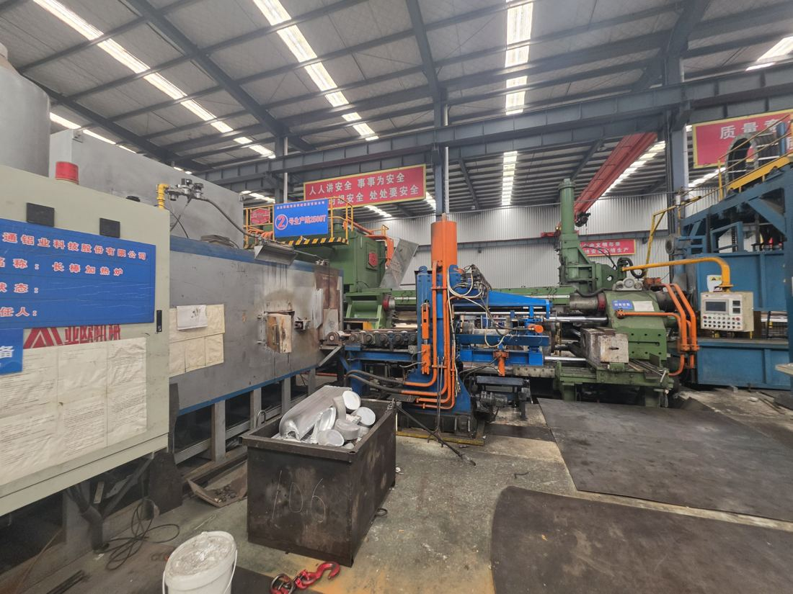  2,500-ton extrusion line (Line No.2, 2500T) | 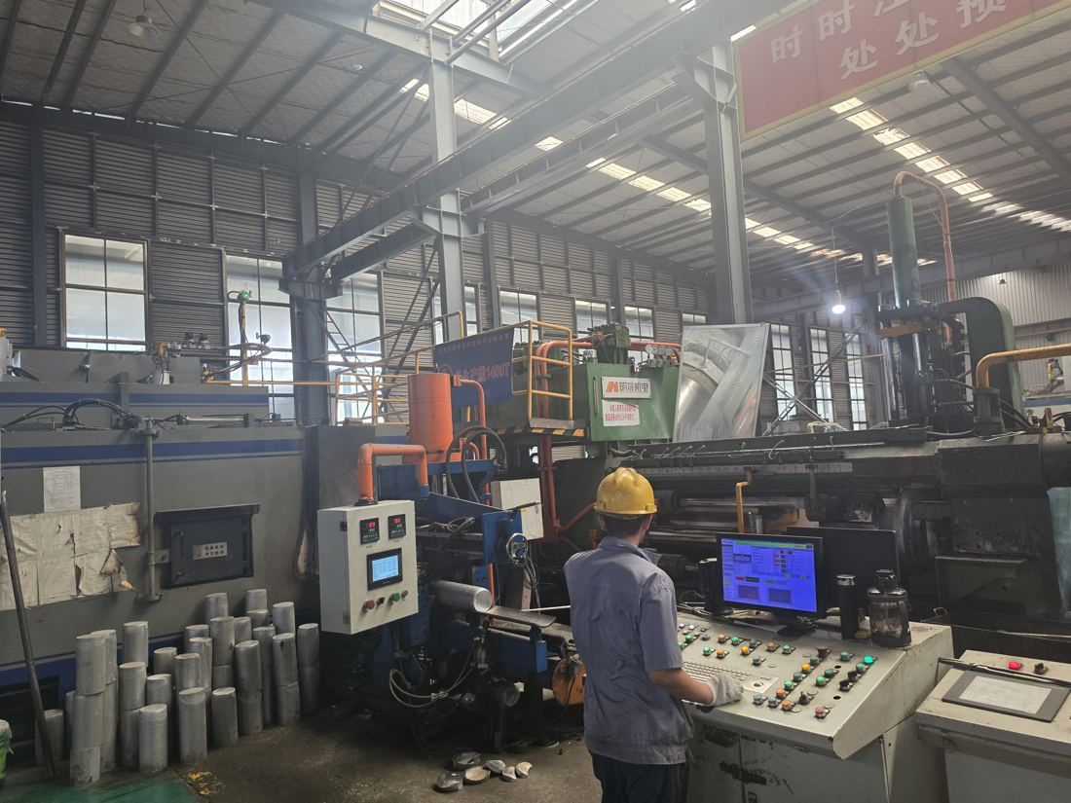  1,400-ton extrusion line in operation
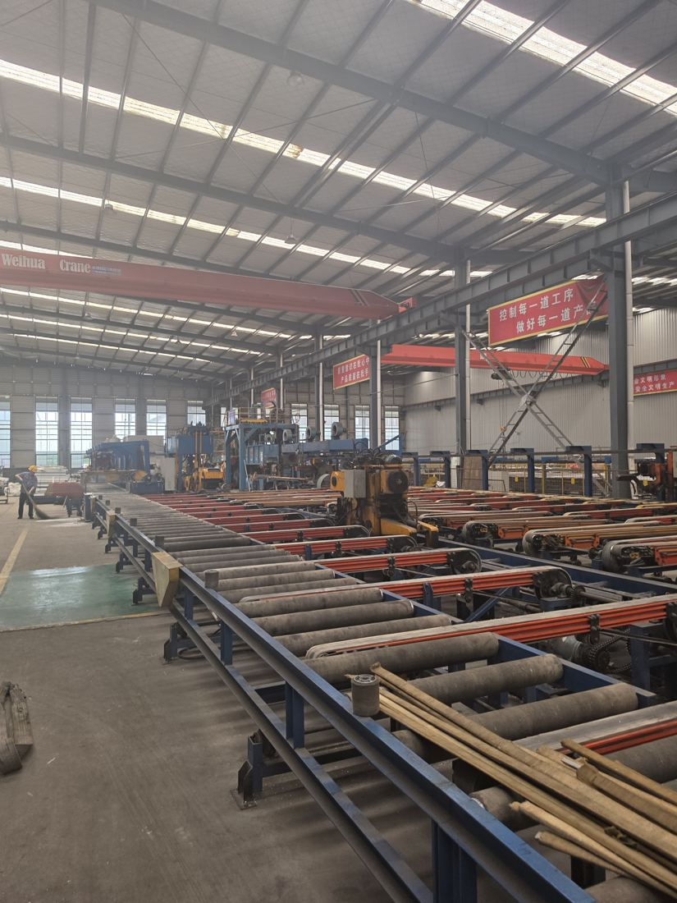  Post-extrusion (stretching / handling) line | 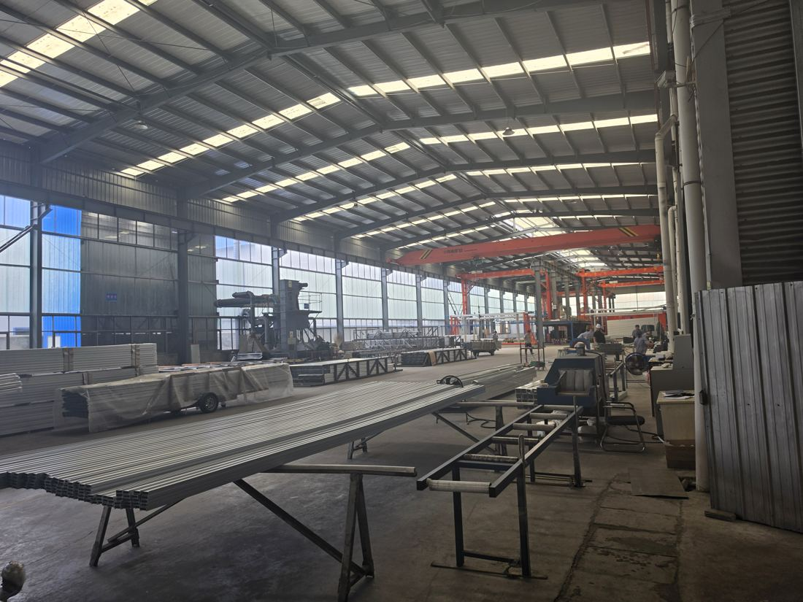  Profile fabrication workshop
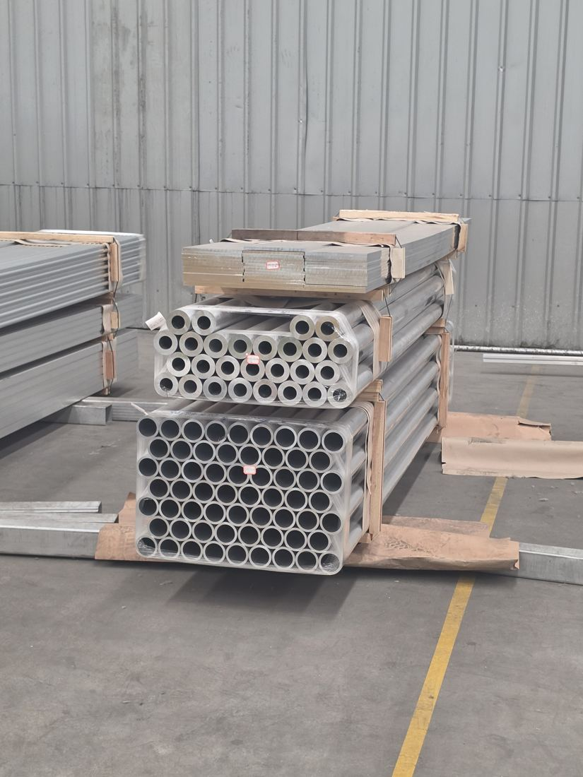  Small-diameter tube stock (Group A·B size range) | 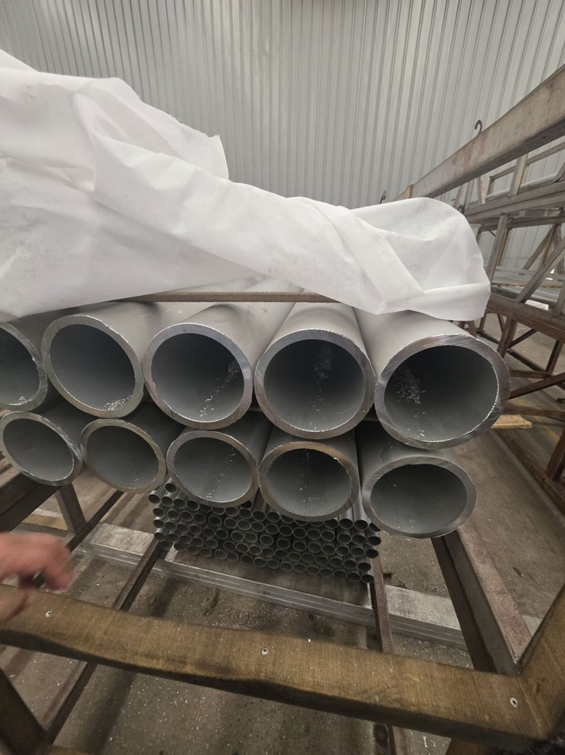  Thick-wall large-diameter tube stock
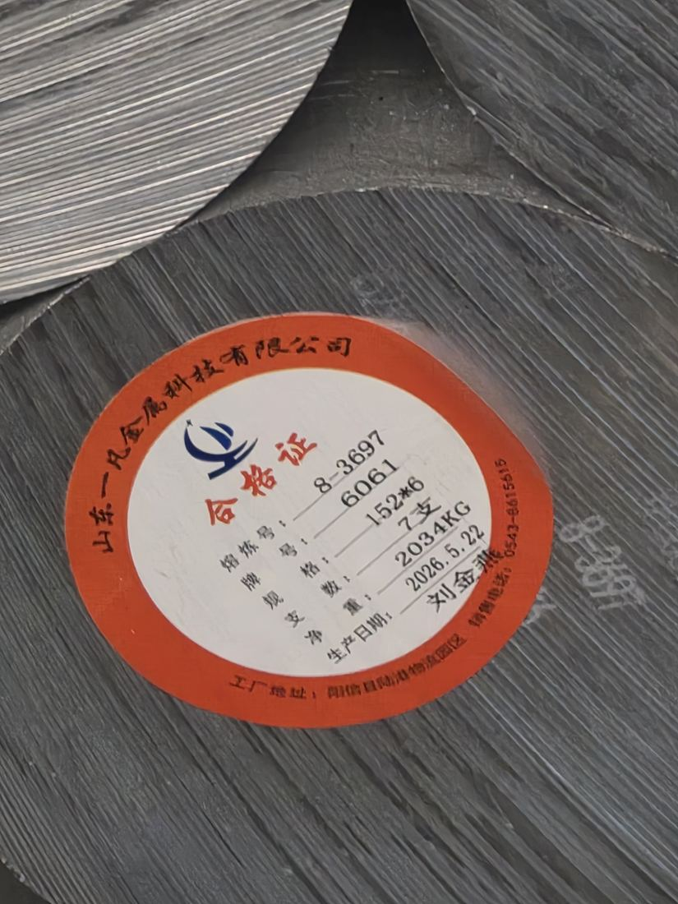  6061 billet label (produced May 2026) | 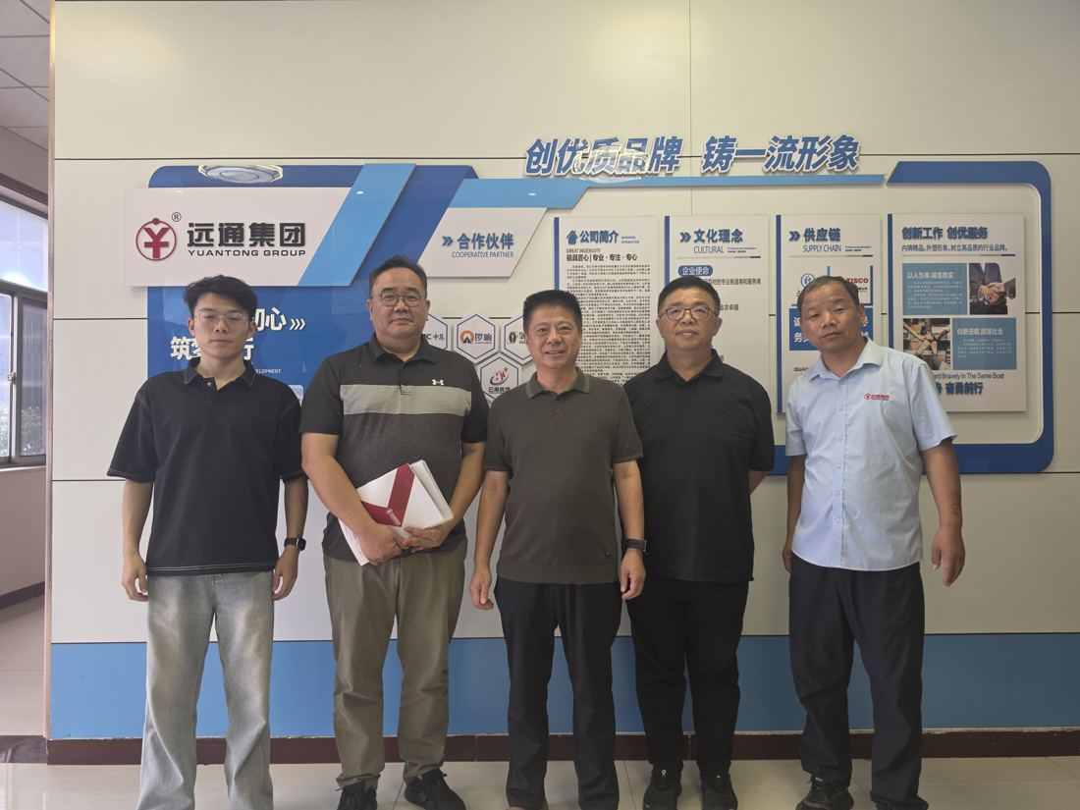  Attendees at Yuantong Group headquarters

