Instruction File for IERG3310 Project Code

Please ensure the deceive have gcc/g++ complier.

For Step 1-5:

1. Import student1-5.cc and robot1-5.cc as the source code
2. Compile its binary file using gcc [source code .cc] -o [binary file name]

Demonstration in Ubuntu:

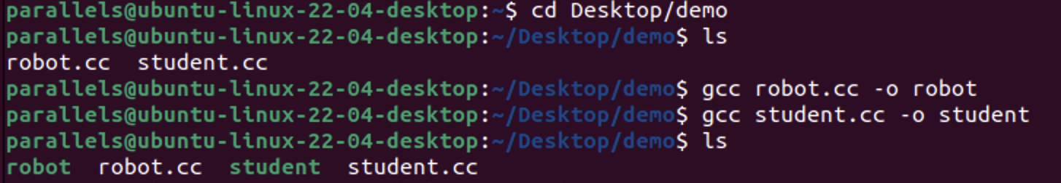

1. Run the robot first by ./[robot binary file name] (./robot in this example)
2. Run the student by . /[student binary file name] (./student in this example)
3. Compile it and wait all the result to output.

For Step 7:

1. Import student7.cc and robot7.cc as the source code
2. Compile its binary file using gcc [source code .cc] -o [binary file name]

Demonstration in CentOS: (VM for IERG3800 course)

One machine as a student, another one as a robot.

1. Run the robot first in machine 1 (ntec26-14 in this example)
2. Run the student in machine 2 (ntec25-14 in this example)
3. Compile it and wait for 30 seconds for the result.

(Optional)

1. As robot IP may change depends demonstrate on different machine, please find the machine ip (using ifconfig ens192 in this example in robot machine), edit the student code in Line 27 if needed.



Then repeat above steps if needed

P.S. Use Control + C to terminate the code if needed/ something went wrong.