Jeffrey Paluch
07/12/2026
CS2430-501
Project 3 - Optimal Selection

This project focuses on the knapsack problem, an optimal selection problem that features a set of elements that have weights and values, of which a certain subset is constructed so as not to exceed a weight limit while maximizing the total value. Since the items belong to a finite set, they are unique and cannot be duplicated nor split apart. There are many algorithms that can be implemented to uncover the optimal path or subset, such as greedy algorithms that select the elements solely according to their weight, value, or the ratio between these two. This problem has a multitude of real-world applications, most of which are typically concerned with resource allocation and logistics, and are centered on achieving maximum value from some amount of work or space. In this project, I was tasked with selecting the optimal subset of payloads from a set of a dozen unique experiments to bring onto a space shuttle with a 700 kg weight limit, for which the efficacy of different types of algorithms were tested in their ability to solve the problem.

These algorithms included three greedy strategies and one exhaustive search, which I implemented using Java SE-21 on the Eclipse IDE. I represented the experiments with a record class titled Experiment and placed a static final List<Experiment> in a separate class titled Strategies with the rest of my code. The first greedy strategy was a rating-first method which sorted the experiments according to their ratings in descending order. It sequentially moved elements to an empty list until the weight limit was exceeded and returned the list. The second was a lowest-weight method which performed identical operations but filtered experiments by weight in ascending order. The third was a best-ratio method that compared the rating-to-weight ratio, functioning in a similar fashion to the other greedy methods. Each of these methods accepted a List<Experiment> as input and had the same return type. They made out-of-place modifications by using a copy of the input list, and sorted the copy using the Comparator interface. Each sorted list was iterated through and its elements were appended to the return List<Experiment>.

I used a single method for implementing a brute force strategy that constructed every possible subset from the experiment set, which consisted of 4096 different subsets. The brute force method relied on bit shift operators, with experiments represented as bit strings, to build the unique list of subsets. I also created a nested class called Subset that held a List<Experiment> and two integers for the total weight and rating of each subset. Inside of the brute force method, each subset that fit the weight criteria was filtered into a list of subsets and the three subsets with the highest ratings were returned. This strategy was particularly useful for assessing the greedy methods by their ability to construct an optimal list. I used a refactored method, printExperiments, to print each subset with their respective weights and ratings.

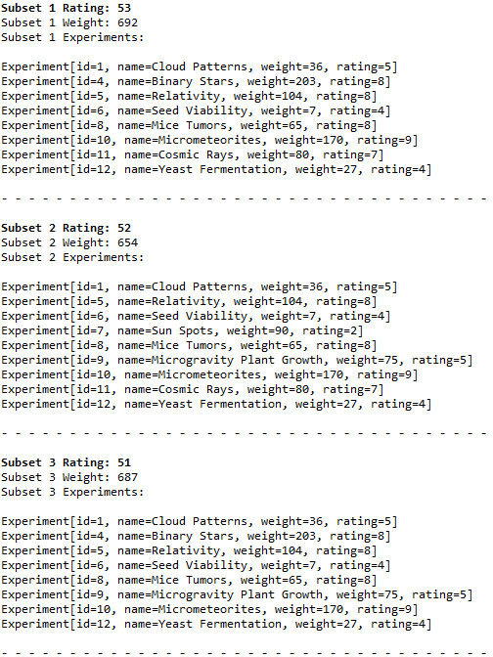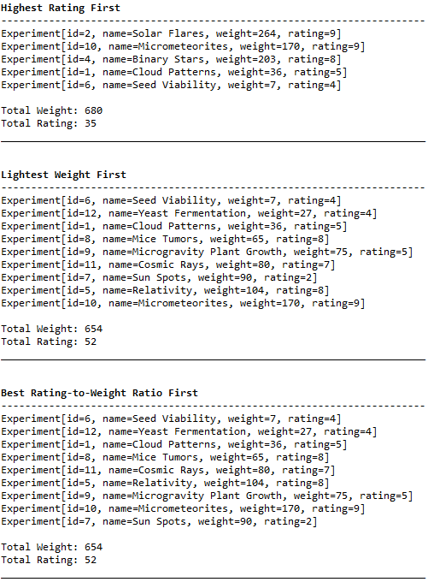

Figure 1. The three subsets with the largest ratings, computed by the brute force method, are listed in descending order on the left-hand side. The three subsets generated by the greedy methods are listed on the right-hand side. Each total weight and rating is printed along with the list of experiments.

According to the brute force method, the largest possible rating for any valid combination of experiments was 53, with a weight of 692 kg. The list of experiments showed a large deviation between rating and weight ratios with both variables directly connected to each other, in that experiments with higher ratings also had significantly higher weights and weight-to-rating ratios. This resulted in a nonoptimal highest-rating list that favored heavy objects. Since the experiments that weighed less had more impressive rating-to-weight ratios, the lightest-first method returned a list with a total rating of 52 and a weight of 654, and the rating-to-weight method returned the same combination of experiments but in a different order. Conversely, the rating-first method returned a total rating of 35 and a weight of 680. The greedy methods that favored better rating-to-weight ratios and lower weights were successful in achieving a combination of experiments with a high rating, while the method favoring higher ratings performed poorly. In this case, heavier experiments had higher ratings, causing the rating-first method to fail. The greedy strategies are largely, if not entirely, dependent on the set they are operating on.

A brute force strategy requires constructing every possible combination of subsets, resulting in an exponential time complexity and making it unscalable. Dynamic programming breaks problems into subproblems, then overlaps them and bypasses sections that have already been solved, allowing for larger sets and improved scalability. Certain computations are not performed twice, drastically lowering the time complexity but increasing the space complexity. Instead, priority-based methods that rely on priority queues may be more effective options. These algorithms assign different priorities to tasks to determine urgency and prevent wasting time from rechecking previously explored pathways. Dynamic programming and heuristic methods stand in stark contrast to each other, one relentlessly checking each combination and the other following a straight-forward procedure for quick computation.

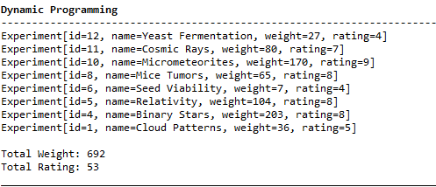 | 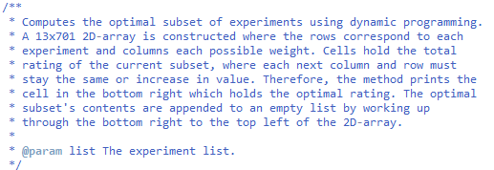
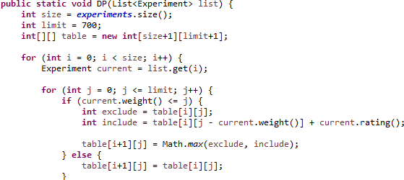 | 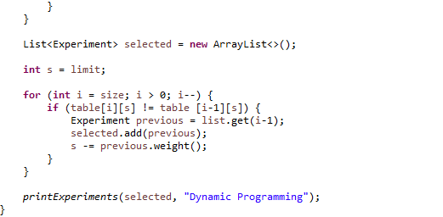

Figure 2. The subset generated by the dynamic programming method and its total rating and weight, followed by the Java pseudocode comment and the method contents.

Discrete optimization problems can seem fairly simple yet become convoluted when various strategies are applied or changes are made to the set of interest. Problems like the knapsack or traveling salesman problem are ubiquitous in practical applications, where each variable and their relationships to each other must be considered, becoming progressively tougher to solve. These variables have an interplay which may involve changing relationships and cannot be modelled by a single equation. Though they are unreliable, simple strategies like the greedy strategies employed in this project may suffice for some problems. Alternatively, dynamic programming stores subproblems in a lookup table to avoid recalculations. Typically, the program uses a recursive algorithm with recurrence relations, choosing the more sensible of two paths to maximize value. The solutions for these problems may be easy to calculate but tradeoffs between time and space complexity make this process complicated. Specifically, the time it took the brute force method to finish compared to the dynamic programming method was roughly twenty times larger.

Altogether, this project taught me about the implications and underlying complexity of using different types of strategies to solve a relatively simple problem. Deciding which strategy to implement becomes tough when factoring in time and space complexity. Certain lazy methods can be surprisingly efficient in finding acceptable solutions but may not be reliable. With changing datasets, these greedy strategies lose their value and dynamic programming should be applied. The implementation of dynamic programming was particularly difficult for me but appeared to be essential for solving comparable types of problems.

Sources

https://www.geeksforgeeks.org/dsa/difference-between-brute-force-and-dynamic-programming/

https://www.w3schools.com/dsa/dsa_ref_dynamic_programming.php

https://www.w3schools.com/java/java_arrays_multi.asp

https://medium.com/@ksaquib/understanding-java-records-a-comprehensive-guide-448442d8cda9

