1.

|  |  |
| --- | --- |
| Area(um^2) | 449628 |
| Clock cycle(ns) | 7.2ns |
| Total simulation time(ns) | 8540.395 ns |
| Cost(um^2* ns^2) | 3.2792E+13 |

2.

area

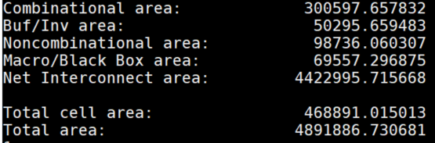

RTL

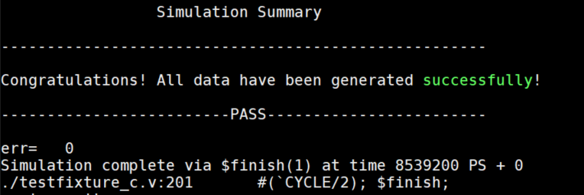

Gate level

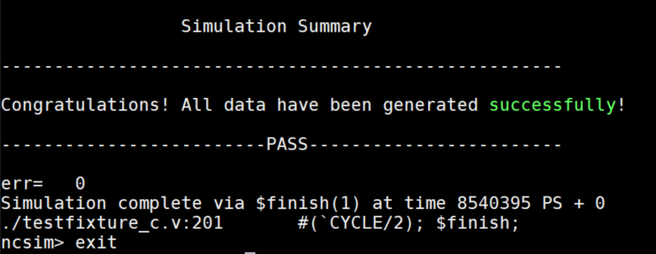

3.

(1)把ROM的value掃一遍讀出來，存到自己的暫存器，

(2)mark label

(3)存到SRAM