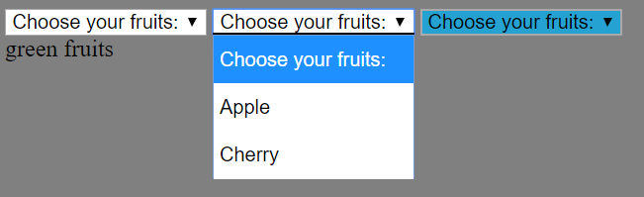

<!DOCTYPE html>

<html>

    <head>

        <title>Page Title</title>

        <style> #fruits01:hover {background-color: #3e8e41;} </style>

        <style> #fruits03:hover {background-color: #25A2D2;} </style>

    </head>

    <body style="background-color:gray;">

        <select id="fruits01" class="select" name="fruits1" >

            <option value="0">Choose your fruits:</option>

            <option value="1">Avocado酪梨</option>

            <option value="2">Guava芭樂</option>

        </select>

        <select id="fruits02" class="select" name="fruits2" >

            <option value="0">Choose your fruits:</option>

            <option value="1">Apple</option>

            <option value="2">Cherry</option>

        </select>

        <select id="fruits03" class="select" name="fruits3" >

            <option value="0">Choose your fruits:</option>

            <option value="1">Blueberry</option>

        </select>

        <div id = 'fruit_check'></div>

        <script src="https://code.jquery.com/jquery-3.3.1.min.js"></script>

        <script>

        $(document).ready(function(){

            console.log( "ready!" );

            // $('#fruits01').mouseover(function() {

            $('#fruits01').click(function() {

                // $('fruits01').hover()

                $('#fruit_check').html(``)

                print('green fruits')

            });

        });

        function print(str) {

            $('#fruit_check').append(`${str}`)

        }

        </script>

    </body>

</html>

My own testing hover example.

We need to detect hover property which means that if you move to the element, some actions will be reacted.

By taking partial screenshot before and after the move action happens, we can know whether it’s a hover element or not. If two pictures are quite different, it means the move action will contribute to the difference. In other words, move action will let the element do some reactions and that’s the hover element’s definition is.

Here we just take partial screenshot for two reasons.

Reason 1: If you take whole screenshot, you will receive some wrong cases. For example, if we have two elements A and B and only A is a hover element, we may also regard element B as a hover element, because during we operation with element B, the prior action that acts on element A may be invalid such as hover list will disappear due to the mouse moving to another element. Hence, we will make a wrong decision that we view element B as a hover element, too.

Reason 2: For the picture comparison, the less pixels we want to compare results in the less comparison time cost. If we have more hover elements, the reduction in time will be more significant. Partial screenshot saves more time than whole screenshot cost.

<https://www.w3schools.com/howto/tryit.asp?filename=tryhow_css_js_dropdown_hover>

w3shool implements Hoverable Dropdown element

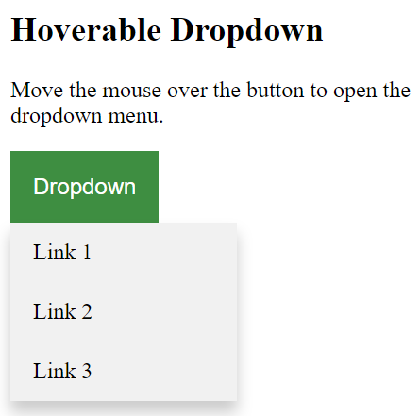

1. In the above, we need to consider green Dropdown button to be a hoverable element. After we move to it, the list will drop down.

2. We also need to detect sublist like Link 1 and see whether it can go a website or not. If yes, whether it go to an effective website, i.e., without 404 not found happening.

https://web.ee.ntu.edu.tw/



There are many hoverable element here. Each of it will give a dropdown list and we can click the sublist to go to some specific subpages.

We need to detect all the hover elements and check whether all the links are valid.

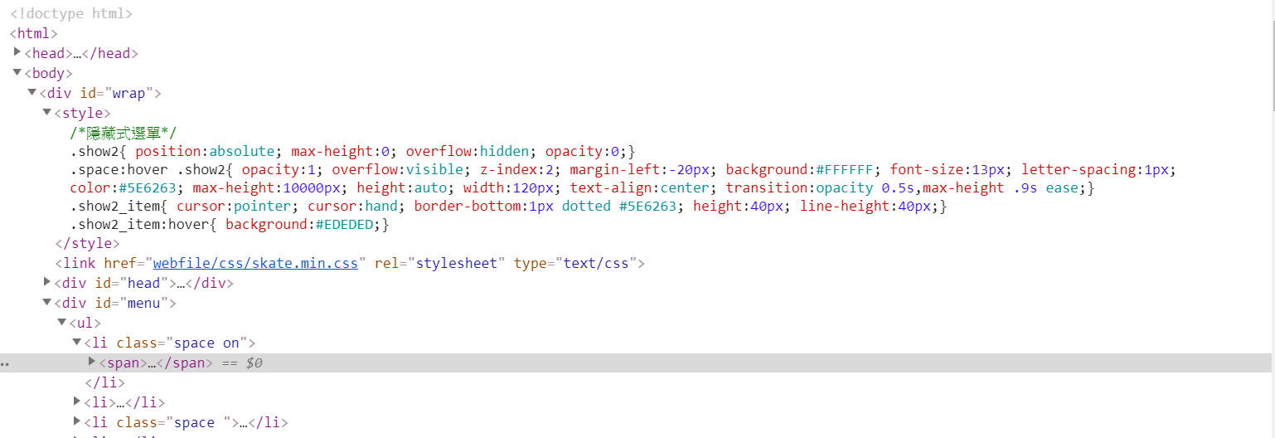

Because these kind of hover element are defined by website creator, i.e., he uses his own classes definition, we need to detect all the class that will be given hover action so as to detect all the possible candidates.