*Empty Apartments* consists of approximately 150,000 photographs of apartments that were listed for rent on Craigslist on May 20, 2016. They were automatically scraped these images from the site, then manually sorted to remove exterior shots, ads, floorplans, and shared areas like gyms and foyers. The images are shown en masse, appearing as an endlessly scrolling field that reveals the transitional, intimate spaces where American renters carry out their private lives.

The images are of paused in-between spaces – rooms in various stages of their inhabitants exiting and entering, their final outcome yet to be realized. Some show a life caught in midstream, a photo documenting a stranger’s living space in disarray, with nothing arranged for the benefit of the camera. Others are highly polished and staged: several glasses of wine and a bottle set out on a table with beckoning chairs inviting the viewer to envision themselves there. Others are newly empty, the bareness intensified by the remnants left by the previous tenant: a pile of pillows stacked in a corner, boxes by a door.

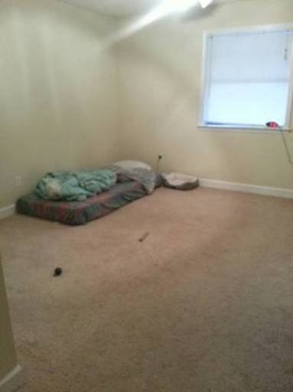

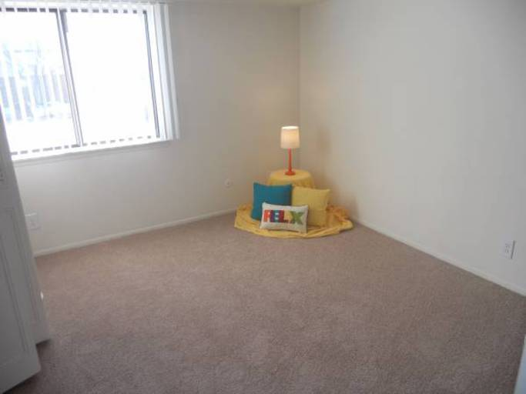

Poring through all these photographs, we were interested in both the documentation of of everyday American living spaces these images represent and the anonymous landlord-photographers who took them. Craigslist organizes their site by location, mostly cities and major metropolitan areas. In total, there were 413 areas listed starting with Abilene, Texas and ending with Zanesville, Ohio. But rather than an ethnographic investigation of homes in the U.S., we wanted the photographs to remain as disembodied images; prices, location, and descriptions are no longer attached but instead a wash of images, arranged by visual similarity.

Working on a project of this scale requires a division of labor. Jeff was responsible for coding (a script to download the original images, intermediate steps of reformatting and sorting, and building the website). I provided the manual labor of going through all of the images (three times) to weed out the ones that we felt didn’t fit our criteria. My task allowed for a granular familiarity with the images. I pored over the images for a period of several months. At times the process of sifting and culling was meditative, other times tedious, with one image bleeding into the next. Each day there was a surprise, an image that would take my breath away with its unintentional beauty or strangeness. The amateur photographers who took the majority of the photographs didn’t know how to handle low light or the difference in exposure between a bright window and dark room. Windows became soft rectangles of glowing light surrounded by shadow. There were inexplicable images where the intention of the photographer was unclear: unfocused pictures of empty corners, stairs descending into darkness, a blurry shot of wood grain.

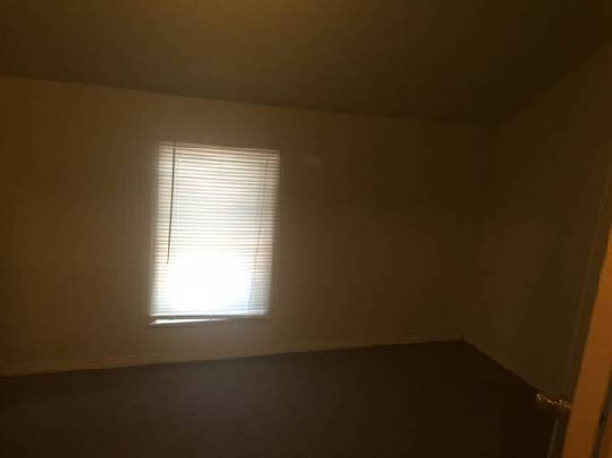

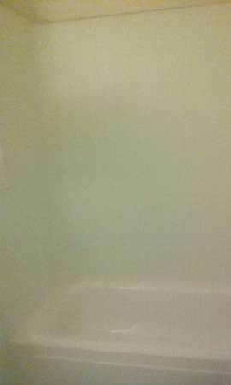

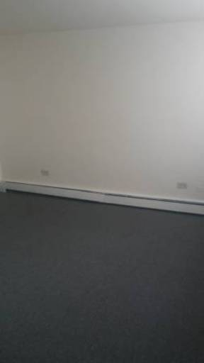

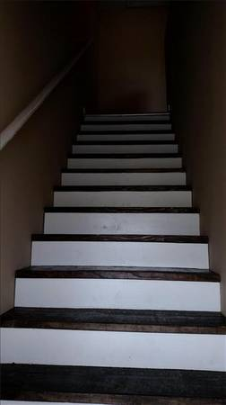

This set of images exists as a vast, seemingly endless array of interior spaces. On the website, you can zoom out and in, varying the degree in which you can engage with the details of the photographs. Pulling out, visual patterns begin to emerge. As curators, we have been especially interested not just in the works that we show, but how we show them. We spent a very long time (months, actually) discussing how best to arrange these images. Though some information does get lost when separating an image from its geography, we ultimately settled on arranging the images by visual similarity. (Jeff used several machine learning algorithms to accomplish this – you can read more about that in this blog post.) Strange repetitions emerge, like the glowing rectangles of windows. Those taken with artificial light are dominated by a yellow cast; soft squares of pastels from carpets and dark staircases find themselves grouped together.

As you zoom in and look more closely, the viewerss experience replicates my own as I individually sorted through the images. There are long slogs of sameness shot through with surprise. A calico cat, captured crossing a bed in a beam of light. The loneliness of an empty lawn chair, in an empty room, by a curtain-less window. The solitude of bare hangers in an otherwise empty closet. The atavistic satisfaction of seeing fresh vacuum marks on a carpet (there are thousands of these). There is a pervading sense of loss and abandonment that hangs over most of these images, only to be broken by a photo of a kinky pink hot tub.

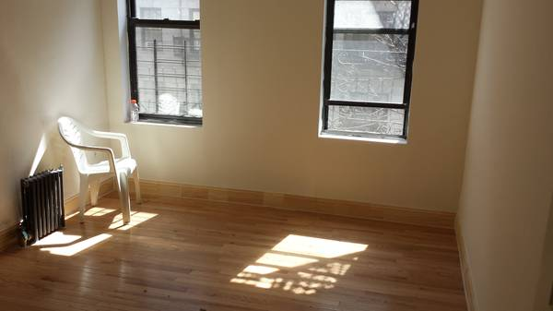

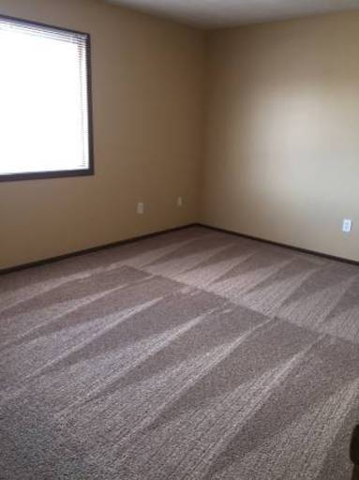

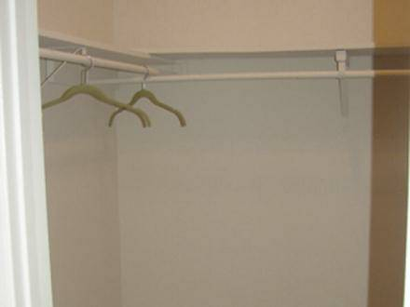

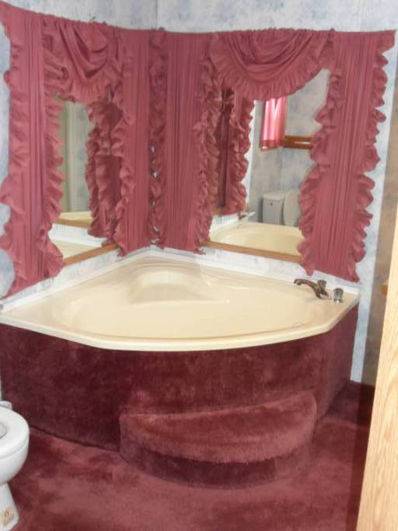

The places we reside in, the walls, ceiling, and floor act like a secondary skin. The house is as a protective layer and inside it we perform our most primary functions and act out our private selves. Even in the reign of social media, most of us still lead very private lives allowing only highly mediated images of self to grace our feeds. But in these images of living spaces there is a feeling of vulnerability, of something exposed to the open air that should not have been. Spaces that we are not normally privy to, turned inside out. It’s the shock of looking at a photograph of a Gordon Matta Clark cut, the disorientation of seeing directly someone’s living room from the street.

And yet, despite there being no people in them, these images were obviously taken by someone. Every photograph on Craigslist is anonymous, no photographer is ever credited. We were drawn to the idea of an accidental, collaborative buildup of images. Thousands of cameras and eyes used for the purpose of capitalism, but the result is an unintentional document of our nomadic, American living spaces. Sometimes I would catch a glimpse of the photographer: a fragment of a face, a crook of an elbow caught in a bathroom mirror, a reflection in a window turned mirror at night, a shadow projected onto the floor. Their presence was always surprising and jarring when stumbled upon. They were fugitives, breaking the illusion of emptiness and introducing a paradox: though the images exuded an existential loneliness, at the moment they were taken, at least one person was present.

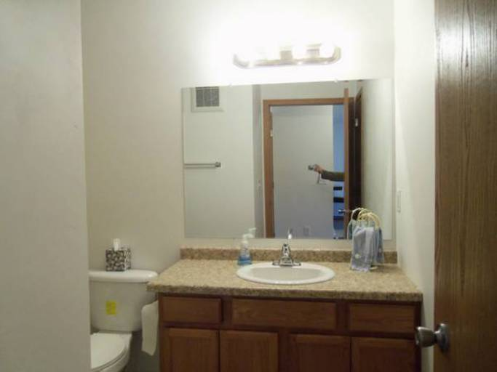

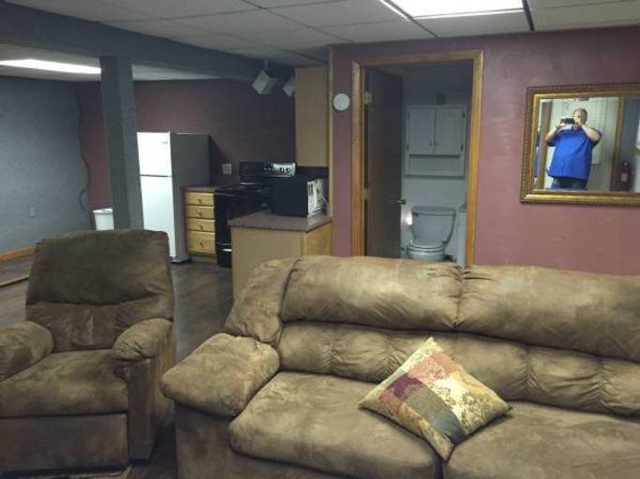

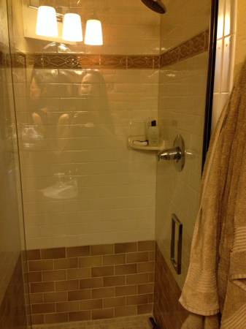

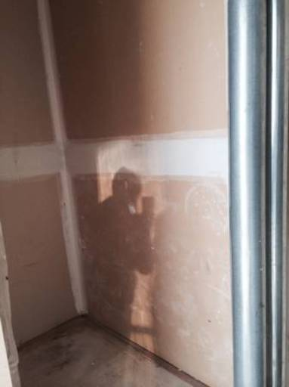

The project also revealed a clear demarcation of class, evidenced by the technical quality of the photographs themselves. Those that could afford to, or for whom it was financially worthwhile, hired professional photographers. The rooms shown were neat, tastefully but blandly decorated without the marks of lives being lived. Exorbitant rents merited the cost of a wide-angle lens and a photographer who knew how to apply HDR post-processing. The professional photographs were lit with care and carefully edited, but were ultimately generic – they all could have been taken by a single photographer. The images taken by amateurs, casual and perfunctory, held the most joy and surprise. Low quality jpeg compression and patterns of overexposed windows with underexposed interiors creating photographic magic. I would imagine the photographer, probably the landlord themselves, pausing and caught up for a moment in the beauty of the way light hit a wall. How it broke up as it ran through the slats of the blind, throwing a pattern on a well-worn wooden floor. That for a moment they paused in their task, distracted by trying to capture something beyond just documentation and a rush to get the place listed.

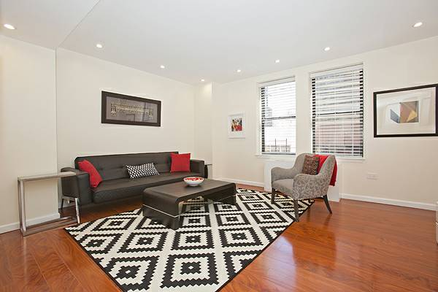

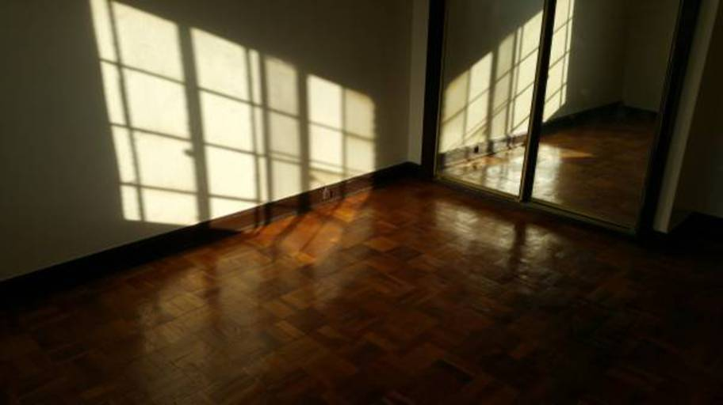

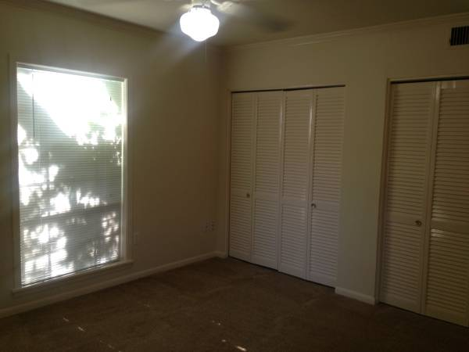

I do not know how to end this btw help. Scrap below paragraph entirely?

