Empty Apartments consists of approximately 150,000 photographs of apartments that were listed for rent on Craigslist on May 20th, 2016. We automatically scraped these images from the site, then manually sorted through them, removing exterior shots, ads, floorplans, and shared areas like gyms and foyers. The images are shown en masse. They appear as an endlessly scrolling field, revealing the transitional intimate spaces where American renters carry out their private lives.

The images are of paused in-between spaces – rooms in various stages of their inhabitants exiting and entering, their final outcome yet to be realized. Some show a life caught in midstream, a photo documenting a stranger’s living space in disarray, with nothing arranged for the benefit of the camera. Others are highly polished and staged: several glasses of wine and a bottle set out on a table with beckoning chairs inviting the viewer to envision themselves there. Others are newly empty – the bareness intensified by the remnants left by the previous tenant; a pile of pillows stacked in a corner, boxes by a door.

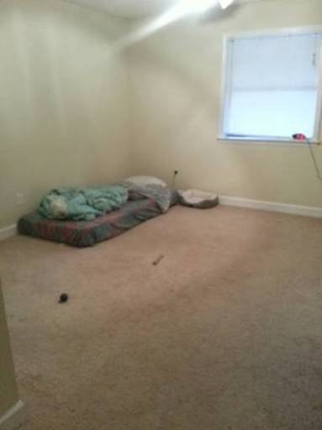

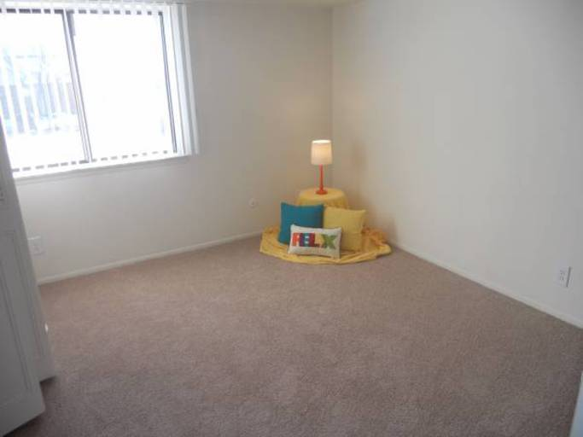

We were interested in both the documentation of these spaces, and the anonymous landlord-photographers who took them. Craigslist organizes their site by location, mostly cities and major metropolitan areas. In total, there were 413 areas listed starting with Abilene, Texas and ending with Zanesville, Ohio. But rather than an ethnographic investigation of homes in the US, we wanted the photographs to remain as disembodied images; prices, location, descriptions are no longer attached to the images, but instead sorted by visual similarity.

In doing this project we divided the labor between us. Jeff was responsible for coding (a script to download the original images, intermediate steps of reformatting and sorting, and the website). I provided the manual labor of going through hundreds of thousands of images (three times) to weed out the ones that we felt didn’t fit our criteria. My task allowed for a granular familiarity with the images. I pored over the images for a period of several months. At times the process of sifting and culling was meditative, other times tedious, with one image bleeding into the next. Each day there was a surprise, an image that would take my breath away with its unintentional beauty or strangeness. Many of the amateur photographers responsible for the majority of the photographs did not know how to handle low light or the difference in exposure between a bright window and dark room. Windows became soft rectangles of glowing light in dark rooms. There were inexplicable images where the intention of the photographer was unclear: unfocused corners, stairs descending into darkness, a blurry shot of wood grain.

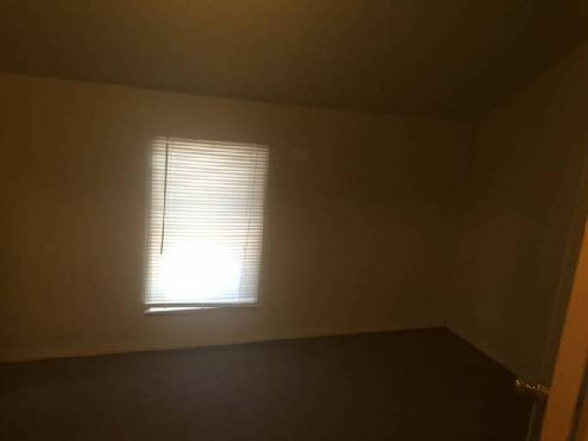

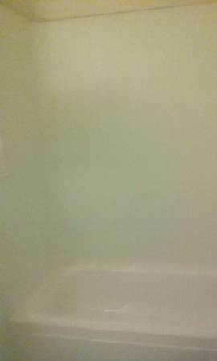

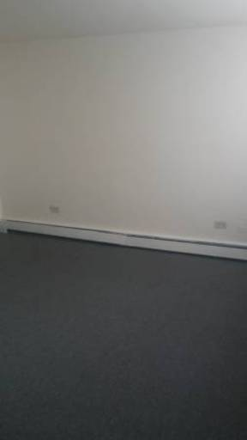

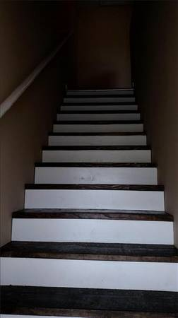

This set of images exists as a vast, seemingly endless array of interior spaces. On the website, you can zoom out and in, varying the degree in which you can engage with details of the photographs or pull out to view overall visual patterns. The manner in which they are sorted is accorded to visual similarity. Images primarily sorting themselves according to light and color. The glowing rectangles of windows are a visual thread running through the whole project. Those taken with artificial light dominated by a yellow cast, soft squares of pastels from carpets and wall find themselves grouped together. [ maybe jeff can talk about this more screen shot of overview]

As you zoom in and look more closely the viewers experience replicates my own as I individually sorted through the images. There are long slogs of sameness shot through with surprise; a calico cat, captured crossing a bed in a beam of light; the loneliness of an empty lawn chair, in an empty room, by a curtain less window; the solitude of empty hangers in an otherwise bare closet. The atavistic satisfaction of seeing fresh vacuum marks on a carpet (there are thousands of these). There is a pervading sense of loss and abandonment that hangs over most of these images, only to be broken by a photo of a kinky pink hot tub.

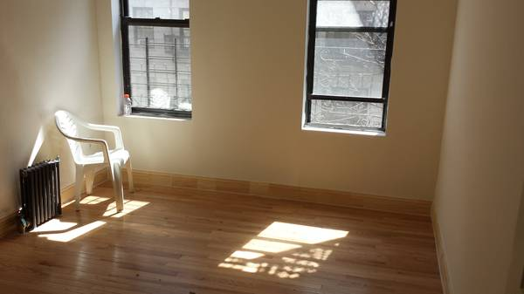

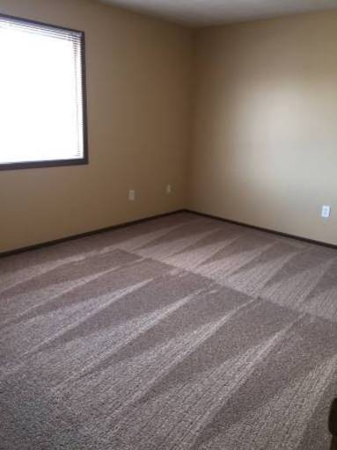

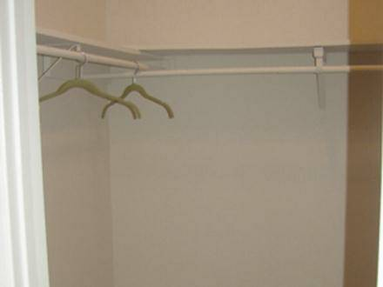

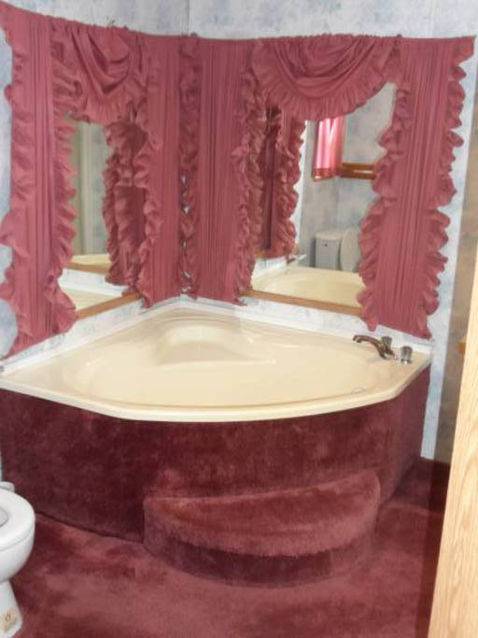

The places we reside in, the walls, ceiling and floor act like a secondary skin. The house acting as a protective layer where we perform and act out our most primary functions of the private self. Even in the reign of social media most of us still lead very private lives allowing only highly mediated images of self to grace our feeds. There is a feeling of vulnerability in these images, of something exposed to the open air that should not have been. Spaces that we are not normally privy to, turned inside out. It’s the shock of looking at a photograph of a Gordon Matta Clark cut, the disorientation of seeing directly someone’s living room from the street.

Every photograph on Craigslist is anonymous, no photographer is ever credited. We were drawn to the idea of an accidental collaborative buildup of images, the culmination of thousands of cameras and eyes. The purpose being that of capitalism, but the result is an unintentional document of our nomadic, American living spaces. Sometimes I would catch a glimpse of the photographer: a fragment of a face, a crook of an elbow caught in a bathroom mirror, a reflection in a window turned mirror at night, a shadow projected onto the floor. Their presence was always surprising and jarring when stumbled upon. They were fugitives, breaking the illusion of emptiness and introducing a paradox: though the images exuded an existential loneliness, at the moment they were taken, at least one person was present.

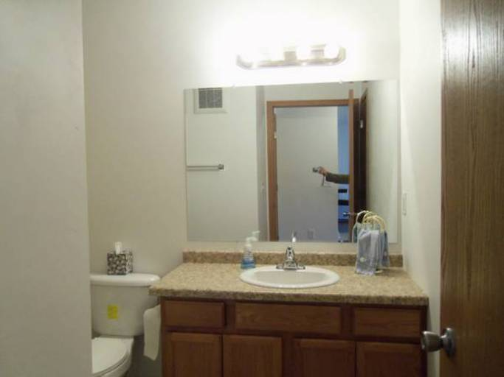

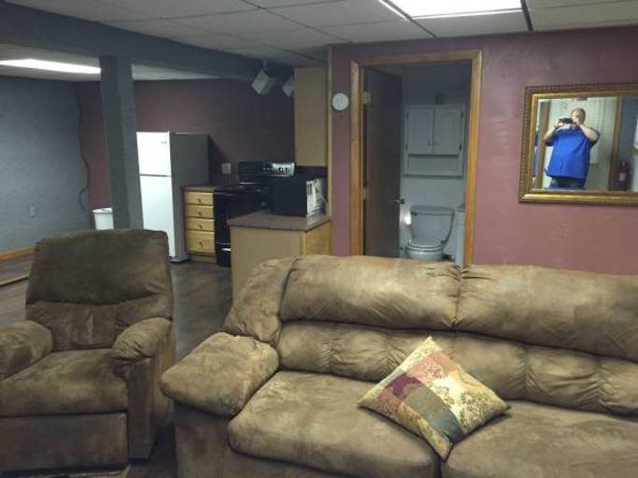

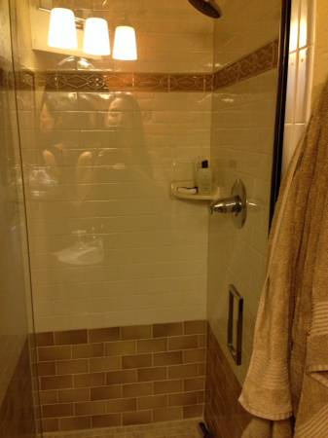

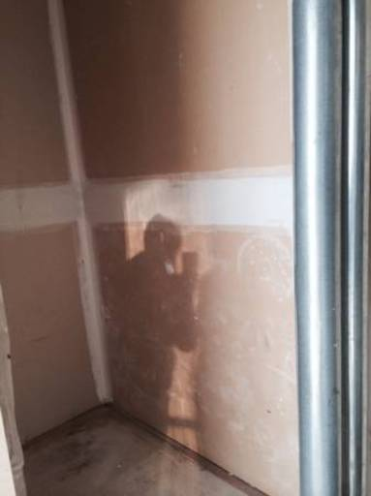

The project also revealed a clear demarcation of class, evidenced by the technical quality of the photographs themselves. Those that could afford to, or for whom it was financially worthwhile, hired professional photographers. The rooms shown were neat, tastefully but blandly decorated without the marks of lives being lived. Exorbitant rents merited the cost of a wide-angle lens and a photographer who knew how to apply HDR post-processing. The professional photographs were lit with care and carefully edited but were ultimately generic – they all could have been taken by a single photographer. The images taken by amateurs, casual and perfunctory, held the most joy and surprise. Low quality jpeg compression and patterns of overexposed windows with underexposed interiors creating photographic magic. I would imagine the photographer, probably the landlord themselves, pausing and caught up for a moment in the beauty of the way light hit a wall. How it broke up as it ran through the slats of the blind, throwing a pattern on a well-worn wooden floor. That for a moment they paused in their task, caught up in capturing something beyond just documentation and a rush to get the place listed.

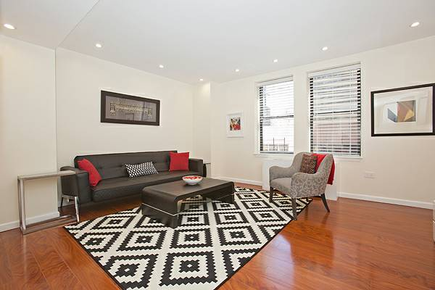

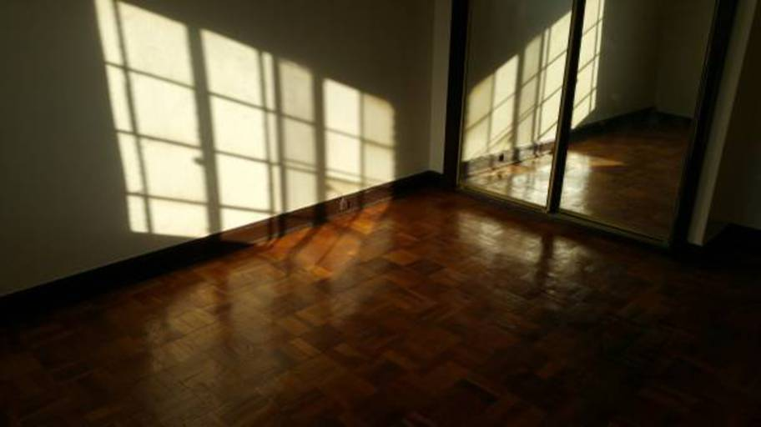

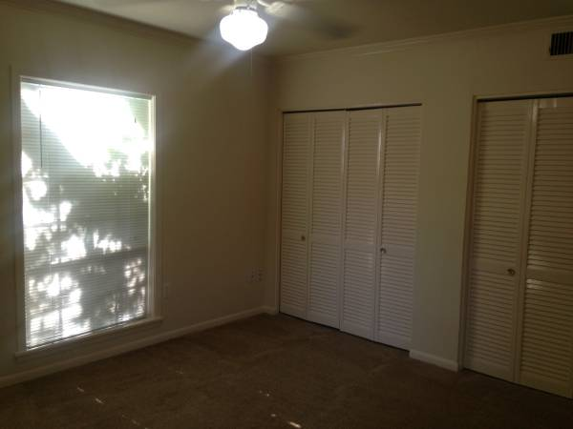

I do not know how to end this btw help. Scrap below paragraph entirely?

So many of us live as renters. As we worked on the project we found ourselves looking for a new apartment. We looked and scanned through hundreds of listing placing ourselves in the virtual spaces. The images served as a framing devices where we could envision our future selves. Would there be enough light? Would all our books fit, would our cats find joy? Nothing can trigger a bout of hopefulness or hopelessness then looking at potential living spaces. Their very anonymousness and emptiness inviting us in.

