Didn’t need much of an edit. A few tweaks, a few suggestions. I did re-order the first paragraph quite a bit for flow.

*Empty Apartments* is an online curatorial project consisting of approximately 125,000 photographs of apartments that were listed for rent on Craigslist on May 20, 2016. Originally, we came upon these images during our own search for an apartment, but we became obsessed with this anonymous trove of images. We automatically scraped the photographs from the site, then manually sorted them to remove exterior shots, ads, floorplans, and shared areas like gyms and foyers. Shown en masse, they appear as an endlessly scrolling field that reveals the transitional, intimate rooms where American renters carry out their private lives, captured by anonymous landlords and rental agencies.

Each image is a paused, in-between space: rooms in various stages of their inhabitants exiting and entering, their next configuration of furniture and personal objects yet to be realized. Some show a life caught in midstream, a photo documenting a stranger’s living space in disarray, with nothing arranged for the benefit of the camera. Others are highly polished and staged: several glasses of wine and a bottle set out on a table with chairs pulled back, inviting us to envision ourselves living there. Some are newly empty, the bareness intensified by the remnants left by the previous tenant: a pile of pillows stacked in a corner, boxes by a door.

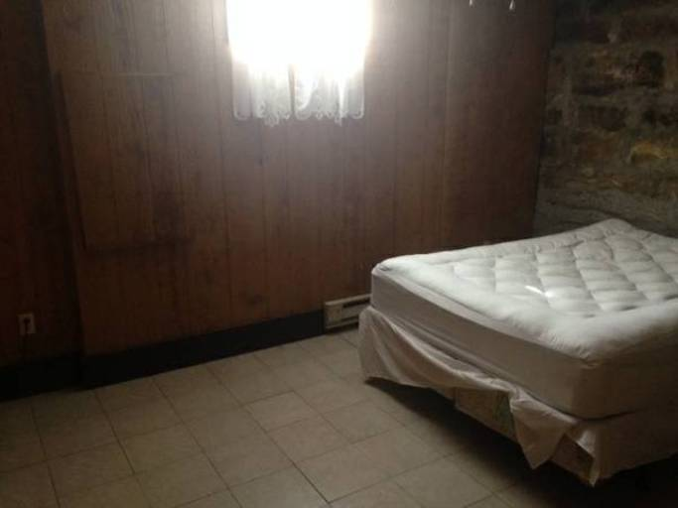

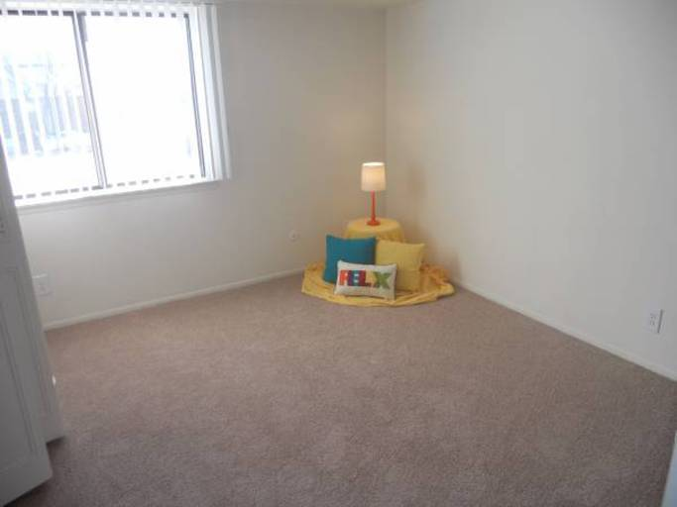

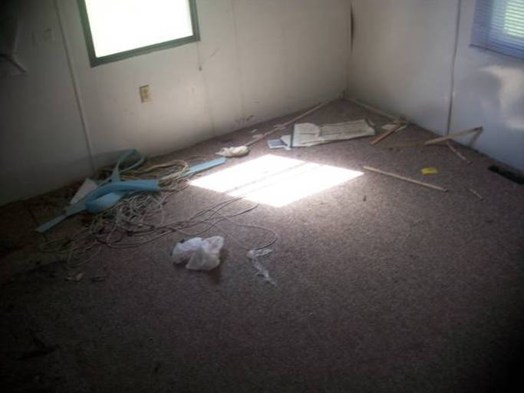

Poring through all these photographs, we were interested in both the documentation of everyday American living spaces that these images represent and the anonymous landlord-photographers who took them. In total, there are 413 areas listed on Craigslist, starting with Abilene, Texas and ending with Zanesville, Ohio (the site is organized by location, mostly by city or major metropolitan area, though less-populated regions are covered by large geographic areas). But rather than an ethnographic investigation of rental properties in the U.S., we wanted the photographs to remain as disembodied images; prices, location, and descriptions are no longer attached but instead exist in a wash of images, arranged by visual similarity.

Working on a project of this scale requires a division of labor. Jeff was responsible for the coding (a script to download the original images, intermediate steps of reformatting and sorting, and building the website). I provided the manual labor of going through all of the images (three times) to weed out the ones that we felt didn’t fit our criteria. Over a period of several months, I became intimately familiar with these images. At times the process of sifting and culling was meditative, other times tedious, with one image bleeding into the next. Each day there was a surprise, an image that would take my breath away with its unintentional beauty or strangeness. The majority of the photographs were taken by amateur photographers, who didn’t know how to handle low light or the difference in exposure between a bright window and dark room. Windows became soft rectangles of glowing light surrounded by shadow. There were inexplicable images where the intention of the photographer was unclear: unfocused pictures of empty corners, stairs descending into darkness, a blurry shot of wood grain.

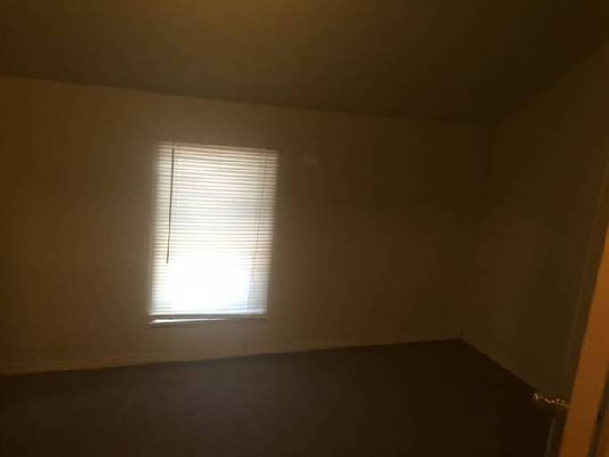

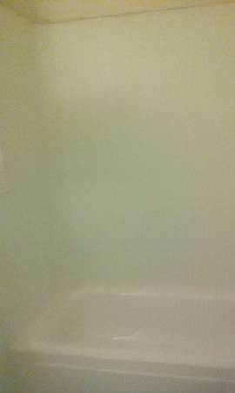

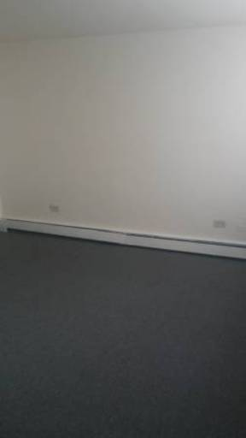

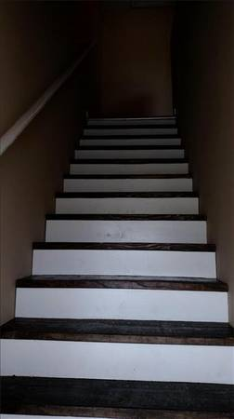

This set of images exists as a vast, seemingly endless array of interior spaces. On the website, you can zoom out and in, varying the degree in which you can engage with the details of the photographs. Pulling out, visual patterns begin to emerge. As curators, we have been especially interested not just in the works that we show, but how we show them. We spent months discussing how best to arrange these images. Though some information does get lost when separating an image from its geography, we ultimately settled on arranging the images by visual similarity. (Jeff used several machine learning algorithms to accomplish this – you can read more about that in this blog post.) Through this arrangement, strange repetitions emerge, like the glowing rectangles of windows. Those taken with artificial light are dominated by a yellow cast; soft squares of pastels from carpets and dark staircases find themselves grouped together. These patterns build connections between disparate images, and this machine-assisted way of curating became an important part of the project.

As you zoom in and look more closely, the viewer’s experience replicates my own as I individually sorted through the images. There are long slogs of sameness shot through with surprise. A calico cat, captured crossing a bed in a beam of light. The loneliness of an empty lawn chair, in an empty room, by a curtain-less window. The solitude of bare hangers in an otherwise empty closet. The atavistic satisfaction of seeing fresh vacuum marks on a carpet (there are thousands of these). There is a pervading sense of loss and abandonment that hangs over most of these images, only to be broken by a photo of a kinky pink hot tub.

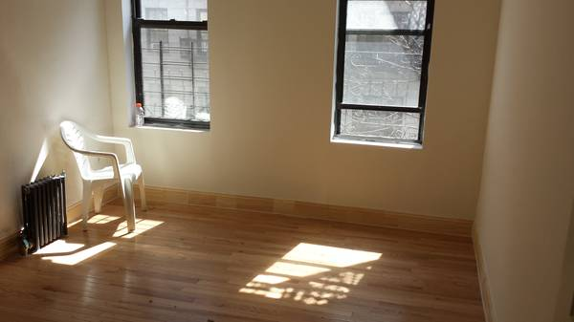

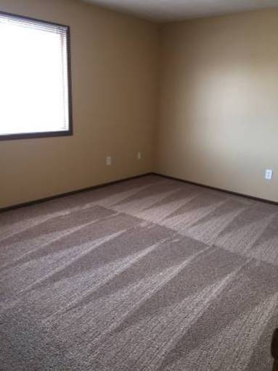

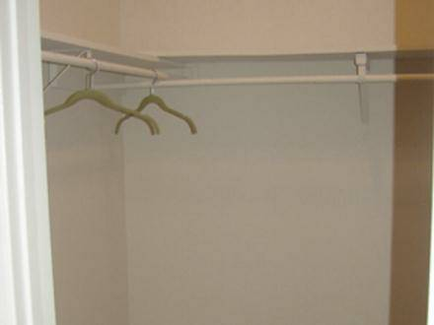

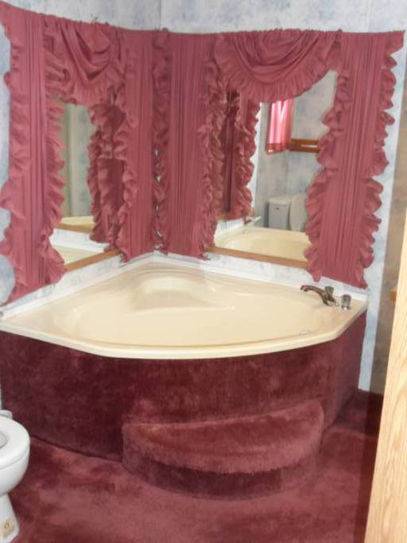

The places we reside in – the walls, ceiling, and floor – act like a secondary skin. The house acts as a protective layer and inside it we perform our most primary functions. Even in the reign of social media, most of us still lead very private lives allowing only highly mediated images of self to grace our feeds. But in these images of living spaces from Craigslist there is a feeling of vulnerability, of something exposed to the open air that should not have been. Spaces that we are not normally privy to, turned inside out. It’s the shock of looking at a photograph of a Gordon Matta Clark cut, the disorientation of seeing directly someone’s living room from the street.

And yet, despite there being no people in them, these images were obviously taken by someone. Every photograph on Craigslist is anonymous, no photographer is ever credited. We were drawn to the idea of an accidental, collaborative buildup of images. Thousands of cameras and eyes used for the purpose of capitalism, but the result is an unintentional document of our nomadic, American living spaces. Sometimes I would catch a glimpse of the photographer: a fragment of a face, a crook of an elbow caught in a bathroom mirror, a reflection in a window turned mirror at night, a shadow projected onto the floor. Their presence was always surprising and jarring when stumbled upon. They were fugitives, breaking the illusion of emptiness and introducing a paradox: though the images exuded an existential loneliness, at the moment they were taken, at least one person was present.

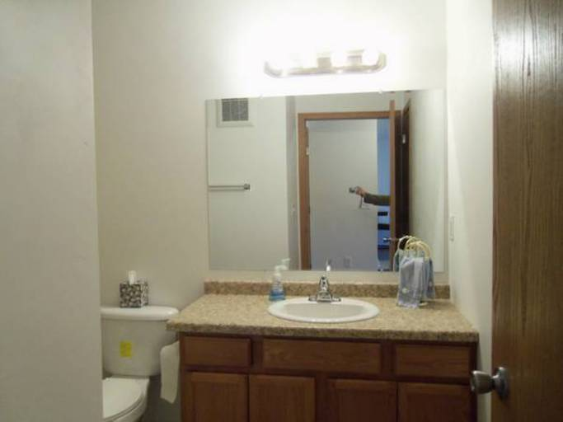

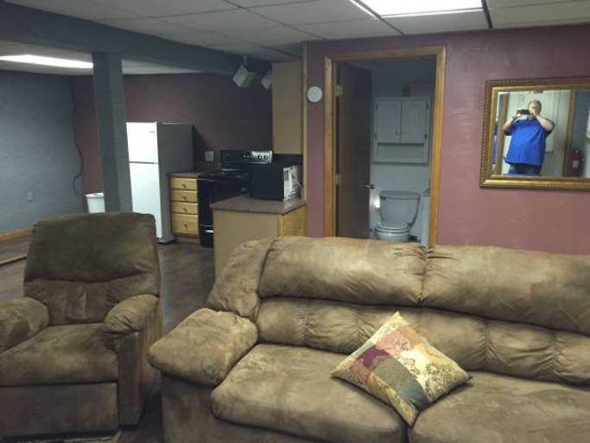

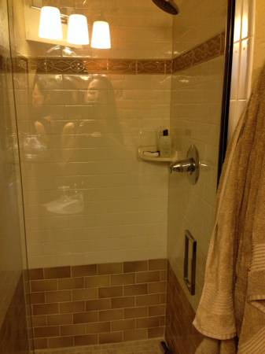

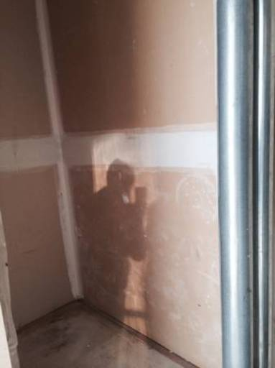

The project also revealed a clear demarcation of class, evidenced by the technical quality of the photographs themselves. Those that could afford to, or for whom it was financially worthwhile, hired professional photographers. The rooms shown were neat, tastefully but blandly decorated without the marks of lives being lived. Exorbitant rents merited the cost of a wide-angle lens and a photographer who knew how to apply HDR post-processing. The professional photographs were lit with care and carefully edited, but were ultimately generic – they all could have been taken by a single photographer. The images taken by amateurs, casual and perfunctory, held the most joy and surprise. Low quality jpeg compression and patterns of overexposed windows with underexposed interiors creating photographic magic. I would imagine the photographer, probably the landlord themselves, caught up for a moment in the beauty of the way light hit a wall. How it broke up as it ran through the slats of the blind, throwing a pattern on a well-worn wooden floor. That for a moment they paused in their task, distracted by trying to capture something beyond just documentation and a rush to get the place listed.

