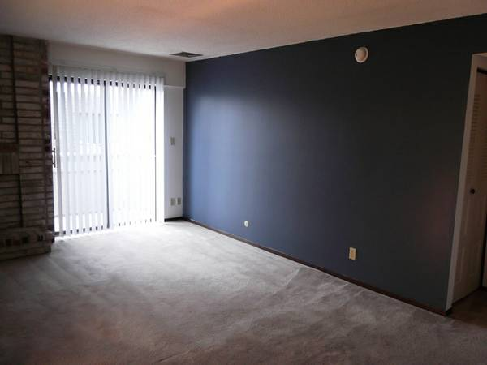

DRIFT STATION/KEMPER MUSEUM OF CONTEMPORARY ART

CRAIGSLIST APARTMENTS

After much thought on the ideas of regionalism and its relationship with architecture, we realized there is an unprecedented database of images of the banal, everyday architecture of America: Craigslist. Using custom written software, we were able to download a total of approximately 166,500 images from 413 US cities. A search was run in each city for apartments under $1260/month, the suggested cost for a family earning the average US household income of $55,000/year.

For “The Center Is A Moving Target,” we propose to curate a digital exhibition of these images, thinking of the anonymous landlord and real estate agent photographers who took these images as collaborators. As Drift Station, we often employ the strategy of curating non-art objects as a way of both bringing new voices

*Above: there are so many images like this – dark apartment with bright sunlight, evidence of recent vacuuming.*

to exhibitions and destabilizing the unique, considered art object – this will be present in this project as well.

The images, some of which are included here, show both a similarity in architectural space and regional differences. Rather than highlight these directly, we are interested in letting viewers map their own paths through the set, finding stories and connections.

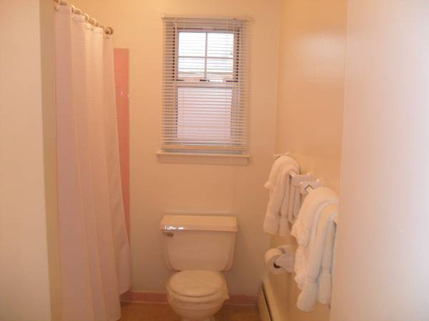 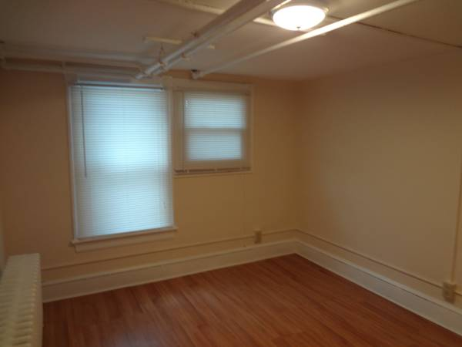

While the exact form is still under development, we anticipate building a web-based platform that displays the majority of the images (we plan to manually remove images like logos, floorplans, and exterior shots). At the moment, we have a few possible trajectories for the project:

* Algorithmic curation of the images such as sorting by similarity
* Curating selections from the set, such as completely empty rooms or rooms with bright sunlight
* Organizing by geography into a massive grid, groups of images in approximate geographic location; visitors can scroll both horizontally and vertically, much like navigating a Google Map

We would welcome discussion of this project with the Kemper, especially how the project might be displayed logistically. The technical requirements are a moving target, and of course would be dependent on the space and availability, but at the moment, the following is our ideal setup:

* Mac Mini running an offline version of the site (we can provide)
* Mac trackpad for navigation, mounted on pedestal or shelf
* HD computer monitor, flush-mounted to wall

We hope this project fits with the exhibition as you had envisioned it; we of course look forward to further conversation.