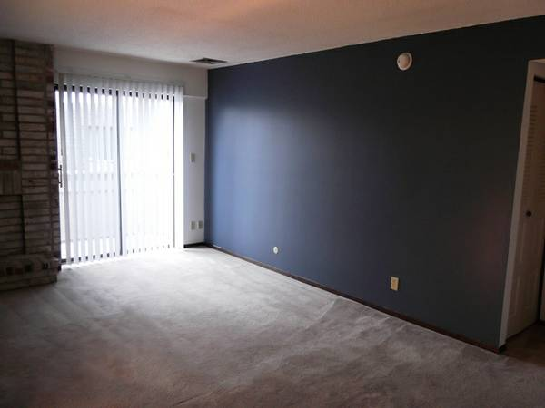

DRIFT STATION/KEMPER MUSEUM OF CONTEMPORARY ART

CRAIGSLIST APARTMENTS

After much thought on the ideas of regionalism and its relationship with architecture, we realized there is an unprecedented database of images of the banal, everyday architecture of America: Craigslist apartment listings. Using custom written software, we were able to download a total of approximately 166,500 images from 413 US cities. A search was run in each city for apartments under $1260/month, the suggested cost for a family earning the average US household income of $55,000/year.

For “The Center Is A Moving Target,” we propose to curate a digital exhibition of these images, thinking of the anonymous landlord and real estate agent photographers as collaborators. As Drift Station, we often employ the strategy of curating non-art objects as a way of both bringing new voices to exhibitions and

*Above: there are so many images like this – dark apartment with bright sunlight, evidence of recent vacuuming.*

destabilizing the unique, considered art object – this will be present in this project as well.

The images, some of which are included here, show both regional differences and similarities in architectural space. Listings in LA have more mirrors and pink; photographs in Seattle show very few sunny windows. Rather than highlight these directly, we will allow viewers to map their own paths through the set, finding stories and connections.

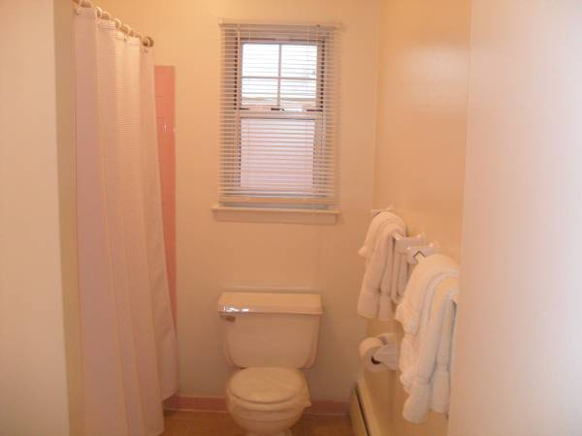 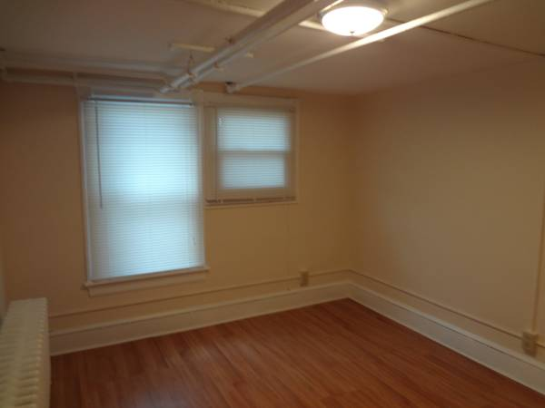

*We are drawn to both the banality of the empty apartments, as well as the clear fact that these are inhabited, personal spaces being viewed on a public platform.*

While the exact form of the project is still under development, we anticipate building a web-based platform that displays the majority of the images (we plan to manually remove images like logos, floorplans, and exterior shots). At the moment, we have a few possible trajectories for the project:

* Algorithmic curation of the images such as sorting by similarity or color
* Curating selections from the set, such as completely empty rooms or rooms with bright sunlight
* Organizing by geography into a massive grid, with groups of images in approximate geographic location; visitors can scroll both horizontally and vertically, much like navigating a Google Map

We would welcome discussion of this project with the Kemper, especially the logistics of how the project might be displayed. The technical requirements are a moving target, and of course would be dependent on the space and availability, but at the moment, the following is our ideal setup:

* Mac Mini running an offline version of the site (we can provide)
* Mac trackpad for navigation, mounted on pedestal or shelf
* HD computer monitor, flush-mounted to wall

We hope this project fits with the exhibition as you had envisioned it; we of course look forward to further conversation.