DataSense Analysis Report
Generated on: 2026-03-27 17:15:23

Executive Summary
Primary Architecture: Custom Fusion MLP (85% match)
Alternatives: CLIP, Flamingo

Visual Insights

Dataset Fingerprint Profile
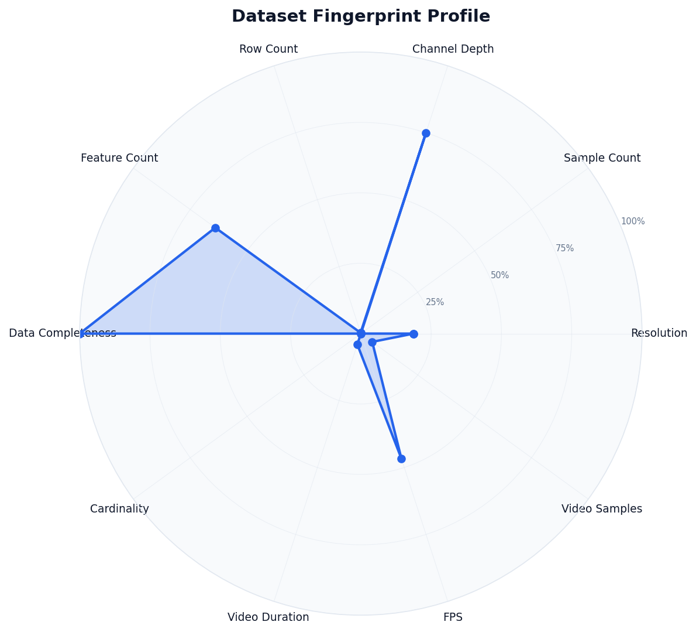

Architecture Leaderboard
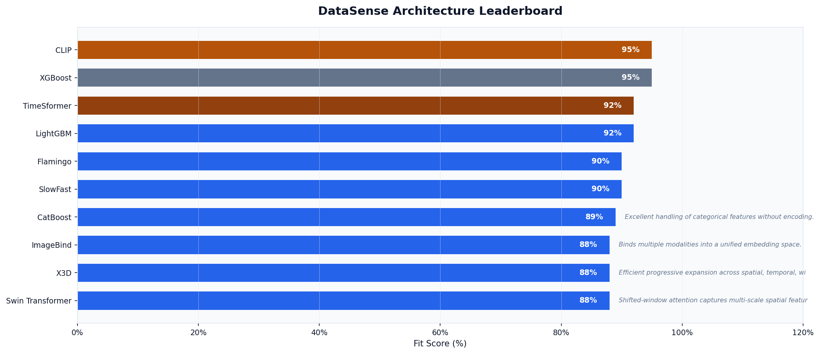

Architecture Ranking
Rank | Model | Fit Score | Justification
1 | CLIP | 95% | Industry standard for image-text alignment and zero-shot tasks.
2 | XGBoost | 95% | Gradient boosting with native missing value handling.
3 | TimeSformer | 92% | Divided space-time attention for complex video understanding.
4 | LightGBM | 92% | Fast gradient boosting with histogram-based splits.
5 | Flamingo | 90% | Powerful multi-modal LLM for visual question answering.
6 | SlowFast | 90% | Dual-pathway design captures both slow and fast motion.
7 | CatBoost | 89% | Excellent handling of categorical features without encoding.
8 | ImageBind | 88% | Binds multiple modalities into a unified embedding space.
9 | X3D | 88% | Efficient progressive expansion across spatial, temporal, width, and depth.
10 | Swin Transformer | 88% | Shifted-window attention captures multi-scale spatial features.
11 | VideoMAE | 87% | Self-supervised pretraining excels with limited labeled video data.
12 | Custom Fusion MLP | 85% | Custom fusion approach allows tailored cross-modal interaction.
13 | 3D CNN (R3D-101) | 85% | Classical 3D convolutions for short-range temporal patterns.
14 | EfficientNet-B0 | 85% | Excellent accuracy-efficiency balance across resolutions.
15 | ConvNeXt | 83% | Modern CNN matching transformer performance with simpler design.

Dataset Fingerprints

Image Modality
Sample Count: 2
Median Resolution: 192x192

Tabular Modality
Sample Count: 2
Rows x Cols: 300 x 64
Missing Data: 0%

Video Modality
Sample Count: 5

