Jeffrey Au

Research Audience and Problem Space Report

**Introduction:**

In recent years, resale marketplace websites for second hand items, also known as the “Re-Commerce” industry, has emerged as a big part of the online retail sector. In fact, according to [this report](https://www.ibisworld.com/industry-trends/market-research-reports/retail-trade/miscellaneous-store-retailers/used-goods-stores.html) from IBISWorld that was just released in October 2018, “the Used Goods Stores industry has outperformed the overall retail market over the five years to 2018, benefiting primarily from changing consumer trends.” This report will look at the goals of the audience for the re-commerce industry, where a problem space may exist and some possible solutions to such problems.

**Research Audience:**

In this [report from theshelf.com](https://www.theshelf.com/the-blog/resale-industry-recommerce-stats) that aggregated statistics about the resale industry, the author claimed that “Millennials are the most likely generation to shop resale, with 30 percent of Millennials in search of that sweet spot where quality intersects price.”

The author cites three catalysts as reasons why re-commerce websites have grown so quickly. The first catalyst that the great recession of the last decade. As the economy plummeted, millennials learned to be financial conscious and shop wisely. For the second catalyst, the author states that “sustainability is big on the list of things millennials are looking for from the products they buy and the brands they support, and sustainability has become a HUGE deal.” The final catalyst for the resale market explosion is the change of demographics. Compared to the baby boomer generation who view buying second handed goods as a sign of financial hardship, millennials, for the reasons mentioned above, embraced the thrifty culture of the resale market.

So, what is our audience looking for when they shop for used products online besides cheap prices and quality products? In this comprehensive journal [article](https://lib.dr.iastate.edu/cgi/viewcontent.cgi?article=4643&context=etd) from Iowa State University that surveys all aspects of the second hand retail industry. The author states that “at exchange sites, consumers and sellers enjoy diverse experiences and fulfill their needs, including treasure and bargain hunting, social interactions—all in an atmosphere of nostalgia.”

Personally, I think the goal for a resale marketplace in terms of the user experience is to foster the atmosphere mentioned above, as well as utilizing technology to present information in a clear and concise way that is easy for the customer to understand.

**Competitors, Problem Space, and Possible solutions:**

As stated from the various reports above, the re-commerce space is very crowded with giants like eBay and Amazon marketplace, listing sites like Craigslist, and new comers to the market place like the new Facebook marketplace feature. We will examine these major players in this space and see where there may be a problem space for improvement.

Out of the websites mentioned. Amazon marketplace’s re-commerce feature seem to be the most problematic. The used section of the product does not allow the seller to post actual pictures of the item. The seller is only allowed to set the price, choose from a list of predefined conditions (like new, good, acceptable, etc..) , and then enter the description of the product in a tiny text field. eBay and Craigslist and Facebook marketplace all allow users to post pictures and type out a description in a defined area. The problem I find with eBay is that the users have to scroll down in an item’s page and get past the generic information boxes about the product to get to the section where the seller describes the actual product condition. The problem is even more exacerbated in eBay’s mobile app or mobile site. I believe the description part of a listing is the most important part of a listing along with price and pictures and should be treated as such, without making it harder than necessary to find. Besides putting all the import information on one page when possible, retailers should also consider allowing sellers to add “tags” like the ones below that are common on blogging or gallery sites to their listings.



Instead tags for an item listing could say: “macbook pro 2015” “13 inch” “like new” “free shipping”

Our main audience, millennials would be very familiar with such tagging styles that are seen across many sites on the web. Such a tag system could display all the most important details of a listing in a small space, making it easy to fit in both mobile and desktop sites.

Another big part of shopping for used item is the question and answer aspect. Sometimes sellers do not provide enough information, or customers just want to know certain details about the product. In this case, the user would usually have to message the seller via the website or even email and wait for a reply. Sometimes, a question is asked repeatedly by different customers and the seller would have to answer it each time, which could be time consuming for a seller with many products for sale.

Another type of question that happens in these resale sites is when a customer make an offer for a product. Some sites like eBay have built in offer systems where buyers and sellers can make counter offers to each other. However, most of the other sites like Amazon marketplace, Facebook marketplace or craigslist do not, and require both parties to message back and forth.

A possible solution to solve both problems of redundancy is to have a “comment wall system” for each listing. A relative smaller re-commerce site for electronics called Swappa actually utilizes such a system and I personally find it to be extremely useful and should be implemented in other re-commerce sites.

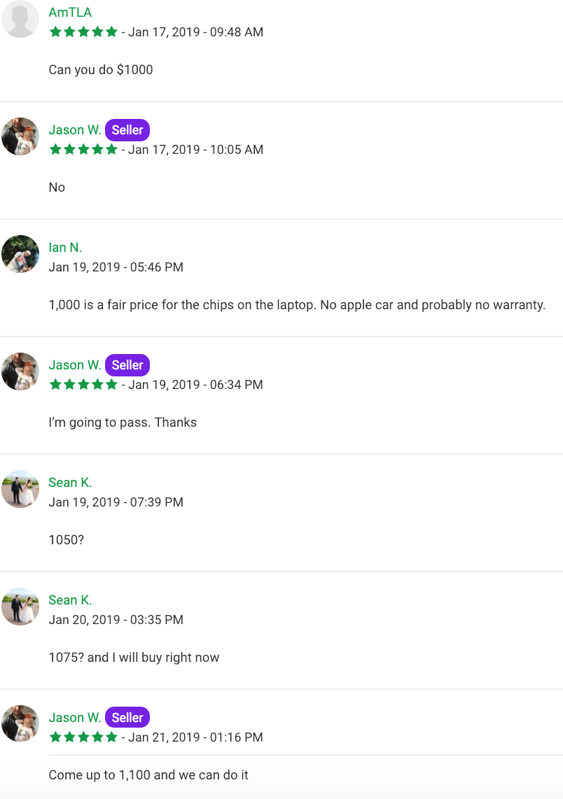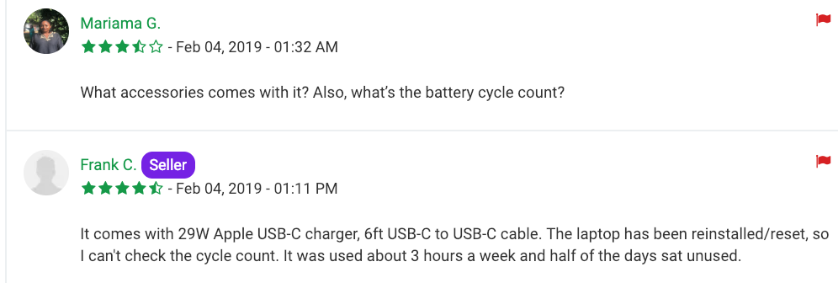

In the above examples we can see that the potential customers can both “bargain” by placing offers and ask questions. This comment wall system can reduce the amount of “low balling” offers to the sellers since other buyers can already see what offer prices are rejected. The buyers can also find specific information about the product (in this case the accessories and battery cycle count).

In summary, while the tag and comment wall systems aren’t brand new technology, I believe there is an opportunity to re-design some of these already very successful re-commerce sites to create an experience that fosters “an atmosphere of nostalgia” of a traditional thrift store or garage sale as well as present information in a way only modern technologies allow.

**References:**

1. <https://www.ibisworld.com/industry-trends/market-research-reports/retail-trade/miscellaneous-store-retailers/used-goods-stores.html>
2. <https://www.theshelf.com/the-blog/resale-industry-recommerce-stats>
3. https://lib.dr.iastate.edu/cgi/viewcontent.cgi?article=4643&context=etd