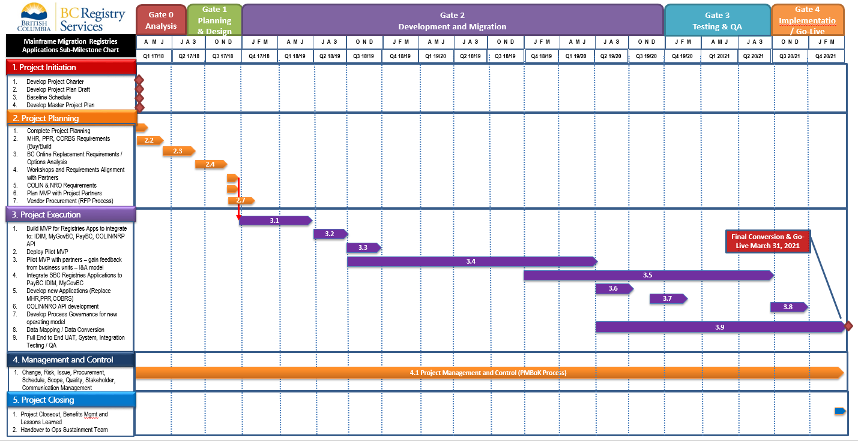

**Decisions to Move Forward with Plan**

|  |  |  |  |  |  |
| --- | --- | --- | --- | --- | --- |
| **Review Item** | **Current Status** | **Decision needed today?** | **Decision Details/Options** | **Proposed Next Steps**  **(Pending SC Approval)** | **Supporting Documents** |
| Governance: adopt agile scrum as the standard project management framework | The methodology was not defined yet in the initial project planning completed March 31 | Yes | 1. Formally adopt agile delivery process with waterfall style oversight (milestones, requirements upfront) 2. Aligns to CSI and other gov’t processes (Deloitte?) 3. Promotes ‘ownership’ and oversight of the plan when working with outside contracts | 1. Move forward with Service Now config (need Istanbul update) 2. Develop and review agile process governance doc (much of work already done in Project Charter) 3. Sign off next SC meeting |  |
| 2.1 Complete Project Planning – Gate 1 | In Progress – is dependent on items below | Yes | Gain approval for the three items below |  |  |
| 2.2 MHR/PPR/COBRS Requirements and Buy/Build Decision | In Progress – see detail in sections below | Yes | See individual sections  2.2a, b, c below |  |  |
| 2.2a MHR Buy/Build | Initial analysis and requirements completed.  Needs to be validated and estimated for build option | Yes | 1. No known COTS product available 2. Dependent on PPR Buy/Build Decision | 1. Integrate requirements and user stories into product backlog 2. Gain decision whether CSI will be doing the estimation work 3. Estimate MVP (will require small team) |  |
| 2.2b PPR Buy/Build | Initial analysis and requirements completed.  Needs to be validated and estimated for build option | Yes | 1. Is decision to buy/build dependent on MVP estimate? Full estimate? 2. Make decision to build/buy | 1. Integrate requirements and user stories into backlog and estimate MVP 2. Work with identified Vendors to understand their solutions capabilities and costs 3. Submit Briefing Note for Buy/Build Decision 4. Gain decision whether CSI will be doing the estimation work |  |
| 2.2c COBRS Buy/Build |  | Yes? | Co-ops  Director Search  NAMES |  |  |
| 2.3 BC Online Replacement Requirements / Options Analysis | Initial Requirements completed by Deloitte | No |  | Finalize SO by end of Week |  |
| 2.4 Workshops and Requirements alignment with Partners | In Planning | No | IDIM  GARMS  MyGov | Workshops are being planned and will be held shortly |  |
| 2.6 Plan MVP with Project Partners | Not Started | No | Future Work – Post MVP Definition |  |  |
| 2.7 Vendor Procurement (RFP) | Not Started | No | Future Work – Post MVP Definition |  |  |

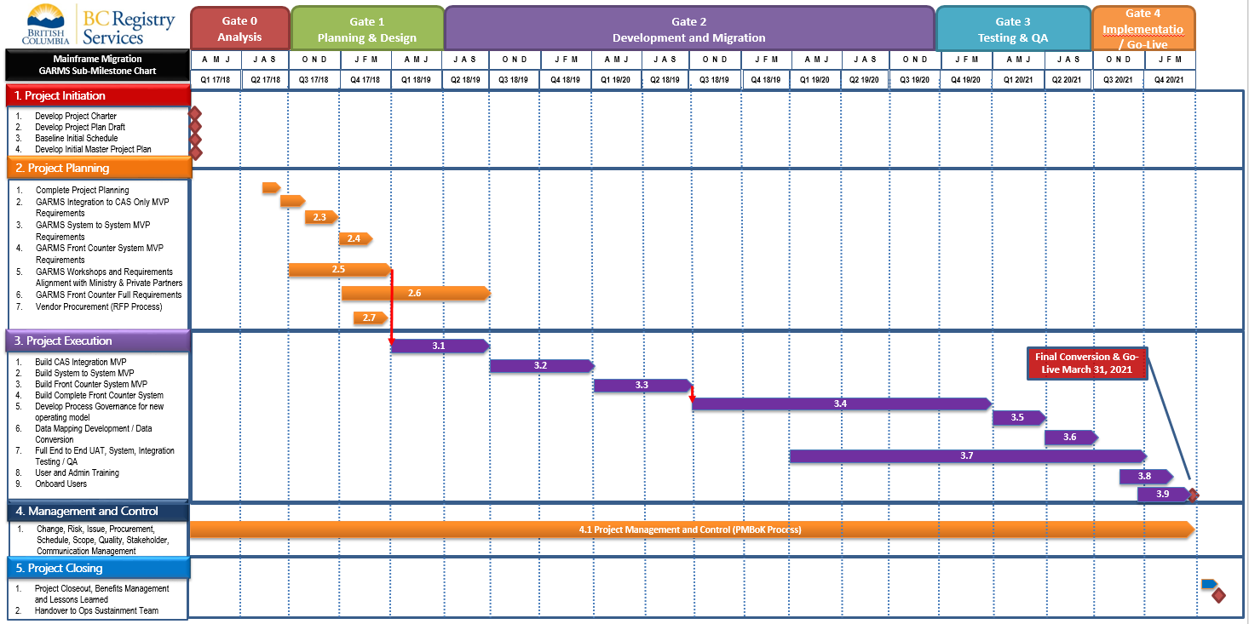

|  |  |  |  |  |  |
| --- | --- | --- | --- | --- | --- |
| **Item from GARMS Migration Plan Chart** | **Current Status** | **Decision Needed Today?** | **Decision Details/Options** | **Proposed Next Steps**  **(Pending SC Approval)** | **Supporting Documents** |
| 2.1 Complete Project Planning – Gate 1 | In Progress – is dependent on Deloitte’s initial requirements work and proposals for next steps | No | Future Work – Post MVP Definition | Finalize SO by end of Week |  |
| 2.2 GARMS integration to CAS MVP Requirements | In Progress | No | Future Work – Post MVP Definition | Assess Deloitte estimate | Assess Deloitte estimate |
| 2.3 GARMS System to System MVP Requirements | Initial analysis completed. No known available COTS product – dependent on PPR Buy/Build Decision | No | Future Work – Post MVP Definition | Assess Deloitte estimate | Integrate requirements and user stories into backlog and estimate MVP |
| 2.4 GARMS Front Counter System MVP Requirements | Initial Analysis in progress. | No | Future Work – Post MVP Definition | Assess Deloitte estimate |  |
| 2.5 GARMS Workshops and Requirements Alignment with Ministries and Private Partners |  | No | Future Work – Post MVP Definition | Assess Deloitte estimate |  |
| 2.6 GARMS Front Counter Full Requirements | Initial Requirements completed by Deloitte | No | Future Work – Post MVP Definition | Assess Deloitte estimate |  |

## Plan Proposal:

1. I suggest we start with the pressing items (PPR/MHR)
2. Create a high level agile style release plan for next SC meeting (example below)

|  |  |  |  |
| --- | --- | --- | --- |
| **Work Item** | **Requirements/Resources** | **Timeline** | **Note** |
| Develop Agile | PM - .5 | July 15 – Aug 7 | Develop and review agile process governance doc (much of work already done in Project Charter) |
| PPR / MHR – Develop Product backlog from existing requirements | PM - .5  BA - .5  PO - .25 | Aug 1 – Aug 31 | Followed up by any gap analysis requirements |
| PPR / MHR Estimate MVP | PM - .5  BA - .5  PO - .25  CSI – 2.0 | Sept 1 – Oct 15 | How does CSI resourcing work?  Who supplies team members? |
| NAMES |  |  | Finalize strategy pending Buy/Build Decision |
| GARMS – Assess Deloitte Estimate  Build Backlog | ? | July 15 – Aug 31 | I assume we would build the backlog and manage the delivery team? |

## 

## Gate 1 - Plan Approval Process

### Overview

The gating process ensures that projects are examined at key decision points and provides assurance that projects can progress successfully to the next stage.

This Gate is to ensure a common understanding and agreement with the project goals, objectives, approach, scope, schedule, and budget.  Appropriate methods for completing the project successfully are defined and approved.  
  
Roles

There are three primary roles for the stage gate:  
1. Presenter, Project Manager  
2. Facilitators – Project Sponsors  
3. Chair, a decision-making role

### **Gate 1 Plan Presentation**

This is the stage gate review meeting, where a group of stakeholders meet and assess the readiness of the project to move into next phase.

### Participants

* Executive Project Sponsors (or delegates)
* Project Sponsors (business area)
* Project Manager
* Representation from Architecture
* Manager Business Analysis

### Decision

1. Proceed as planned: Project has met its stage gate criteria and project can proceed to next phase
2. Proceed with remedial action: Project has met certain stage gate criteria and can proceed to next phase provided unaddressed needs are addressed immediately
3. Rework required: Project has not met its stage gate criteria and project cannot proceed to next phase unless criteria is met

## 

## Method Scope – High Level Definitions

Table 1 - Method Scope

| Discipline | In Scope (Y/N) | Discipline Description | Method Scope Assumptions |
| --- | --- | --- | --- |
| **Project Governance** | Y | The combined efforts of all levels of Project Management and Oversight for the Mainframe Migration Project. | The overall Project Governance is the combined effort and outcomes of all individual Governance activities described below. Used as a generic term to describe all governance and accountability activities for the Migration Project. |
| **Project Sponsorship (Executive Sponsors)** | Y | Provides strategic direction from the executive level. | There will be two executive level sponsors in the Mainframe Migration Project. These sponsors will set the strategic objectives and direction to the Steering Committee and the Project Delivery Team. They will also be the point of escalation from the Project Steering Committee. |
| **Project Steering Committee (SC)** | Y | Provides strategic direction from the Service BC level. Primary escalation point for the Project Delivery Team. Understands high level project risks and constraints. Is authorized and able to resolve or escalate project risks and issues. Provides input on scope, scope change management, budget, and schedule | Chaired by two Director level leaders. The Project Steering Committee will provide direction to the Project Delivery team and serves as the escalation point from the Project Management Office and the Project Delivery Team. |
| **Project Management Office (PMO)** | Y | Provides support to Project Management Team in the areas of methodologies and processes, resource management, procurement, and project integration (other projects) | Provides direction to Project Manager(s), and serves as the escalation point for the Project Manager(s) and the Project Delivery Team. |
| **Project Management (PM)** | Y | Provides approaches and assets for effective project management and planning. | Project will follow BC OCIO approved project management processes. These processes are based on PMI’s PMBoK methodology with slight variations to fit BC Government planning and management processes. Clear guidelines are available on OCIO project site.[1]  Serves as the primary escalation point for Project Leads and the Project Delivery Team. |
| **Team Leads** | Y | Responsible for direction and support to team members in specific teams. | Team examples: Development, Quality Assurance (QA), Requirements.  Is the primary escalation point for project team members. |
| **Organizational Change Management (OCM)** | Y | Addresses adoption and sustainability of the change initiatives. It encompasses an integrated approach to communications, stakeholder engagement and preparation, capability transfer, training, and organizational alignment and transition. | Project use, follow and implement the Organizational Change Management Plan Checklist provided by OCIO.[2] |
| **Technology (e.g., Waterfall, Agile, etc.)** | Y | Defines the approach to design, develop, test, and operate the infrastructure and software components required for the system applications. | Project will use a hybrid rolling wave planning model to achieve stage gates as the project progresses. This model allows use of waterfall processes for overall planning and control in all areas: initiation, planning, executing, manage and monitor and close activities, while using a more efficient agile/scrum model for development activities. |

1.
2.