# Crop Compass Style Guide

Crop Compass Style Guide

Overview

General UI behavior notes

Color and Font

Colors:

Data scale colors:

Header UI/UX

Header scroll

Crop/County Choice

Section headers + other notes

Data Components

Circle percentage charts

County average bars

Bar Charts

Timescale Charts

Map

Choropleth

Choropleth dropdown

Farmed land/farmable land

Crop farm location

## Overview

Links to examples are for illustration of ideal interaction only, does not need to be exact or needed at all if too difficult to implement.

See final mockups for entry to the page, if county and crop are selected, header while scrolling + sidenav pop out for crop or country selection in the main [Crop Compass UI resources](https://drive.google.com/folderview?id=0ByiJpMc4NpBKWU14SVhXTmRzYXM&usp=sharing) folder.

Please feel free to contact me in slack @adrienne or [acetilley@gmail.com](mailto:acetilley@gmail.com) if anything is missing or needs further explanation.

## General UI behavior notes

* Nothing should be empty when entering the page, with nothing selected you see general Oregon stats
* When scrolled down the page and adjust the crop or county **you should stay on that portion of the page and the data should adjust as you watch**. This is critical for using this as a comparison tool

## Color and Font

Header fonts:

<https://www.google.com/fonts/specimen/Grand+Hotel>

H1: 48px

H2: 35px

H3: 26px

Body font:

<https://www.google.com/fonts/specimen/Dosis>

Size: 18px

Line height: 26px

### Colors:



#523C03 #5EAA00 #C4BC21



#6F5204

Background color:



#F6F5F0

### 

### Data scale colors:



#5EAA00

#87B725

#A1C02A



#BCCA30



#E1D837

## 

## Header UI/UX

When hovering over the ‘choose a crop’ text or icon, the crop flips between the following images (icons can be found in the resources folder - please let me know if different sizes are needed, as I don’t have a ton of experience exporting icons):



Example of what it would looks like (see one on the left, not super fast):

<http://codepen.io/rimager/pen/vAHgd/>

### Header scroll

The top header scrolls with the page - see full view in main drive folder:

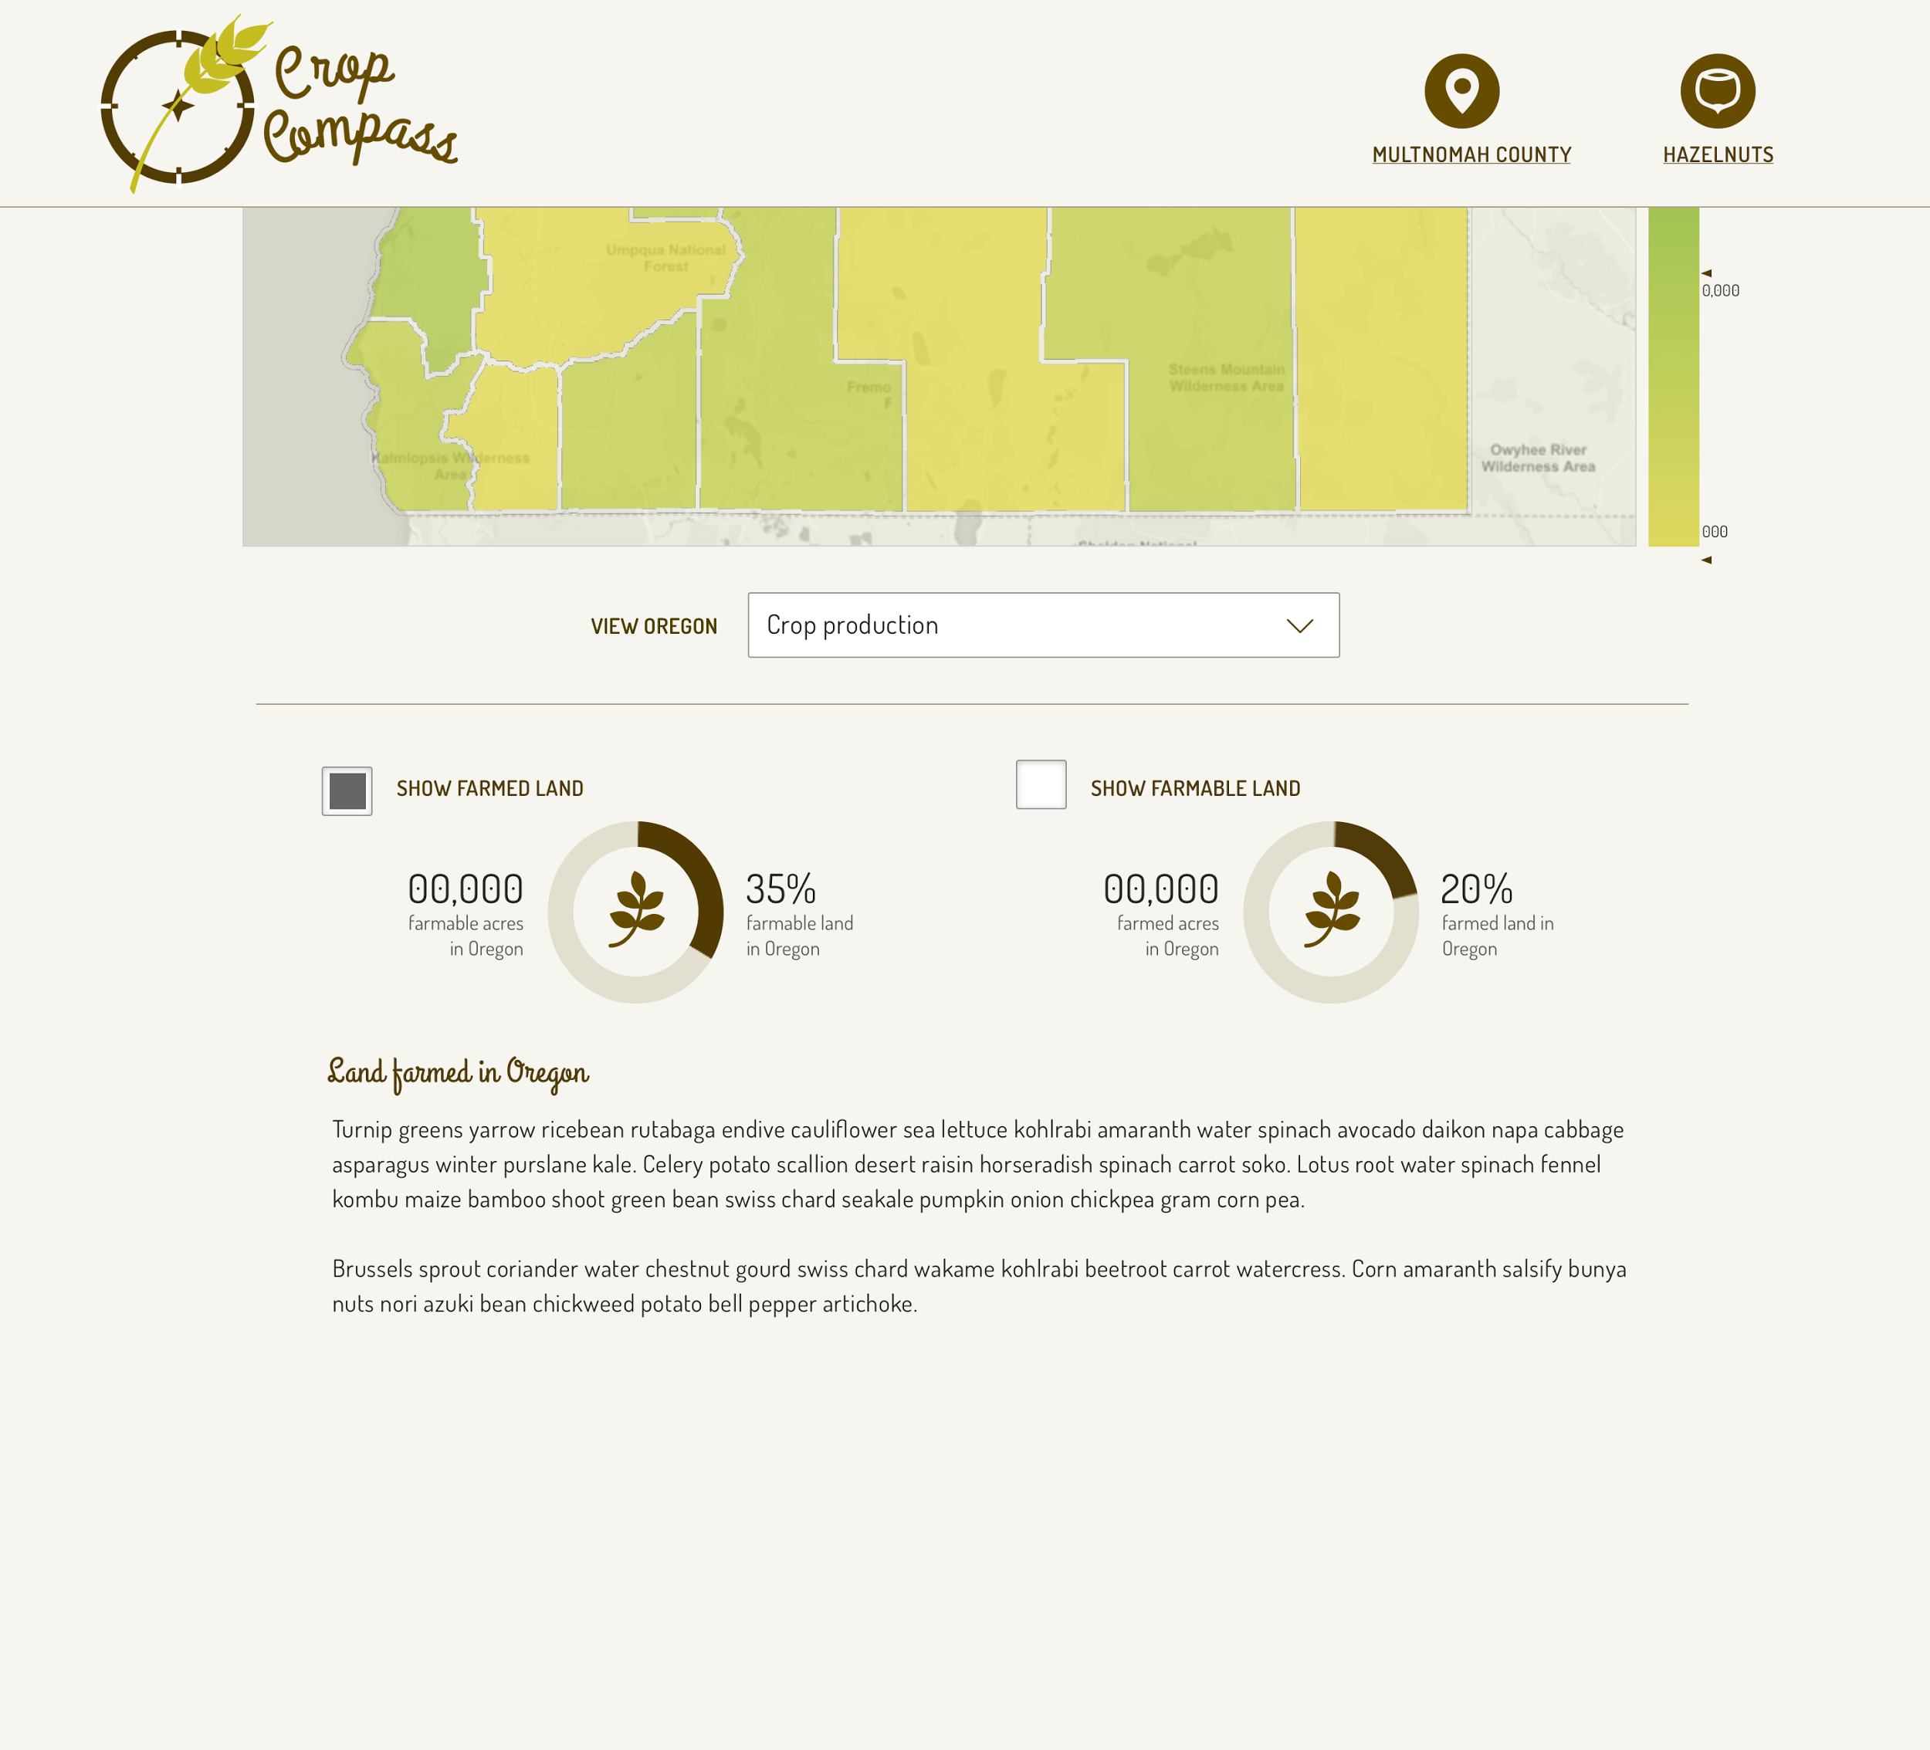

### 

### 

### Crop/County Choice

When clicking ‘choose a crop’ or ‘choose a county’ a sidenav with available options pushes content over. See full view in main drive folder.

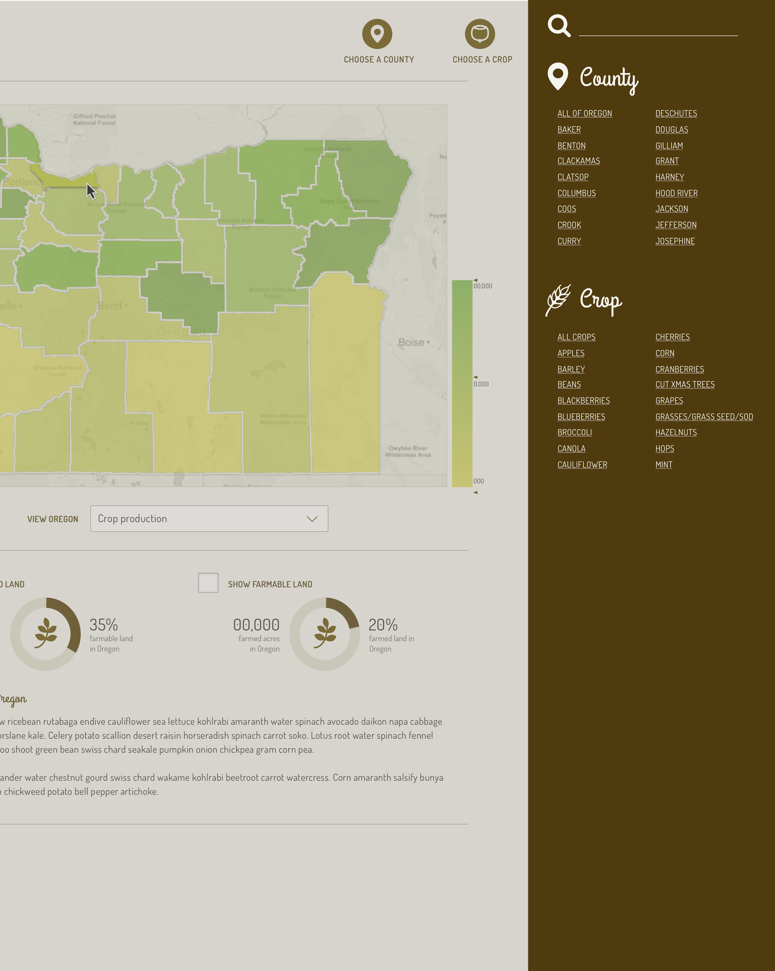

Example:

<http://tympanus.net/Development/SidebarTransitions/> (‘reveal’ or ‘push’)

### Section headers + other notes



Anywhere you see text underlined this means that this has been selected as an option - either county as in example above or crop - user can click this to open the county or crop selector sidenav

## Data Components

### Circle percentage charts

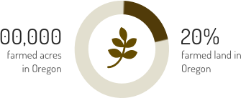

On page entry or selection that will adjust percentage, example of behavior (if possible): <http://vizuly.io/product/radial-progress/?demo=d3js>

### County average bars









* Text modifies based on section and in comparison to other counties
* Background color: #E2DFCE
* Line segment color: #A8A286

### Bar Charts

## 

* The line + ‘Hazelnuts’ - only shown when crop has been selected
* # underneath bars is obviously the actual unit amount
* Foreseeable issue - this line could be basically indecipherable next to the other crops - just keep it to a 5px line
* Pretty straightforward, let me know if you need more details and I’ll add some

### Timescale Charts

* Same as old one, but colored with the yellows - don’t need to slave to get this one looking exact :) 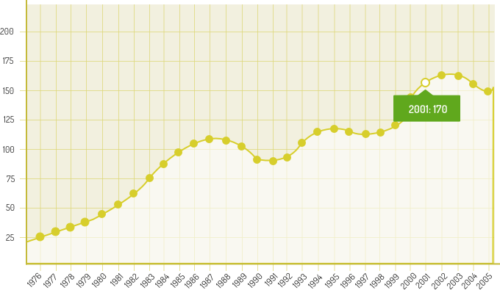

## Map

* Hover state seen in the mockups - ideally clicking a county would let you choose that county (but not absolutely nessesary)
* Additionally - if hover state, then label giving county name also a plus

### Choropleth

* Uses the colors found in the ‘data scale colors’ section found at the top of this document but w/ **opacity at 70%** to take some of the visual weight off
* I grabbed a leaflet looking map - but can be however you would like it to behave
  + Zoom is a plus - but only useful if map details like cities and roads are there

### Choropleth dropdown

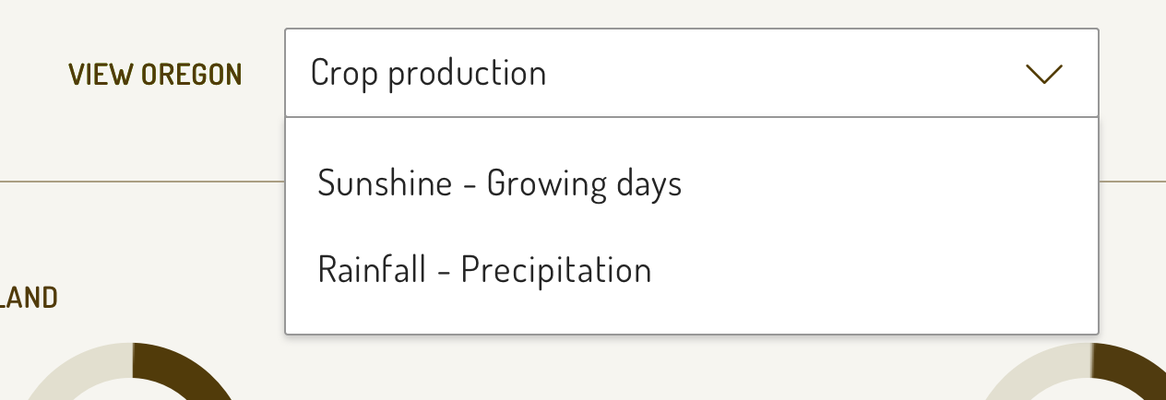

* ‘Crop production’ scale adjusts down for individual crop when chosen
* Growing days + precipitation are just overall for all counties

### Farmed land/farmable land

Checkbox toggles - based off of the current beta

Adrienne - styles in progress

### Crop farm location

Believe we have this data based off of zipcode

Adrienne - styles in progress